
COMS
Verifiable Cost Manual

v0.05

Table of Contents

Table of Contents 2
Revisions and Approval Information 5
Approval Date: 5
Effective Date: 5
Revision History: 5
Introductory Information 6
Purpose 6
Intended Audience 6
Global Definitions 6
Section 1: An Introduction to Verifiable Costs 8
Verifiable Cost Flowcharts 10
Chart 1: Verifiable Startup Cost Data: Calculations and Dependencies 10
Chart 2: Verifiable Minimum Energy Cost Data: Calculations and Dependencies 11
Chart 3: Real Time Mitigation Data: Calculations and Dependencies 12
Section 2: General Rules of Verifiable Costs 13
Generally Applicable Rules 13
Additional Rules for Combined Cycle Plants 14
Additional Rules for Split Generation Resources 15
Section 3: Verifiable Startup Costs 17
Verifiable Startup Costs Policies 17
Submitting Startup Costs 17
Startup Fuel Consumption 18
Fuel Type Percentages 18
Non-Fuel Startup Costs 19
Start Type Descriptions 19
Table 1: Startup Verifiable Cost Data Requirements per Resource per start type 20
Section 4: Verifiable Minimum Energy Costs 21
Verifiable Minimum Energy Cost Policies 21
Submitting Minimum Energy Costs 21
Minimum Energy Fuel 22
Fuel Type Percentages at LSL 22
Non-Fuel Minimum Energy Cost 22
Verifiable Operation Minimum Energy Costs 23
Verifiable Maintenance Minimum Energy Costs 23
Table 2: Minimum Energy Cost Data Requirements per Resource 23
Section 5: Mitigated Offers and Verifiable Costs 24
Mitigated Offer Cap Policies 24
Submitting Data for Mitigated Offers 24
Variable O&M 24
Verifiable IHR 25
Table 3: Real Time Mitigation Data 25
Section 6: Verifiable Heat Rates 26
Verifiable Heat Rate Policies 26
Submission of Heat Rate Curve Data 26
Input-Output Curve 26
Incremental Heat Rate Curve 27
Average Heat Rate Curve 27
Section 7: Forced Outages of a RUC-Committed Resource 29
Policy for Costs Resulting from a Forced Outage 29
Submission of Forced Outage Cost Data 29
Section 8: Operating and Maintenance Cost Guidelines 31
Operating and Maintenance Cost Policies 31
Verifiable Operating Costs 31
Verifiable Maintenance Costs 31
Event Specific Verifiable O&M Costs 32
Options for Submitting Verifiable O&M Costs 32
Option 1: Submission of O&M costs with Documentation and Calculated Using a Resource Specific Methodology 32
Option 2: Submission of O&M costs with Documentation and Calculated Using the Methodology Described in Appendix 1 33
Additional Conditions Applicable to Option 1 and Option 2 33
Conditions Applicable to All Types of Resources 33
Conditions Applicable to Combustion Turbines 34
Conditions Applicable to Fossil Thermal Resources 36
Maintenance Period Conditions 36
Operating and Maintenance Cost Submissions Types 36
Section 9: Timelines Applicable to the Submission and Review of Verifiable Costs 37
Submission and Approval of Verifiable Cost Data 37
Timeline Applicable to the Submission and Approval of Verifiable Costs 38
Chart 4: Verifiable Cost Submission Timeline 39
Section 10: Timeline for Rescinding Approval of Verifiable Costs 41
Policy for Rescinding Previously Approved Verifiable Costs 41
Timeline Applicable to Rescinding Approval of Verifiable Costs 41
Chart 5: Timeline Applicable to Rescinding Approval of Verifiable Costs 43
Section 11: Appealing Rejected Verifiable Costs 45
Appealing Verifiable Cost Rejections 45
Verifiable Cost Appeal Process and Timeline 45
First Level of Appeal 45
Second Level of Appeal 46
Appendix 1A: Methodology for Determining Maintenance Costs of Nuclear and Fossil Steam Units 48
Method of Calculating Total Maintenance Costs using 1998 as the Operating Year 48
Appendix 1B: Methodology for Determining the Maintenance Costs of CT and CCP Units 49
Example Calculation of Total Maintenance Dollars using Operating Year of 1998 49
How to Calculate Equivalent Service Hours (ESH) 49
How to Calculate Equivalent Hourly Maintenance Cost (EHMC) 50
Applying Equivalent Hours Maintenance Costs to Calculate Maintenance Rates: 50
Example Calculation of the Maintenance Adder for a Combustion Turbine 51
Appendix 2: Typical Variable O&M Values 52
Figure 1: Generic Unit Characteristics (in 2005 Dollars) 52
Figure 2: Fossil Steam Plant Operations and Maintenance Costs, 1981-1997 53
Figure 3: Fossil Steam Plant Operations and Maintenance Costs, 1981-1997 54
Figure 4: Cost Characteristics for New Generating Technologies 55
Figure 5: Cost Characteristics for New Generating Technologies 56
Figure 6: Levelized Costs for Merchant Plants 57
Figure 7: Levelized Costs for Publically Owned Plants 58
Figure 8: Emission Factors 59
Figure 9: Combined Cycle Operating Cost Analysis – Base Case 60
Figure 10: Combined Cycle Operating Cost Analysis – Base Case 60
Figure 11: Simple Cycle Operating Cost Analysis – Base Case 61
Figure 12: Simple Cycle Operating Cost Analysis – Base Case 62
Figure 13: California Energy Commission Technology Levelized Cost Comparison 63
Figure 14: Handy-Whitman Index 64
Appendix 3: Operating and Maintenance Cost Categories 65
Maintenance Cost Categories 65
Operating Cost Categories 65
Table of References 67

Revisions and Approval Information

Approval Date:

Effective Date:

Revision History:

Date | Version | Description | Author
10/07/07 | 0.01 | Verifiable Cost Manual – Initial Public Draft | Ino Gonzalez and Scott Meyerott
10/12/07 | 0.02 | Updated to remove all provisions that were inconsistent or outside the scope of the Nodal Protocols – Presented at Verifiable Cost Workshop | Ino Gonzalez and Scott Meyerott
10/29/07 | 0.03 | Version presented to SDAWG on 11/02/08. This update  - Includes decisions made at the Verifiable Cost Workshop;  - Incorporates feedback received from market participants; and  - Has been edited for clarity and mistakes. | Ino Gonzalez and Scott Meyerott
11/09/07 | 0.04 | This update  - Removes Maintenance categories listed in previous versions;  - Allows Maintenance categories defined by NERC;  - Removes the requirement that a PE sign off on submitted Heat Rate Curves; and  - Renames “Actual Verifiable Costs” to “Event Specific Verifiable Costs”; and  - Has been edited for clarity and mistakes. | Ino Gonzalez and Scott Meyerott
11/19/07 | 0.05 | This version includes general edits, flowcharts illustrating the review process, and clarifications to various timelines. | Ino Gonzalez and Scott Meyerott

Introductory Information

This Manual details the rules and procedures pertaining to the Verifiable Cost Process in the Texas Nodal Market. If any provision in this document is in conflict with the Nodal Protocols, then the Protocols prevail to the extent of the inconsistency. See section 1.1 Paragraph 5 of the Nodal Protocols.

Purpose

This Manual provides an overview of ERCOT’s Verifiable Cost Process. It defines Verifiable Costs and also delimitates which costs are properly included within that definition. This Manual also details the format and the manner in which various types of Verifiable Cost data are to be submitted to ERCOT. It details the processes used by ERCOT to evaluate submitted Verifiable Cost data and also the considerations bearing on ERCOT’s decision to approve or reject that data. This document also establishes the procedures to be used when disputing ERCOT’s treatment or rejection of submitted data. Lastly, this document details the various timelines that apply to the submission, review, approval, update, and dispute of Verifiable Costs.

Intended Audience

This Manual is primarily intended to be used by those submitting Verifiable Cost data or disputing ERCOT’s treatment of submitted data. This Manual, however, is also intended for anybody wishing to learn more about the rules and procedures applicable to the Verifiable Cost Process in the Texas Nodal Market.

Global Definitions

Where this Manual uses the generic phrase “Verifiable Costs,” it is intended to refer to the sum of any applicable, Verified Operating and Maintenance Costs and any appropriate, Verified Fuel Costs. ERCOT itself calculates Fuel Costs, but does so using Fuel Consumption data that has been submitted and verified. Thus, the Fuel Cost component implied by the term “Verifiable Costs” should be interpreted to mean whichever of the following is contextually appropriate:
- Fuel Consumption per-start (MMBtu/start)
- Fuel Consumption per-hour at LSL (MMBtu/hr)
- Fuel Consumption as determined from submitted heat rate (a measure of generator efficiency) data

The following are several abbreviations that are used throughout this Manual and the intended meaning of each:

- “AHR Curve” denotes Average Heat Rate Curve
- “CCP” denotes Combined Cycle Plant
- “FIP” denotes Fuel Index Price
- “FOP” denotes Fuel Oil Price
- “IHR Curve” denotes Incremental Heat Rate Curve.
- “I/O Curve” denotes Input-Output Curve
- “LSL” denotes Lowest Sustainable Limit
- “HSL” denotes Highest Sustainable Limit
- “Manual” refers to this document, ERCOT’s Verifiable Cost Manual
- “MMBtu” denotes one-million British Thermal Units
- “O&M costs” denotes Operations and Maintenance costs.
- “QSE” denotes Qualifying Scheduling Entity
- “RUC” denotes the Reliability Unit Commitment
- “SGR” denotes Split Generation Resource
- “VOM" denotes Variable O&M
- “VCMS” denotes Verifiable Cost Management System

Section 1: An Introduction to Verifiable Costs

This section of ERCOT’s Verifiable Cost Manual provides an introduction to Verifiable Costs and explains what they represent.

Verifiable Costs are a significant component in the Texas Nodal Market. They are used by ERCOT in various calculations and internal processes, including the replacement of generic generator-type cost caps and to provide QSEs with forms of cost recovery that would otherwise be unavailable.

Verifiable Costs are used as a proxy for the costs a Resource incurs while operating. These costs are determined for, and allocated according to, the three discrete stages of the power generation cycle: startup through breaker close, operation at LSL, and operation above LSL. While Verifiable Costs are calculated uniquely for each of these stages, Verifiable Costs in all stages are a function of two types of costs: Fuel Costs and Operation and Maintenance (“O&M”) costs.
The Fuel Cost component of Verifiable Costs is intended to capture the fuel costs a Resource incurs while generating power during a given period. This component of Verifiable Costs is itself a function of fuel price ($/MMBtu) and fuel consumption rate (either MMBtu/start or MMBtu/hr). When calculating Resource-specific offer caps, ERCOT uses the Fuel Index Price (“FIP”) and the Fuel Oil Price (“FOP”)—and, in the case of solid fuel, a fixed amount of $1.50/MMBtu. Therefore, Resources do not need to include fuel prices with their other Verifiable Cost submissions.
The O&M component of Verifiable Costs is intended to capture various other non-fuel, incremental (marginal) costs a Resource incurs while generating power in a given period. The O&M component of Verifiable Costs is first calculated by a Qualified Scheduling Entity (“QSE”) representing the Resource and then verified by ERCOT using data submitted by the QSE. Both the data and the methods used to calculate these costs will vary, depending, for example, on the costs intended to be captured or on the different internal record-keeping and cost-allocation schemes implemented by Resources. Additional detail is provided in subsequent sections of this Manual.
ERCOT calculates Verifiable Costs using data particular to a Resource and that is submitted by a QSE representing the Resource. Submitted data is only valid for a single Resource (i.e., it is Resource-specific). Generally, submitting data for the purpose of calculating Verifiable Costs is optional. However, Resources receiving RUC instructions are required to submit and update their Verifiable Costs in accordance with various deadlines detailed in the Nodal Protocols.
The process of calculating Verifiable Costs begins when a QSE submits, in the appropriate manner, cost and/or Resource performance data which is permitted by this document. ERCOT subsequently reviews the submitted data and will approve (“verify”) it if ERCOT finds the data to be sufficiently accurate and documented. Only after approving submitted data does ERCOT use it as a basis for calculating Verifiable Costs.
Once approved, Verifiable Cost data is used prospectively to calculate Verifiable Costs. An important exception to this rule pertains to Event Specific Verifiable Costs. Event Specific Verifiable Costs are documented costs a Resource actually incurred during a specific event and, thus, exclude amortized or discounted future costs. Event Specific Verifiable Costs are only relevant to Section 7: Forced Outages of a RUC-Committed Resource. Event Specific Verifiable Costs are applied retroactively (i.e., used when resettling the Operating Day on which an applicable event occurred) and only apply to the event from which they arose (i.e., must be resubmitted for all similar events and will not be used for “normal” Verifiable Costs). The phrase “Event Specific Verifiable Costs” is underlined and italicized within this Manual in an effort to increase clarity, reduce confusion, and emphasize the contrast between Verifiable Costs and Event Specific Verifiable Costs.

Verifiable Cost Flowcharts

Chart 1: Verifiable Startup Cost Data: Calculations and Dependencies

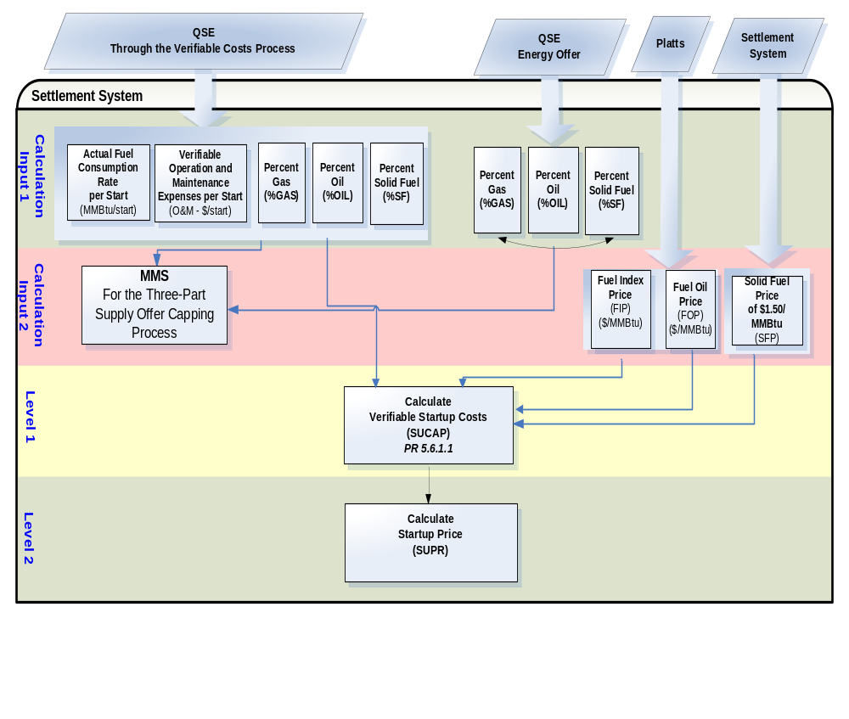

Chart 2: Verifiable Minimum Energy Cost Data: Calculations and Dependencies

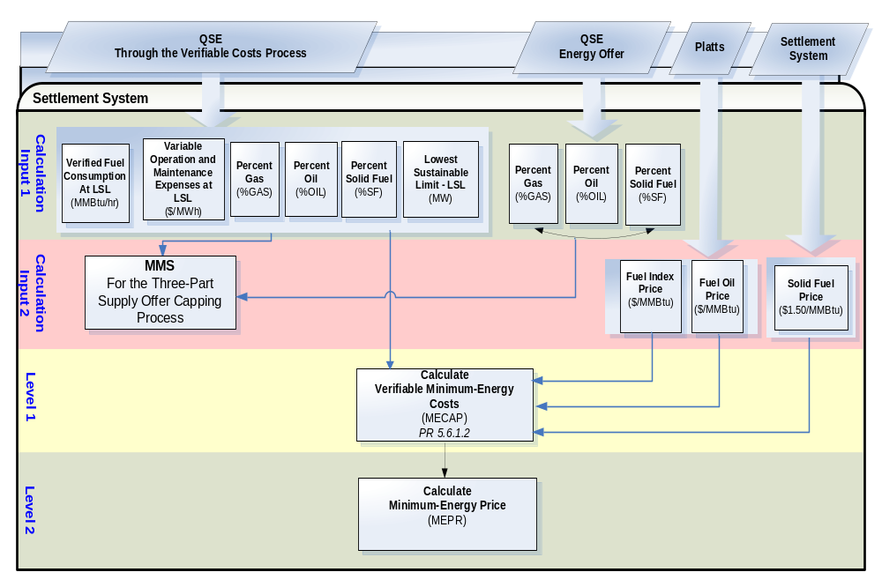

Chart 3: Real Time Mitigation Data: Calculations and Dependencies
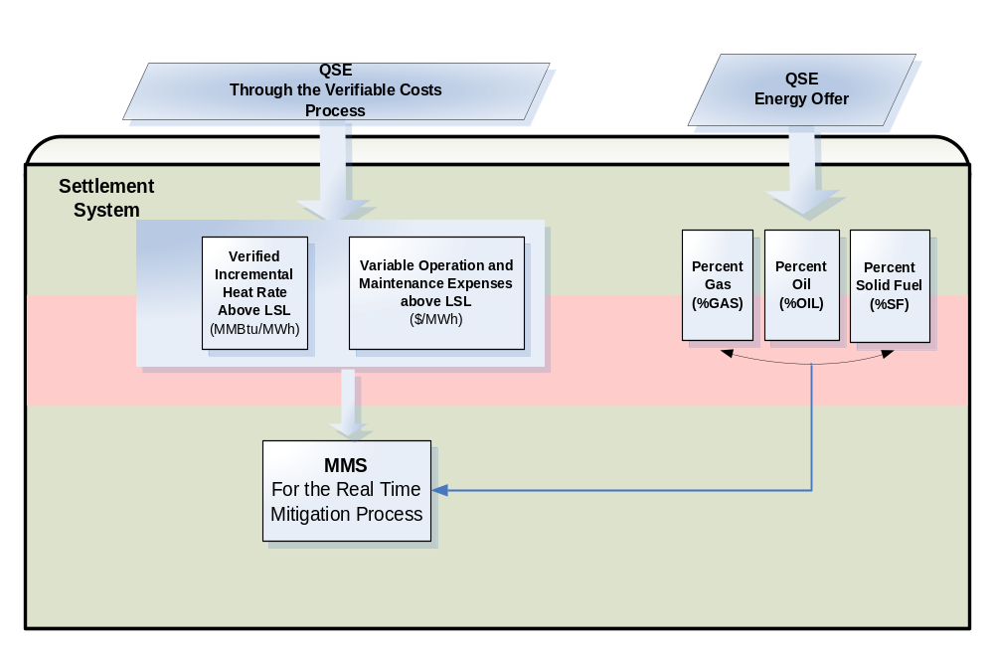

Section 2: General Rules of Verifiable Costs

This section of ERCOT’s Verifiable Cost Manual provides general rules that apply to Verifiable Cost submissions.

Generally Applicable Rules

The use of Verifiable Costs, rather than generic amounts capped according to Resource Category, is optional for Resources that do not receive RUC instructions. Resources receiving RUC instructions are required to submit Verifiable Cost data in various circumstances. For Resources opting to submit Verifiable Cost data and also for those required to submit it, the following rules apply:

- All Verifiable Cost data must be submitted by a QSE representing the Resource; ERCOT will NOT accept Verifiable Cost data directly from a Resource entity.
- Data must be submitted that allows for the verification of startup costs for each start type (cold, intermediate, and hot).
- A Resource is not considered to have submitted Verifiable Cost data unless data is submitted for all startup types (cold, intermediate, and hot) and for minimum energy costs.
- In the event that multiple Resources are tied to a fuel header, each Resource submitting fuel consumption data must provide their individual meter values if available. Otherwise, each Resource must provide ERCOT with the aggregate meter values and the relative percentages of fuel consumption during the relevant stage of the generation cycle (startup, operation at LSL, and operation above LSL).
- All references to Heat Rate Curves and Heat Rate data within this document refer to Net Output.
- For use in Real Time Mitigation, Resources have the option of submitting, but none are required to submit Incremental Heat Rate (IHR) curves and the incremental O&M costs of generating power at greater than LSL output. Submission of this information is also optional for Resources that have received RUC Commitments.
- ERCOT will not separately approve Verifiable Startup Costs and Verifiable Minimum Energy Costs. Both must be submitted and approved together.
- If fuel consumption rates vary by season, Resources must submit such seasonal costs in accordance with the procedure describe herein.
- All submissions of Verifiable Cost data must include an affidavit that avers to the data’s accuracy and authenticity and that is signed by an officer of the QSE representing the Resource.
- All Verifiable Costs submitted must represent “true” costs and must be submitted in sufficient detail to allow ERCOT to validate the data.
- If future versions of the Nodal Protocols alter the amount of Nodal Surcharge, ERCOT will automatically adjust the relevant portions of Resources’ previously approved Verifiable Costs.
- Verifiable Cost documentation must be submitted to ERCOT electronically, as is described within Section 9: Timeline for Submitting and Reviewing Verifiable Costs. However, if ERCOT requests additional documentation for which electronic submission would be impractical, e.g., physical manuals, such documents may be submitted by mail or other courier.

- ERCOT has authority to review and reject the Verifiable Costs it previously approved if a Resource is provided with sufficient notice. Rescinded approval will only affect future Operating Days. See Section 10: Timeline for Rescinding Approval of Verifiable Costs for additional information.

- A Resource may not register as both an SGR and a CCP; therefore, ERCOT will not accept Verifiable Cost data from an SGR that is also a CCP.

- ERCOT's Settlements & Billing group may share Resource-specific Heat Rate and O&M data with ERCOT’s Planning group for the purpose of performing economic planning studies. ERCOT will share this information on a "need to know" basis and will continue to treat the information as Protected Information pursuant to the ERCOT Protocols.

Additional Rules for Combined Cycle Plants

In addition, the following apply specifically to combined cycle units:

- Costs will only be verified for CCP configurations that are registered with ERCOT. A QSE representing a CCP must submit Verifiable Cost data for all registered configurations simultaneously.

- Verifiable Costs will be approved or rejected for all configurations as a group. That is, ERCOT will not approve Verifiable Costs for an individual configuration unless the Verifiable Costs for all other configurations are also approvable.

- Resources submitting Verifiable Cost data for startup or operation at LSL must submit fuel and O&M data for each configuration that the plant will be operated at. Resources submitting Verifiable Cost data for operation above LSL may submit O&M data for each configuration at which the plant will be operated.

- Input-Output (“I/O”) curves and heat rate curves need only be submitted on a per-configuration basis. If the costs incurred by individual units are determined by apportioning per-configuration costs, there must be a reasonable financial and/or engineering basis for doing so and it must be described in the QSE’s Verifiable Cost submission.

Additional Rules for Split Generation Resources

- Entities representing Split Generation Resources (“SGRs”) must select a Master QSE to provide ERCOT with the facility’s total Verifiable Costs. The Master QSE must also submit each unit’s individual costs that were aggregated into the facility’s total costs. Verifiable Costs and their associated cost caps are the total amounts calculated for the facility itself; these are then used for all owners.

- The Master QSE must be chosen from one of the QSEs representing the SGR. Only for purposes related to the submission of total Verifiable Costs, a QSE designated “Master QSE,” is responsible for representing the interests of, and serving as the point-of-contact for, all entities associated with the SGR.

- The Master QSE must notify ERCOT in writing that it will act as representative for the other SGR owners. The letter must be signed by all other SGR owners and a contact person must be listed for each.

- Individual SGR costs must be consistent with the total Verifiable Costs of the generation facility. All owners of a facility should therefore participate in preparing Verifiable Cost data for submission by the Master QSE. ERCOT may compare both the individual units’ costs and also the SGR’s total Verifiable Costs with other similar situated Generation Resources to determine the reasonability of the submitted costs.

- Each QSE representing an SGR must determine their individual Verifiable Costs and must ensure that they are appropriately included in Verifiable Cost submissions made by the Master QSE. However, ERCOT will not separately approve Verifiable Costs for individual owners. Individual costs will only be approved as a group; i.e., upon approval of the Master QSE’s submission of aggregated costs.

- Individual owners of an SGR may utilize different methodologies to determine their individual costs. However, costs must not be included in the Master QSE’s submission more than once and, if multiple owners submit fractional shares of a cost, the sum of those shares must equal the facility’s associated cost.

- The Master QSE, and only the Master QSE, must submit the percentages of each type of fuel consumed during startup and operation at LSL.

Section 3: Verifiable Startup Costs

This section of ERCOT’s Verifiable Cost Manual describes policies and procedures that relate to the submission of Verifiable Startup Costs.

Verifiable Startup Costs Policies

- The components of startup costs are fuel consumption rate and incremental O&M costs. These are to be derived by applying financial and/or engineering analysis to manufacturer data, operational data, or the results of recent tests on a Resource.

- Startup fuel consumption rates (MMBtu/start) must be submitted for all startup types (cold, intermediate, and hot) for a QSE to be considered as having submitted Verifiable Startup Costs. However, if a Resource does not have a distinct start type which is analogous to intermediate startup (or if there are no costs specific to an intermediate start), the Resource must assign a value to the intermediate startup costs equal to the hot startup costs.
- Submitted startup fuel consumption rates and O&M costs will be reviewed by ERCOT and, upon approval, will be used prospectively to calculate Verifiable Startup Costs.

- The Verifiable Startup Cost ($/start) for a Resource is the verified per-start fuel consumption rate (MMBtu/start) multiplied by the relevant fuel price ($/MMBtu) plus the verified O&M costs for the Resource.

Submitting Startup Costs

Verifiable Startup Costs represent a proxy for all of the costs a Resource incurs during a sequence beginning when a Resource is first brought online and ending when the Resource synchronizes to the grid at transmission or distribution voltage (“breaker close”).

The nature of the data that QSEs may submit is set forth below and also partially within Section 5 of the Protocols, which defines Verifiable Startup Costs as:

- Fuel consumption rate per start (MMBtu/start) multiplied by a resource category generic fuel price (FIP, FOP, or $1.50 per MMBtu, as applicable); and
- Unit-specific verifiable operation and maintenance expenses.

Startup Fuel Consumption

Fuel consumed during a startup is defined as fuel consumed from the first fire of startup process through breaker close (including auxiliary boiler fuel), excluding normal plant heating and auxiliary-equipment fuel requirements.

It is expected that the amount of fuel consumed will be different for each of the three start types. If available, historical data must be used to determine the typical amount of fuel consumed per start for each start type. This typical per-start fuel consumption is to be determined in accordance with the following rules:

- When possible, startup fuel consumption rates are to be based on the amount of fuel a Resource has historically consumed per-start.

- If available, submitted historical usage data should, for each start type, include fuel consumption rates for the lesser of the last 10 starts or every start within the past three years. For each start type, the Resource shall submit the historical fuel consumption data, an average amount of historical fuel consumption, and the fuel consumption rate that the Resource believes represents the current startup fuel consumption rate.

- If a Resource does not have the historical fuel consumption rates for each start described above, the Resource must submit the aforementioned data that it does possess and may also include per-start fuel consumption rates based on manufacturer suggested values or tests which are ERCOT approved.

- If a Resource submits historical startup fuel consumption on a per hour basis (MMBtu/hour), it must also provide proof of the average number of hours it requires to reach breaker close for each startup type.

- In its sole discretion, however, ERCOT may choose not to accept a Resource’s submitted per-start fuel consumption rates if ERCOT determines that they do not represent a Resource’s “true” startup fuel consumption or that they have not been proven in sufficient detail.

- Historical fuel consumption rates must be based on documented metered reads when available.

Fuel Type Percentages

For each start type, Resources must provide documentation establishing the respective ratios of gas, oil, and solid fuel consumed during the startup through breaker close sequence. Historical and/or manufacturer suggested ratios are to be submitted as percentages and in accordance with the manner of submitting startup fuel consumption data, detailed above. For each start type, the Resource must calculate and submit:

- total fuel consumption per-start (MMBtu/start); and
- the ratio of each type of fuel consumed to the total amount of fuel consumed per startup.

Resources with approved fuel consumption ratios are to submit updated data to ERCOT if they subsequently use a different fuel type during startup and if they also anticipate doing so for any substantial period of time, whether due to fuel market conditions or otherwise.

Non-Fuel Startup Costs

Verifiable Non-Fuel Startup Costs represent a proxy for all non-fuel costs that a Resource incurs during the startup through breaker close sequence. The costs that ERCOT considers in calculating this proxy is limited to incremental operation and maintenance costs (Verifiable O&M) that can reasonably be said to result from the Resource starting up . ERCOT will not approve fixed costs of any type nor insufficiently documented costs.

To be included as a Verifiable O&M Cost of Startup , O&M costs must be submitted in accordance with Section 8: Operating and Maintenance Cost Guidelines. ERCOT will not approve submitted O&M startup costs if the amounts or the methods used to calculate them do not coincide with other O&M costs a Resource has submitted, unless there is a reasonable, documented reason for doing so. For example, startup operating costs might be different because there are greater chemical, water or emissions costs during the startup sequence. Also, it might be reasonable to multiply an hours-based maintenance cost by the amount of time it takes to complete a startup to breaker close sequence. Additionally, if maintenance costs are allocated on a per-start basis, it might be reasonable for the maintenance component of verifiable startup costs to differ per start type.

Start Type Descriptions

The following is a general description of startup costs per start type:

Hot Startup Cost

Hot startup cost is the expected cost to start a Resource, which is in the "hot" condition. Hot conditions vary unit by unit, but in general, a steam unit is hot through an overnight shutdown.

Intermediate Startup Cost

Intermediate startup cost is the expected cost to start a Resource that has recently been online and for which neither hot nor cold conditions are applicable.

Cold Startup Cost

Cold startup cost is the expected cost to start a Resource which is in the "cold" condition. Cold conditions vary unit by unit, but in general, a unit is cold after a two or three-day shutdown.

Table 1: Startup Verifiable Cost Data Requirements per Resource per start type

Input Data | Description
AFCRS (MMBtu/Start) | Fuel consumption rate per start
GASPERSU (%) | Gas fuel consumed per start as a percentage of total per start fuel consumption
OILPERSU (%) | Oil fuel consumed per start as a percentage of total per start fuel consumption
SFPERSU (%) | Solid fuel consumed per start as a percentage of total per start fuel consumption
O&M ($/start) | Verifiable O&M expenses per start

Section 4: Verifiable Minimum Energy Costs

This section of ERCOT’s Verifiable Cost Manual describes the policies and procedures that relate to the submission of Verifiable Minimum Energy Costs.

Verifiable Minimum Energy Cost Policies

- The components of Minimum Energy Costs are fuel consumption rate and incremental O&M costs. These are to be derived by applying financial and/or engineering analysis to manufacturer data, operational data, or the results of recent tests performed on the Resource.

- Resources must submit the rate at which fuel is consumed during operation at LSL (MMBtu/hour).

- Resources must submit the LSL level of output (MW) expected during normal operations. This LSL should also represent the LSL a Resource expects to submit in future COPs.

- If Minimum Energy fuel consumption rates vary by season, Resources must submit such seasonal rates in accordance with the procedure describe herein.

- Submitted minimum energy fuel consumption rates and O&M costs will be reviewed by ERCOT and, upon approval, will be used prospectively to calculate Verifiable Minimum Energy Costs.

- The Verifiable Minimum Energy Cost ($/MWh) for a Resource is the verified fuel consumption rate at LSL (MMBtu/hr) divided by the Resource’s LSL (MW), multiplied by the relevant fuel price ($/MMBtu), plus the verified O&M ($/MWh) at LSL for the Resource.

Submitting Minimum Energy Costs

Verifiable Minimum Energy Costs are the verifiable costs a Generation Resource incurs while operating at the LSL. The Verifiable Minimum Energy Cost shall also include the Nodal Implementation Surcharge ($/MWh) if properly included in a Resource’s Verifiable Cost submission. The nature of the data that Resources may submit is set forth below and within Section 5 of the Protocols, which defines Verifiable Minimum Costs as:

1) The unit-specific verifiable minimum-energy costs for a Resource are:
(a) Actual fuel cost to operate the unit at LSL;
(b) Variable operation and maintenance expenses;
(c) Nodal implementation surcharges to operate the unit at LSL.

Minimum Energy Fuel

Minimum Energy Fuel is defined as fuel consumed by a Resource while operating at the Lowest Sustainable Limit, excluding normal plant heating/auxiliary equipment fuel requirements. Minimum Energy Fuel is to be determined in accordance with the following:

- Resources must submit resource-specific Average Heat Rate curves (MMBtu/MWh) for the period from which their verifiable cost data was derived. If fuel consumption at LSL varies by season, Resources must submit seasonal average heat rates. More information on heat rates is provided below in Section 6: Verifiable Heat Rates.

- If available, submitted historical usage data should include fuel consumption rates for the last 25 periods a Resource operated at the LSL.

- If a Resource does not have the historical fuel consumption rates for all of the deployments described above, the QSE must submit the aforementioned data that it does possess and may also include a fuel consumption rate at LSL (MMBtu/hour) based on manufacturer suggested values or actual tests which are ERCOT approved.

- In its sole discretion, however, ERCOT may choose not to accept a Resource’s submitted fuel consumption rate at LSL if ERCOT determines that it does not represent a Resource’s “true” fuel consumption at LSL or that it has not been proven in sufficient detail.

Fuel Type Percentages at LSL

Resources must provide documentation establishing the respective ratios of gas, oil, and solid fuel consumed during operation at the Lowest Sustainable Limit. Historical and/or manufacturer suggested ratios are to be submitted as percentages and in accordance with the manner of submitting minimum energy fuel consumption data, detailed above.

Non-Fuel Minimum Energy Cost

Verifiable Non-Fuel Minimum Energy Costs represent a proxy for all non-fuel costs that a Resource incurs while operating at LSL. These costs need to be submitted in terms of $/hr or $/MWh. ERCOT will not approve fixed costs of any type nor insufficiently documented costs. The costs that ERCOT considers in calculating this proxy are limited to:

- Incremental operation and maintenance costs (Verifiable O&M) that can reasonably be said to result from operation at LSL; and
- The Nodal implementation surcharge ($/MWh).

Verifiable Operation Minimum Energy Costs

To be included as a Verifiable Minimum Energy Cost, operating costs must be submitted in accordance with Section 8: Operating and Maintenance Cost Guidelines. ERCOT will not approve submissions for the operating cost component of Verifiable Minimum Energy Costs if the amounts or the method used to calculate them do not coincide with other Verifiable Operating Costs a Resource has submitted, unless there is a reasonable, documented reason for doing so.

Verifiable Maintenance Minimum Energy Costs

To be included as a Verifiable Minimum Energy Costs, maintenance costs may be submitted in accordance with Section 8: Operating and Maintenance Cost Guidelines. ERCOT will not approve submissions for the maintenance cost component of Verifiable Minimum Energy Costs if the amounts or the method used to calculate them do not coincide with other Verifiable Maintenance Costs a Resource has submitted, unless there is a reasonable, documented reason for doing so.

Table 2: Minimum Energy Cost Data Requirements per Resource

Input Data | Description
VFCLSL (MMBtu/h) | Verified fuel consumption at LSL
GASPERME (%) | Gas fuel consumed during operation at LSL as a percentage of total LSL fuel consumption
OILPERME (%) | Oil fuel consumed during operation at LSL as a percentage of total LSL fuel consumption
SFPERME (%) | Solid fuel consumed during operation at LSL as a percentage of total LSL fuel consumption
LSL (MW) | Low Sustainable Limit Output
VOMLSL ($/MWh) | Variable O&M expenses at LSL

Section 5: Mitigated Offers and Verifiable Costs

This section of ERCOT’s Verifiable Cost Manual pertains to the use of Verifiable Costs for the purpose of calculating Mitigated Offer Caps. It describes the policies and procedures relating to the submission of Verifiable Incremental Heat Rate and Variable O&M data.

Mitigated Offer Cap Policies

Under Section 6.5 of the Nodal Protocols, Energy Offer Curves are subject to mitigation in Real-Time Operations by Security Constrained Economic Dispatch (“SCED”). That is, Energy Offers may be capped at the Mitigated Offer Cap when a Mitigated Offer Cap is greater than its related Reference LMP. Pursuant to Section 4.4, ERCOT will create a Mitigated Offer Cap curve such that each point on the curve is the greater of (1) FIP or FOP multiplied by a constant or (2) the Resource’s Verifiable Incremental Heat Rate multiplied by FIP or FOP, plus VOM multiplied by a constant. Thus, the first product (default or generic Cap) will be used unless a QSE submits (and ERCOT approves) the required Verifiable Cost data and if the submitted data yields a greater Mitigated Offer Cap.

Submitting Data for Mitigated Offers

Resources may submit two types of resource-specific Verifiable Cost data for inclusion in the calculation of Mitigated Offer Caps: Variable O&M data and Verifiable Incremental Heat Rate (“IHR”) data. Submission of this data, for use in calculating Mitigated Offer Caps, is optional. A Resource that submits Variable O&M Cost data for use in calculating Mitigated Offers must also submit IHR Curve data. However, a Resource may submit IHR Curve data without submitting corresponding VOM data. The Master QSE representing Split Generation Resources (SGRs) may submit one set of IHR Curve and VOM data which will apply to all owners of the Resource. To be verified by ERCOT, submitted data must also comply with the relevant requirements set forth below.

Variable O&M

For purposes of calculating Mitigated Offer Caps, Variable O&M costs are limited to the incremental O&M costs a Resource incurs while operating above LSL. Variable O&M costs will only be verified if both the type of cost and its method of calculation are permissible under Section 8: Operating and Maintenance Cost Guidelines of this document. Submitted data is to be in terms of dollars per Megawatt-hour ($/MWh) and may be a single average cost or multiple values (no more than 10) for points that are within the LSL to HSL range on the IHR Curve submitted.

Fuel Type Percentages above LSL

Resources that submit Incremental Heat Rates must also provide the type of fuel consumed at above-LSL operation. Only one fuel type may be submitted.

Verifiable IHR

If a Resource submits Verifiable Variable O&M costs, the Resource must also submit Verifiable IHR Curves in accordance with Section 6: Verifiable Heat Rates to complete the submission of Verifiable Costs for Mitigated Offer Caps. Additionally, submitted IHR Curve data must be calculated directly from the I/O equation, as described in that same section. IHR Curve data must:

- Consist of at least 2, but no more than 10, pairs of MMBtu/MWh and MW points; and
- Include the a, b, and c coefficients calculated from the IHR equation (i.e., IHR = 3ax²+2bx+c).

Table 3: Real Time Mitigation Data

Input Data | Description
Incremental Heat Rate Data Points (MMBtu/MWh, MW) | Points along the Incremental Heat Rate Curve – Up to 10 pairs
VOM ($/MWh) | Variable O&M expenses above LSL - Up to 10 points on IHR Curve
GASPROL (%) | Gas fuel consumed during operation over LSL as a percentage
OILPEROL (%) | Oil fuel consumed during operation over LSL as a percentage
SFPEROL (%) | Solid fuel consumed during operation over LSL as a percentage

Section 6: Verifiable Heat Rates

This section of ERCOT’s Verifiable Cost Manual describes the policies and procedures for submitting Heat Rate information.

Verifiable Heat Rate Policies

Heat rate curve data is utilized within the Nodal Verifiable Cost Process because it can be used, in conjunction with the market price of fuel, to provide a proxy for the actual fuel costs of operating a Resource.

In the ERCOT Nodal market, there are two types of Resource-specific Heat Rate Curve data that QSEs may submit: Incremental Heat Rate and Average Heat Rate data. Average Heat Rate data must be submitted with Verifiable Minimum Energy Cost submissions. Incremental Heat Rate data must be included with data submitted for use in calculating Mitigated Offer Caps. ERCOT, however, will not approve any submitted heat rate data unless a QSE also develops and submits Resource-specific heat-input versus power-output curves (“I/O Curves”). That is because ERCOT uses I/O Curves as a basis for verifying heat rate curves.

The first of the aforementioned curves, the Incremental Heat Rate (“IHR”) Curve, is defined as the first derivative of the I/O Curve. It provides the amount of thermal energy used by a Resource to achieve an incremental change in electrical energy output (i.e., the amount of thermal energy used to produce an additional unit of output). The second, the Average Heat Rate (“AHR”) Curve provides the average amount of energy used by a Resource to provide each unit of power output. The AHR Curve is determined by dividing input in fuel by the power it generates for various levels of generation.

Submission of Heat Rate Curve Data

All Heat Rate Curves and Heat Rate data must be submitted in terms of Net Output. QSE’s have two options for submitting Heat Rate Curves and Heat Rate data: submit the results of tests actually performed on the generating unit or submit the manufacturer suggested Heat Rate values. If a QSE has reason to believe that the physical characteristics of a generator have changed so that previously submitted Heat Rate Curves overstate fuel consumption or understate efficiency, the QSE must notify ERCOT and must submit updated Heat Rate data.

Finally, submitted data relating to these curves must comply with the relevant requirements set forth below in order to be approved by ERCOT.

Input-Output Curve

For each Resource that they submit Heat Rate Curve data, a QSE shall submit to ERCOT an I/O Curve in accordance with the following:

- Resource total heat (or fuel) I/O curves based on design or data from comparable units, modified by available actual unit test data
- The actual data for the total heat (or fuel) I/O curve must include minimum and maximum load points and at least two intermediate load points
- I/O curves are to be fitted from data using either manual or computer techniques
- Submitted I/O Curves are to be defined by the third-order equation: y = ax³ + bx²+ cx + d
  - Where: x = Output in MW; y = Input in Btu/hr; and a-d = coefficients that define the equation
  - All values (y, x, a, b, c, d) must be provided to ERCOT

ERCOT will verify this I/O Curve and will use it a basis for verifying the IHR and AHR Curves.

Incremental Heat Rate Curve

All submitted IHR Curve data must:

- be determined, either mathematically or graphically, directly from the relevant Resource’s I/O Curve;
- provide a monotonic, non-decreasing function;
- be submitted in terms of MMBtu/MWh;
- consist of at least 2, but no more than 10, pairs of IHR (MMBtu/MWh) and Output (MW) points; and
- be defined as the I/O Curve’s first derivative: IHR = dy/dx = 3ax² + 2bx + c
- Where: x = Output in MW; y = Input in Btu/hr; and a-c = coefficients that define the equation
- All values (dy/dx, x, a, b, c) must be provided to ERCOT

If a generator does not have a monotonic and non-decreasing IHR, a QSE may instead submit both of the following:

  - their actual IHR curve; and
  - a representative monotonic, non-decreasing curve that has been derived from the actual IHR. This representative curve is subject to the above paragraph.

Average Heat Rate Curve

All submitted AHR Curve data must:
- be determined, either mathematically or graphically, directly from the relevant Resource’s I/O Curve;
- be submitted in terms of MMBtu/MWh;
- consist of at least 2, but no more than 10, pairs of AHR (MMBtu/MWh) and Output (MW) points; and
- be defined as the I/O Curve divided by the output (x): AHR = y/x = (ax³ + bx² + cx + d) / x
- Where: x = Output in MW; y = Input in Btu/hr; and a-d = coefficients that define the equation
- All values (y/x, x, a, b, c, d) must be provided to ERCOT

Section 7: Forced Outages of a RUC-Committed Resource

This section of ERCOT’s Verifiable Cost Manual describes the policies and procedures for submitting Event Specific Verifiable Cost data relating to a Forced Outage of a RUC Committed Resource.

Policy for Costs Resulting from a Forced Outage

Pursuant to Section 5.6 of the Protocols, if, before reaching breaker close, a RUC-committed Resource experiences a Forced Outage resulting from startup failure, ERCOT shall include the Resource’s Event Specific Verifiable Costs in the Resource’s RUC Guarantee, limited to the lesser of:

- costs that qualify as normal startup expenses, including fuel and operation and maintenance expenses, incurred before the event that caused the Forced Outage; and

2. the Resource’s Startup Offer in the RUC.

Submission of Forced Outage Cost Data

For purposes of calculating Event Specific Verifiable Costs resulting from the Forced Outage of a RUC committed Resource, a QSE may submit the actual costs it incurred as an unavoidable and direct result of the forced outage. All submitted costs must be sufficiently documented so as to allow ERCOT to verify them. Only actual, incremental costs relevant to the startup attempt will be approved. Fixed costs will not be accepted.

In addition to the above restrictions, fuel and O&M costs are subject to the following:

- Resources should submit O&M costs in terms of dollars for the attempted start ($/attempted start). These O&M costs must be calculated using the methodology described in Section 8: Maintenance and Operations Cost Guidelines, but only actual, documented costs relevant to the start-up attempt should be submitted.

- Resources may submit the amount of fuel actually consumed for the attempted start (MMBtu/attempted start).

- The ERCOT Settlement and Billing system will not automatically calculate a payment for a Resource that experiences a failed startup attempt. Resources that experience a failed start-up attempt must submit a settlement dispute in accordance with the dispute process outlined in Section 9.14 Settlement and Billing Dispute Process of the Nodal Protocols in order to receive payment. In addition to the standard information required by the dispute form located on the ERCOT Market Information System (MIS), the dispute should clearly indicate:

- The Dispatch Instruction associated with the Forced Outage;

- The total Event Specific Verifiable Costs of attempting to provide the service; and

- A description of the supporting documentation to be subsequently provided to ERCOT

A Resource seeking to have additional Forced Outage costs, which are not specifically discussed in this section, included in their RUC Guarantee must seek to have them approved by the ERCOT Board of Directors during an Executive Session at the next regularly scheduled meeting. Requests must be presented to the Board in person by a representative of the company that incurred the costs. Should the Board approve the inclusion of such costs in the RUC Guarantee, the submitting company must draft and submit a Nodal Protocol Revision Request (NPRR), in accordance with Protocol Section 21, Process for Protocol Revision. Therefore, to ensure subsequent NPRRs accurately capture what the Board did (and did not) approve and clearly provide what is required of similar cost submissions in the future, initial requests to the Board of Directors must include a typewritten statement of the lobbying company’s position. This statement must:
- define all additional costs sought and do so in a manner that is not specific to the lobbying company (e.g., “insurance deductibles”); and
- describe the documentation necessary to establish the accrual of such costs.

Section 8: Operating and Maintenance Cost Guidelines

This section of ERCOT’s Verifiable Cost Manual describes the policies and procedures relating to the submission of Operating and Maintenance Costs.

Operating and Maintenance Cost Policies

Manuals drafted by the manufacturer of a generating unit and that relate to O&M should be submitted to ERCOT if a Resource submits O&M cost data for use in the Verifiable Cost process. These manuals are necessary for ERCOT to analyze such data.

Verifiable Operating Costs
Operating costs are the non-fuel costs incurred while a generator is operated, whether incurred during startup or at different output levels. These costs may include, for example, labor costs, the cost of consumables and non-durable goods, costs related to emissions, water costs, etc.

ERCOT will only approve operating costs that are incremental costs; fixed operating costs will be rejected. Additionally, ERCOT will only approve submitted operating costs to the extent that they reasonably represent the incremental operating costs at the stage of the power generation cycle for which they are submitted (startup, operation at LSL, or operation above LSL). For example, ERCOT might approve the wages paid to on-call, hourly employees that are needed to help start a Resource. On the other hand, ERCOT would not approve labor costs that are incurred regardless of an incremental deployment (such as those associated with salaried, on-call employees). The reasonableness of an allocation is highly dependant on individual circumstances; thus, ERCOT will make this determination on a case-by-case basis. In making this determination, ERCOT will consider factors such as whether a Resource’s operating costs relate to starting the unit or running at different operating levels, follow industry standards, and coincide with manufacturer expectations.

Verifiable Maintenance Costs
Maintenance costs are those costs associated with the maintenance, repair, inspection, and upkeep of generation resources, as well as their parts and equipment. Maintenance costs will only be approved to the extent that they represent the maintenance costs resulting from an incremental period of usage.

Verifiable Maintenance Costs are a proportionate share of future maintenance costs; the allocation of maintenance costs not yet borne must be based upon Resource usage that is reasonably anticipated to occur during the interim. For example, maintenance expenses might be allocated using hours-based, starts-based, or equivalent-operating-hours criteria

In considering whether or not to approve submitted maintenance costs, ERCOT will consider factors such as whether the costs and frequency of maintenance anticipated by a Resource coincides with manufacturer expectations; whether the starts and usage anticipated by a resource is practical, or is likely given the type of generator and general market conditions, or coincides with historical data; etc. Prospective opportunity costs, such as the loss of generating capacity during maintenance, are not verifiable and, therefore, will not be approved by ERCOT.

Event Specific Verifiable O&M Costs
Event Specific Verifiable O&M Costs are limited to provable O&M costs that are actually incurred as a direct result of the specific events detailed in Section 7: Forced Outage of a RUC-Committed Resource.

O&M costs incurred during this event (to the extent they exceed O&M costs incurred during any similar, normal operations) must not be incorporated when Resources calculate their incremental Verifiable O&M Costs. Because these added O&M costs are incurred as a result of anomalous and infrequent events; it is improper to include them when allocating O&M costs to incremental generation. Resources, however, may submit Event Specific Verifiable O&M Costs by following the dispute process outlined in Section 9.14 Settlement and Billing Dispute Process in the Nodal Protocols.

Options for Submitting Verifiable O&M Costs

QSEs may submit Verifiable O&M Costs (but neither Event Specific Verifiable O&M Costs nor Fuel Costs) using either of the following two methods:

Option 1: Submission of O&M costs with Documentation and Calculated Using a Resource Specific Methodology

- Resources must submit the O&M costs of starting up ($/start) for each start type, cold, hot and intermediate, calculated according to a specific methodology that the Resource previously requested and which ERCOT approved.

- Resources must submit the O&M costs of operating at LSL ($/MWh) calculated according to a specific methodology that the Resource previously requested and which ERCOT approved.

- Resources may submit the O&M costs of operating above LSL ($/MWh) calculated according to a specific methodology that the Resource previously requested and which ERCOT approved.

- The amounts and methods used to calculate both the operation and maintenance components of Verifiable O&M Costs must be clearly detailed.

- A Resource’s methodology must meet the guidelines of ERCOT’s Verifiable Cost Manual.

- ERCOT may rescind its prior approval of Verifiable Costs submitted under this Option at any time, but it must have a material, factual basis for doing so. For example, ERCOT may rescind its approval if it subsequently determines the Resource-specific method of calculating O&M was inherently flawed.

Option 2: Submission of O&M costs with Documentation and Calculated Using the Methodology Described in Appendix 1

- Resources must submit O&M costs that result from starting for each type, cold, hot and intermediate ($/start).

- Resources must submit O&M costs that result from operation at the LSL ($/MWh).

- Resources may submit O&M costs that result from operation above LSL ($/MWh).

- Resources must submit a detailed account of the amounts used to calculate these costs and the manner in which they applied the methodology set forth in Appendix1.

- ERCOT may rescind its prior approval of Verifiable Costs submitted under this Option at any time, but it must have a material, factual basis for doing so. For example, ERCOT would rescind its approval of part (or all) of the labor costs associated with a scheduled outage upon learning that some (or all) of the workers were salaried.

Additional Conditions Applicable to Option 1 and Option 2
O&M Costs submitted to ERCOT under either Option 1 or Option 2 above are subject to additional conditions, as set for below.

Conditions Applicable to All Types of Resources

- All O&M costs must be incremental; that is, they may not include fixed costs.

- Submitted O&M documentation must be Resource specific. Exceptions may be granted for Combined-Cycled Resources on a case-by-case basis.

- O&M costs must not include fuel costs.

- Both individual component costs and the final aggregated O&M values must be clearly detailed and shown as $/start or $/MWh.

- Maintenance costs are to be calculated taking into account all available maintenance history (limited by the number of years in a maintenance period where applicable) regardless of unit ownership.

- Resources must submit operating costs (including water, chemical emission credits, consumables, etc) per-start ($/start) and per hour of operation at LSL ($/MWh).

- Resources that include water consumption as part of their operating costs must include documentation indicating the number of gallons used and the output level and duration of operation during which the water was used. The price(s) paid for water ($/gal) must also be submitted.

- Resources including emission credits as part of their operating costs must provide ERCOT a description of the credits and the methodology used to allocate their costs to O&M.

- All consumables included in O&M must be clearly documented and include both the quantities used and prices paid.

- Resources must provide a description of all components included as operating costs and the reason for their inclusion.

- If a company feels that a unit modification or required change in operating procedures will affect the unit's maintenance cost, revised maintenance costs must be submitted to ERCOT for approval.

- A Resource may submit only one value ($/MWh) for the O&M cost of operation at LSL.

- A Resource may submit multiple values ($/MWh) for the O&M cost of operation above LSL. However, each submitted value must coincide with a point on the IHR Curve and only one value may be submitted for any given point.

Conditions Applicable to Combustion Turbines

- The Maintenance Cost component of starting a Combustion Turbine Resource ($/start) or operating at or above LSL ($/MWh) may be calculated and applied on a "per equivalent service hour" (ESH) basis as described in Appendix 1B. If this option is chosen, the calculation can be based on maintenance expenses in a Maintenance Period chosen by the Resource.

- Resources that determine their costs on an ESH basis may use either the methodology described below in Appendix 1B or another methodology approved in advance by ERCOT to determine their ESH values.

- The maintenance cost component for a given period must be stated as the total dollars spent per period.

- Resources must submit the total number of running hours during the maintenance period.

- Resources must submit the total number of starts during the maintenance period.

- Resources must submit the average time in hours spent starting up, shown per start type if possible, in the maintenance period.

- A Resource may include manufacturer recommended values in ESH calculations, if approved by ERCOT in advance.

- Resources must calculate the maintenance costs per hour of operation in the maintenance period ($/hr) as the total maintenance cost divided by the ESH, unless ERCOT approves another methodology in advance.

- Resources must calculate the maintenance cost ($/hour) times the average length of start in hours to arrive at an average maintenance cost per start ($/start).

- Resources must divide the calculated maintenance cost ($/hour) by the LSL (MW) to determine the average maintenance cost per hour of operation at LSL.

- A generation owner that has a currently effective Long Term Service Contract (LTSA) with a third party vendor that provides for overhaul and maintenance work on a Combustion Turbine (CT), either as part of a Combined Cycle Plant (CCP) plant or as a stand-alone CT, may include it within Verifiable O&M if the following conditions are met:

  - The included incremental or variable long term maintenance costs are consistent with the definition of such costs as described in the verifiable cost process document.

  - The dollar value of each component of the variable long term maintenance is set specifically in the LTSA.

  - Cost curves showing variable O&M values versus Run time are submitted.

  - ERCOT can verify the incremental or variable maintenance costs ($/MWh) or ($/start) in the LTSA.

  - LTSA contracts must be submitted directly to ERCOT for review and approval and must be currently effective.

- All O&M costs calculated using equivalent service hours (ESH) must clearly show how the ESH are calculated.

Conditions Applicable to Fossil Thermal Resources

- Resources must submit the methodology that was used to determine their O&M costs ($/start or $/MWh) for a maintenance period using either a Resource specific methodology or the one described in Appendix 1a.

- Any methodology used to determine O&M costs ($/start or $/MWh) for the maintenance period should also describe the costs on a $/MMBtu basis.

Maintenance Period Conditions

When calculating maintenance costs, a 10-year historical period should be used. If data is not available for the previous 10 years, then the length of the maintenance period is the length of time for which the data is available. Resources may determine maintenance costs on an annual basis and then normalize them for the entire 10 year (or less) maintenance period. In addition, Resources must provide the methodology used to determine any maintenance escalation factors used.

ERCOT will assess all submitted O&M costs for reasonability. When making this assessment for submissions with a maintenance period less than 10 years, ERCOT will consider Original Equipment Manufacturers (OEM) recommendations and similar Resources’ costs.

Operating and Maintenance Cost Submissions Types

Appendix 3: Operating and Maintenance Cost Categories provides an exclusive list of the types of O&M costs that ERCOT will approve. Only the types of Operating Costs specifically listed within Appendix 3 will be approved. Only the Maintenance Costs allowed within Appendix 3 will be approved.

Section 9: Timelines Applicable to the Submission and Review of Verifiable Costs

This is the section of ERCOT’s Verifiable Cost Manual that details the processes and procedures that apply to the submission and approval of Verifiable Costs.

Submission and Approval of Verifiable Cost Data

A Resource initiates the Verifiable Cost Process by submitting their costs to the Verifiable Cost Management System (“VCMS”) using the eEnergy website.. In the Nodal market, Verifiable Costs take affect three (3) Business Days after the day they are approved by ERCOT. They will only be used prospectively.

A separate process applies to the submission of Event Specific Verifiable Costs, which must be submitted in accordance with the dispute process outlined in Section 9.14, Settlement and Billing Dispute Process of the Nodal Protocols. Event Specific Verifiable Costs take effect upon approval. They will be applied retroactively and will be used to resettle the Operating Day on which the costs were incurred. Furthermore, Event Specific Verifiable Costs are only valid for the specific event for which they are initially submitted; they will not be reused for any similar, subsequently occurring events.

When a Resource initiates an iteration of the Verifiable Cost Process, the following must be submitted to the VCMS:
- the Verifiable Cost Template with all relevant fields completed;

- electronic copies of supporting documentation and any required affidavits and signatures;
- a list of any physical supporting documentation that is being sent to ERCOT; and
- any other relevant materials that this document requires to be submitted.

Note: The timeline within this section pertains to Verifiable Costs, but not to Event Specific Verifiable Costs.

A Resource may submit Verifiable Costs at any time, but it must file those costs no later than 30 days after first receiving a RUC instruction.

If the RUC process instructs a Resource to start 50 times within a year, ERCOT will notify the Resource to update its Verifiable Cost data, but ERCOT will not make such a request more frequently than annually. ERCOT will also notify a Resource to update its Verifiable Cost data if at least five years have passed since ERCOT last approved the Resource’s Verifiable Cost data and if the Resource has received at least one RUC instruction in the past. If a Resource does not submit updated data within 30 days of being notified to do so under either of these scenarios, ERCOT will determine payments using the lower of the following until updated costs are approved:

- Resource Category Startup Generic and Resource Category Minimum-Energy Generic Caps; and
- the Resource’s most recently approved Verified Startup and Minimum Energy Costs (except for Event Specific Verifiable Costs which are submitted and applied to a specific Operating Day).

Timeline Applicable to the Submission and Approval of Verifiable Costs

Verifiable Costs submitted to ERCOT after implementation of the Texas Nodal Market will be reviewed based on the following timeline:

- Once a Resource’s verifiable cost data is in the VCMS, ERCOT will review the data for accuracy and to ensure the submission has met all of the requirements described within the guidelines of ERCOT’s Verifiable Cost Manual.

- Within fifteen (15) business days from the date on which the data is submitted, ERCOT will inform the submitting QSE that:
  - the review is complete and the amounts that ERCOT is able to approve have been posted to the VCMS;
  - the review is complete and whether the submission was approved, rejected,
  - the submission was incomplete, or
  - or additional supporting documentation must be submitted.

- A QSE must submit any additional information ERCOT requests no later than thirty (30) business days after ERCOT first requests it. Multiple submissions of data are permissible, but a complete submission, which includes all information requested, must be made within thirty days of ERCOT”s request.

- Upon receiving additional documentation, ERCOT will acknowledge receipt and review it for completeness within ten (10) business days. If ERCOT receives all requested information, ERCOT will make a decision to approve or reject Verifiable Costs within the same ten (10) business days.

- At any time during the approval process, ERCOT may request additional information from a QSE. All requests must be fulfilled within thirty (30) days.

- From the time that ERCOT’s final decision is available on the VCMS, QSEs have five (5) business days to either accept or reject any amounts approved by ERCOT. If a QSE rejects the amounts calculated by ERCOT, generic costs and caps will be used. Failure to accept or reject ERCOT’s approvable amounts within these five business days will be deemed as acceptance.

- If ERCOT does not approve a Resource’s Verifiable Costs, the QSE representing the Resource may file an appeal in accordance with the procedure described in Section 11: Appealing Rejected Verifiable Costs.

- ERCOT’s deadline for reviewing Verifiable Costs submissions (15 or 10 business days) applies from the date ERCOT receives a submission. ERCOT will not postpone review until a QSE’s submission deadline has passed.

Chart 4: Verifiable Cost Submission Timeline

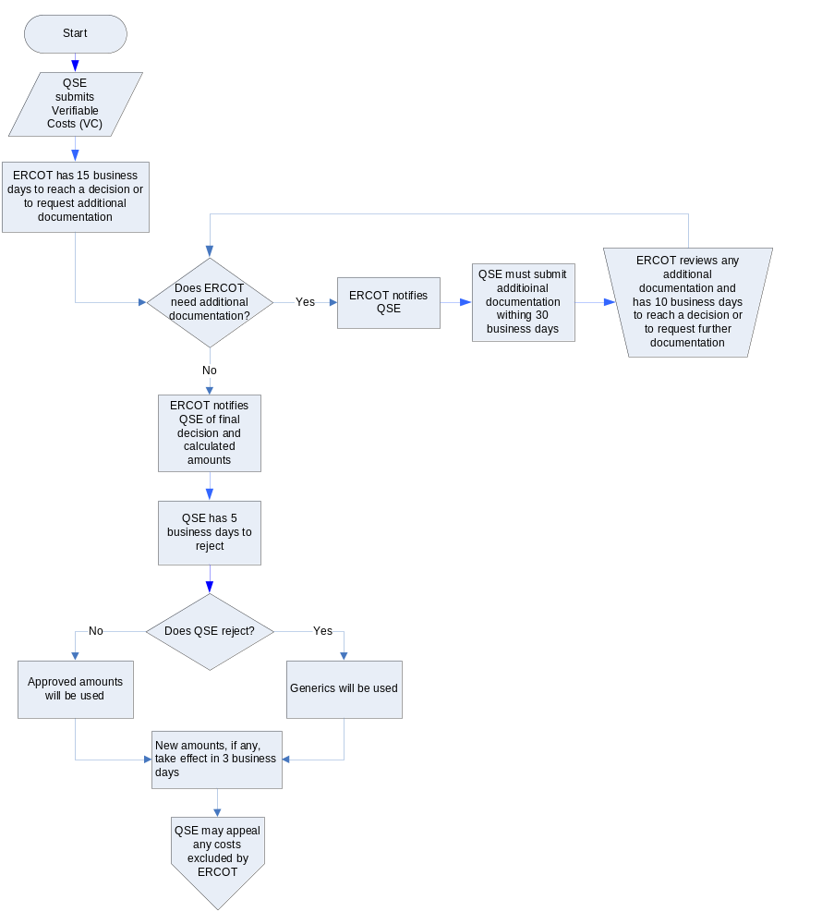

Section 10: Timeline for Rescinding Approval of Verifiable Costs

Policy for Rescinding Previously Approved Verifiable Costs

ERCOT has authority to, at any time, review and reject the Verifiable Costs that it has previously approved. ERCOT must, however, be judicious and impartial when rescinding its approval. Furthermore, ERCOT must not rescind Verifiable Costs unless there is a material, factual basis that justifies rescission. For example, rescission would be justified upon ERCOT determining: a Resource’s submitted data was inaccurate based on public filings or comparisons with substantially similar generators; a type of O&M cost submitted was a fixed cost (or a portion thereof); changed Nodal Market policies disallow or limit certain costs, accounting practices, or calculation methodologies; etc. ERCOT must approach these types of situations with the aim of rescinding approval only to the extent necessary to eliminate all inaccurate cost data.

Rescission of approval does not affect the timing of Verifiable Cost updates mandated under Section 5.6.1 of the Nodal Protocols.

For payment purposes, a Resource that has their approval rescinded for an entire category of costs (Fuel or O&M) will be treated as though it never submitted Verifiable Costs. Resource Category Generic Caps will, therefore, apply.

If ERCOT only rescinds approval for a specific type of costs (or reduces the approved amount), ERCOT will recalculate the Resource’s Verifiable Costs using the corrected data, other unchanged amounts, and the previous calculation methodology. A Resource has the option to reject ERCOT’s recalculated amount. Generic costs will apply to Resources that reject the amounts calculated by ERCOT.

Finally, a decision by ERCOT to rescind approval does not immediately take effect. ERCOT must first provide an affected QSE with notice and then permit a QSE a chance to respond. During this interim period, the unaltered Verifiable Costs will still be in use.

Timeline Applicable to Rescinding Approval of Verifiable Costs

The process of rescinding Verifiable Costs proceeds according to the following timeline:

- Once ERCOT decides to initiate rescinding a Resource’s Verifiable Costs, ERCOT must provide the Resource with notice of:
  - the impending rescission;
  - the amounts and or categories that will no longer be approved;
  - the specific reason(s) for rescission;
  - the date on which notice is being provided; and
  - the last date a Resource may submit explanatory information.

- A Resource has ten (10) business days after the day on which they receive notice to provide ERCOT with any documents, justifications, and other information that supports inclusion of the cost in question. Not submitting supporting information and untimely submission are deemed as acquiescence.

- After the passing of the last day a Resource can submit explanatory information, ERCOT has seven (7) business days to review all submissions and to reach a decision.

- ERCOT will inform Resources whether or not it will be rescinding its prior approval within one (1) business day of reaching its decision.

- If ERCOT is sufficiently persuaded by a Resource’s supplementary information and determines that no costs had been improperly included, ERCOT will not update the stored Verifiable Costs.

- If a Resource did not submit any information, if a Resource submitted information that was unpersuasive, or if a Resource submitted information that only persuaded ERCOT to approve a portion of the costs in question, ERCOT must recalculate and update the Resource’s Verifiable Costs. These recalculated amounts will be communicated to the Resource at the same time that ERCOT informs the Resource of its decision.

- Once ERCOT’s final decision and recalculated amounts are available on the VCMS, QSEs have five (5) business days to accept or reject any amounts approved by ERCOT. If a QSE rejects the amounts recalculated by ERCOT, generic costs and caps will be used. Failure to accept or reject ERCOT’s approvable amounts within these five business days will be deemed as acceptance.

Rejection of ERCOT’s recalculated amounts will not affect the timing of Verifiable Cost updates mandated under Section 5.6.1 of the Nodal Protocols.

- Any changes to a Resource’s Verifiable Costs—whether due to recalculation or replacement with generics—take effect three (3) business days after a QSE accepts them.

- Any Resource wishing to appeal a rescission of their Verifiable Costs must follow the procedures provided in Section 11: Appealing Rejected Verifiable Costs.

Chart 5: Timeline Applicable to Rescinding Approval of Verifiable Costs

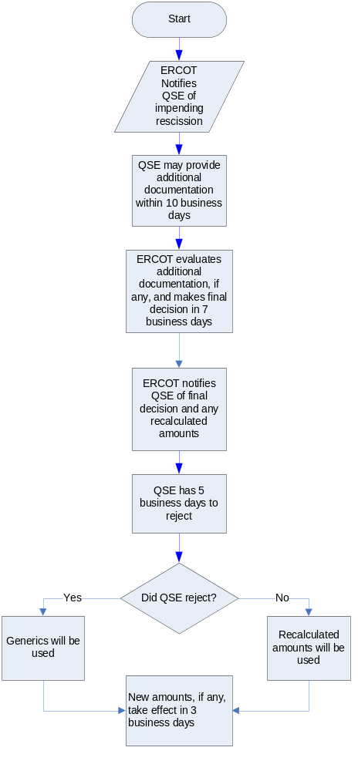

Section 11: Appealing Rejected Verifiable Costs

This section of ERCOT’s Verifiable Cost Manual describes the policies and procedures that apply when a QSE wishes to appeal a rejection of their Verifiable Costs.

Appealing Verifiable Cost Rejections

If ERCOT denies a QSE’s Verifiable Cost submission (or a portion thereof) or if ERCOT rescinds its prior approval of a QSE’s Verifiable Cost submission (or a portion thereof), the QSE may appeal ERCOT’s decision.

If any additional costs are approved as a result of the appeal process, the additional costs will only be used going forward. The newly approved costs will not be used to resettle prior Operating Days. If the inclusion of the newly approved costs represents a shift in ERCOT’s Verifiable Cost doctrine, this Manual will be updated and, if necessary, Nodal Protocol Revision Requests will be drafted. These updates will inform Market Participants of the doctrinal shift, will allow similarly situated QSEs to submit analogous costs, and, thus, will ensure that ERCOT approves Verifiable Costs without bias.

Verifiable Cost Appeal Process and Timeline

There are [undetermined] levels of review available to QSEs wishing to appeal a rejection of their Verifiable Costs. They are as follows:

First Level of Appeal

- QSEs initiate appeals of rejected Verifiable Costs. This is done by submitting an appeal to the VCMS through the eEnergy website.
- Appeals must be submitted no more than twenty (20) business days after ERCOT informs a QSE of its final decision and the rejection. If a QSE does not submit an appeal within this 20 business day period, the QSE is deemed to have accepted the rejection.
- A Review Meeting between the appealing QSE and ERCOT must be scheduled to occur within twenty (20) business days of a QSE initiating an appeal. This Review Meeting may be held over the phone. When scheduling a Review Meeting, QSEs must name a primary and an alternate representative. The QSE’s representative will meet with [TBD ERCOT employee(s)], who will represent ERCOT and who is outside of the Settlements and Billing Department.
- Both ERCOT and the appealing QSE must submit a position paper to each other at least two (2) business days before the Review Meeting. These papers are to:
  - explain why a cost or a portion thereof should or should not be included in the QSE’s Verifiable Costs;
  - include copies of documentation that proves the costs were incurred; and
  - reference sections within the Nodal Protocols, this Manual, or other controlling documents that supports inclusion/exclusion of the disputed costs.
- The goal of this first level of appeal is to reach an agreement and understanding between ERCOT and a QSE as quickly as possible by providing dialog between a QSE and a representative of ERCOT that is external to the Settlements and Billing department.
  - If [TBD ERCOT employee(s)], finds a QSE’s arguments and position paper to be persuasive, ERCOT will update the QSE’s Verifiable Costs to the extent approved by the representative(s). The inclusion of these costs will take effect not more than three (3) business days after approval by ERCOT’s representative(s).
  - If ERCOT’s representative(s) is unpersuaded by the QSE, the rescission or rejection stands.
  - If at any time it becomes apparent from discussions between the QSE and ERCOT that no agreement will be reached or that the positions of the QSE and ERCOT are diametrically opposed, this level of review should quickly be terminated to allow the QSE to elevate their appeal to the next level.
- Review at this level must terminate within 50 business days after an appeal is submitted. If no agreement is reached or if ERCOT’s representative does not make a decision in this time, the appeal is deemed denied and the rejection/rescission stands.

Second Level of Appeal
This level of appeal is only available to QSEs that unsuccessfully appealed ERCOT’s treatment of their Verifiable Costs through the first level of appeal. That is, this level of appeal is only open to QSEs that timely appealed Settlements and Billing’s rejection of their costs but were unable to persuade ERCOT’s representative to approve inclusion of a cost (or the extent requested).

A QSE may only appeal the costs or amounts that were rejected by ERCOT’s representative in the first level of appeal. If ERCOT’s representative and a QSE reach an understanding in the first level of appeal, their agreed upon treatment of a cost is not appealable. For example, if a QSE and ERCOT’s representative agree to include 50% of disputed cost “A” but do not agree as to the treatment of disputed cost “B”, a QSE may only appeal for the inclusion of cost “B”. On the other hand, if a QSE never assents to the partial inclusion of cost “A”, the QSE may appeal to have all of cost “A” included.

- QSEs initiate this second level of appeal by submitting an appeal to ERCOT through MIS.
- Appeals must be submitted no more than ten (10) business days after the termination of the first level of appeal, as determined by the status shown on the MIS. If a QSE does not submit an appeal within this 10 business day period, the QSE loses their right to appeal.
- Appeal at this level is determined by [undetermined party—possibly IMM or ERCOT’s unaffiliated members of BoD]. The [undetermined party] will make a decision at [undetermined place/time—next board meeting? a meeting with ERCOT and the QSE within 60 days?].
- To aid [undetermined party] in making their decision, they will receive the position papers and meeting notes from the first level of appeal. Additionally, representatives of ERCOT and the QSE must attend the [undetermined place/meeting] to answer any questions that the [undetermined party] may have.
- If the [undetermined party] approves the inclusion of any additional costs or amounts, ERCOT will update the QSE’s Verifiable Costs to the extent approved. The inclusion of these costs will take effect not more than three (3) business days after approval by the [undetermined party].
- If [undetermined party] denies inclusion of the appealed costs or amounts, ERCOT’s the rescission or rejection stands.

Appendix 1A: Methodology for Determining Maintenance Costs of Nuclear and Fossil Steam Units

Method of Calculating Total Maintenance Costs using 1998 as the Operating Year

TMD = (A₉₇ * F₉₈/F₉₇) + (A₉₇ * F₉₈/F₉₇) …. + (A₈₈ * F₉₈/F₈₈)

TFuel = Fuel₉₇ + F₉₆…. + F₈₈

TSD = (B₉₇ * F₉₈/F₉₇) + (B₉₆ * F₉₈/F₉₆) … + (B₈₈ * F₉₈/F₈₈)

TS = S₉₇ + S₉₆…. + S₈₈

MA₉₈ = TMD / TFuel

SMA₉₈ = TSD / TS

Where:

- TMD = Total Maintenance Dollars in period
- A = Total Maintenance spent in period
- B = Total Maintenance costs that are startup related
- F = Escalation Factor for a particular year, as approved by ERCOT and based on the Handy-Whitman Index. (See Figure 14 in Appendix 2)
- TFuel = Total fuel burn or heat released (for same years used in TMD)
- Fuel = Total annual fuel consumed (expressed in tons, barrels, gallons, etc.) total annual heat released (expressed in MBTUs, etc.)
- TS = Total Starts
- TSD = Total Start maintenance Dollars
- S = Number of Starts per year
- MA = Maintenance Cost Adder ($/unit of fuel or heat)
- SMA = Start Maintenance Cost Adder ($/start-up)

Total Maintenance Dollars (TMD) plus Total Start maintenance Dollars (TSD) must be included with a Verifiable Cost submission and will be reviewed by ERCOT.

Appendix 1B: Methodology for Determining the Maintenance Costs of CT and CCP Units

Example Calculation of Total Maintenance Dollars using Operating Year of 1998

TMD = (C₉₇ * F₉₈/F₉₇) + (C₉₆ * F₉₈/F₉₆) … + (C₈₈ * F₉₈/F₈₈)

Where:
- C = Total dollars spent on maintenance during a particular year
- F = Escalation Factor for a particular year, as approved by ERCOT and based on the Handy-Whitman Index. (See Figure 14 in Appendix 2)

Note: TMD must be calculated for the same historical period as Equivalent Service Hours.

How to Calculate Equivalent Service Hours (ESH)

ESH = (A * number of starts) + Z hours + (B * Y hours)

Where:

- A = Cyclic starting factor (A = 5.0 for aircraft - type CT's; A = 10.0 for industrial - type CT's)

For example, the incremental maintenance charged to one start on an industrial - type CT is equivalent to the incremental maintenance attributable to ten hours of base load operation.

- B = Cyclic peaking factor (B = 3.0 for all CT's)

This means that the additional incremental maintenance charged to the incremental energy between base and peak loads is equivalent to the incremental maintenance attributable to three hours of base load operation.

- Z = Total unit operating hours at any load level

- Y = Hours above base load temperature limit

Note: ESH must be calculated using all available history in the Maintenance Period. QSEs may propose alternative cyclic starting factors or cyclic peaking factors for individual units. Such alternative factor proposals should include supporting documentation (e.g., manufacturer recommendation) of this new factor, to be reviewed for approval by ERCOT, on a case-by-case basis.

How to Calculate Equivalent Hourly Maintenance Cost (EHMC)

EHMC = TMD / ESH

Where:

- TMD = Total maintenance dollars as approved by ERCOT
- ESH = Equivalent service hours
- EHMC is in terms of $/hour

Applying Equivalent Hours Maintenance Costs to Calculate Maintenance Rates:

Starting Maintenance Cost ($/Start) = A * EHMC

Where:
- A = Cyclic starting factor as defined above

- EHMC = Hourly Maintenance Cost ($/Hour)

This hourly value is assigned as a capacity cost and is independent of unit loading.

- Peak Incremental Maintenance Rate ($/MWh) = [B/peak pickup] x EHMC

Peak pickup is equal to the difference between a CT's energy outputs at base and at peak loading levels.

Comments:

- The above formulations are applicable for determination of Maintenance Cost Adder for both aircraft and industrial type combustion turbines.

- CT incremental costs may only be developed and applied on a unit-by-unit basis

Example Calculation of the Maintenance Adder for a Combustion Turbine

If:
- Peak Hours = Y = 200hr
- Service Hours = Z = 2000hr (Total Base Peak Hours)
- Number of of Starts = 300
- Peak Pickup = 5 MW
- A = 10, B = 3 (Note: A = 5 for aircraft engine CT's)
- TMD = $100,000 (Actual historical maintenance data escalated to present value)

Then Equivalent Hourly Maintenance Cost:

EHMC = $100,000 / [ (10*300) + 2,000 + (3*200) ] = $17.86/hr

And Maintenance Rates:

Starting Maintenance Rate = A * EHMC = 10 * $17.86/hr = $178.60/start

Peak Incremental Maintenance Rate = B / [peak pickup] * EHMC

= 3/5 * $17.86 = $10.72/MWh

Appendix 2: Typical Variable O&M Values

Figure 1: Generic Unit Characteristics (in 2005 Dollars)
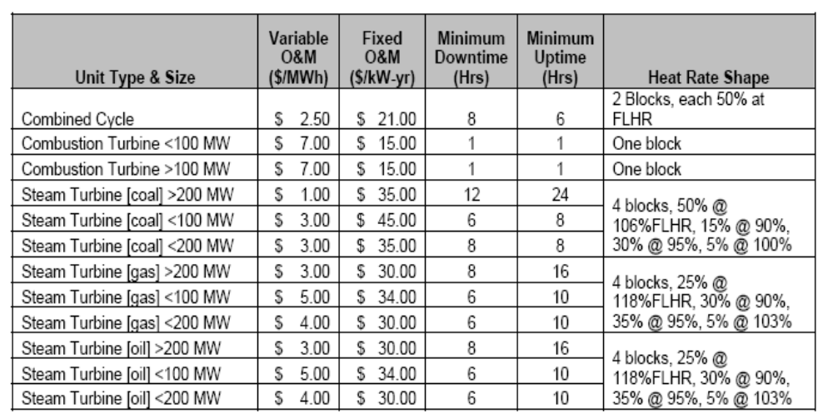
Source: U.S. Department of Energy, Memorandum: GE MAPS Input Assumptions: Eastern Interconnect, p. 3, available at http://www.oe.energy.gov/DocumentsandMedia/Appendix_6_MAPS_Assumptions_3-13.pdf.

Figure 2: Fossil Steam Plant Operations and Maintenance Costs, 1981-1997
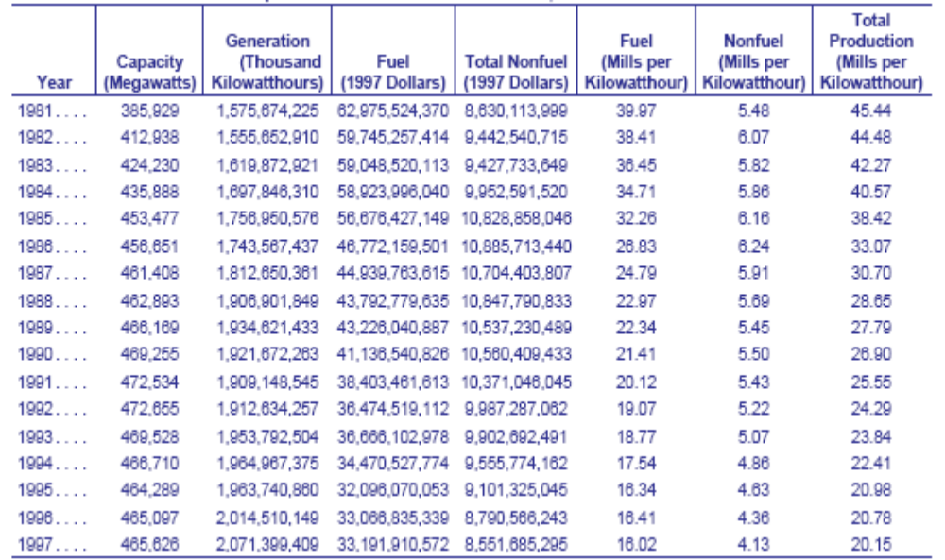
Note: 1 mill = 0.1 cent.
Source: Office of Integrated Analysis and Forecasting, U.S Department of Energy, Issues in Midterm Analysis and Forecasting 1999, p. 3, available at http://www.eia.doe.gov/oiaf/issues/pdf/060799.pdf.

Figure 3: Fossil Steam Plant Operations and Maintenance Costs, 1981-1997
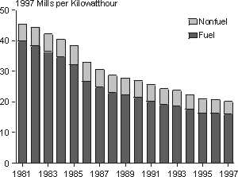
Note: 1 mill = 0.1 cent.
Source: Office of Integrated Analysis and Forecasting, U.S Department of Energy, Issues in Midterm Analysis and Forecasting 1999, p. 2, available at http://www.eia.doe.gov/oiaf/issues/pdf/060799.pdf.

Figure 4: Cost Characteristics for New Generating Technologies
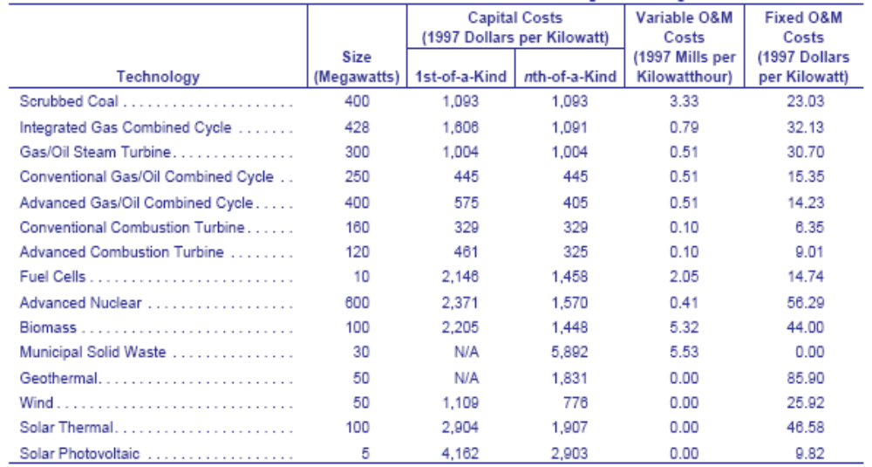
Source: Office of Integrated Analysis and Forecasting, U.S Department of Energy, Issues in Midterm Analysis and Forecasting 1999, p. 41, available at http://www.eia.doe.gov/oiaf/issues/pdf/060799.pdf.

Figure 5: Cost Characteristics for New Generating Technologies

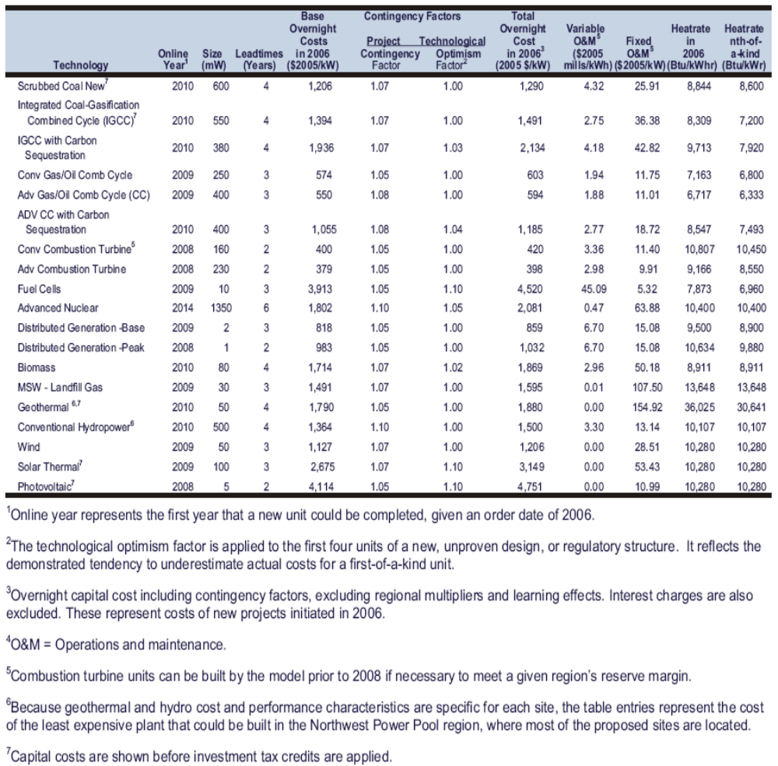
Source: Energy Information Administration, U.S Department of Energy, Assumptions to the Annual Energy Outlook 2007, p. 77, available at http://www.eia.doe.gov/oiaf/aeo/assumption/pdf/0554(2007).pdf.

Figure 6: Levelized Costs for Merchant Plants

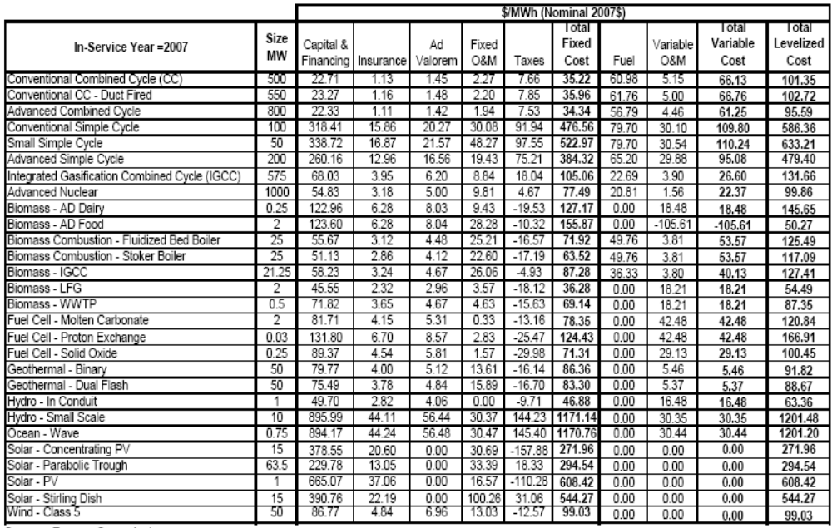
Source: California Energy Commission, Comparative Costs of California Central Station Electricity Generation Technologies, June 2007 CEC-200-2007-011-SD Report, p. 10 available at http://www.energy.ca.gov/2007publications/CEC-200-2007-011/CEC-200-2007-011-SD.PDF.

Figure 7: Levelized Costs for Publically Owned Plants

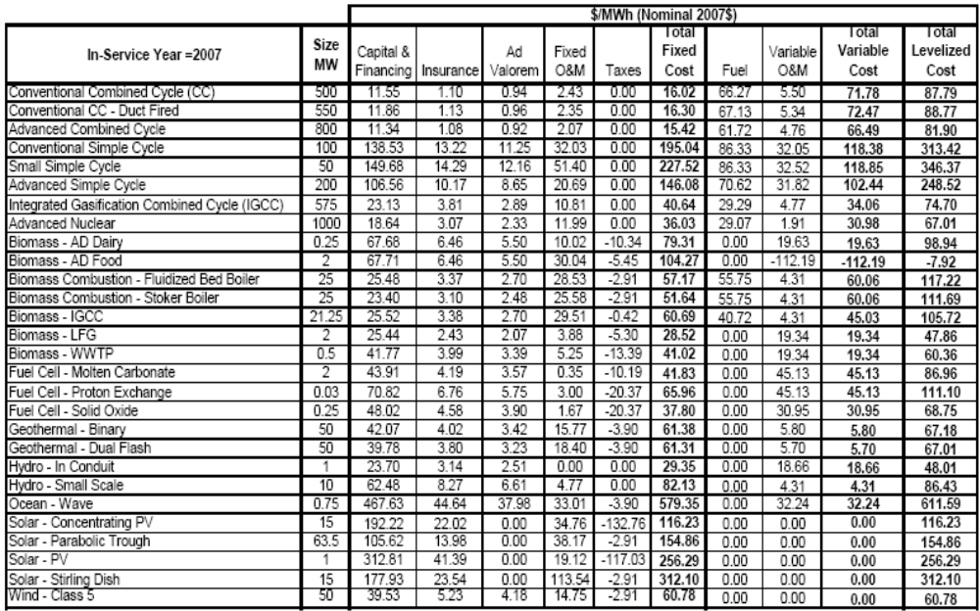

Source: California Energy Commission, Comparative Costs of California Central Station Electricity Generation Technologies, June 2007 CEC-200-2007-011-SD Report, p. 14 available at http://www.energy.ca.gov/2007publications/CEC-200-2007-011/CEC-200-2007-011-SD.PDF.

Figure 8: Emission Factors

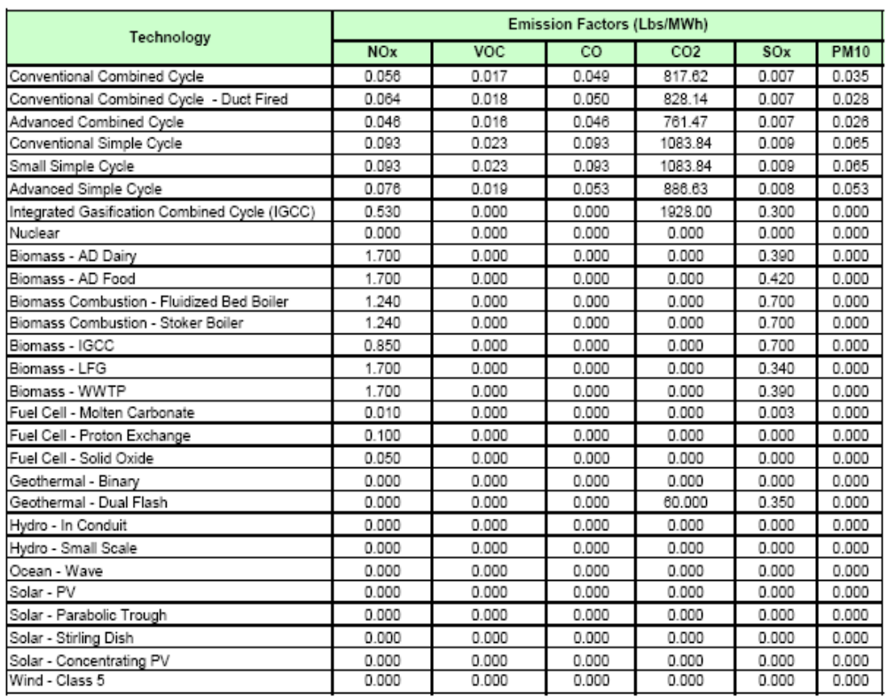

Source: California Energy Commission, Comparative Costs of California Central Station Electricity Generation Technologies, June 2007 CEC-200-2007-011-SD Report, p. 18 available at http://www.energy.ca.gov/2007publications/CEC-200-2007-011/CEC-200-2007-011-SD.PDF.

Figure 9: Combined Cycle Operating Cost Analysis – Base Case

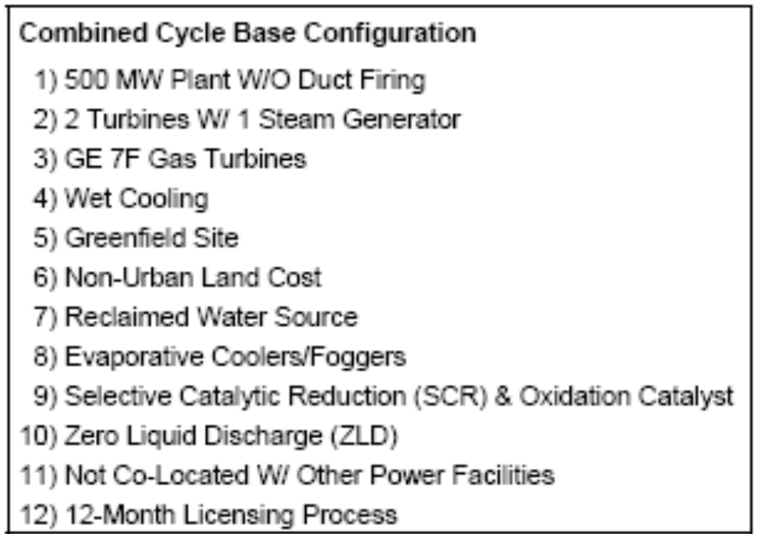

Source: California Energy Commission, Comparative Costs of California Central Station Electricity Generation Technologies, June 2007 CEC-200-2007-011-SD Report, p. 26 available at http://www.energy.ca.gov/2007publications/CEC-200-2007-011/CEC-200-2007-011-SD.PDF.

Figure 10: Combined Cycle Operating Cost Analysis – Base Case
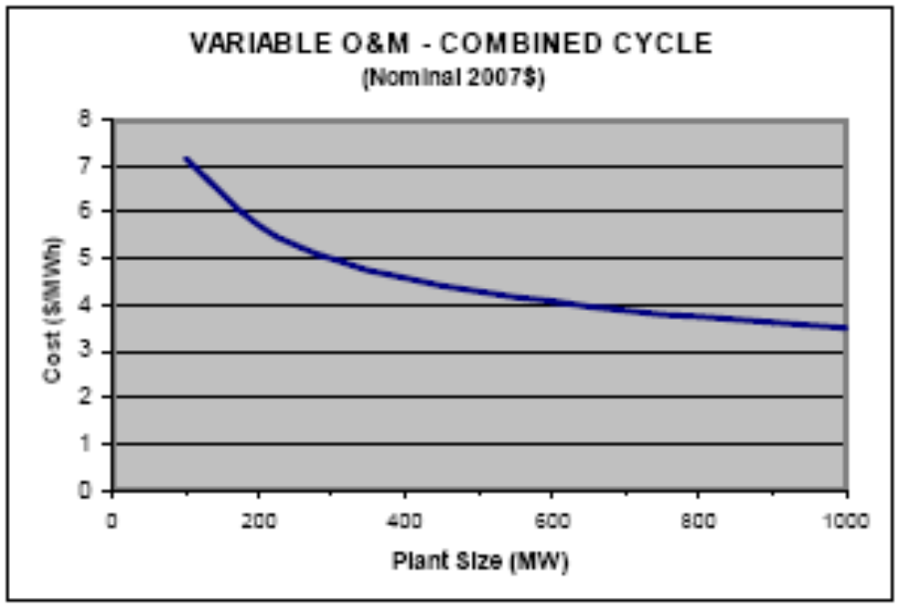
Source: California Energy Commission, Comparative Costs of California Central Station Electricity Generation Technologies, June 2007 CEC-200-2007-011-SD Report, p. 30 available at http://www.energy.ca.gov/2007publications/CEC-200-2007-011/CEC-200-2007-011-SD.PDF.

Figure 11: Simple Cycle Operating Cost Analysis – Base Case

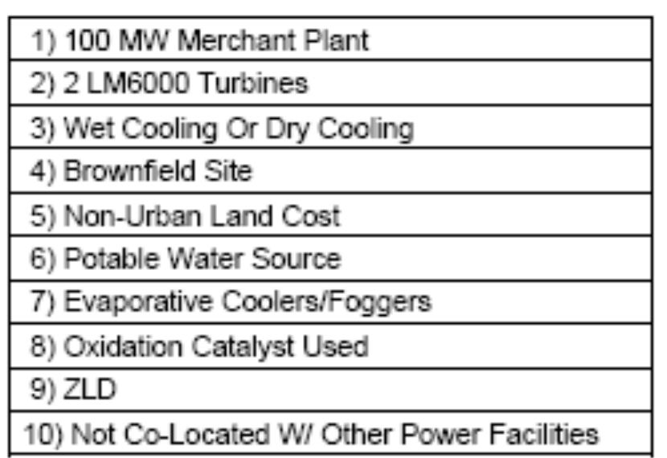
Source: California Energy Commission, Comparative Costs of California Central Station Electricity Generation Technologies, June 2007 CEC-200-2007-011-SD Report, p. 31 available at http://www.energy.ca.gov/2007publications/CEC-200-2007-011/CEC-200-2007-011-SD.PDF.

Figure 12: Simple Cycle Operating Cost Analysis – Base Case
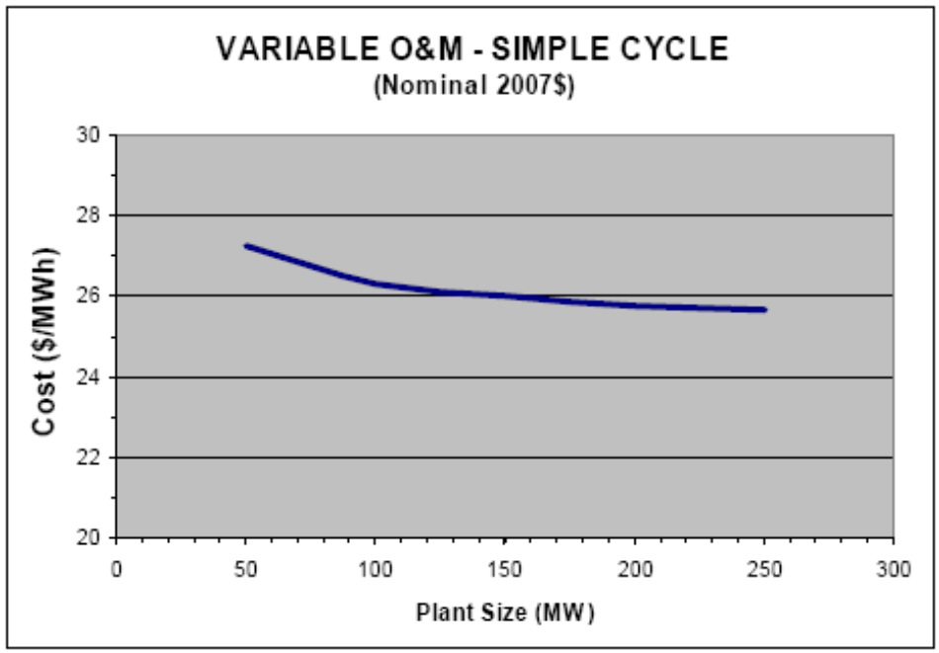
Source: California Energy Commission, Comparative Costs of California Central Station Electricity Generation Technologies, June 2007 CEC-200-2007-011-SD Report, p. 33 available at http://www.energy.ca.gov/2007publications/CEC-200-2007-011/CEC-200-2007-011-SD.PDF.

Figure 13: California Energy Commission Technology Levelized Cost Comparison
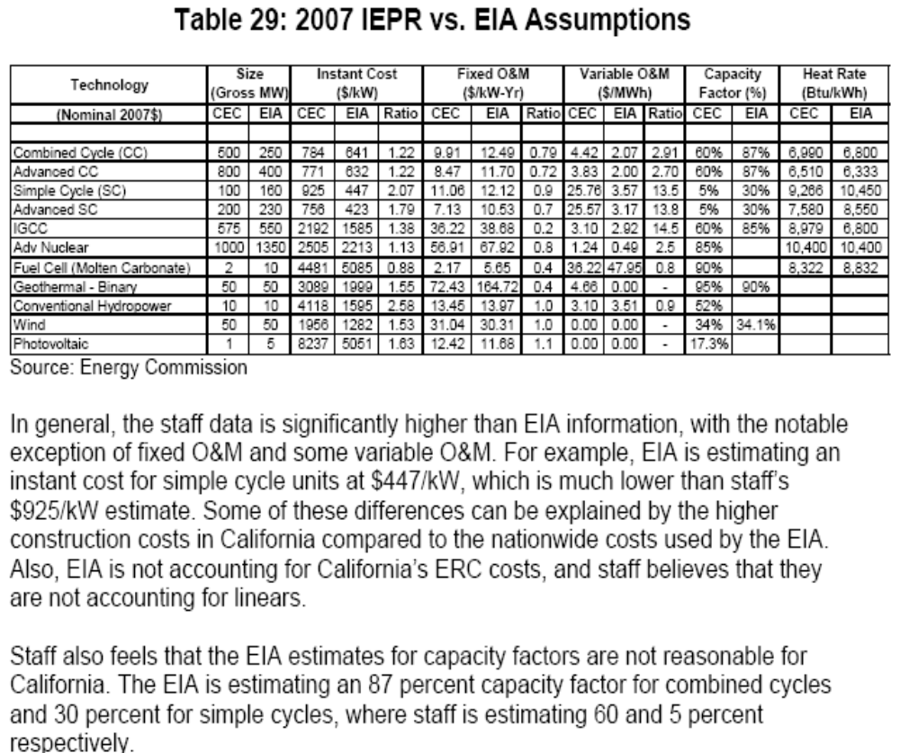

Note: EIA = Energy Information Administration; CEC = California Energy Commission
Source: California Energy Commission, Comparative Costs of California Central Station Electricity Generation Technologies, June 2007 CEC-200-2007-011-SD Report, p. 44 available at http://www.energy.ca.gov/2007publications/CEC-200-2007-011/CEC-200-2007-011-SD.PDF.

Figure 14: Handy-Whitman Index
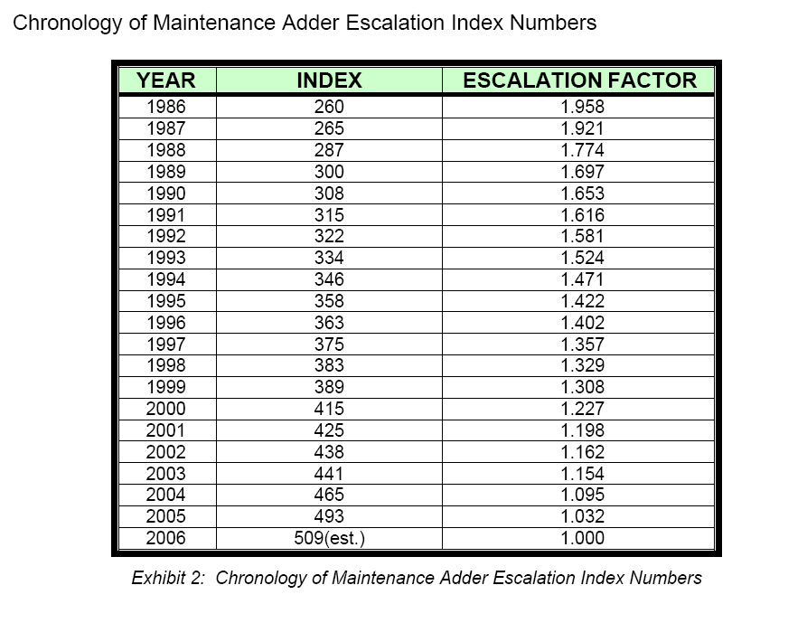
Source: PJM, PJM Manual 15: Cost Development Guidelines, p. 24-25, available at http://www.pjm.com/contributions/pjm-manuals/pdf/m15.pdf.

Appendix 3: Operating and Maintenance Cost Categories

Maintenance Cost Categories

Only Maintenance Costs that fall within the categories listed in NERC’s Data Reporting Instructions may be included as a Resource’s Verifiable Maintenance Costs. Submitted Maintenance Costs must include a reference to an appropriate GADS Code. Additionally, submitted maintenance costs will only be approved to the extent that they comply with all other relevant provisions within this Manual. This means, for example, fixed maintenance costs, maintenance costs which cannot be verified, and Event Specific Verifiable Maintenance Costs will not be approved, even if they fall within a GADS category.

NERC’s Data Reporting Instructions with an effective date of January 2007 may be found at the following link:
ftp://www.nerc.com/pub/sys/all_updl/gads/dri/2007_GADS_DRI.pdf

Maintenance Cost submissions are governed by the categories and codes within the Data Reporting Instructions in effect at the time of submission.

Currently, the Data Reporting Instructions may be found by following these steps:

Step 1: Connect to www.nerc.com
Step 2; From the drop down menu, choose GADS Services
Step 3: From the title menu, select Data Reporting Instructions
Step 4: Choose Appendix B1-B9

Operating Cost Categories

Only Operating Costs that are listed below may be included as a Resource’s Verifiable Costs. Additionally, submitted Operating Costs will only be approved to the extent that they comply with all other relevant provisions within this Manual.

Table 4: Operating Categories applicable to all generating plants

- Water consumption in plant operations
- Emission credits
- Incremental operating labor
- Vibration analysis monitoring
- Waste water treatment
- Oil and water level checks
- Auxiliary power consumption
- Auxiliary fuels/lubricants
- Water demineralization and treatment
- On-line performance testing
- Chemical waste disposal fees

Table 5: Operating Categories applicable to Coal-Fired Generating Plants

- Coal drying

Table of References

California Energy Commission, Comparative Costs of California Central Station Electricity Generation Technologies, June 2007 CEC-200-2007-011-SD Report, June 2007, available at http://www.energy.ca.gov/2007publications/CEC-200-2007-011/CEC-200-2007-011-SD.PDF. . . . . . . . . . . . . . . . . . . . . . . . . . . . . . . . . . . . . . . | p. 59-65
Energy Information Administration, U.S Department of Energy, Assumptions to the Annual Energy Outlook 2007, March 2007, available at http://www.eia.doe.gov/oiaf/aeo/assumption/pdf/0554(2007).pdf. . . . . . . | p. 58
GE Energy, Heavy-Duty Gas Turbine Operating and Maintenance Considerations, 2004, available at http://www.gepower.com/prod_serv/products/tech_docs/en/downloads/ger3620k.pdf . . . . . . . . . . . . . . . . . . . . . . . . . . . . . . . . . . . . . . . . . . . . . . | p. 67
Office of Integrated Analysis and Forecasting, U.S Department of Energy, Issues in Midterm Analysis and Forecasting 1999, August 1999, available at http://www.eia.doe.gov/oiaf/issues/pdf/060799.pdf. . . . . . . . | p. 55-57
PJM, PJM Manual 15: Cost Development Guidelines Revision 07, 08/03/2006, available at http://www.pjm.com/contributions/pjm-manuals/pdf/m15.pdf. . . . . . . . . . . . . . . . . . . . . . . . . . . . . . . . . . . . . . . . | p. 42, 50-53, 66
U.S. Department of Energy, Memorandum: GE MAPS Input Assumptions: Eastern Interconnect, 03/13/2006, available at http://www.oe.energy.gov/DocumentsandMedia/Appendix_6_MAPS_Assumptions_3-13.pdf. . . . . . . . . . . . . . . . . . . . . . . . .. . . . . . . . . . . . . . . . . | p. 54

At this time, it is unknown how many levels of appeal will be available or all parties that will be involved. Specific details in this section that are unknown are represented by a generic description enclosed in brackets. ERCOT is awaiting responses from key parties and is unable to fully detail the appeal process until these are received. ERCOT nevertheless included this incomplete and general framework in the Manual in order to inform Market Participants and to encourage Market Participants to submit feedback and suggestions.
The Methodology detailed within this Appendix is based upon the one currently used by PJM. See PJM, PJM Manual 15: Cost Development Guidelines, p. 24-25, available at http://www.pjm. com/contributions/pjm-manuals/pdf/m15.pdf.
Both the methodology and the example detailed within this Appendix are based upon ones used by PJM. See PJM, PJM Manual 15: Cost Development Guidelines, p. 25-29, available at http://www.pjm.com/contributions/pjm-manuals/pdf/m15.pdf.
In the next version of this Manual, ERCOT will update this sub-section to list GADS categories and codes that are not allowed.

