RECTF
August 31st, 2021
WebEx only
Attendee | Company | Attendee | Company |  | Attendee | Company
Jim Lee | AEP | Diana Rehfeldt |  | TNMP | Mariah Benson | PUCT
Jordan Troublefield | ERCOT | Andrea Couch |  | TNMP | Chris Hendrix | Demand Control
Debbie McKeever | Oncor | Marilyn Hudson |  | CNP | Cynthia Morrow | Gexa
Chris Rowley | Oncor | Lee Doehring |  | CNP | Eric Lotter | GridMonitor
Sam Pak | Oncor | Terri Wilson Lester |  | CNP | Sheri Wiegand | Vistra
Malcolm Ainspan | NRG | Alberto Lopez |  | CNP | John Schatz | Vistra
Norm Levine | NRG | Chris Dominguez |  | CNP | Deb Belin | Marketwise
Angela Ghormley | Calpine | Kathy Scott |  | CNP | Eric Goodwin Jr | ?
Scott Smith | Tenaska | Carolyn Reed |  | CNP | Martin Ramirez | ?
Kim Rainwater | LCRA | Jill Bell |  | CNP | Mansoor Khanmohamed | EDF

Jim Lee opened the meeting reading the Antitrust Admonition.
Meeting minutes from July 27th were reviewed and approved.

Emergency Conditions List (ECL)
Jim reviewed the attached ECL noting status of each item. A few notables:
- #18 – Meter Data and Estimations
#125 –TDSP Demand Billing Considerations
#126 – TDSP Data Practices During Prolonged Widespread Outages
AMS Data Practices matrix and proposed addendum questions were reviewed for any additional modifications. See later notes regarding matrix.
- #20 – “Should there be modifications for Validation, Editing and Estimation of meter data? What is the extent of billing errors caused by this?” Upon presenting ECL list at TAC, it was thought this item was still open for RECTF noting TDSP Data was “routinely late” in delivery to ERCOT. Kathy Scott and Jim Lee worked with Randy Roberts and Kelly Brink of ERCOT to provide a report on timing and availability of AMS Data for Settlement processes. Below is a graph of the timeliness of AMS data received by ERCOT on Day 2 from Jan through June 2021.
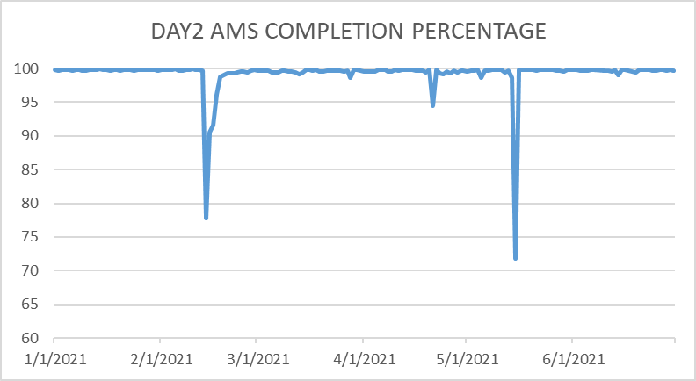
ACTION ITEM: Randy will follow up with Day 1 availability of data. RECTF will review data before closing out this issue.
- #19 – modification of proxy data for subset of C&I customers for initial settlement – TDSPs are providing a list of ESIs not transitioning from BUSIDRRQ to BUSLRG to determine if the load ERCOT will continue to estimate for initial settlement is significant and if estimation methodologies need to be reviewed. This is being discussed at PWG and the Oct 13th IDR/AMS Workshop.
- #22 – Mass Transition (MT) expectations (stacking logic) of transactions –RMS will consider RMGRR168 at the next meeting and it was noted PUC Subst Rule 25.43 was also being addressed in Project 51830 via REP comments

TDSP AMS Data Practices Matrix
Jim presented the “final” version of the AMS Data Practices matrix with the addendum questions added to the end in same color format. (questions # 7 – 16). A few clarifying edits were made to Oncor’s responses on #8, #9 and #15 and CNP’s response on #16.

ACTION ITEM: TDSPs will revisit the response to #13 and consider adding an overall comment in the “Notes/Comments” column regarding market notices on deviations/schedules for gap retrieval. Q#13: After a widespread, prolonged outage concludes, does the TDSP deploy any gap retrieval processes to recover interval data once power is restored to a premise?

The TF will review the matrix one final time at the next meeting on September 28th, then the matrix will be presented at October RMS for final review and approval, then onto TAC and #18, #20 and #125 will be completed on the ECL.

The final resting place for the matrix will be both the RMS and TXSET home pages.

Weather Preparedness – Q & A – Updated Matrix
Jim presented two TDSP response matrices: one FAQ for ERCOT Energy Emergency Alert (EEA) and a second for TDSP Emergency Operation Plan(EOP) .

ACTION ITEM: Jim and Sheri will work to define some of the differences between when an EEA and/or an EOP may be deployed to provide clarity on when each of the FAQ responses may apply. These clarifications will be reviewed and finalized next month.

EEA matrix was reviewed first.
- A question regarding the response to #4 How long could a Customer be without power during a load shed event? Was presented regarding timely market notices providing updates on expectations. With an EEA event, TDSPs explained this issue was being addressed in PUCT Project #51889.
- For #6 Are TDSPs AMS systems integrated with their Outage Management Systems (OMS)? , Oncor aligned their EEA response with their EOP response indicating ‘partially’ meaning today their system does not estimate zeros when an outage is detected, however, other features are integrated. Oncor did present this was a project “they were looking into”.
- On #14 How are Service Orders impacted during a load shedding event” , when questioned if CNP’s first part of their response applied to all other TDSPs, all wanted to keep the original language on their response. CNP’s response: “Delays could be experienced during any power outage event since all AMSR meters’ remote functionality become inoperable until power has been restored to the meter(s).”
- Title block was changed to include “Chronic Condition” as well
- #18 added “for EEA” to the question for clarity since the responses for EOP varied from EEA.

EOP matrix was then reviewed. In general, an EOP can be deployed in TDSP specific areas or they can be widespread citing examples such as a hurricane, tornado, or other weather-related incidents. This matrix focused more on specific business practices employed by the TDSPs, hence the varying answers.
- For #5, For Customers who have registered for TDSP-specific outage alerts, will TDSPs utilize those communication channels during an EOP event?”, TNMP was asked if they were considering an outage alert system and responded it was being discussed yet no timeline is available.
- #11 Will Critical Care/Chronic Conditions/Critical Load Customers receive special messaging? Responses received clarification:
  - Oncor: “making outbound calls” indicated a recorded message would be sent
  - CNP: “blasting messages” indicated communication would be made via email/text/phone calls (robocalls)
- TDSPs explained typically during an EOP event, TDSPs have additional time and bandwidth for outreach as opposed to an EEA event when changes can happen very quickly.
- The question was asked “What happens if we have both an EEA and an EOP event, which responses can be used to set expectations? Initial response was always echo out EEA responses with possible secondary market notices indicating an EOP response. TDSPs will review and provide clarity in the “definitions” of an EEA vs EOP.

Agenda Planning for Nov 2nd Winter Preparedness Workshop
Jim presented the agenda from last year’s workshop seeking feedback on topics. Initial plan is to follow the same basic agenda only discussing the EEA and EOP matrices FAQs. It was also suggested to add Mass Transition Process as an agenda item. The agenda will be finalized at the next RECTF meeting.

Next Steps/Next Meeting
Next meeting is scheduled for September 28th.

Proposed Agenda topics:
- Update on ECL items
- Final Review TDSP AMS Data Practices matrix w/Addendum for prolonged widespread outages
- Review of Summer/Winter Preparedness FAQ matrices – EEA and EOP
- Finalize Agenda for Weather Prep meeting on November 2nd

Meeting adjourned ~ 12:30 PM

