November 2021 ERCOT Monthly Operations Report
Reliability and Operations Subcommittee Meeting
January 06, 2021

Table of Contents
1. Report Highlights 2
2. Frequency Control 3
2.1. Frequency Events 3
2.2. Responsive Reserve Events 4
2.3. Load Resource Events 4
3. Reliability Unit Commitment 4
4. IRR, Wind, and Solar Generation as a Percent of Load 5
5. Largest Net-Load Ramps 7
6. COP Error Analysis 7
7. Congestion Analysis 9
7.1. Notable Constraints 9
7.2. Generic Transmission Constraint Congestion 13
7.3. Manual Overrides 13
7.4. Congestion Costs for Calendar Year 2021 13
8. System Events 14
8.1. ERCOT Peak Load 14
8.2. Load Shed Events 15
8.3. Stability Events 15
8.4. Notable PMU Events 15
8.5. DC Tie Curtailment 15
8.6. TRE/DOE Reportable Events 15
8.7. New/Updated Constraint Management Plans 15
8.8. New/Modified/Removed RAS 15
8.9. New Procedures/Forms/Operating Bulletins 15
9. Emergency Conditions 16
9.1. OCNs 16
9.2. Advisories 16
9.3. Watches 16
9.4. Emergency Notices 16
10. Application Performance 16
10.1. TSAT/VSAT Performance Issues 16
10.2. Communication Issues 16
10.3. Market System Issues 16
11. Model Updates 17
Appendix A: Real-Time Constraints 19

Report Highlights
- The unofficial ERCOT peak load was 48,966 MW.
- There were 3 frequency events.
- There were 4 instances where Responsive Reserves were deployed.
- There were 24 HRUC commitments.
- There were 20 days of congestion on the West Texas Export GTC, 26 days on the Panhandle GTC, 21 days on the North Edinburg to Lobo GTC, 11 days on the Valley Export GTC, 20 days on the Raymondville to Rio Hondo, 3 days on the Bearkat GTC, 10 days on the Nelson Sharpe to Rio Hondo GTC, 2 days on the North to Houston GTC, and 1 day on the McCamey GTC. There was no activity on the remaining GTCs during the month.

Frequency Control

Frequency Events
The ERCOT Interconnection experienced 3 frequency events, which resulted from unit’s trips. The average event duration was 00:04:46.

A summary of the frequency events is provided below. The reported frequency events meet one of the following criteria: Delta Frequency is 60 mHz or greater; the MW loss is 350 MW or greater; resource trip event triggered RRS deployment. Frequency events that have been identified as Frequency Measurable Events (FME) for purposes of BAL-001-TRE-1 analysis are highlighted in blue. When analyzing frequency events, ERCOT evaluates PMU data according to industry standards. Events with an oscillating frequency of less than 1 Hz are inter-area, while higher frequencies indicate local events. Industry standards specify that damping ratio for inter-area oscillations should be 3.0% or greater. For the frequency events listed below, the ERCOT system met these standards and transitioned well after each disturbance.

Date and Time | Delta Frequency | Max/Min Frequency | Duration of Event | PMU Data |  | MW Loss | Load | IRR | Inertia
 | (Hz) | (Hz) |  | Oscillation Mode (Hz) | Damping Ratio |  | (MW) | % | (GW-s)
11/1/2021 4:57:04 | 0.108 | 59.905 | 00:09:14 | 0.65 | 5% | 539.87 | 31,788 | 25% | 190,153
11/15/2021 17:53:11 | 0.092 | 59.868 | 00:02:37 | 0.98 | 8% | 452.28 | 45,335 | 18% | 241,063
11/17/2021 14:32:48 | 0.079 | 59.880 | 00:02:26 | 1.79 | 14% | 351.98 | 48,752 | 45% | 191,133
(Note: All data on this graph encompasses frequency event analysis based on BAL-001-TRE-1.)

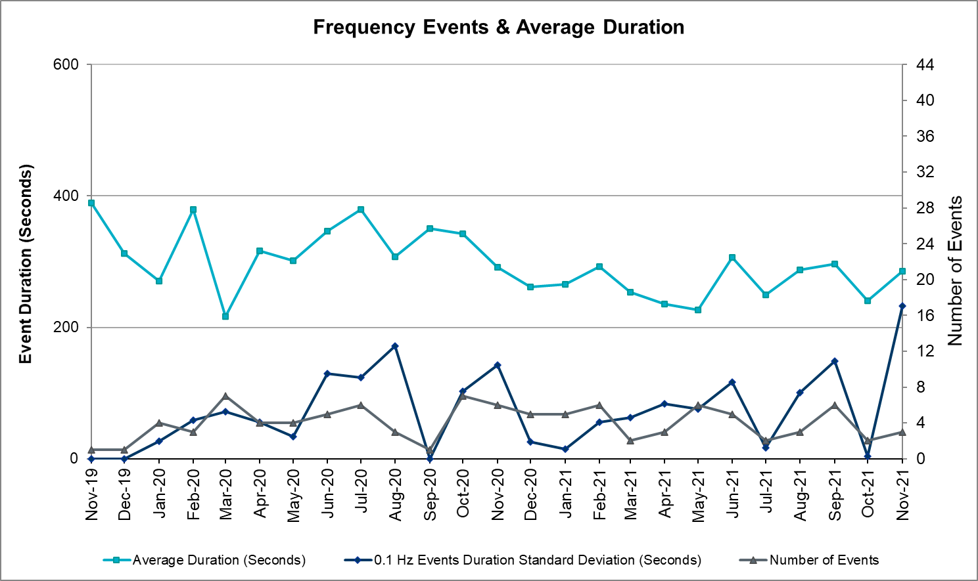

Responsive Reserve Events
There were 4 events where Responsive Reserve MWs were released to SCED. The events highlighted in blue were related to frequency events reported in Section 2.1 above.

Date and Time Released to SCED | Date and Time Recalled | Duration of Event | Maximum MWs Released | Comments
11/1/2021 4:57:17 | 11/1/2021 5:05:00 | 00:07:43 | 403
11/15/2021 17:53:22 | 11/15/2021 17:56:06 | 00:02:44 | 722
11/17/2021 14:32:56 | 11/17/2021 14:35:56 | 00:03:00 | 768

A fourth Responsive Reserve event involving load resources is described in the next section.

Load Resource Events
Two load resources deployed Responsive Reserve on 11/10 due to a transmission emergency event. The first load resource was deployed at 11:03 and the second load resource was deployed at 11:22 for a total deployed quantity of 69.9 MW. Both units were recalled at 11:38.

Reliability Unit Commitment
ERCOT reports on Reliability Unit Commitments (RUC) on a monthly basis. Commitments are reported grouped by operating day and weather zone. The total number of hours committed is the sum of the hours for all the units in the specified region. Additional information on RUC commitments can be found on the MIS secure site at Grid Generation Reliability Unit Commitment.

There were no DRUC commitments.

There were 24 HRUC commitments

Resource Location | # of Resources | Operating Day | Total # of Hours Committed | Total MWhs | Reason for Commitment
EAST, NORTH_CENTRAL, SOUTH_CENTRAL | 8 | November 1, 2021 | 70 | 25,003.0 | Capacity
EAST, NORTH_CENTRAL, SOUTH_CENTRAL | 6 | November 2, 2021 | 30 | 6,592.0 | Capacity
EAST, NORTH_CENTRAL | 4 | November 3, 2021 | 33 | 3,075.5 | Capacity
EAST, NORTH_CENTRAL | 2 | November 4, 2021 | 28 | 4,816.0 | Capacity
NORTH_CENTRAL | 1 | November 5, 2021 | 24 | 2,880.0 | Minimum Run Time
NORTH_CENTRAL | 1 | November 6, 2021 | 1 | 120.0 | Minimum Run Time
NORTH_CENTRAL | 1 | November 9, 2021 | 4 | 1,740.0 | Capacity
NORTH_CENTRAL | 1 | November 15, 2021 | 2 | 1,046.0 | Capacity

IRR, Wind, and Solar Generation as a Percent of Load
Graph below shows the maximum, minimum and average aggregate solar, wind and IRR output as a percentage of total ERCOT load when evaluated as 10-minute averaged intervals, over the past 13 months. Current wind, solar generation and penetration records are listed in the footnote below. Maximum IRR penetration for the month was 63.9% on November 17, 2021 interval ending 01:20 and minimum IRR penetration for the month was 5.4% on November 22, 2021 interval ending 17:40.

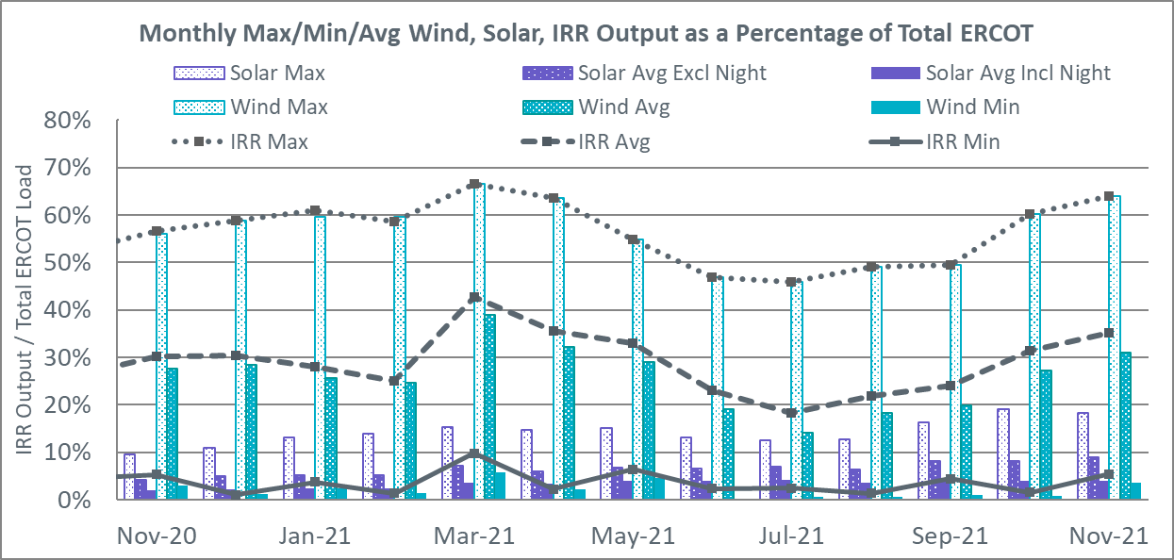

During the hour of peak load for the month, hourly integrated wind generation was 16,022 MW and solar generation was 5,863 MW. Graph below shows the wind and solar penetration percentage during the hour of the peak load in the last 13 months.

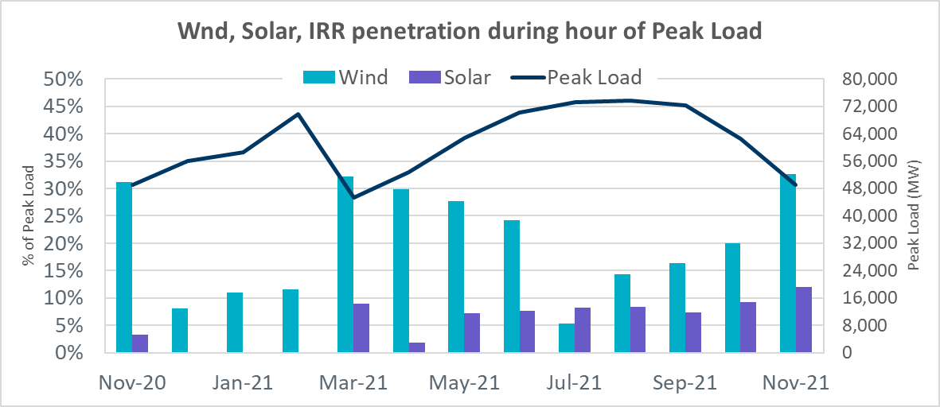

Lastly, the graph below shows the minimum wind, solar and IRR output during the peak load hour as a percentage of the daily peak load for every day in the month.

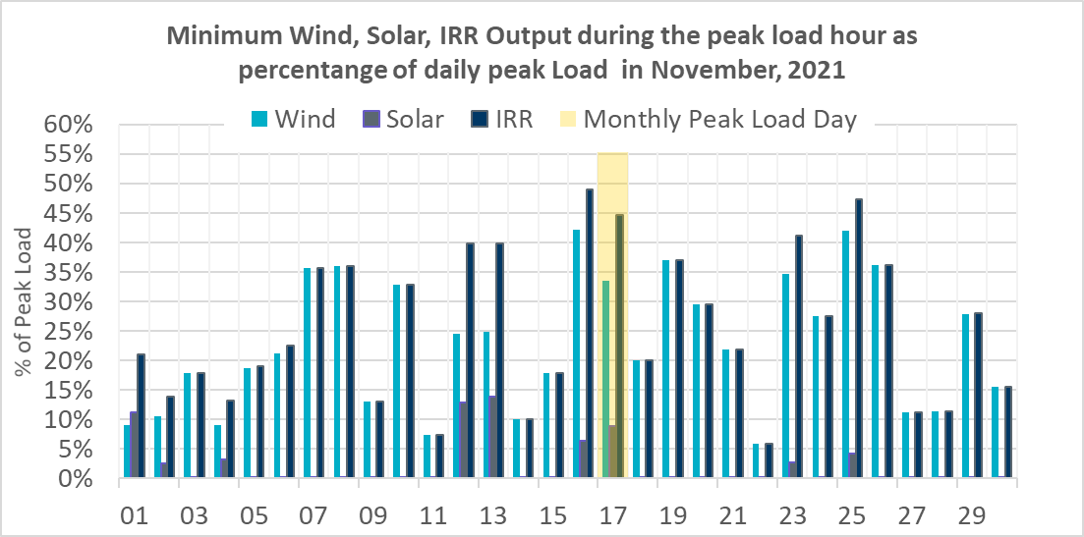

Largest Net-Load Ramps
The net-load ramp is defined as the change in net-load (load minus wind and PVGR generation) during the defined time horizon. Such a variation in net-load needs to be accommodated in grid operations to ensure that the reliability of the grid is satisfactorily maintained. The largest net-load ramp during 5-min, 10-min, 15-min, 30-min and 60-min in November 2021 are 1311 MW, 1639 MW, 2281 MW, 3781 MW, and 6587 MW, respectively. The comparison with respect to the historical values is given in the table below.

Month and Year | 5 min | 10 min | 15 min | 30 min | 60 min
November 2021 | 1311 MW | 1639 MW | 2281 MW | 3781 MW | 6587 MW
November 2014 | 991 MW | 1689 MW | 2112 MW | 3289 MW | 5392 MW
November 2015 | 915 MW | 1637 MW | 1995 MW | 3241 MW | 5516 MW
November 2016 | 821 MW | 1404 MW | 1827 MW | 3166 MW | 5866 MW
November 2017 | 877 MW | 1581 MW | 2078 MW | 3393 MW | 5708 MW
November 2018 | 814 MW | 1553 MW | 2148 MW | 4109 MW | 7218 MW
November 2019 | 940 MW | 1606 MW | 2269 MW | 3934 MW | 6317 MW
November 2020 | 971 MW | 1264 MW | 1655 MW | 3061 MW | 5751 MW
2014-2021 | 1311 MW | 1689 MW | 2281 MW | 4109 MW | 7218 MW

COP Error Analysis
COP Error is calculated as the capacity difference between the COP HSL and real-time HSL of the unit. Mean Absolute Error (MAE) stayed over 8,590 MW until Day-Ahead at 12:00, then dropped significantly to 1209 MW by Day-Ahead at 14:00. In the following chart, Under-Scheduling Error indicates that COP had less generation capacity than real-time and Over-Scheduling Error indicates that COP had more generation capacity than real-time.
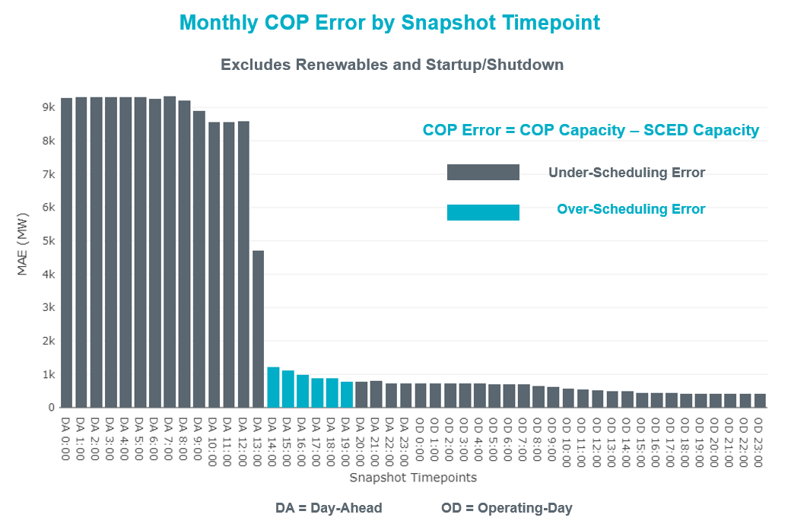

Monthly MAE for the Latest COP at the end of the Adjustment Period was 417 MW with median ranging from -360.7 MW for Hour-Ending (HE) 23 to 161.6 MW for HE 13. HE 22 on the 29th had the largest Over-Scheduling Error (1,549 MW) and HE 22 on the 2nd had the largest Under-Scheduling Error (-2,016 MW).

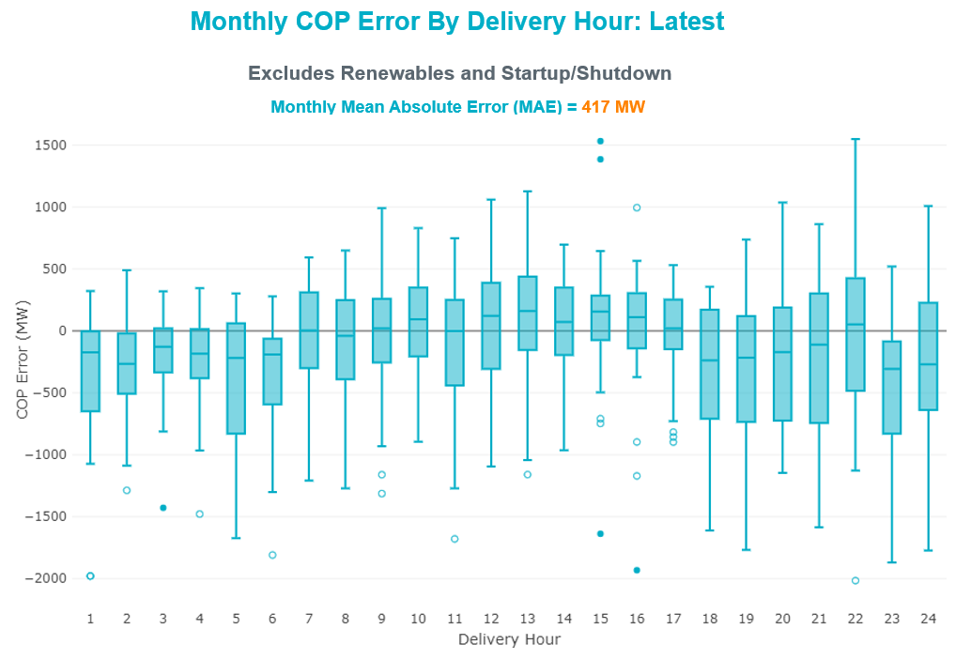

Monthly MAE for the Day-Ahead COP at 12:00 was 8,603 MW with median ranging from -12,646 MW for Hour-Ending (HE) 18 to -3,637 MW for HE 3. HE 20 on the 2nd had the largest Under-Scheduling Error (-19,072 MW) and HE 24 on the 7th had the largest Over-Scheduling Error (597 MW).

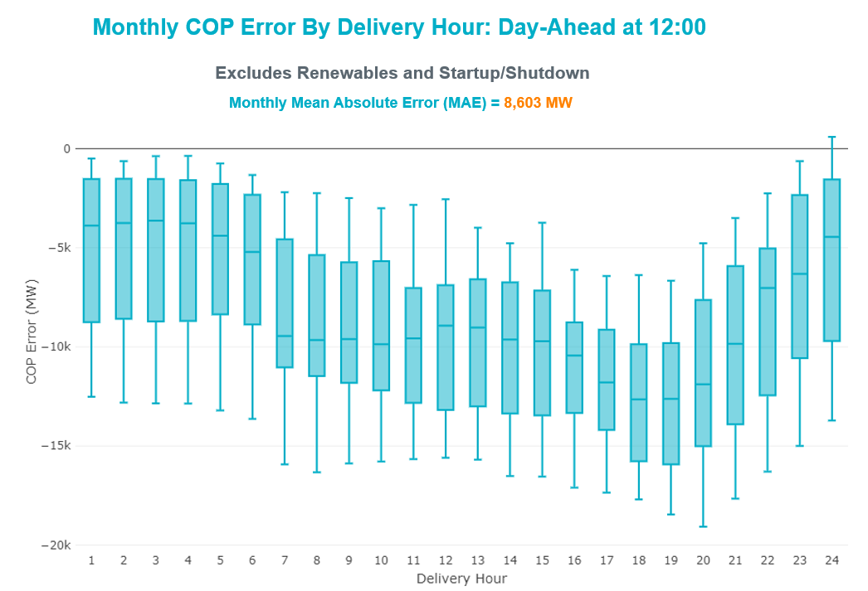

Congestion Analysis

Notable Constraints
Nodal protocol section 3.20 specifies that ERCOT shall identify transmission constraints that are binding in Real-Time three or more Operating Days within a calendar month. As part of this process, ERCOT reports congestion that meets this criterion to ROS. In addition, ERCOT also highlights notable constraints that have an estimated congestion rent exceeding $1,000 for a calendar month. These constraints are detailed in the table below, including approved transmission upgrades from TPIT that may provide some congestion relief based on ERCOT’s engineering judgement. Rows highlighted in blue indicate the congestion was affected by one or more outages. For a list of all constraints activated in SCED, please see Appendix A at the end of this report.

Contingency Name | Overloaded Element | # of Days Constraint Binding | Congestion Rent | Transmission Project
Basecase | WESTEX GTC | 17 | $31,323,862.00
Basecase | PNHNDL GTC | 23 | $18,594,737.30
TWR (345) JN-WAP64 & JN-WAP72 | Bellaire - Smithers 345kV | 12 | $8,854,577.40 | Bellaire to Smithers Ckt.98A Upgrade (64491)
LUTHER Sub - Sharyland Utilities to VEALMOOR - Sharyland Utilities LIN 1 | Big Spring West - Stanton East 138kV | 12 | $7,647,630.50 | Natural Dam 138 kV Switch (52295)
Manual dbl ckt for NEDIN-BONILLA 345kV & RIOH-PRIM138kV | Haine Drive - La Palma 138kV | 10 | $7,001,677.10 | Stewart Road: Construct 345 kV cut-in (5604)
ODEHV-MOSSW 345&ODEHV-WLFSW 345_DBLCKT | Midessa South Sw 345kV | 5 | $6,880,727.97
Manual TWR(345) JOR-KG97 & JOR-NB99 | Bigvue - Lyondell 138kV | 8 | $5,849,090.14
Basecase | NE_LOB GTC | 16 | $5,418,407.60
Fowlerton to LOBO 345 LIN1 | North Laredo Switch - Piloncillo 138kV | 14 | $4,866,537.28
Manual TWR(345) JOR-KG97 & JOR-NB99 | Lychem - Power Systems Arco Cogen 138kV | 6 | $4,814,533.53
TWR(345) JCK-REF27 & JCK-STP18 | Blessing - Pavlov 138kV | 3 | $4,174,899.34
SWESW TO MULBERRY AND SWESW TO LNCRK 345 DBLCKT | Bluff Creek - Abilene Mulberry Creek 345kV | 9 | $3,659,963.19
FORMOSA GEN FORMOSG11 | Formosa - Lolita 138kV | 5 | $2,835,781.36
ODEHV-MOSSW 345&ODEHV-WLFSW 345_DBLCKT | Odessa Ehv Switch 345kV | 2 | $2,664,913.84
PH ROBINSON to MEADOW LIN A | Magnolia Tnp - Seminole Tnp 138kV | 12 | $2,235,671.37 | Rebuild Magnolia - Seminole 138 kV line. (4010)
EASTSIDE to GABLE STREET LIN A | Downtown - Polk 138kV | 3 | $1,945,451.04
EDITHCLA-RILEY 345kV | Long Creek - Abilene Mulberry Creek 345kV | 6 | $1,562,462.60
SAN MIGUEL GEN to FOWLERTON LIN 1 | George West Switching Station - Sigmor 138kV | 2 | $1,509,719.30
ODLAW SWITCHYARD to ASPHALT MINES LIN 1 | Hamilton Road - Maverick 138kV | 12 | $1,454,812.27 | Brackettville to Escondido: Construct 138 kV line (5206)
SAN MIGUEL GEN to FOWLERTON LIN 1 | San Miguel Gen - Choke Canyon Aep 138kV | 3 | $1,202,843.49
COLETO CREEK to PAWNEE SWITCHING STATION LIN 1 | Coleto Creek - Victoria 138kV | 5 | $1,109,274.83
Basecase | VALEXP GTC | 10 | $971,181.66
KING RANCH GAS PLANT to FALFURRIAS LIN 1 | Falfurrias - Premont 69kV | 4 | $859,235.96
Fowlerton to LOBO 345 LIN1 | Asherton - Catarina 138kV | 5 | $706,487.10
Cagnon-Kendal 345 &Cico-Mengcr 138 | Bergheim - Kendall 345kV | 3 | $676,618.50
SWEETWATER EAST SWITCH to Long Creek LIN _A | Long Creek - Abilene Mulberry Creek 345kV | 4 | $607,096.82
SOUTH TEXAS PROJECT to BLESSING LIN 1 | Coleto Creek - Victoria 138kV | 4 | $530,792.74
EDITHCLA-RILEY 345kV | Anson - Radium 69kV | 6 | $441,716.08
POMELO to NORTH EDINBURG LIN 1 | Lobo - Freer 69kV | 4 | $430,049.65
Wht_Rvr-Cottonwood 345kV | Farmland - Wett_Long_Draw 345kV | 3 | $413,726.50
Fowlerton to LOBO 345 LIN1 | Bruni Sub 138kV | 3 | $374,823.80
Grissom to COLETO CREEK LIN 1 | Lon Hill - Callicoatte 138kV | 3 | $354,066.67
ODLAW SWITCHYARD to ASPHALT MINES LIN 1 | Escondido - Ganso 138kV | 4 | $244,926.34 | Escondido to Ganso: Rebuild 138 kV line (55624)
Bighil-Kendal 345kV | Carver - Tinsley Tap 138kV | 3 | $231,374.48
COLETO - GRISSOM (345) & VICTORIA - FANNINS (69) | Pettus - Normanna 69kV | 4 | $166,748.60
BRACKETTVILLE to HAMILTON ROAD LIN 1 | Hamilton Road - Maverick 138kV | 3 | $155,614.82 | Brackettville to Escondido: Construct 138 kV line (5206)
Basecase | BEARKT GTC | 3 | $145,680.64
Basecase | NELRIO GTC | 6 | $130,438.32
BLESSING TRX 1382 345/138 | Sargent Sub - Franklins Camp Sub 69kV | 3 | $103,004.29
Bighil-Kendal 345kV | Hamilton Road - Maxwell 138kV | 5 | $79,050.53 | Hamilton - Maxwell: Line Rebuild (61396)
LAMPASAS to NARUNA LIN 1 | Coronado 138kV | 3 | $64,385.79
COLEMAN LAKE IVIE TAP to EAST COLEMAN TAP LIN 1 | Ballinger - Ballinger Humble Tap 69kV | 3 | $61,382.63
COMANCHE SWITCH (Oncor) to COMANCHE PEAK SES LIN _A | Comanche Tap - Comanche Switch (Oncor) 138kV | 3 | $56,817.34 | Add Blanket South 138 kV Substation (61595)
Basecase | RV_RH GTC | 3 | $46,272.33
COMANCHE SWITCH (Oncor) to COMANCHE PEAK SES LIN _A | Hasse 138kV | 3 | $18,614.64
Fowlerton to LOBO 345 LIN1 | North Laredo Switch - Piloncillo 138kV | 14 | $1,583.59

Generic Transmission Constraint Congestion
There were 20 days of congestion on the West Texas Export GTC, 26 days on the Panhandle GTC, 21 days on the North Edinburg to Lobo GTC, 11 days on the Valley Export GTC, 20 days on the Raymondville to Rio Hondo, 3 days on the Bearkat GTC, 10 days on the Nelson Sharpe to Rio Hondo GTC, 2 days on the North to Houston GTC, and 1 day on the McCamey GTC. There was no activity on the remaining GTCs during the month.

Note: This is how many times a constraint has been activated to avoid exceeding a GTC limit, it does not imply an exceedance of the GTC occurred or that the GTC was binding.

Manual Overrides
None

Congestion Costs for Calendar Year 2021
The following table represents the top twenty active constraints for the calendar year based on the estimated congestion rent attributed to the congestion. ERCOT updates this list on a monthly basis.

Contingency | Overloaded Element | # of 5-min SCED | Estimated | Transmission Project
Basecase | PNHNDL GTC | 26946 | $104,169,801.68
Elmcreek-Sanmigl 345kV | Pawnee Switching Station - Calaveras 345kV | 2558 | $76,324,705.77
Basecase | WESTEX GTC | 14722 | $72,265,697.68
Basecase | NE_LOB GTC | 27827 | $68,923,085.75
Manual dbl ckt for NEDIN-BONILLA 345kV & RIOH-PRIM138kV | Haine Drive - La Palma 138kV | 13682 | $61,202,381.31 | Stewart Road: Construct 345 kV cut-in with two 450 MVA 345/138 autotransformers connected to Stewart Rd 138 station (5604, 6382)
LOST PINES AEN to FAYETTE PLANT 1 LIN 1 | Winchester - Fayette Plant 1 And 2 345kV | 415 | $51,438,867.64
JOHNSON SWITCH (ONCOR) to CONCORD LIN G1 | Decordova Dam - Carmichael Bend Switch 138kV | 726 | $46,614,977.07 | DeCordova 345/138kV_Sw. (7129)
TWR(345) JCK-REF27 & JCK-STP18 | Oasis - Dow Chemical 345kV | 524 | $46,495,190.60 | Freeport - Master Plan (6668B)
Basecase | N_TO_H GTC | 3486 | $39,698,719.75
TWR(345) JCK-REF27 & JCK-STP18 | South Texas Project - Wa Parish 345kV | 1909 | $35,934,198.14 | Freeport - Master Plan (6668)
HCKSW TO DENSW 138 DBLCKT | Rosen Heights Tap 2 - Deen Switch 138kV | 5354 | $32,160,180.36
Hicross-Pilot & Garfield 138kV | Carson Creek - Pilot Knob 138kV | 803 | $30,600,531.85
MIDLAND EAST TRX MDLNE_3_1 345/138 | Tall City - Telephone Road 138kV | 5502 | $28,105,961.70 | Tall City - Telephone Road 138 kV Line Rebuild (57915)
Basecase | Colorado Bend Energy Center - Dyann 138kV | 242 | $26,093,025.30
TWR(345) JCK-REF27 & JCK-STP18 | Blessing - Pavlov 138kV | 5472 | $23,185,130.18 | Blessing to Bay City Pumps: Rebuild 69 kV Line (52066), Freeport - Master Plan (6668)
CRLNW TO LWSSW 345 DBLCKT | West Tnp - Highlands Tnp 138kV | 8701 | $23,171,860.68
CONCORD TRX CRD1 345/138 | Concord 345kV | 840 | $21,139,669.60
Lostpi-Austro&Dunlap 345kV | Sim Gideon - Winchester 138kV | 665 | $20,504,608.91 | Sim Gideon - Tahitian Village Transmission Line Storm Hardening (61438), Bastrop West - Split Transmission Line Storm Hardening (61436)
Lytton_S-Slaughte&Turner 138kV | Mccarty Lane - Zorn 138kV | 245 | $20,185,815.81
SALSW TO KLNSW 345 DBLCKT | Harker Heights South - Killeen Switch 138kV | 6040 | $19,729,313.80

System Events

ERCOT Peak Load
The unofficial ERCOT peak load for the month was 48,966 MW and occurred on the 17th, during hour ending 16:00.

Load Shed Events
None.

Stability Events
None.

Notable PMU Events
ERCOT analyzes PMU data for any significant system disturbances that do not fall into the Frequency Events category reported in section 2.1. The results are summarized in this section once the analysis has been completed.

There were no PMU events outside of those reported in section 2.1.

DC Tie Curtailment
Date | DC Tie | Curtailing Period | # of Tags Curtailed | Initiating Event | Curtailment Reason
11/5/2021 | DC-L | HE 18 – HE 19 | 1 | Unplanned Outage | Planned or Unplanned Outage
11/13/2021 | DC-L | HE 1 – HE 7 | 2 | Unplanned Outage | Planned or Unplanned Outage

TRE/DOE Reportable Events
- BPUB submitted an OE-417 for 11/30/2021. Reportable Event Type: Suspicious activity to its facility.

New/Updated Constraint Management Plans
- MP_2021_08 expired

New/Modified/Removed RAS
None.

New Procedures/Forms/Operating Bulletins

Date | Subject | Bulletin No.
12/01/2021 | Real Time Desk V1 Rev 77 | 1006
12/01/2021 | Reliability Unit Commitment Desk V1 Rev 65 | 1007
12/01/2021 | Resource Desk Operating Procedure V1 Rev 66 | 1008
12/01/2021 | Scripts V1 Rev 38 | 1009
12/01/2021 | Shift Supervisor Desk V1 Rev 74 | 1010
12/01/2021 | Transmission and Security Desk V1 Rev 89 | 1011

Emergency Conditions

OCNs
Date and Time | Message
Nov 10, 2021  07:20 CPT | ERCOT issued an OCN for taking manual actions using PANHANDLE GTC to pre-posture for PANDANLE area outage.
Nov 29, 2021  10:15 CPT | ERCOT issued an OCN due to modifying the PANHANDLE GTC due to current transmission outage topology.

Advisories
Date and Time | Message
Nov 3,2021  19:06 CPT | ERCOT issued an advisory for Geomagnetic Disturbance (GMD) alert of magnitude k-7.
Nov 15, 2021  13:30 CPT | ERCOT has postponed the deadline for the posting of the DAM solution for Operating Day 11/16/2021 due to delay in clearing DAM.

Watches
None.

Emergency Notices
Date and Time | Message
Nov 10,2021  11:15 CPT | ERCOT issued a Transmission Emergency Notice for the TNMP area due to forced outage in the Texas City area.

Application Performance

TSAT/VSAT Performance Issues
None.

Communication Issues
None.

Market System Issues
None.

Model Updates
The Downstream Production Change (DPC) process allows ERCOT to make changes in the on-line Network Operations Model without loading a completely new model. The purpose of this process is to allow for reliable grid operations as system conditions change between designated Network Operations Model database loads. The DPC process is limited in scope to just those items listed below, with equipment ratings updates being the most common. ERCOT has seen a rise in the use of the DPC process to make on-line updates to the Network Operations Model in recent years, instead of through the standard Network Operations Model Change Request process.

- Static Line ratings (Interim Update)
- Dynamic Line ratings (non-Interim Update)
- Autotransformer ratings (non-Interim Update)
- Breaker and Switch Normal status (Interim Update)
- Contingency Definitions (Interim Update)
- RAP and RAS changes or additions (Interim Update)
- Net Dependable and Reactive Capability (NDCRC) values (Interim Update)
- Impedance Updates (non-Interim)

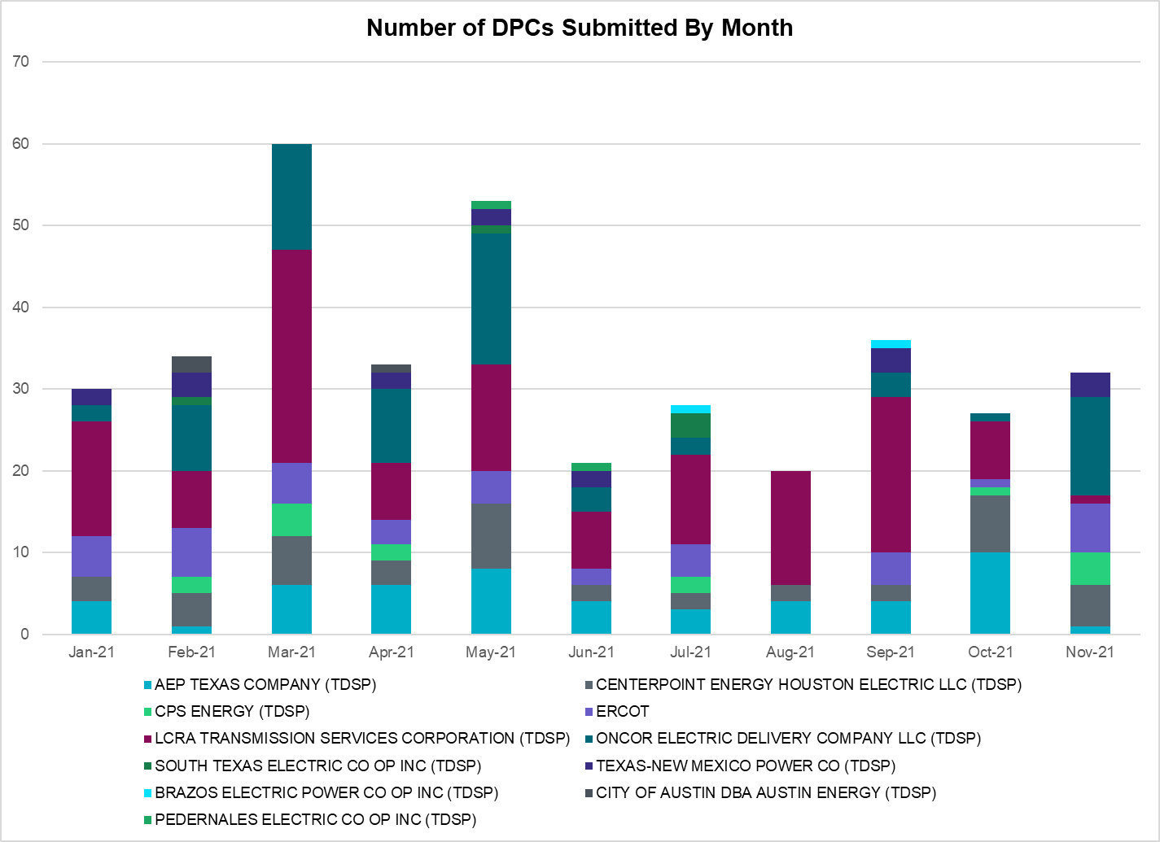

Transmission Operator | Number of DPCs
AEP TEXAS COMPANY (TDSP) | 1
BRAZOS ELECTRIC POWER CO OP INC (TDSP) | 0
BROWNSVILLE PUBLIC UTILITIES BOARD (TDSP) | 0
BRYAN TEXAS UTILITIES (TDSP) | 0
CENTERPOINT ENERGY HOUSTON ELECTRIC LLC (TDSP) | 5
CITY OF AUSTIN DBA AUSTIN ENERGY (TDSP) | 0
CITY OF COLLEGE STATION (TDSP) | 0
CITY OF GARLAND (TDSP) | 0
CPS ENERGY (TDSP) | 4
DENTON MUNICIPAL ELECTRIC (TDSP) | 0
ELECTRIC TRANSMISSION TEXAS LLC (TDSP) | 0
ERCOT | 6
LCRA TRANSMISSION SERVICES CORPORATION (TDSP) | 1
LONE STAR TRANSMISSION LLC (TSP) | 0
ONCOR ELECTRIC DELIVERY COMPANY LLC (TDSP) | 12
PEDERNALES ELECTRIC CO OP INC (TDSP) | 0
RAYBURN COUNTRY CO OP DBA RAYBURN ELECTRIC (TDSP) | 0
SHARYLAND UTILITIES LP (TDSP) | 0
SOUTH TEXAS ELECTRIC CO OP INC (TDSP) | 0
TEXAS MUNICIPAL POWER AGENCY (TDSP) | 0
TEXAS-NEW MEXICO POWER CO (TDSP) | 3

Appendix A: Real-Time Constraints
The following is a complete list of constraints activated in SCED. Full contingency descriptions can be found in the Standard Contingencies List located on the MIS secure site at Grid Generation Reliability Unit Commitment.

Contingency Name | Overloaded Element | From Station | To Station | Count of Days
BASE CASE | PNHNDL | n/a | n/a | 25
BASE CASE | RV_RH | n/a | n/a | 20
BASE CASE | NE_LOB | n/a | n/a | 20
BASE CASE | WESTEX | n/a | n/a | 19
BASE CASE | LGD_SANTIA1_1 | LGD | SANTIAGO | 18
SMDOPHR5 | G138_10B_1 | SEMINOLE | MAGNO_TN | 16
SLOBSA25 | NLARSW_PILONC1_1 | NLARSW | PILONCIL | 14
SLOBSA25 | NLARSW_PILONC1_1 | PILONCIL | NLARSW | 14
S127STA8 | 6620__A | STASW | MRCAP | 14
SBRAUVA8 | HAMILT_MAVERI1_1 | HAMILTON | MAVERICK | 14
MHARNED5 | HAINE__LA_PAL1_1 | LA_PALMA | HAINE_DR | 13
SLUTVEA8 | 6144__A | BSPRW | STASW | 13
DBIGKEN5 | HAMILT_MAXWEL1_1 | MAXWELL | HAMILTON | 13
DWAP_JN5 | BI_SMR98_A | SMITHERS | BI | 12
BASE CASE | VALEXP | n/a | n/a | 11
BASE CASE | NELRIO | n/a | n/a | 10
DSWELNC5 | BLUF_C_MULBER1_1 | BLUF_CRK | MULBERRY | 10
MKG_NB_5 | BCVLY_03_A | BCV | LY | 10
SSPUSLT8 | ROBY_ROTN1_1 | ROTN | ROBY | 9
SSPUSLT8 | ROBY_ROTN1_1 | ROBY | ROTN | 9
SSPUSLT8 | SPUR_69_1 | SPUR | SPUR | 9
SBRAHAM8 | HAMILT_MAVERI1_1 | HAMILTON | MAVERICK | 9
DRILEDI5 | 6025__A | MULBERRY | LNCRK | 8
UFO1FOR1 | FORMOS_LOLITA1_1 | LOLITA | FORMOSA | 8
SBLESTP5 | COLETO_VICTOR2_1 | COLETO | VICTORIA | 8
DRILEDI5 | ANSN_RADIUM1_1 | RADIUM | ANSN | 8
SSWCLNC5 | 6025__A | MULBERRY | LNCRK | 7
SSPUSLT8 | GIRA_T_SPUR1_1 | SPUR | GIRA_TAP | 7
SLOBSA25 | ASHERT_CATARI1_1 | ASHERTON | CATARINA | 7
SSPUSLT8 | GIRA_T_SPUR1_1 | GIRA_TAP | SPUR | 7
MKG_NB_5 | LHMPSA08_A | LHM | PSA | 7
DCAGCI58 | 656T656_1 | KENDAL | BERGHE | 7
DBIGKEN5 | TREADW_YELWJC1_1 | TREADWEL | YELWJCKT | 7
SLOBSA25 | LARDVN_LASCRU1_1 | LARDVNTH | LASCRUCE | 6
SCOLBAL8 | BALLIN_HUMBLT1_1 | BALLINGE | HUMBLTAP | 6
SILLFTL8 | HAMILT_MAXWEL1_1 | MAXWELL | HAMILTON | 6
SCOLPAW5 | COLETO_VICTOR2_1 | COLETO | VICTORIA | 6
DWHICOT5 | FARMLAND_LONGD_1 | FARMLAND | W_LD_345 | 6
DSWETKW5 | 6036__A | TKWSW | MGSES | 5
SODLBRA8 | HAMILT_MAVERI1_1 | HAMILTON | MAVERICK | 5
SCMNCPS5 | HAS_HAS2 | HAS | HAS | 5
SCMNCPS5 | 651__B | CMNSW | CMNTP | 5
DBIGKEN5 | CARVER_TINSLE1_1 | CARVER | TINSLEY | 5
SLOBSA25 | BRUNI_69_1 | BRUNI | BRUNI | 5
UFO2FOR1 | FORMOS_LOLITA1_1 | LOLITA | FORMOSA | 5
SBRAUVA8 | ESCOND_GANSO1_1 | GANSO | ESCONDID | 5
DODEMOS5 | MDSSW_MR1H | MDSSW | MDSSW | 5
MHARNED5 | BURNS_RIOHONDO_1 | RIOHONDO | MV_BURNS | 5
SFORYEL8 | HEXT_MASONS1_1 | HEXT | MASONSW | 4
DSALKLN5 | 630__B | KLNSW | HHSTH | 4
SREAUVA8 | DOWNIES_AX1H | DOWNIES | DOWNIES | 4
SFORYEL8 | HEXT_MASONS1_1 | MASONSW | HEXT | 4
SGRICOL5 | CALLIC_LON_HI1_1 | LON_HILL | CALLICOA | 4
XBLE58 | SAR_FRAN_1 | FRANKC | SARGNTS | 4
SKINFAL8 | FALFUR_PREMON1_1 | FALFUR | PREMONT | 4
DCOLFA59 | NORMAN_PETTUS1_1 | PETTUS | NORMANNA | 4
DKENCA58 | 656T656_1 | KENDAL | BERGHE | 4
DCOLFA59 | NORMAN_PETTUS1_1 | NORMANNA | PETTUS | 4
STALTEL8 | 6144__A | BSPRW | STASW | 4
DSTPRED5 | BLESSI_PAVLOV1_1 | BLESSING | PAVLOV | 4
DGRSLNC5 | ESTES_PECAN_1_1 | PECAN_BY | ESTES | 4
SPOMNED5 | FREER_LOBO1_1 | LOBO | FREER | 4
SDUKNE28 | ADERHO_HEC1_1 | HEC | ADERHOLD | 3
SGSES8 | DT_PK_91_A | DT | PK | 3
SENSEN28 | 940__C | ENWSW | WXHCH | 3
DCOLFA59 | BEEVIL_NORMAN1_1 | BEEVILLE | NORMANNA | 3
DODEMOS5 | ODEHV_MR2H | ODEHV | ODEHV | 3
MSHKESE8 | 940__C | WXHCH | ENWSW | 3
SLAMNAR8 | CORONA_AT4 | CORONA | CORONA | 3
SSANFOW5 | SNMIG_AEPCHKCN_1 | SANMIGL | CHOKCNYN | 3
DMGSQAL5 | 6144__A | BSPRW | STASW | 3
DCAGCO58 | 656T656_1 | KENDAL | BERGHE | 3
MSHKESE8 | 940__C | ENWSW | WXHCH | 3
DSTEXP12 | COLETO_VICTOR2_1 | COLETO | VICTORIA | 3
SFORYEL8 | HEXT_YELWJC1_1 | YELWJCKT | HEXT | 3
SENSEN28 | 940__C | WXHCH | ENWSW | 3
BASE CASE | BEARKT | n/a | n/a | 3
SGAFGRN8 | G138_5_1 | ATTWATER | PHR | 3
SSILRIO8 | SILASRAY_T1 | SILASRAY | SILASRAY | 3
SDUKNE28 | ADERHO_ELSA1_1 | ADERHOLD | ELSA | 3
DLWSRNK5 | 587__A | ARGYL | LWSVH | 3
DAUSLOS5 | 190T152_1 | WINCHES | GIDEON | 2
SCOLBAL8 | SANA_FMR1 | SANA | SANA | 2
DLONWAR5 | NCARBI_SEADRF1_1 | SEADRFTC | NCARBIDE | 2
SASPPAI8 | ROBY_ROTN1_1 | ROBY | ROTN | 2
DBUCKLN5 | 282__A | LHLSW | LCSES | 2
DCLASCO5 | 6437__F | SCRCV | KNAPP | 2
DMTSCOS5 | 6437__F | SCRCV | KNAPP | 2
SLAQLOB8 | BRUNI_69_1 | BRUNI | BRUNI | 2
SCT2CAR8 | HAMILT_MAXWEL1_1 | MAXWELL | HAMILTON | 2
SLOBSA25 | LASCRU_MILO1_1 | LASCRUCE | MILO | 2
DODEMOS5 | ODEHV_MR2L | ODEHV | ODEHV | 2
SMGIENW8 | TRU_UAT1 | TRU | TRU | 2
DMGSBTR5 | 6036__A | TKWSW | MGSES | 2
SSANFOW5 | GEO_SIG_1 | GEOWEST | SIGMOR | 2
XCO2L58 | CALLIC_LON_HI1_1 | LON_HILL | CALLICOA | 2
SSANFOW5 | CATARI_PILONC1_1 | CATARINA | PILONCIL | 2
DCAGCI58 | 398T389_1 | BERGHE | HAYSEN | 2
XSCO258 | 6437__F | SCRCV | KNAPP | 2
MPEBENS8 | 940__C | ENWSW | WXHCH | 2
DCOLFA59 | CALLIC_LON_HI1_1 | LON_HILL | CALLICOA | 2
SSANFOW5 | COTULL_REVEIL1_1 | REVEILLE | COTULLA | 2
SBRAHAM8 | ESCOND_GANSO1_1 | GANSO | ESCONDID | 2
DPHRAL58 | G138_10B_1 | SEMINOLE | MAGNO_TN | 2
SBRAUVA8 | GANSO_MAVERI1_1 | MAVERICK | GANSO | 2
SGRICOL5 | MELONC_SEADRF1_1 | MELONCRE | SEADRFTC | 2
BASE CASE | N_TO_H | n/a | n/a | 2
SGARBAT8 | 15010__B | BLISS | ESTILES | 2
DBUCBWN5 | 282__A | LHLSW | LCSES | 2
SGRABRO8 | 6144__A | BSPRW | STASW | 2
SLOBSA25 | FALFUR_PREMON1_1 | FALFUR | PREMONT | 2
DCOTDMT5 | FARMLAND_LONGD_1 | FARMLAND | W_LD_345 | 2
DMGSMDS5 | MDSSW_MR1L | MDSSW | MDSSW | 2
SASPPAI8 | ROBY_ROTN1_1 | ROTN | ROBY | 2
BASE CASE | HHGTOM_1 | HHGT | OMEGA | 2
SCITNUE8 | MORRIS_NUECES1_1 | NUECES_B | MORRIS | 2
DPHRBUN8 | DT_PK_91_A | DT | PK | 2
DKENCA58 | 255T279_1 | PIPECR | MEDILA | 1
SJONCPS5 | 6020__D | EVRSW | CRTLD | 1
DSALHUT5 | 630__B | KLNSW | HHSTH | 1
MENSENW8 | 941__C | ENWSW | ENSSO | 1
SDUKNED8 | ADERHO_ELSA1_1 | ADERHOLD | ELSA | 1
SCO2EUL8 | BEEVIL_NORMAN1_1 | BEEVILLE | NORMANNA | 1
SILLFTL8 | CARVER_TINSLE1_1 | CARVER | TINSLEY | 1
SLAQLOB8 | FALFUR_PREMON1_1 | FALFUR | PREMONT | 1
DLONWAR5 | NORMAN_PETTUS1_1 | PETTUS | NORMANNA | 1
XTEL458 | 6144__A | BSPRW | STASW | 1
DCDHVEN5 | 6410__D | HLSES | LKWOD | 1
DWHILON5 | BLESSI_PALACI1_1 | BLESSING | PALACIOS | 1
SN_SLON5 | CELANE_N_SHAR1_1 | N_SHARPE | CELANEBI | 1
MHARRIO5 | HAINE__LA_PAL1_1 | LA_PALMA | HAINE_DR | 1
DBIGKEN5 | HAMILT_MAVERI1_1 | HAMILTON | MAVERICK | 1
SCOLPAW5 | MAGRUD_THOMAS1_1 | MAGRUDER | THOMASTN | 1
BASE CASE | MCCAMY | n/a | n/a | 1
SSPRVAL8 | SNT_ST__1 | SJO | SNTJO | 1
SMOOPEA8 | UVALDE_W_BATE1_1 | W_BATESV | UVALDE | 1
DBUCBWN5 | 281__A | THSES | LHLSW | 1
DMGSQAL5 | 6095__D | LMESA | JPPOI | 1
DGRSLNC5 | 6380__D | PAINTCRE | MURRAY | 1
SBTECH25 | BTE_AT-2 | BTE | BTE | 1
SBWDDBM5 | LPLMK_LPLNE_1 | LPLMK | LPLNE | 1
DCOLFA59 | NCARBI_SEADRF1_1 | SEADRFTC | NCARBIDE | 1
SCRTCDH5 | 6410__D | HLSES | LKWOD | 1
XBOM58 | 6558__B | FSHSW | WFALS | 1
SSANFOW5 | ASHERT_CATARI1_1 | ASHERTON | CATARINA | 1
SGRILON5 | CALLIC_LON_HI1_1 | LON_HILL | CALLICOA | 1
DDUKCLO8 | DUKE_HEC3_1 | DUKE | HEC | 1
DABPAB98 | GRIFFI_HUB1_T1_1 | GRIFFIN | HUB1_TAP | 1
BASE CASE | I_DUPP_I_DUPS1_1 | I_DUPP1 | I_DUPSW | 1
DCMBJON5 | 6020__D | EVRSW | CRTLD | 1
DMGSBIT5 | 6036__A | TKWSW | MGSES | 1
DSCOTKW5 | 6437__F | SCRCV | KNAPP | 1
MCHBJO25 | CBY_AT3 | CBY | CBY | 1
DWHIGIB8 | RINCON_WHITE_2_1 | WHITE_PT | RINCON | 1
DBEEPAL8 | 415T415_1 | MILLER | HENLY | 1
SVEAW_L5 | 6144__A | BSPRW | STASW | 1
SGRICOL5 | BEEVIL_NORMAN1_1 | BEEVILLE | NORMANNA | 1
DWAP_JN5 | BI_WAP50_A | WAP | BI | 1
SEBALAM8 | CORONA_AT4 | CORONA | CORONA | 1
DSTPRED5 | HLJSTP64_A | STP | HLJ | 1
DCAGCI58 | 255T279_1 | PIPECR | MEDILA | 1
SHAYZOR5 | 388T388_1 | HAYSEN | ZORN | 1
DBUCBWN5 | 505__A | SAMSW | THSES | 1
XBOM358 | 6558__B | FSHSW | WFALS | 1
XHOL89 | 6850__B | NVKSW | ARCTY | 1
SAMOGR38 | G69_FA_1 | HEIGHTTN | CHOCTAP | 1
SCOLPAW5 | MAGRUD_VICTOR2_1 | VICTORIA | MAGRUDER | 1
DLONWAR5 | BEEVIL_NORMAN1_1 | BEEVILLE | NORMANNA | 1
DSTPANS5 | BLESSI_LOLITA1_1 | BLESSING | LOLITA | 1
SODLBRA8 | ESCOND_GANSO1_1 | GANSO | ESCONDID | 1
BASE CASE | MAXWEL_WHITIN1_1 | MAXWELL | WHITING | 1
DCOLFA59 | VICTO_WARBU_1A_1 | VICTORIA | WARBURTN | 1

Current Wind Generation Record: 23,702 MW on 11/16/2021 at 18:36 | Current Wind Penetration Record: 66.47% on 03/22/2021 at 00:46 Current Solar Generation Record: 7,077 MW on 10/16/2021 at 15:29 | Current Solar Penetration Record: 19.01% on 10/30/2021 at 10:29
This is the hourly integrated peak demand as published in the ERCOT D&E report.
All DC Tie Curtailments are posted publicly on the ERCOT Market Information System. See that posting for additional details for the event(s) in question.
See DC Tie Operating Procedure (http://www.ercot.com/mktrules/guides/procedures) for more details.

