

System Planning

**Monthly Status Report**

Report Highlights

* ERCOT is currently reviewing proposed transmission improvements with a total estimated cost of $585.48 million as of August 31, 2023.
* Transmission Projects endorsed in 2023 total $1.589 billion as of August 31, 2023.
* All projects (in engineering, routing, licensing, and construction) total approximately $12.469 billion[1] as of May 12, 2023.
* Transmission Projects energized in 2023 total approximately $442 million[2] (as of May 12, 2023).

Regional Planning Group Reviews

RPG Projects under Review:

* CPS has submitted the San Antonio South Reliability Project (RPG Project ID: 22RPG048). This is a Tier 1 project that is estimated to cost $281.00 million. ERCOT has completed the independent review on June 23, and the recommended project is estimated to cost $329.10 million. TAC voted unanimously to endorse the project on July 25. The ERCOT Board of Directors endorsed the project on August 31, 2023, and ERCOT will issue the ERCOT endorsement letter.
* TNMP has submitted the Silverleaf and Cowpen 345/138-kV Stations Project (RPG Project ID: 23RPG013). This is a Tier 1 project that is estimated to cost $299.00 million. This project is currently under ERCOT’s independent review.
* Oncor has submitted the Tributary Switch to Vincent Rebuild Project (RPG Project ID: 23RPG016). This is a Tier 3 project that is estimated to cost $29.30 million. The RPG review of this project was completed on July 25, and ERCOT has issued an acceptance letter.
* Oncor has submitted the Arlington Reliability Enhancement Project (RPG Project ID: 23RPG018). This is a Tier 2 project that is estimated to cost $72.00 million. This project is currently under ERCOT’s independent review.
* Oncor has submitted the Stanton Loop South Dynamic Reactive Power Project (RPG Project ID: 23RPG019). This is a Tier 3 project that is estimated to cost $96.90 million. The RPG review of this project was completed on August 25, and ERCOT will issue an acceptance letter.
* Oncor has submitted the Hackberry Switch to DFW D East 2 138-kV Double-Circuit Line Section Project (RPG Project ID: 23RPG020). This is a Tier 3 project that is estimated to cost $80.00 million. The RPG review of this project was completed on August 30, and ERCOT will issue an acceptance letter.
* CNP has submitted the West Columbia to Big Creek ckt 89 Reconductor Project (RPG Project ID: 23RPG021). This is a Tier 3 project that is estimated to cost $64.17 million. This project is currently in the RPG comment period.
* Oncor has submitted the McLennan County Transmission Project (RPG Project ID: 23RPG022). This is a Tier 3 project that is estimated to cost $42.31 million. This project is currently in the RPG comment period.
* TNMP has submitted the Pecos County Transmission Improvement Project (RPG Project ID: 23RPG023). This is a Tier 1 project that is estimated to cost $108.00 million. This project is currently in the RPG comment period.

RPG Project Reviews Completed in 2023:

|  |  |  |  |  |  |
| --- | --- | --- | --- | --- | --- |
| RPG Project ID | RPG Project Name | Submitted Entity | Tier | Estimated Cost  ($ Millions) | Review Completion Month |
| 22RPG043 | Haskell to Munday 69 kV Line Rebuild Project | AEPSC | Reclassified from Tier 3 to Tier 4 per Protocol | 31.00 | January |
| 22RPG044 | Escondido to Hamilton Road 138 kV Line Rebuild Project | AEPSC | Reclassified from Tier 3 to Tier 4 per Protocol | 73.50 | January |
| 22RPG045 | Yucca to Moss 138 kV Line Project | Oncor | Reclassified from Tier 3 to Tier 4 per Protocol | 60.70 | January |
| 22RPG046 | Peppervine to Temple 69 kV Line Conversion Project | Oncor | Reclassified from Tier 3 to Tier 4 per Protocol | 36.00 | January |
| 22RPG026 | Wimberley Loop Project | PEC | Tier 2 | 61.93 | February |
| 23RPG001 | Bessel to Falfurrias 138 kV Line Rebuild Project | AEPSC | Reclassified from Tier 3 to Tier 4 per Protocol | 84.76 | February |
| 23RPG002 | Hamlin to Roby 69 kV Line Rebuild Project | AEPSC | Reclassified from Tier 3 to Tier 4 per Protocol | 33.00 | February |
| 23RPG003 | Eagle Ford Large Load Interconnection Project | GVEC | Tier 3 | 35.15 | March |
| 23RPG004 | Lockhart to Luling 69-kV Transmission Line Overhaul Project | LCRA TSC | Reclassified from Tier 3 to Tier 4 per Protocol | 33.50 | March |
| 23RPG005 | La Palma to Stewart Road Rebuild and Conversion to 138-kV Project | AEPSC | Reclassified from Tier 3 to Tier 4 per Protocol | 71.50 | March |
| 23RPG006 | North Lake 138 kV Switch Rebuild | Oncor | Reclassified from Tier 3 to Tier 4 per Protocol | 34.11 | March |
| 22RPG047 | Peck to Driver 138 kV Line Project | Oncor | Tier 2 | 36.20 | May |
| 23RPG007 | Asherton to Uvalde 138-kV Conversion Project | AEPSC | Tier 3 | 56.00 | May |
| 23RPG008 | Fort Stockton Plant to Lynx 138-kV Line Rebuild Project | AEPSC | Reclassified from Tier 3 to Tier 4 per Protocol | 44.90 | May |
| 23RPG009 | Spraberry to Polecat 138-kV Line Rebuild Project | Oncor | Tier 3 | 56.90 | May |
| 23RPG010 | Big Spring West to Stanton East 138-kV Line Rebuild Project | Oncor | Tier 3 | 52.00 | May |
| 23RPG011 | Morgan Creek to McDonald Road 138-kV Line Project | Oncor | Tier 3 | 40.20 | May |
| 23RPG012 | Stone Lake Area Upgrades Project | CNP | Tier 3 | 74.38 | May |
| 23RPG014 | Lamesa to Jim Payne POI to Paul Davis Tap 138-kV Line Rebuild Project | Oncor | Tier 3 | 36.80 | June |
| 23RPG015 | Cuero Substation Upgrade Project | LCRA TSC | Reclassified from Tier 3 to Tier 4 per Protocol | 25.90 | June |
| 23RPG016 | Tributary Switch – Vincent Rebuild Project | Oncor | Tier 3 | 29.30 | July |
| 23RPG017 | Watermill 345/138-kV Switch Project | Oncor | Tier 3 | 74.90 | July |
| 22RPG048 | San Antonio South Reliability Project | CPS | Tier 1 | 329.10 | August |
| 23RPG019 | Stanton Loop South Dynamic Reactive Power Project | Oncor | Tier 3 | 96.90 | August |
| 23RPG020 | Hackberry Switch to DFW D East 2 138-kV Double-Circuit Line Section Project | Oncor | Tier 3 | 80.00 | August |

More information on current and past RPG projects can be found on the ERCOT MIS Secure (digital certificate required): https://mis.ercot.com/secure/data-products/grid/regional-planning

Past email communication on RPG projects can be found on the ERCOT listserv by signing up for the REGPLANGROUP list: <http://lists.ercot.com/scripts/wa-ERCOT.exe?A0=REGPLANGROUP>

Planning Model Activities

The short-term calendar of major planning model events is as follows:

* By October 15, 2023 23SSWG_U1 cases and TPIT will be posted
* By November 10, 2023 23SSWG_U1 Contingency set & Planning Data Dictionary will be posted

The following table shows interconnection projects that met Planning Guide section 6.9(1) and 6.9(2) and were modeled in the SSWG cases as a full model or as a simple model in accordance with Planning Guide section 6.9.



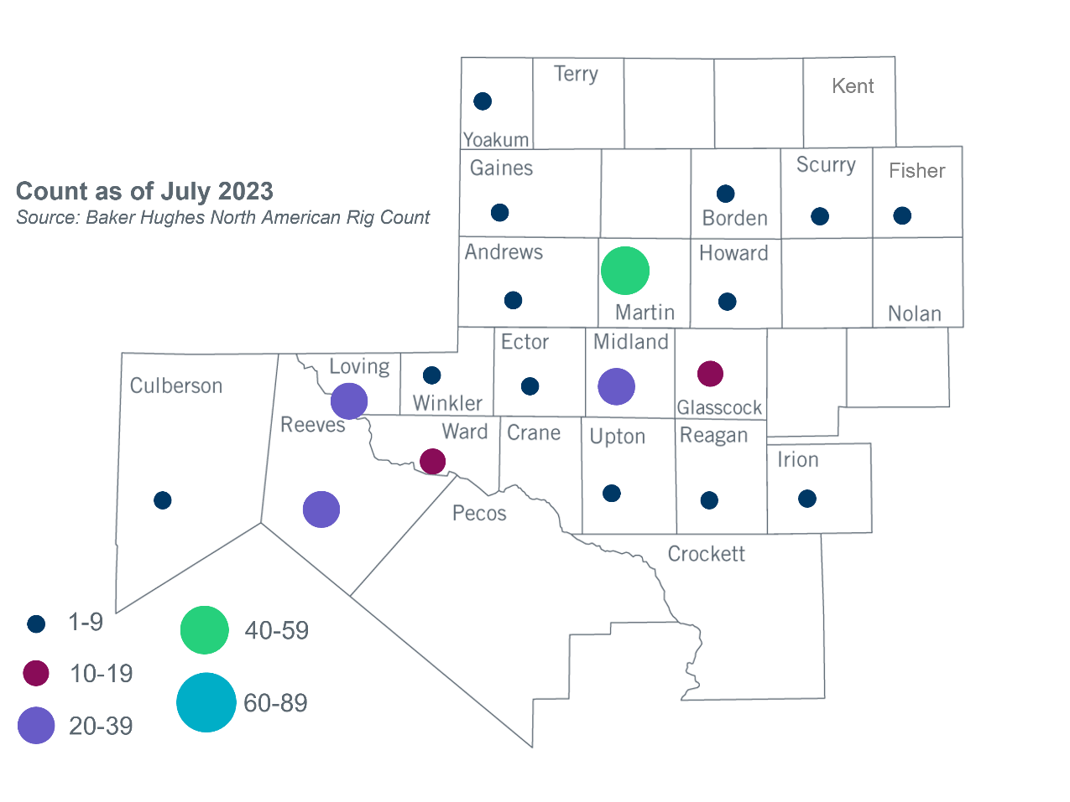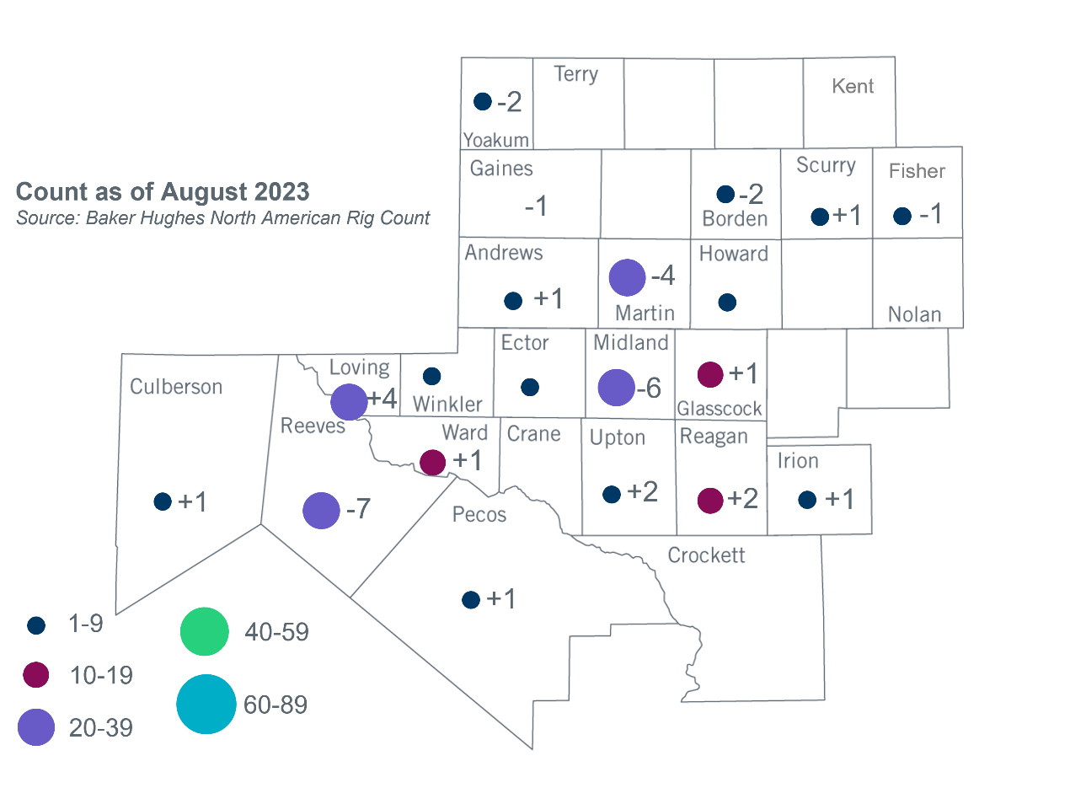Permian Basin Oil Rig Count[3]Other Notable Activities

None

1. Based on the Total Project Estimated Cost for all future projects listed in the Transmission Project Information and Tracking (TPIT) report. TPIT is updated three times each year based on information TSPs provide in Model on Demand (MOD) as specified in the ERCOT Steady State Working Group Procedure Manual. The latest TPIT is available at https://www.ercot.com/gridinfo/planning.
2. Based on the Total Project Estimated Cost for all completed projects with Projected In-Service Dates in 2023 listed in the TPIT.
3. +/- symbol indicates the increase or decrease from the previous month in oil rigs present in each county. There are 210 rigs, including a decrease of 12 oil rigs, in the Permian Basin from July to August 2023.