IBRWG Meeting Minutes
Development of the list of issues related to NOGRR245 implementation, priority poll
- Julia reviewed initial list with IBRWG asking for any additional topics, including:
  - RoCoF Measurement
  - Multiple Ride Through Capability and Verification
  - Phase Jump Ride Through Capability and Verification
  - POI verification for sites with multiple technologies, like solar and storage – multiple OEMs
- Julia will post a survey for members to submit topics and IBRWG will vote on priority next meeting
- Slido.com ; Code: IBRWG
Eri Goff proposed one additional on hybrid plants (e.g. Solar + storage), details may not be as clear in IEEE2800 compared to individual IBR types.
IEEE2800.2 Update, Design Evaluation Sub-Group, focus on Phase Jump and RoCoF
Andy Hoke (NREL, IEEE P2800.2 Chair) presented.
- Review of IEEE2800 conformity assessment process
- Phase angle jump ride through (IEEE2800 requirement, potential IBR conformity assessment)
- RoCoF ride through (IEEE2800 requirement, potential IBR conformity assessment)
- Consecutive voltage excursion ride through (IEEE2800 requirement, potential IBR conformity assessment)
- Are IBR vendors ready to comply with IEEE2800?
Almost all IEEE 2800 apply at the point of measurement (POM) by default, see figure below:
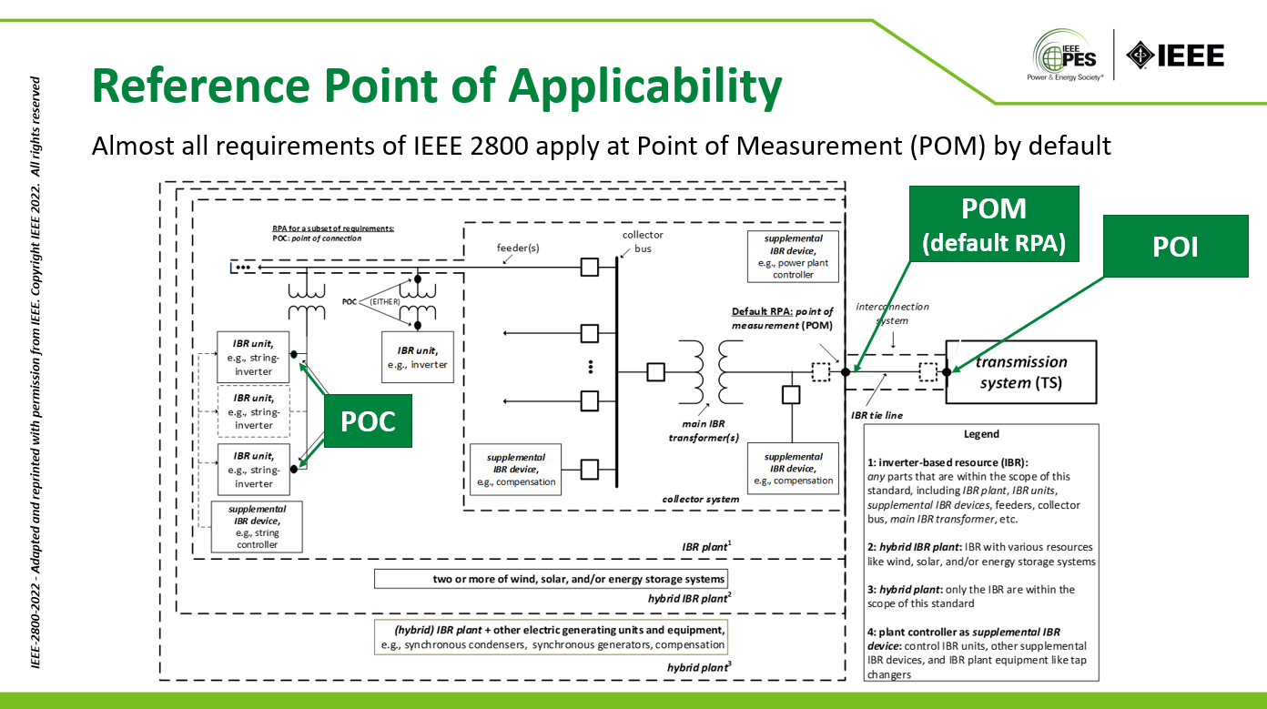
IEEE P2800.2 scope includes:
- Type tests
  - Unit level, not full compliance with 2800
  - Test results are used to validate unit level model
- Design evaluation using verified plant model
  - Includes procedures to validate unit level model
- As-built evaluation and commissioning tests
- Post-commissioning model validation, monitoring, periodic tests & verifications
- Recommended Practice: uses “should” language, not “shall” language
- In recognition that prescribing uniform procedures across all IBR types and interconnecting locations would be very challenging.
Type test will not have pass / fail criteria, just test results. The test results will also be used to validate unit-level models. Type test model is used to build a plant model.
Then in the Design Evaluation phase you only some of the capabilities are verified because not all of them are included in the IBR plant model. For example, MRT is not included in the EMT model so therefore this capability can only be partially validated. IEEE2800.2 is not going to answer all the questions.
Slides on equipment certification – self certification for unit level compliance doesn’t make much sense because this is plant performance standard not unit level. As mentioned earlier, type tests in IEEE2800.2 will not have pass/fail criteria. Even self-certification of equipment (inverters/WTGs) is not possible because compliance is determined at plant level. Inverters/WTG could potentially be IEEE2800 compatible, meaning that IEEE2800 been taken into consideration in equipment design. This is different to IEEE1547 paradigm, where pass/fail type tests and NRTL certification play a large role in conformity assessment.
Adoption of IEEE 2800 is not contingent upon publication/adoption of IEEE P2800.2. In the absence of IEEE P2800.2, IBR owners, TS owners/operators, OEMs, etc. could develop their own assessment procedures or use existing procedures. For systems experiencing IBR ride-through events/problems, some requirements may be higher priority than others (ride through of low voltage, TOV, ROCOF, phase jump).
Phase jump discussion
Phase jump ride through requirement - IBR plant shall ride through positive sequence phase angle changes ≤25° within a sub-cycle to cycle timeframe (may be cause by fault occurrence or clearance, line switching, load rejection). Slower phase over many cycles is not what this requirement is about.
An inverter doesn’t actually “measure” a phase jump. Think of this as a design criterion for synchronization mechanism/PLL.
Stephen (ERCOT) is asking with PMU having resolution of one sample per cycle, how can ERCOT say if an IBR complied or not with phase jump ride through requirement. For example, if the plant owner is saying the phase angle jump was more than 25 degrees, how can ERCOT say if it was or if it wasn’t?
Andy responds that it’s a good question and points towards challenges with these requirements. Measuring phase angle change over such a short period of time is very challenging. Different equipment may do it differently. The easy part of the answer is the change is observed over one cycle. Note, that phase jump is a calculated quantity that cannot be measured. IEEE2800.2 is not going to answer this. Also as a manufacturer, you would try to build in some margin for error.
Miguel (Vestas) has a question and concern with regard to the phase jump and requirement definition. The voltage propagation from POI to IBR unit terminals depends on many factors. Is the intent that 25 deg is at the inverter or at the IBR plant. Andy says the requirement is at the POI. Miguel says if we don’t have a common understanding of how to measure the angle how do we define the test to measure this capability?
Andrew Isaacs (Electranix): We can apply 25 deg phase angle step in the simulation to determine conformity. If you need to verify can go to the fault recorder traces of individual oscillography and calculate what the phase angle was, but the phase angle is not measured. Andy adds that for the phase angle ride through the capability will be present in the model so from the simulation you can get pretty good idea of the expected ride through performance.
Sometimes it’s easier to see from one phase than another, you can measure time between the peaks of the waveform, e.g. time between A-B vs time from B-C (assuming in the figure below (red sketch) that the phase jump happened during B-C time).
Miguel says but it’s hard to do this way when the fault happens or when you are clearing the fault. Andrew response that his impression of the IEEE2800 phase jump requirement applies to the conditions when there’s a phase jump due to load step or line switching. And 25 deg was based on the discussion of what they have seen on their systems during line switching or fault rejection type of events. The phase jump during the fault and after fault clearing can be fairly high and would be covered under fault ride through capability requirement?
Nath Venkit (GE) comments in the chat that footnote 116 in IEEE2800 clarifies that the phase jump is from line switching, load rejection etc.
Harmeet Narang (GE) comments that of all the validation options on Andy’s slide (pasted below) there is really just one (option 4) so it’s very hard to verify. Andy says it is hard to verify in the field but large IBR plants should have digital fault recorders and be able to verify.
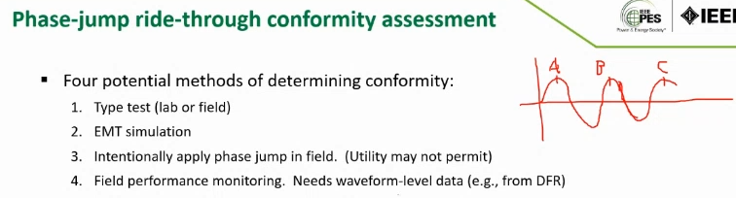
Harmeet says there is no way from OEM to proactively certify compliance with the requirement without field tests. Andrew asks why can’t show conformity on type test that validates the IBR unit model and then simulate phase jump on IBR plant model that was built based on IBR unit model in EMT. Why doesn’t that show you compliance. Harmeet says it does but the slide shows there are four ways to do it when in fact there is just one way. Miguel says type test will give you confidence in the IBR unit capability and EMT simulation will help you verify IBR plant capability with the simulation. Andy clarifies that these 4 methods were not meant to be used individually. So, the combination of 1 and 2 is probably the best you got before the event happens in the field. Harmeet reiterates that type testing for these new requirements takes time.
Stephen reiterates that in the absence of detailed 25 deg phase jump requirement the expectation from ERCOT is that an IBR plant stay synchronized through the disturbances. The way ERCOT looks at this is that this now allows a threshold, where if you previously haven’t tested for this now you have a chance assess it and take it into account in your overall design. Stephen asking a question to Harmeet, is the type testing a new process or is it an existing process for any product that you have? Harmeet says it’s an existing process for the areas where they had type test requirements historically. Says type tests are not required in the U.S.
Andrew adds, that IEEE2800 is not clear on and it needs to be further clarified in ERCOT’s protocols as they apply the standard is if the phase jump of 25 deg applies at fault or not and during faults there is not discussion of the phase jump you just need to ride through low voltage and phase jump considerations do not apply there. Much higher fault jump could be experienced during faults. Manish confirms, the second paragraph on Andy’s slide says “IBR plant shall remain in operation for any change in the phase angle of individual phases cause by occurrence and clearance of unbalanced faults, provided that the positive sequency angle changes does not exceed” 25 deg. If you have a line-to-line fault two phases are going to shift by 60 deg. The drafting team didn’t want anyone to say that because there was a line to line fault an IBR is allowed to trip. So they clarified that POSITIVE SEQUENCE voltage won’t shift the angle by more than 25 degrees. This requirement is about 3 phases shifting almost instantaneously by 25 deg. Nothing here is about going into and coming out of the fault.
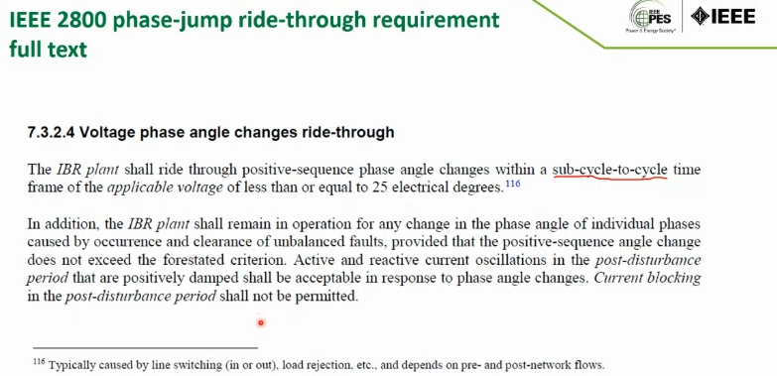

Stephen reiterates what he understood from Manish, it’s really both for switching load rejection and also for positive sequence angle during faults and after fault clearing? Mansh says no it’s only for first, see footnote 116. The intent of this paragraph is to say not to count faults for this 25 degree angle change requirement. Also the requirement is for sub-cycle to a cycle, so if you are looking at the angle difference between pre-fault and post-fault will span longer time and so, again this requirement will not apply then. This requirement is for a voltage phase angle shift in all three healthy phases (less than 25 deg) because of switching of transmission elements or e.g. reclosing after a fault has been cleared. It’s not about coming in and out of a fault, specially unbalanced.
John Schmall makes comment in the chat that “typically” in footnote 116 is not very clear in terms of an enforceable requirement.
Stephen: so does it mean a resource should ride through any phase angle change going into and out of the fault as long as positive sequence angle changes does not exceed 25 degrees? Andrew says this requirement only applies to line switching. Manish, the intent of second paragraph was to convey the point don’t count phase angle jump going into a fault and coming out of the fault for that 25 deg requirement. Andy adds in the fault events just focus on low voltage criteria and not phase jump.
Stephen: for typical line switching or load rejection I need the right triggers for DFR and then for faults if I have PLL loss of sync or some failure codes that comes in how do I enforce this requirement if they are tripping and the don’t know why. Seems like you are saying that for VRT within the curves you just need to ride through no matter the phase angle. Andrew says – yes.
Stephen is asking how does the OEM verify this? Andy clarifies these are two tests one for 25 phase jump and one for VRT. Manish adds IEEE2800.2 SG2 (Type Testing) has already written a procedure to test 25 phase jump but jumping all 3 phases (healthy voltages) to test.
Manish confirms that not having a DFR trigger for phase jump remains the challenge for verification in operations during actual events.
RoCoF ride through discussion
The overall approach is similar to the phase jump ride through. The requirement is that any rate of change of frequency that persists for more than a 100 ms need to ride through if the RoCoF is Events RoCoF <= 5Hz/s. It doesn’t mean trip at 5 Hz/s! It means design your equipment to ride through RoCoF of at least 5 Hz/s.
Challenging to measure RoCoF, there are different methods. Challenging to test for large equipment. Similar to phase jump, via type testing and injecting fictitious frequency or via programmable power supply to modulate real frequency (more accurate but not viable for larger IBRs). + EM simulation at plant level, but expected performance is similar to type tests. What are the challenges with RoCoF?
Stephen in event analysis when we are trying to assess if we crossed the threshold where we would expect trips? How you calculate it matters. It says average RoCoF over an averaging window of “as least” 0.1 seconds (what if it’s more). Higher is possible “upon mutual agreement”. The question ERCOT have do we need higher RoCoF? Depending on methods that we use it can be higher. Took PMU data 3 samples = 0.1 second, took 3 sample delta and had a running average and it resulted in conversation internally about “at least 0.1 second”. What is OEM using to measure, shouldn’t we have same criteria? Is there a standard way to measure it and align it with what the system is seeing in this measurement intervals and decide what requirement ERCOT should have.
Andy says OEM not necessarily measures RoCoF unless they are asked to respond to RoCoF. Otherwise, similarly to phase jump consideration, it’s just a design criterion to may sure PLL can synchronize and function properly. It’s definitely not the intent to trip on certain RoCoF, hopefully OEMs understand that.
Miguel will talk about that in his presentation, says Vestas doesn’t have any RoCoF protection, it translates to PLL being able to synchronize and either tripping or riding through. Need to make a distinction from equipment providing Ancillary Services (AS) and not providing AS and he hasen’t seen it in IEEE2800. The restriction there may come not from inverter at all. Says there may be a condition within a turbine providing AS that might create trip situations. – will talk more about it in his presentation.
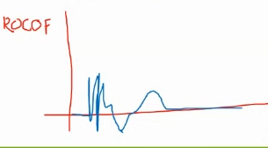
Andrew says they done some work in Hawaii where it is extremely sensitive to frequency, and tried to understand what their needs from the system perspective are. Frequency is not a smooth straight line there. A single sample of RoCoF may end up being very high, frequency doesn’t exist in instantaneous timeframe.
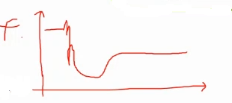
The faster you measure frequency the higher RoCoF you get the less useful it becomes. 5 Hz/s is already very high. It’s hard to apply this standard in reality. You can test in EMT model exactly 5 Hz/s and this is exactly what happens in the model. But in the field, it becomes fast, so not sure how you verify. Miguel says even in that case you can get false positive if turbine is providing AS, because AS provision is usually not a part of EMT models. Andrew agrees, says there is still no good tests for RoCoF in IEEE2800.2
John Schmall (ERCOT), what exactly is RoCoF? In synchronous machine it translates to change of speed in rotating mass and you don’t see these spikes of frequency as you see around particular IBR locations. Is this RoCoF in IEEE2800 is intended to be related to system frequency or on individuial bus.
Stephen says the easier solution where there is a lack of clarity, make is as resilient as possible. Same issue as with phase jump how to avoid ambiguity between GO and ISO during the event. If ERCOT says you need to mitigate it before you are coming back on, how does ERCOT verify? What if the generator calculated higher RoCoF than what ERCOT is saying? This becomes a difficult to enforce performance requirement. This is a design requirement that is very difficult to enforce because there is not consistency about how it is measured and assessed. Andy says may be one way to be resilient is to require higher (than 5Hz/s) RoCoF upfront? Stephen says that based on how they calculate RoCoF there is 1-2 places on the system where it goes higher if they use the calculation methods that he spoke earlier about.
Manish mentioned in the chat that there is an IEC TS 62786-41: 2023

Consecutive ride through discussion
Andy has a list of exemptions on the slide
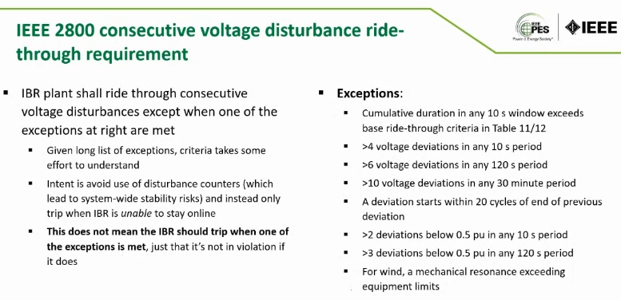
Need to ride through everything apart from these exceptions. The concern came from other systems like Australia where we don’t want IBRs to all trip at the same time after multiple ride through instances. Consecutive voltage disturbance ride-through requirements (MRT) is not captured in EMT models. Andy showed a draft type testing proposal from IEEE2800.2, there are infinitely many of possibilities so there’ll be just a subset recommended in IEEE2800.2 and then you use a validated model to run broader range of disturbances.
Stephen comments for transmission companies on the phone. It would be helpful information to identify in our region what are expected MRT events, e.g. in case of faults, cleared unsuccessfully what is the normal/expected process and number of reclosures before it is opened permanently?
Manish comments that this is still work in progress and we’ll learn more in time. The intent here was twofold: one is that transmission uses automatic reclosing so that the temporary faults and outages could be restored very quickly. The second one was that we learned that some OEMs are using a counter but hopefully no one does this anymore.
Andrew says the problem is that the issue faced by OEMs with MRT, is that it can be related to thermal energy management inside the crowbar. Another issue is that in EMT studies normally consecutive events over prolonged timeframes are not simulated, at most its just 1-2 fault/reclose event in a window of one dynamic study. Andrew points out that in IEEE2800 we take a VRT curve and call it a cumulative curve, if you exceed that cumulative duration, allowed to trip. You are not requirement to do UVRT many times just one time for the duration of the requirement. Apart from exceptions listed on Andy’s slide. A lot of OEMs are involved in this discussion, so not sure we are we standing with that. Miguel said he’ll talk about that in his presentation. Andy points out that the first exception on his slide is very important (the one that pointing towards cumulative nature of the requirement).
Stephen says that part of the concern is retroactive application of this requirement. With OEM’s feedback there is now better understanding about thermal constraints on WGRs. It’s good to understand that there are some exceptions here for meeting this requirement.
Andy concludes his presentation saying there are some technical details as we just discussed (around RoCoF, phase jump, etc.) where 2800.2 will not provide all details and erase uncertainties. People are still researching better ways to assess conformity with some of these more challenging requirements. It will take flexibility on both sides. But it is very important that we at least get basic requirements out there to prevent more tripping events from happening. While it remains difficult to verify and measure the performance for enforcing them, it is important that these considerations are factored into plant design.
Stephen reiterates the question if 2800 adoption is contingent upon 2800.2 implementation. Andy confirms that we shouldn’t wait. 2800.2 is not going to answer all the questions and these concerns are not going to be erased with IEEE2800.2. And 2800.2 is not a standard it’s recommended practice.
Stephen continues that while it is clear from that some requirements are hard to enforce ERCOT. But ERCOT wants to make sure that these parameters are factored into design of the equipment and IBR plants. ERCOT wants routine events for generators to be able to ride through. Their modeling and reliability studies are based on that expectation.
Andy discusses retroactive application and if there’s a way to find the middle ground because there are too many inverters out there that may trip, maybe there are ways to find a compromise with resources where it’s easier to implement. But overall IEEE2800 was not designed to apply retroactively.
Stephen comments we need to understand what’s possible. ERCOT wants GRs to maximize their capabilities and maximize what’s feasible because we can potentially have events that will be catastrophic. Still the question remains on how ERCOT can define performance requirements when there is so much complexity around what can me measured. ERCOT wants to get to solution that balances the performance that meets system needs and on the other hand isn’t unreasonable or infeasible in their application.
Erik Goff (on behalf on NextEra) makes a comment: I understand the point around the difficulty around these issues even with IEEE2800.2 being published. OEMs made point to NERC (in their survey) that they are waiting for IEEE2800.2.
Andy wonders if this perspective from OEM is changing now that OEMs are realizing that 2800 is plant requirement not equipment requirement, it cannot be directly translated to equipment performance. It’s in their interest to update their equipment without waiting on 2800.2. While we focused a lot on the difficult cases today that are hard to measure and proof performance but there are simpler events where it will be clear that IEEE2800 says should be ridden through. Andy also adds that in recent NERC events it’s clear that 2800 performance capability would help them ride through these routine events.
Andrew adds on how people can collaborate to make this standard useful. There is a lot of low hanging fruit. You don’t have to say all of this you have to comply with. Go for simpler requirements that you know how to do/test. Work on the more challenging ones internally within ERCOT to iron out until there is more clarity.

Technical implementation of Phase Jump, RoCoF withstand, and MRT
Miguel A Cova Acosta (Vestas) presented
Multiple Fault Ride Through
Challenges are not the same depending on the OEM and technology.
Type 4 A machines using a chopper – models neglect any aerodynamic of mechanical parts and thus not simulating any power oscillations. Type 4B without choppers inject post fault oscillations due to damping of torsional oscillations. Type 4B model includes 2 mass mechanical model to replicate the power oscillations but assuming constant aerodynamic torque.
Type 3 uses doubly fed induction generator includes either chopper or a crowbar for VRT without bypassing or disconnecting the converter.
EMT models can be very useful but should be very careful when to use it. Most of the challenges we’ll see for the FRT are not included in the EMT models.
The main two limitations during MFRT are thermal and mechanical. Thermal limitation is due to stress on the dc-chopper in the converter, while burning the excess of energy that cannot be transferred during low voltage. And the mechanical oscillations of the drive train when you enter and exit the fault multiple times during the short time window. Shows the table showing which types of limitations each turbine Type will experience.
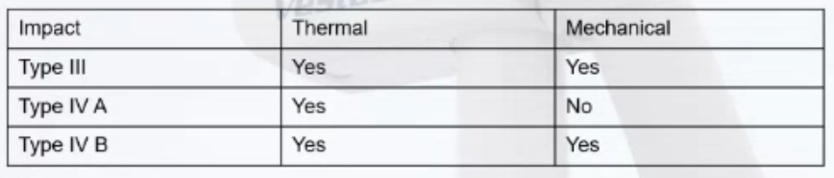
When you have multiple activations of chopper the energy is dumped into the chopper, increasing the temperature of the chopper. In the timeframe of 10-15 seconds of IEEE2800 we can almost consider this as an adiabatic process, no heat exchange. The cooling time constant is very slow. It is important to keep in mind that cumulative effect should be respected in terms of the Table 8 (in IEEE2800) of the multiple FRT.
Focuses presentation on Type 4 A but some of these concepts can be extrapolated to Type 3 and Type 4. In type 4A machine the mechanical speed of the drive train is quasi constant during FRT event, the only oscillation that you can see is due to wind fluctuations (not related to the actual FRT). During FRT mechanical and electrical energy still has to remain in balance so any extra energy from mechanical side is burned in the chopper. When we have a single fault in a relatively strong grid the active power will be recovered very fast about 10pu/s ramp rate. While that power is ramping up however the chopper is still active so mechanical power that still cannot be delivered to the grid is still being dumped into the chopper. Energy that the chopper is building up, or thermal stress, is not only the part that happens during fault event itself but also during the recovery part. This is very important to keep in mind when we look at the exemptions! The cumulative effect will carry over with the number of multiple FRTs the turbine is experiencing. Normally the recovery in the weak grid conditions is slowed down, e.g. 2 pu/s to avoid voltage overshot, this may result in almost in same time of engaging the chopper during the recovery as the duration of the event itself. Each project may be configured differently, and this will have an effect on the MRT capability. All the requirements in IEEE2800 are written in terms of number of disturbances and duration but in his opinion, there should be exemptions based on energy dissipation, depending on specific configuration of the project.
These thermal limitations are not included in EMT models. Vestas recently included it to comply with AEMO’s modeling requirements. If we want to rely on EMT models the thermal limitation’s part has to be carefully validated.
Also need to keep in mind that while asking to comply with MRT, it can inadvertently compromise weak grid stability. Because to comply with MRT rate of active power recovery may need to be increased, but it’s not desirable in weak grids.
This specific challenge is also applicable to Type 3 turbines.
Julia is asking how MRT requirement in Australia is compared to that of IEEE2800.
Miguel responded that in the DMAT (Dynamic Model Acceptance Test Guideline) they have a random MRT configurator (random combination of voltage levels and durations). The first exemption of IEEE2800 in Table 8 seem relatively easy to comply with but in some locations in weak grid scenarios during MFR you may carry over as much as 50% of the excess energy prior to the next fault occurring so exceptions of the cumulative effect of IEEE2800 will not be sufficient.
Julia: have you run into this weak grid limitation in South Australia? Miguel says yes, many times. Julia is asking what was the trade-off between weak grid stability and MRT requirement? Miguel: In Australia DMAT more soft specifications for the models and then there are site specific specifications so in case of weak grid some mutual agreement will be reached.
Nath (GE) comments in the chat that a different section of IEEE2800 requires that active power recovery rate is configurable between 1 and 10 seconds. The thermal issues for a 10 second recover would be even more concerning.
Stephen is asking on slide 4 if I have mechanical issue, what trip am I expecting? Is it vibration alarm or vibration trip code for the oscillations. Miguel says there are many supervisions, but these protections are similar to SSR (recurring oscillations in active power). Some OEMs have counters for multiple ride through. Vestas also has it in Type 3 turbines, the counter setting is based on the mechanical stress that they can handle. This is done to avoid triggering oscillations in active power.
Stephen: Similar question to the thermal limitation part. You are saying that you need account for that energy during recovery. Stephen is asking assuming it tripped due to this limitation, what will show up as in terms of trip code: is it energy is it temperature? Miguel says it’s temperature in the chopper. Stephen: so to practically put in the exemption there would be an exemption related to temperature? Miguel is saying he thinks there is a part in HVDC requirement of IEEE 2800 that says DC chopper may be designed for 2 seconds of rated current or something like that. Stephen: so to overcome that thermal limitation the solution would be a properly sized DC-chopper to withstand additional thermal stress. Can you retrofit these dc-choppers, e.g. to increase the cooling? Miguel says redesigning cooling system will not make a difference on these short timeframes of 10-15 seconds. I don’t know if chopper retrofit is feasible. Vestas choppers are already overdimensioned to separate mech and electrical part. It might be very challenging and OEM dependent. In exemptions what can be done is an additional exemption that says if you burn for more than 1-2 second the rated current of the converter you may be allowed to trip. This will also help keeping slower active power recovery feature in weak grids and achieve some MRT.
Andrew Isaacs is asking if you neglect the ramp rate in a weak grid system would existing exemptions in IEEE 2800 be ok with you. Miguel says yes for Vestas Type 4 turbines. Andrew: ok if that’s the case you’d be happy with additional exemptions in general around the dc-chopper circuitry thermal limit allowing inverter to trip (e.g. 1 p.u. current for x seconds) or a site-specific exception trading off weak grid features and MRT features, but first option seems more clear and general. Miguel adds that another one could be a minimum ramp rate of recovery, to prevent it from being too slow. Andrew refers back to Nath’s comment and says in some cases you might even want to configure recovery being less than 1s.
Denis is asking about the difference between balanced and unbalanced faults? Not as much energy in unbalanced faults isn’t it? Miguel: the chopper will be activated based on dc voltage. This voltage will be rising based on delta in energy between mech and electrical side. When you have an unbalance fault you might be able to push more energy through and the worst case scenario would when you are considering 3-phase fault.
Andrew proposed an exception language as “Additional exception: if DC chopper circuitry reaches thermal limit, the inverter may trip to protect itself, provided the chopper is rated to handle 1 pu current for at least x seconds, with agreement of TO." What would a good x be before the cost or difficulty started to rise dramatically? Miguel: Will circle back, he knows the value but needs to find out if possible to disclose, but thinks this language is more appropriate for cases where slower recovery ramp rates applies.
Manish comments it’s not only recovery time, but also how your reactive current gains are dimensioned for given voltage deviation. So it probably starts to become very complicated quickly. Miguel: it’s correct but wouldn’t want to complicate.
Julia is asking wouldn’t it just be a design criterion for a chopper but then the gains and settings can become a site-specific issue? Miguel agrees that if you have an accurate EMT thermal model and define MRT requirement based on energy, then you also consider there is a cooling period and can probably withstand more faults.
Nath comments that the requirement to size the chopper for certain energy value should be restricted to the variety Type 4 machines where the chopper is designed to absorb the entire difference in energy between mechanical side and electrical side. For other virieties of Type 4 machnies as well as all Type 4 machines the chopper is just the fraction of the size and this requirement should not apply because for example for Type 3 machines we let the drive train speed up and the energy absorption is on mechanical side.
Andrew is asking then if for Type 3 machines the standard as written with existing exemptions is that ok? Nath is saying there can be other mechanical concerns (there can be coupling slit between highspeed, and low speed side and you could trip for those reasons). Exemptions should be expanded on the mechanical side to include allowance of trip for other reasons other than just resonance.
Aung (NERC) is asking if the exceptions will be phased out over time? Similar comment from Andy Hoke in the chat: I wonder if the wind OEM concerns are related to existing products and could be overcome in future designs.
Nath responds in the chat: The mechanical limitations are extremely hard to overcome. For example, it is not possible to increase the strength of the tower by increasing its diameter beyond the existing maximum of 4.3m approx. due to transportation height limitations. Increasing the thickness (which is already typically between 2 to 3 inches) does not increase strength by as much.
from Andy Hoke: And I assume the chopper thermal mass is limited by the tower strength?
from Nath Venkit: In Type 3 machines and certain types of Type 4 machines the chopper does not absorb all the energy to fully isolate the turbine mechanical system. For these turbines the drive train reacts to the fault and imposes significant loads on the tower, drive train and other mechanical components.
from Andrew Isaacs: Thank you Nath, that is very helpful (I'm learning a lot on this call!!). I guess the Type 4 plants with fully rated chopper will still ultimately have a thermal limit in future equipment too... We can change the x, but there will still be an x and may need an exception unless we get a very large number. At some point there will be a cost problem.
Phase Jump
The root cause of phase jump were already covered in the previous presentation. But important to discuss phase jump created by faults. This is not the same as the phase jump created by load switching or line switching and the tests for these will be different, we need to agree on how it is tested.
Challenges created by the phase jump are purely in the PLL of the converter regardless of technology. The whole purpose of the PLL is to create an angle and a reference for the dq control in order to inject the current. In the case of Vestas there is no such thing as phase jump protection/tripping related to measured phase jump or RoCoF. There is no accurate way of really measuring these quantities. What happens in reality is when you have a phase jump, there is a perturbation in the angle and the references that your control is calculating are not where they have to be, and you might create e.g. overvoltages or undervoltages on the grid and PLL is also not tracking frequency correctly and RMS values will also be disturbed.
Looking at 25 phase jump the question, a lot of discussion on when it is applicable and how to test? Personal opinion is that when we define phase angle change sub-cycle to cycle, this is type of RoCoF, (though not quite because the fundamental signal will still be 60Hz) but you are progressively changing the angle of the waveform. This is not as challenging to ride through, compared to applied phase jump at the certain timestamp due to load rejection and reconfiguration of the power system. Instantaneous phase jump is more challenging than applying phase jump within half cycle to full cycle, but it’s also hard to extrapolate what you are seeing in the converter to the point of interconnection.
Currently the only one asking for phase jump verification in model quality test is ERCOT. The way it is performed today is that in SMIB in EMT we change the phase jump within the timestamp, and we evaluate the consequences of that in the inverter. What we have seen in the EMT models is that impact of the phase jump, when you are doing the test in that way, will be significantly different depending on the strength of the grid. And if PLL is not tracking correctly and results injecting current causing overvoltage or undervoltage it may trip the inverter.
A few takeaways on the slide below:
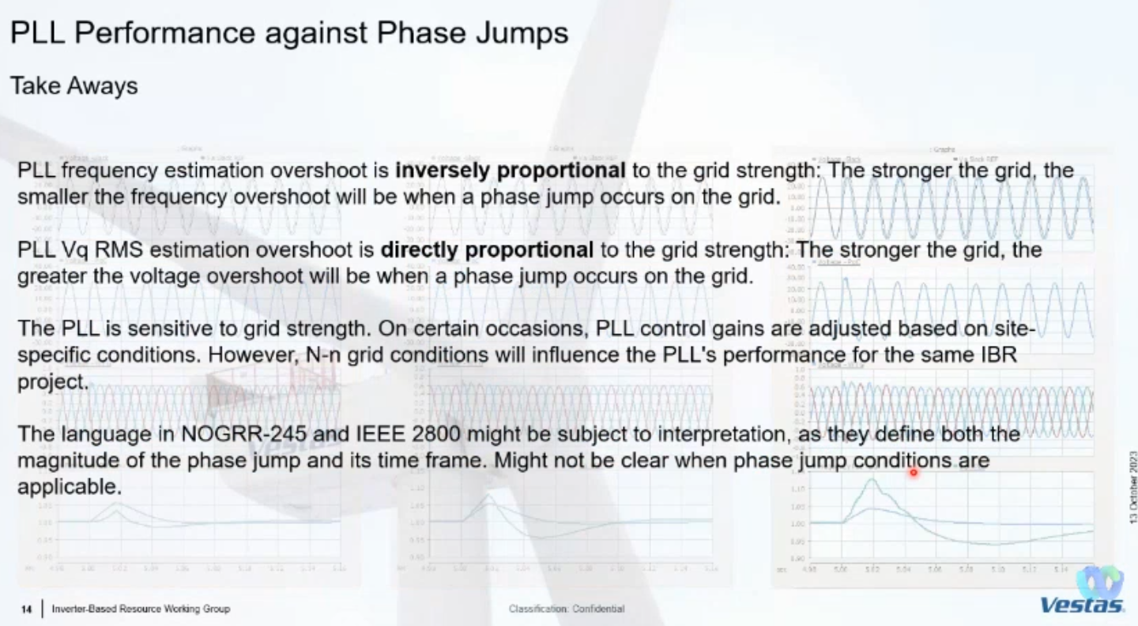
One more point is that system strength will change together with the phase jump (due to system reconfigurations).
To question from Andy if previous discussion with Manish and Andrew helped to clear out the questions about phase jump testing? Miguel still is unclear how it is proposed to validate phase jump? Let’s assume we have an accurate model in EMT how is IEEE2800.2 suggesting to validate a 25 deg phase jump is this SMIB that will chose a phase from a to a+25 within half cycle or is it by changing equivalent impedance of the grid X and R to simulate reconfiguration of the grid resulting in 25 deg phase jump?
Andrew says the draft for the test in IEEE2800.2 currently is 25 deg is applied within 1 time step to the voltage source angle of the system in the relatively low SCR system, about 2.5. Andrew also comments on SCR change. How Miguel says SCR matters here and IEEE2800.2 pics fairly low SCR but SCR as a design parameter eventually has to stop, it’s not going to be meaningful parameter going forward. Miguel agrees that’s a different metric for system strength is needed. Says the point with the SCR is that the overvoltage might be the wors case scenario in weak grid, but frequency is much more stable if SCR is lower. Andy says 2800.2 is not going to test every permutation of conditions (SCR etc.) in the end the ultimate test is these events in the field and the designer has to come up with the worst case. It does make some works for the designer but IEEE2800.2 is not going to answer those questions for you.
Miguel says this is similar to the voltage control. We tune the controllers for the screen shot of the system. E.g. we’ll tune PLL control for specific conditions of the system but when phase jump occurs these conditions will changes, what it is the expectation of the phase jump test, will other variable change at the same time. Andy says the expectation is for the IBR not to trip for phase jump, RoCoF, MRT etc. Miguel is asking but what about actual strength of the grid. If your grid changes you possibly won’t be able to continue with the same control setting. Is the expectation that all of the controllers perform as prior to the change. Andy says yes. Miguel says it might be challenging. Proof through simulation may be easy but it might create false expectations for ISOs because it might not be possible to do multiple things.
Texas Reliability Entity presenting on NERC Alert for IBRs Summary
David Penny from TRE is presenting.
NERC Alert when earlier this year on IBR performance issues. TRE felt it was important to get this information out as soon as possible because it’s relevant for NOGRR245 discussions. Summary of the Alert is on the slide below:
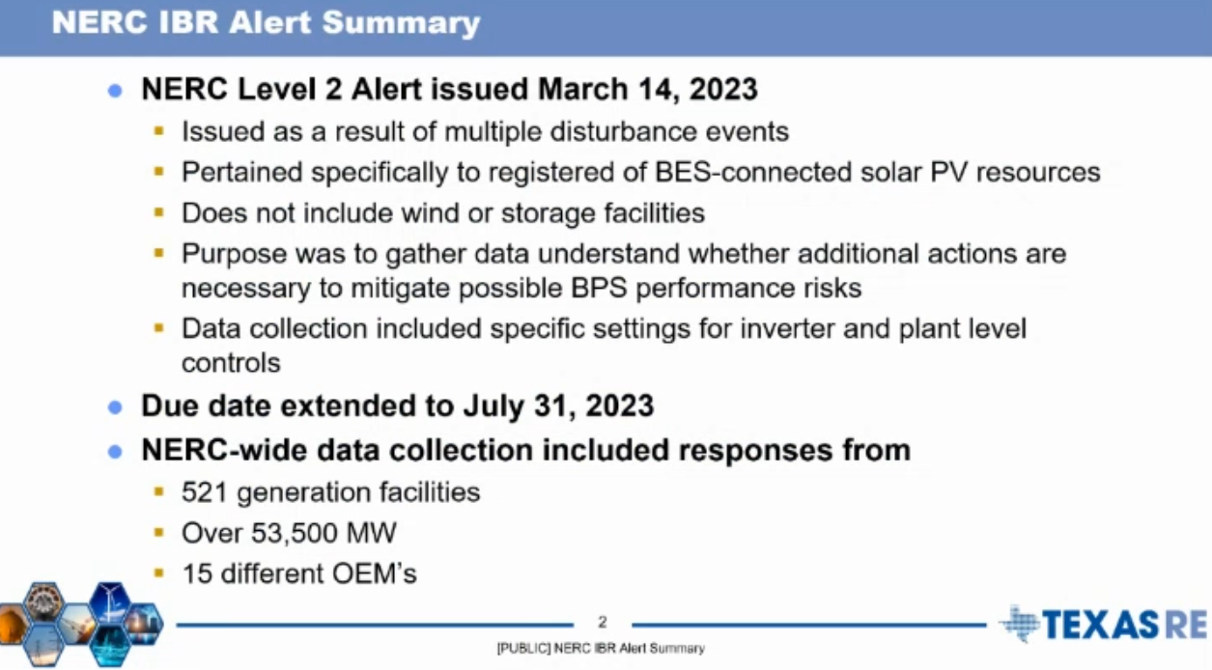
One of the first questions was about fault ride through, still five facilities with momentary cessation (no active or reactive current injection) enabled for their ride through behavior (including two plants involved in the 2022 Odessa event and five facilities with active current going to zero during faults but have reactive current injection. About 60% of facilities have the desired ride through behavior, i.e. active and reactive current injection with reactive (in some cases active) current priority at current limit.
PLL loss of sync and phase jump protection enabled or hard-coded in the inverters, here is about 50/50 split between those that have it enabled (five plants involved in the 2022 Odessa event) and those that don’t. In some where it’s enabled it is now set to higher levels (60-90deg) after the Odessa event. While some others still have 15 deg phase jump setting, 25 deg or higher is desired as per earlier discussion.
Most of the inverters have instantaneous overcurrent protection (enable or hardcoded). This is expected but we seen in Odessa events where too aggressively set inverter controls, after a fault is cleared result in either overcurrent or overvoltage that trips the inverters.
Power plant controller has protection settings enabled that can trip the facility or individual inverters? About 40% of inverters do. PPC controls need to be optimized to support the grid and not delay or inhibit this recovery.
One interesting question was specifically related to inverter OEMs. The question was if the facility has inverters from OEMs that have been involved in previous unexpected tripping (with the list of causes provided). The results show that 21 plants in ERCOT footprint with about 3 GW total capacity (including ones directly involved in Odessa event) that to the said “No”. This is very concerning because it illustrates that Resource Entities are still unaware about what is happening. Need to do a better job with outreach to reduce risk of future disturbance events.
Last few slides about voltage and frequency ride through settings if those are set at equipment capabilities or right of PRC-24 curve. Turns out that many are set right and the curve and/or are using non-filtered measurements.
Also collected individual frequency and voltage tripping time settings but cannot share due to confidentiality.
Julia asks if in the one to last slide (question about OEMs) these 21 plants were not involved in Odessa events but only have equipment from the same OEMs? David says it’s both, i.e. 21 plants include some plants that were directly involved in Odessa events but also ones that were not directly involved but have same equipment in their facility and they both answered “No” to the question. Alex (NERC) clarifies that expectation was that some No-s would come from the facilities that have inverters from these OEMs but not directly involved in the events but didn’t expect the plants that were directly involved in the events to answer know.
Alex (NERC) also adds that a public report for the entire alert is on the way (hopefully by the end of the year). But the results presented for ERCOT are in line with other findings. David adds that the reason to present it today was to inform NOGRR245 discussions.
Stephen is asking the generators: when I look at the settings and not maximizing generator capabilities, what are the barriers from the generator perspective for not doing so? This seems like a lower hanging fruit to improve resilience.
Alex (NERC), there is not a great collaborative relationship between OEMs and generator owners, but you need understanding from both sides to do what Stephen is asking about, but also there is no requirement to maximize capabilities. It’s just a strong recommendation from NERC. It’s not mandatory but requires additional work for what is not mandatory.
Stephen is asking for generators to add any comments.
Alex adds from his prior OEM-side job, the true maximum capability of the equipment is extremely sensitive from the IP perspective.
Chase (Southern Power) comments it’s a complex problem and presents a challenge. SP has experience of having a facility not performing during disturbance event, fixing it in collaboration with OEM, and next event happened, and performance didn’t match what was expected. There are still discrepancies between what’s being done and what’s happening in the field due to increased complexities. – but agrees that need to work further.
Julia: Looking at just one generator company responding to Stephen’s question while we normally have 70-100 ppl on each meeting call, 79 today. Do we need to do something more to get this message across, so that facility owners with inverters from OEMs involved in prior events are aware and do something?
Alex mentioned IBR Webinar series that NERC organized over the summer and encourages people to get informed. https://www.nerc.com/pa/Documents/IBR_Quick%20Reference%20Guide.pdf (the IBR Guide contains link to the Webinar series and more, and is one shop stop to information about IBRs). Alex added that NERC Inverter Based Resource Performance Subcommittee is a group that’s discussing these issues on monthly basis and encourage people to join by letting him Alex.Shattuck@nerc.net or Julia (IRPS chair) julia@esig.energy know.
Andrew shares frustration about barriers of not getting a low hanging fruit and pushes back on that being insufficient communication problem. Their experience working with utilities all over is different. They hear thing like “dc-voltage protection is disabled in the model because in a given market it is not tested in the model”, so they only include what’s required and tested but not necessarily what matters.
Patrick (ERCOT) one thing that ERCOT has been doing (though it’s time consuming) is when they see dc-bus unbalance, overcurrent mitigation, PLL loss of sync form specific inverter types, the sent a market notice about the issue and solutions available from OEMs and track progress from those market notices if those being followed up upon and if not hear back then following up with them. When he looks at the last slide from David for frequency rides through settings right on the curves, he finds it concerning and feels there’s a need for another market notice on this. But feels like generators need to be more proactive on this as well.
Stephen comments his question was to gage the response because we don’t want to assume bad faith and understand if there are generator owners that want to get it fixed if there are any other barriers that ERCOT is not aware about. We all have to evolve and make it work and adapt to new challenges as the system evolved.
Divya (Orsted generator owner and developer) – we have been trying to reach out to OEMs. The intent is to comply as much as possible, but we cannot go and change settings without doing studies and understanding the impact. What we are seeing in the industry, we rely heavily on EMT studies but it’s hard to find engineers that do EMT. We also depend on the OEMs to provide data and models. If it’s legacy equipment it’s even more difficult to get information and models. Also, we often hear about IP issues. These are all non-technical challenges. There are also technical challenges with auxiliaries that sometimes are a limiting factor, but they are not modeled in any of the studies, but they may be the reason why we sometimes are hesitant to make any changes in the field.
NOGRR245, NOGRR 55 Up
Stephen Solis, ERCOT presented.
First update on NOGRR255, it has been presented at IBRWG previously, it is about disturbance monitoring equipment requirements. ERCOT didn’t get a lot of feedback on this from IBRWG. Received some comments from DWG and SPWG, but by enlarge sections 6.1.4 and beyond affect IBRs. Looking to ask ROS in November to move this along. If there’ll be comments ERCOT will take a look at those, a lot of comments that came back ERCOT doesn’t have major concerns with. These will apply to all transmission-connected facilities (20 MVA and above) to allow analysis after disturbances with the following implementation timeline:
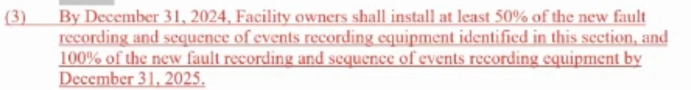
This may need to be extended a little to include equipment procurement and supply chain limitations.
For NOGRR 245 sent two RFIs, one to REs, asking about their ability to comply with ROS-approved version of NOGRR245 (from September 14, 2023) or ERCOT approved version of NOGRR245 (from August 18, 2023). ROS version focuses on commercially reasonable solutions while ERCOT version focuses on technically feasible solutions. These are due on Nov 6th. Also issues similar but different RFI to the OEM and asked for feedback for each product focusing on technically feasible portion. Also due on Nov 6. Siemens Gamesa submitted some comments that spurred some discussion but will provide a public version of their RFI by Nov 6. Note than when talking about technically feasible please look if installation of supplemental dynamic reactive devices or co-located short duration ESR is a technically feasible solution (and potentially more commercially attractive than more expensive retrofit)? Asked Julia to put it on the list of things we need to discuss further to see if we can get any presentations from OEMs that could evaluate the types of these solutions.
Julia asking if RFIs are posted publicly? Stephen says the RFIs are not posted but everything that was asked is in the comments that ERCOT posted on NOGRR245, September 29, 2023.
Stephen will bring a summary of RFI, but probably not by the next IBRWG meeting that’s on Nov 10, too little time to process.
Kristin Cook (Southern Power) question on NOGRR255, regarding data retention time period in 6.1.4.4 it says if the data needs to be validated because of the disturbance event it needs to be stored for at least 3 years, will there be specific beginning and an end of the event and data to store, just to understand about storage capability that will be needed? Patrick responds: ERCOT will identify the time period for which data will be needed, it won’t be extended period of time, e.g. with PMU data it usually 5-10 minutes for DFR data it’s usually event files and those are not large. And this will be the only data to hold on to.
Andrew Nigro (Invenergy) question on NOGRR255, about location of IBR-related devices, are you looking for DFRs at inverter terminals? on the high side of the pad mount transformer? or are you looking for PMU? Partick responds that they are trying to mirror language in the new PRC-028 (new standards being created for IBRs specifically), on the individual terminals of inverters or turbines as well. PRC-028 has some clarity and diagrams. Patrick also clarifies that PMU data requirement is for 30 days and DFR data for the event files. Stephen brough up the link of the NERC Project where PRC-028 is being developed https://www.nerc.com/pa/Stand/Pages/Project-2021-04-Modifications-to-PRC-002-2.aspx
Aung (NERC) comments that this data is very important for event analysis! And asks if there is a requirement for automatic reporting or only on request from ERCOT? Patrick says no requirements to self-report so far.
Stephen: we do have new language on the PMU side for where we need to have DFR equipment. But ERCOT is going to identify certain transmission interphases where they’ll need PMU data (on transmission side) to be streamed to ERCOT. This will help to identify the events and then ERCOT can make requests to the generators.
Julia comments: we submitted a SAR from NERC IRPS, to do modification to PRC-002 or new IBR focused standard, whereby IBR owner, if they see an unexpected trip on their side will have to self-report (in this case would be to ERCOT), investigate and fix the issue. Alex confirms that it is within this same NERC Project 2021-04 that was just brough up and is being worked at.
NERC update, BESS disturbance Event
Aung Thant, NERC presented
Aung is doing a quick version of the presentation and will provide more details on 10/19 NERC IRPS meeting. NERC put a new report on March 9 (total loss 1.1 GW, with 408 MW attributed to IBRs, frequency dropped to 59.916 Hz and took 3 minutes to return to normal) and April 6 (total loss 498 MW all attributed to IBRs, frequency dropped to 59.924 Hz, took 1.5 minutes to recover) of 2022 of two disturbance events in California, involving PVs and BESS but since this involves multiple BESS this time too, focus is on BESS. In March they were discharging and in April charging so were able to see both behaviors. Same facilities were involved in both events. The slide showed the map of affected IBRs.
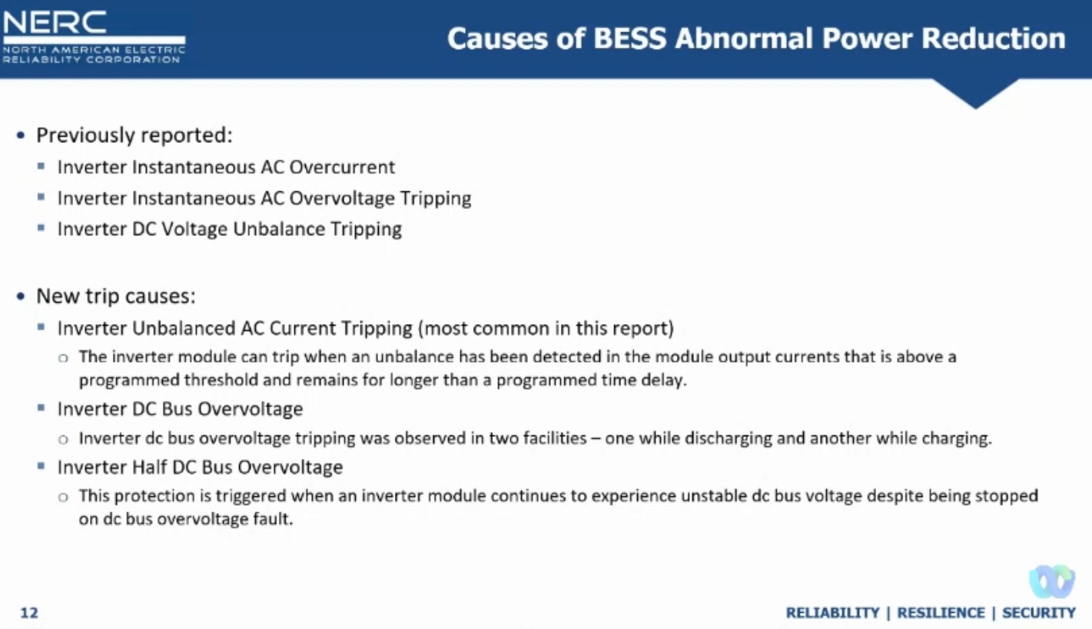
None of the data available met CAISO’s requirement of 10 ms data recording resolution and fast logging, miscoding of inverter codes was an issue.
CAISO mitigated with referring back to LGIA and pointing that the conditions of the IA are not met and called for the facilities to develop mitigation plans and make changes to meet the requirements in LGIA.
CAISO reports that all by one facility has been enhanced with software upgrades. CAISO reviewed evidence of the effectiveness of the mitigation plans, which included lab test results from OEM showing performance before and after software upgrades.
BESS may have the same performance problems as solar PV. BESS ride through performance is not adequately assessed during interconnection process, EMT modeling during interconnection process would have helped to detect some of the issues. Poor commissioning practices was observed. Lack of monitoring. GO should check with their OEMs to ensure that their inverters are not prone to tripping on the causes that were observed in this and other events and makes sure their facility meet their requirements in LGIA and that they have monitoring equipment appropriately configured and working.
Stephen asks how long it took from the event to this analysis to be ready? By December 2022 the software upgrades were implemented so it took 8 months to implement mitigation.
Stephen asks about new causes of tripping should ERCOT be proactive and do a market notice to bring it to GOs attention and ask to evaluate and implement those software upgrades? Aung says yes.
Stephen: Did CALISO follow the process develop a solution – implement in the model – test the model before implementing or implement first then evaluate? Aung responds that they are still investigating this.
David Penny (TRE) asks if these facilities involved in the events were providing any AS? The concern may be if BESS are providing critical amounts AS. Aung says that these resources were at least required to provide PFR because it’s required by LGIA.
Aung also provided an update that NERC IRPS Whitepaper: Grid Forming Functional Specifications for BPS-Connected Battery Energy Storage Systems has now been published.
IBR Quick Reference Guide is a good source on all information about IBRs (webinars, disturbance events, relevant papers.
NERC is observing a number of small wind events, where output at the time was small and that resulted in a small event but if the plants were at their full output, it would have been larger events. NERC is looking to do something proactively and investigate causes of these events. Alex adds that currently it almost exclusively have been solar events but it’s just because they happened to be at high output while other types of resources also unexpectedly trip at lower output and these events are going unnoticed/unanalyzed. The findings of NERC reports should be followed up on by ALL types of resources, not just ones that tripped in the event.
Julia comments that during August IBRWG meeting Stephen shared some of the similar wind events where multiple wind resources unexpectedly tripped but at lower output.
Divya (Orsted) question to Aung, has the grid conditions have changed over time for these batteries that could have impacted POI characteristics, or was it really just inverters being incorrectly turned and respond incorrectly. Aung responds that the IBRs were added in that area of study gradually so it’s possible that SCR was reducing over time. It’s a good point that these plants are tuned and we never touch them again but the grid evolves over time and retuning probably needed and would have led to better societal benefit. Diviya says she was pointing to that. With the dynamically changing grid conditions how much of these plant capabilities do we actually utilize? We as a GO do not understand/know what’s happening on the grid, it would be very helpful if ISOs and utilities updated this information so that a GO could proactively tune their parameters as needed.
Aung says this is a great point but also a different problem where some things were not done properly during commissioning. Points out that NERC IRPS is working on a white paper focusing on best commissioning practices.
Julia concludes with the list of technical topics that need further discussion and below are the results of slido (i.e. added topics) and priority poll results as of 10/22/2023 are below. Stephen adds that we wanted to have group’s feedback on the important topics, this was the attempt to help the group to drive the content more that the leadership team. If you have any additional items please email Mohammad, Julia and Stephen.
