**IBRWG Meeting Minutes**

**Review of the poll on the topics related to NOGRR245 implementation**

Stephen Solis (ERCOT) reviewed the Slido poll results from the October IBRWG meeting.

* Topics were focused on testing and verification
* If additional topics need added to the list, people can reach out to the IBRWG Chair or Vice-Chair.

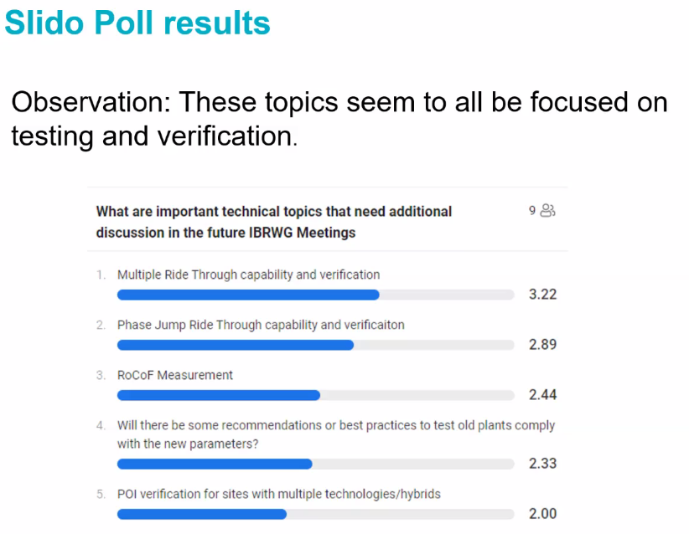

Mohammad Albaijat asked about synchronous condenser project status in ERCOT and it’s impact. Stephen Solis (ERCOT) said that the potential synchronous condenser project is still under review. It could potentially help system strength.

**OEM perspective on NOGRR245 and potential benefits of BESS**

Ravi Dodballapur (SMA) presented on SMA’s perspective on NOGRR245

* Comments in reference to August 18th NOGRR245

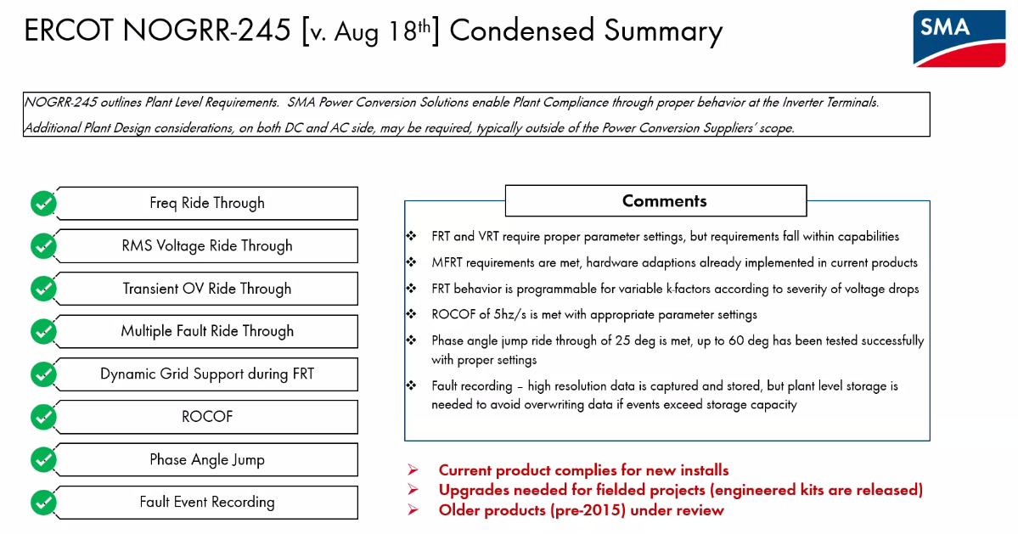

Questions

* Mohammad Albaijat asked about pre-2015. Ravi (SMA) said that there are kits available to be added to older products, but they are still under review.
* Stephen Solis (ERCOT) said that the above slide (5) seems to conflict with the OEM’s response to the ERCOT RFI on NOGRR245, so we may need to have a meeting or conversation offline to discuss the differences. SMA expressed challenges on phase angle jump and ROCOF in the RFI.
* Ken Donohoo (OwlERC, representing APA) – asked if this was primarily solar. Ravi said solar and BESS. Ken said there might be a need for EMT study requirement in order to prove compliance.
* Mohammad – Are these comments based on simulations or factory tests? Ravi said it’s a combination

Frank Berring presented on the potential benefits of BESS

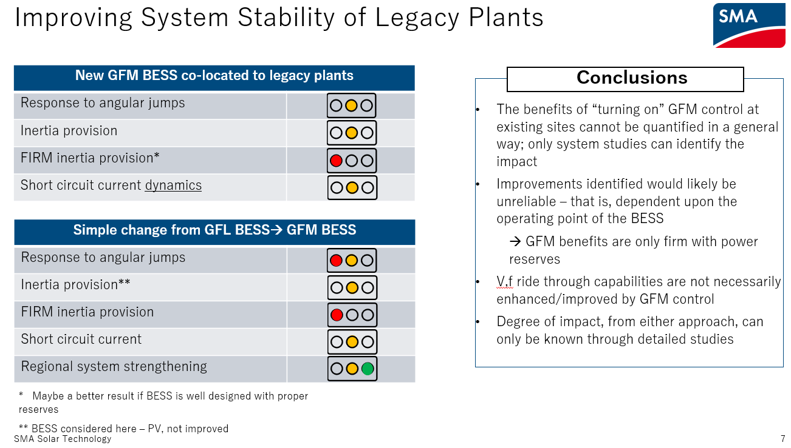

Questions

* Patrick Dalton (MISO) asked about the energy buffer required for BESS system strength contributions. Frank said that they have to quantify the reserved for short circuit strength and inertia.
* Stephen Solis (ERCOT) asked about the process of providing the inverters at a site and what drives the default parameters and then who tunes the parameters? Frank said that for SMA normal grid following projects, SMA uses the cited grid codes in default parameters and is executed prior to commissioning and agreed on with developer. Typically, that’s where SMA’s role stops other than validating results in the field. But now with grid forming projects, there is more work put in for tuning ahead of time. Stephen asked for OEMs to stay involved in field validation code improvements and said there could be a need for working groups in this area.
* John Schmall (ERCOT) what are the potential negative impacts of too much GFM? Frank said that SMA categorizes GFM as a voltage source controller. If there was too much inertia in a system, it’s effectively slowing down synchronization to becoming the point of asynchronous. Andreas Knobloch (SMA) said that if you had too much short circuit current that could be adverse. Frank said that the SMA message is that GFM is a good thing, but that it needs to do wisely and with proper studies and validation.
* Ken Donohoo (OwlERC, representing APA) asked about the physical distance that GFM could be beneficial to the rest of the system. Frank said that the answer would come from a system study to look at the impact on various regions.

**MISO Update on IEEE 2800 adoption efforts**

Patrick Dalton (MISO) presented on MISO’s IEEE 2800 adoption efforts

* MISO has relatively low levels of solar and moderate levels of wind with a total of 35 GW (wind + solar) within 190 GW total generation capacity
* MISO’s interconnection queue is almost all IBRs
* MISO began IEEE 2800 adoption efforts in 2022. Patrick said that approach has been similar to ERCOT’s and they performed a gap analysis as well
* MISO included top priority requirements shown below from slide 9
* MISO contemplated the various IEEE 2800 adoption approaches and decided to pursue a Detailed Reference approach
* MISO is proposing offering exceptions to some IEEE 2800 capabilities and requirements through 1/1/2025. Patrick said that this is specific to MISO context and every region has different needs due to system and resource mix differences.
* MISO will be investigating potential GFM requirements in the future and will be paying attention to NERC recommendations

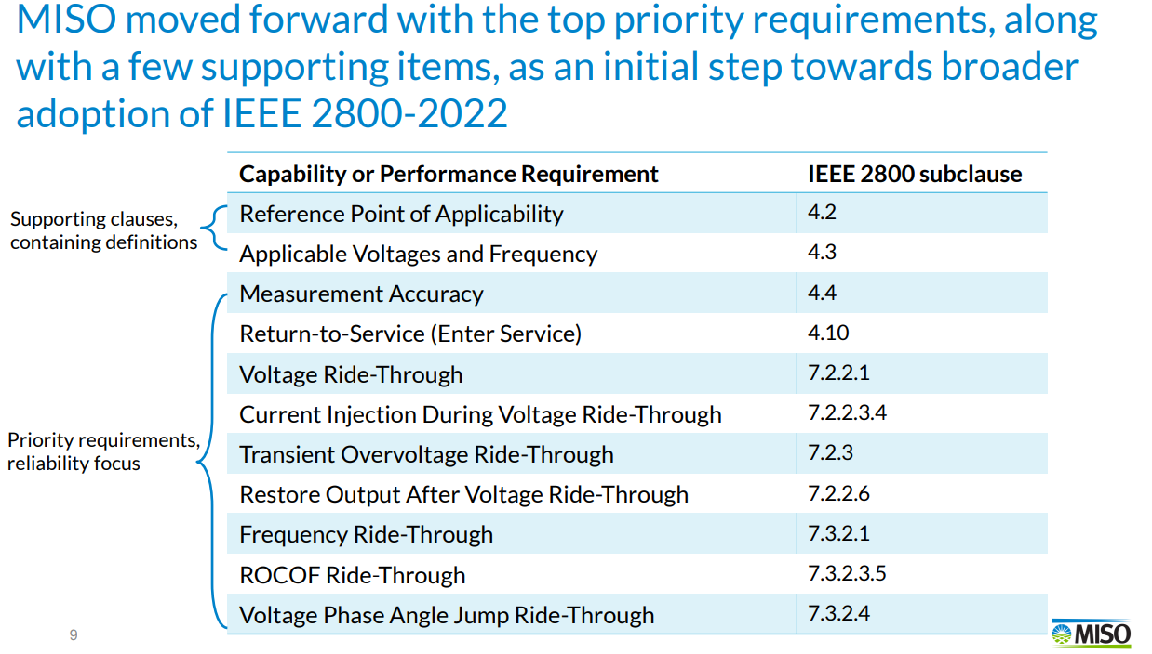

Questions

* Mohammad asked what the starting point was for the tariff. Patrick said that they started with the NERC 2019 recommendations and now are proposing around 1/3 of the IEEE 2800 requirements to start with.
* Stephen Solis (ERCOT) asked if FERC Order 901 coming out has any impact on MISO’s plans. Patrick said MISO is still evaluating this. What Patrick is seeing from industry and NERC IRPS is that the general direction is that this will be aligned with IEEE 2800 as a starting point. To be determined how NERC responds to the FERC order.
* Rishi Maharaj (ENGIE) asked if MISO’s strategy is to apply new requirements on future generator interconnection applications and not on existing resources. Patrick said yes, that is the intention.

**Nighttime reactive power support from solar inverters**

Aminul Huque (EPRI) presented on solar PV inverter potential for providing nighttime reactive power support.

* Can solar PV inverters provide nighttime reactive power support?
  + The PV inverter tested was able to maintain the reactive power absorption continuously during the daytime to nighttime transitions and vice versa
* What is the cost of providing nighttime reactive power support?
  + Active power demand. A field demonstration and performance assessment was conducted and the active power “cost” is shown below from slide 11

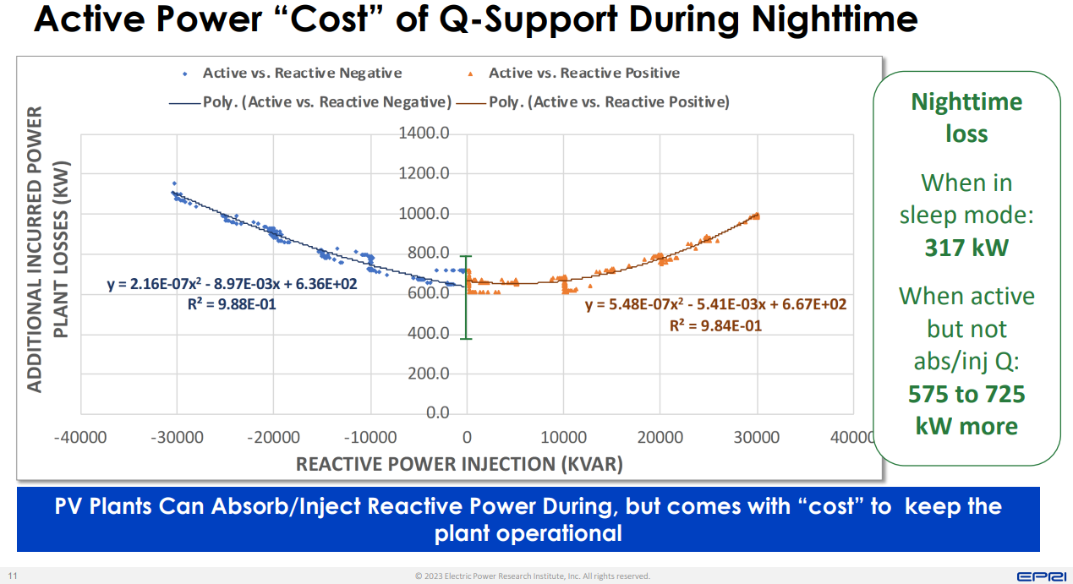

Questions

* Stephen Solis (ERCOT) asked if it was on high or low side of transformer. Aminul said he thinks it was the high side voltage, it was not the inverter level.
* Bret Burford (AEP) asked if they had done any simulations on how it responds to system events like faults. Aminul said that they have not yet tested that.
* Mohammad Albaijat mentioned that considering business cases could be helpful.
* Mohammad Albaijat asked if it was done in partnership with anyone. Aminul said they worked with the manufacturer and utility.
* Stephen Solis (ERCOT) said that ERCOT has been evaluating this topic and wants to understand the real power costs associated with it. Stephen mentioned that there is a discrepancy with another OEM’s comments on this capability not having an impact on equipment life expectancy. Aminul agreed that OEMs have different OEMs have different opinions on life expectancy impact – some even saying that this would extend life expectancy.

**Phase jump and RoCoF ride-through capability and conformity assessment**

Dustin Howard (GE) presented on the OEM perspective of Phase Jump equipment, protection, and testing aspects. Slide 3 shown below.

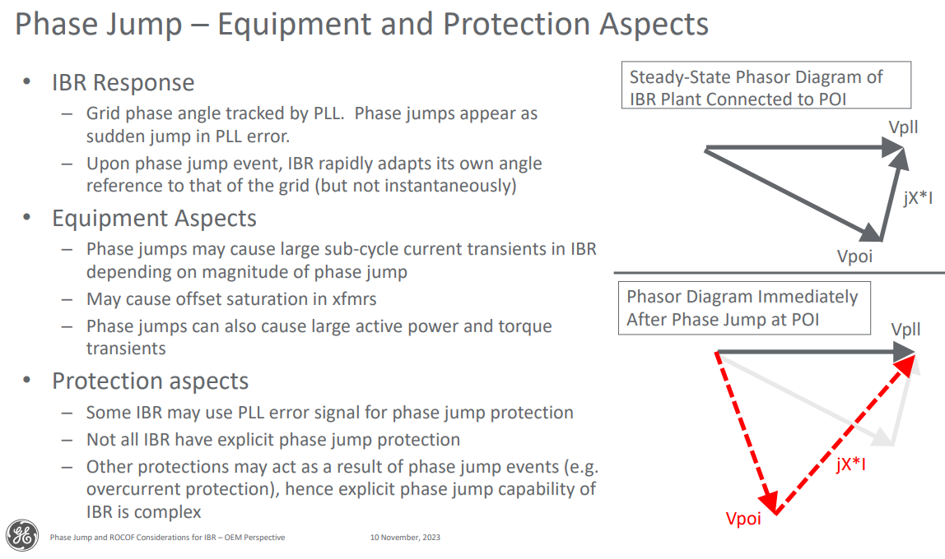

* Phase jump hardware testing takes place in state of the art lab testing facilities
* Phase jump tests in the field are impractical due to lack of testing equipment

Dustin also presented on ROCOF equipment, measurement, mitigation approaches, and risks

* Not all IBR have ROCOF protection
* Some regional grid requirements have been adopted to mitigate: active current priority control and fast active power recovery after fault. These mitigations could increase risk in weaker systems
* Best approach to mitigating risks are:

Questions

* Yunzhi Cheng (ERCOT) asked what should be added to model quality tests. Dustin said that EMT simulations are a practical way of testing phase jumps capability. Dustin wasn’t sure on PSS/e models, but assumes EMT models would be more reliable. Aminul Huque (SMA) said that SMA does phase jump testing in their lab.
* John Schmall (ERCOT) asked about measurement and what is the actual equipment capability when you have waveform distortion. Dustin said it could show a large deviation and it is really a consequence of the algorithm to calculate frequency and distortions creating artificial variations in frequency. Dustin said it’s important to test the equipment on a level of ROCOF and evaluate the ability to ride through
* Stephen Solis (ERCOT) asked if when GE does testing and verification if there is an average ROCOF used. Dustin said that in a grid emulator test they would apply a ramp of 5 Hz/sec. Stephen asked if they would do a hardware test for this. Dustin said that this isn’t a test of measurement so wouldn’t require a hardware test. Aminul Huque (SMA) put a comment in the chat: “That's how we do the ROCOF test at the lab, program the grid emulator to ramp frequency at 0.06Hz/s and 3Hz/s. for both low and high frequency.”
* Stephen Solis (ERCOT) said that we don’t know if the IEEE 2800 standard of ROCOF is fast enough for the ERCOT region or not. He asked if GE has ideas for a requirement that would equate to ROCOF resiliency for the region. Dustin said that tests cases and simulations could be created applying faults to various areas of the system and different nodes across the system could potentially show high ROCOF. An alternative would be testing or simulating for a large generator trip event and seeing how equipment behaves
* John Zong asked if the GE PSCAD model currently models the actual PLL and phase jump protection. Gary Chmiel (GE) said that the PLL is represented in the EMT models.
* Miguel Cova Acosta (Vestas) commented that EMT models wouldn’t give you a full evaluation of the auxiliary system. Miguel said that the Vestas converter is robust to ROCOF and might ride through IEEE 2800 standard. Dustin said that the EMT model is practical way of testing phase jump and ROCOF as long as protection and hardware components are also represented. Stephen asked if the auxiliary systems are the weak point, then are those in the EMT model? Miguel said they don’t have cooling machines, etc in PSCAD model because it’s not useful. PSCAD are useful but have limitations. Miguel said the most advanced testing lab in Denmark even can’t represent the full system. Miguel asked what the requirement for ROCOF would be. Stephen said there is value in the testing, even if it’s just one part of it, because ultimately we need IBRs to ride through events. Stephen said that ERCOT having VRT and FRT curve requirements has not been effective and that’s one reason prompting NOGRR245.

**OEM perspective on NOGRR245**

Miguel Cova Acosta (Vestas) presented on Vestas Perspective on NOGRR245

* Miguel said that NOGRR245 is only a short section of IEEE 2800.
* Vestas is concerned that over the years each region would implement their own version of IEEE 2800 requirements. There will be some necessary differences between regions, especially in the case of ERCOT. Miguel said that we should try to prevent different interpretations of the same requirements in each region.
* The majority of Vestas turbines in ERCOT are Type 3 and 4
* Vestas Type 3 turbines were assessed to pass NOGRR245
* Vestas Type 4 turbines were assessed to pass NOGRR245, with the exception of VRT curves
* Vestas Type 1 and 2 turbines were assessed to fail NOGRR245
* Vestas Legacy Type 3 and 4 turbines were not assessed
* Vestas plant life cycle is shown below

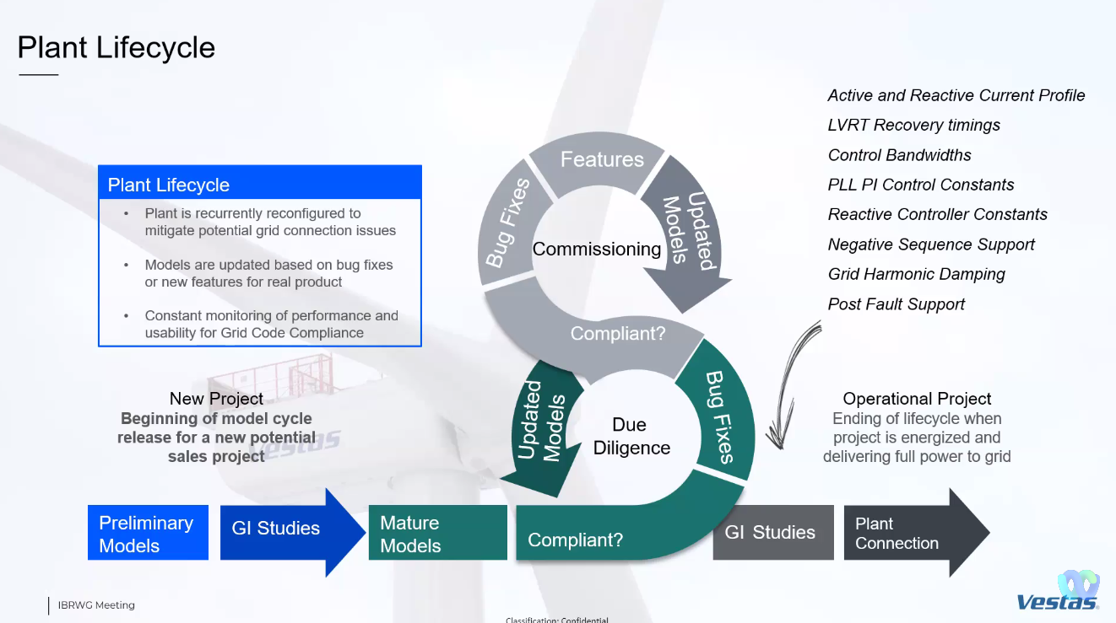

* Multiple FRT is essential for maintaining grid stability. However, requirements should consider exemptions for energy dissipation, depending on the specific configuration of the project. Balance of multiple FRT and voltage stability is needed.
* Phase jump ride through is beneficial for maintaining grid stability. However, requirements should consider exemptions for site specific PLL tuning to maintain control stability under very weak grid conditions. Balance between phase jump requirement and control stability is needed.
* Vestas requires clarifications on test conditions and deliverables for evaluating various requested features.
* Vestas notes that NOGRR245 verification process should be in accordance with IEEE 2800.2

Questions

* Stephen Solis (ERCOT) commented that exemptions connotate not needing to ride through. Stephen asked if Miguel if he meant exemptions or just variances. Miguel said he did mean something along the lines of variances and not exemptions. Miguel said that sometimes they will have to evaluate which is the less worse condition. Stephen said there will need to be reasonability. Stephen mentioned trying to avoid putting Type 3 turbines near series compensated lines. Stephen brought up VRT requirement and said there is a difference between there not being a way to meet a requirement and not installing readily available equipment that can meet performance. Miguel said some of the requirements would be retroactive, so that makes a difference on feasibility. Miguel brought up the weighing of priorities, like in the case of SSO, avoiding SSO might be the priority as opposed to reactive support. Stephen agreed on the need to prioritize in these scenarios.
* Stephen Solis (ERCOT) brought up slide 13 and the list of items that are unknown about NOGRR245. Stephen asked people to come forward with comments/suggestions and be involved in these areas especially since this will be the next area ERCOT is looking at.

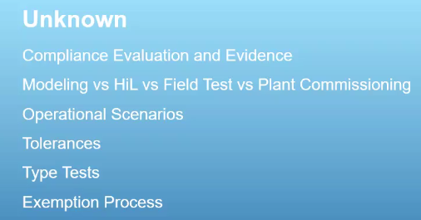

* Kristin Cook (Southern Power) commented on appreciation for presentation and asked if presentation would be posted. Miguel said it will get posted
* Ken Donohoo (OwlERC representing APA) asked how much coordination ERCOT has with other ISOs with NOGRR245. Stephen says ERCOT has monthly updates from NERC IRPS. Some regions have gotten farther along than ERCOT. Some regions have or haven’t had events, differing levels of IBRs in systems. ERCOT seems to be the first to dip into how to evaluate performance in long term.
* Rishi Maharaj (ENGIE) asked about a turbine in proposal stage, before full scale testing, what are the challenges of evaluating which turbine to use (sometimes not commercially available yet). Miguel said Vestas has changed their process to be more modular now. There are turbines sold during development stage and could try to guarantee more requirements depending on grid code. Miguel said that they could have to make changes – PPC is software so easier to implement changes, as opposed to something like the chopper. Software upgrades possible to implement in commissioning.

**NOGRR245 Update**

Stephen Solis (ERCOT) presented a NOGRR245 update

* ERCOT has received RFI responses from all OEMs except TMEIC (expecting this week) which represents 57 GW of capacity
* ERCOT has received RFI responses from 292 of 349 REs
* Preliminary aggregation of OEM RFI responses from slide 3:



* ERCOT will bring additional aggregations of RFI results to the December TAC meeting.
* ERCOT will have an updated Impact Analysis prior to the TAC meeting based on the ROS approved version of NOGRR 245
* NOGRR 245 as proposed by ERCOT in their August 18, 2023 comments addresses/aligns with multiple directives in FERC Order 901.
* ERCOT may submit comments prior to the December TAC as well.

Questions

* Eric Goff noted that there will be industry comments ahead of December TAC
* Todd Chwialkowski (EDF) asked if ERCOT broke out responses by wind vs solar. Stephen said ERCOT has not yet separated out by technology type yet.
* Rishi Maharaj (ENGIE) asked how the aggregation percentages were weighted. Stephen said it was done by number of MWs and filtered by “Yes” and “No”s.
* Chase Smith (Southern Power) asked a question on aggregations of responses. Stephen said that how it’s posted differs based on OEM. Some OEMs were more detailed than others.

Stephen Solis (ERCOT) presented a NOGRR255 update

* ERCOT submitted comments on November 1, 2023: Addresses some minor issues and consistencies on top of ONCOR’s edits. ERCOT has agreed to defer the PMU streaming requirements to a future NOGRR but this still remains an important issue to address to allow support real-time situational awareness.
* ERCOT would like to have ROS approve NOGRR 255 in December to allow it to continue moving forward.
* Expecting comments from at least one TSP and generator(s) prior to December ROS
* PRC-028-1 did not pass its initial ballot

Questions

* Ransome Egunjobi (Enel) – NOGRR255 will cover PMUs or DFRs? Stephen said it includes fault recording, sequence of event reporting, and dynamic event recording. Stephen said going toward continuous recording, like PMU, would be useful.

**New ERCOT disturbance event**

Julia Hariharan presented on a West Texas Solar and LFL Event from October 26, 2023

* Event summary shown below from slide 2

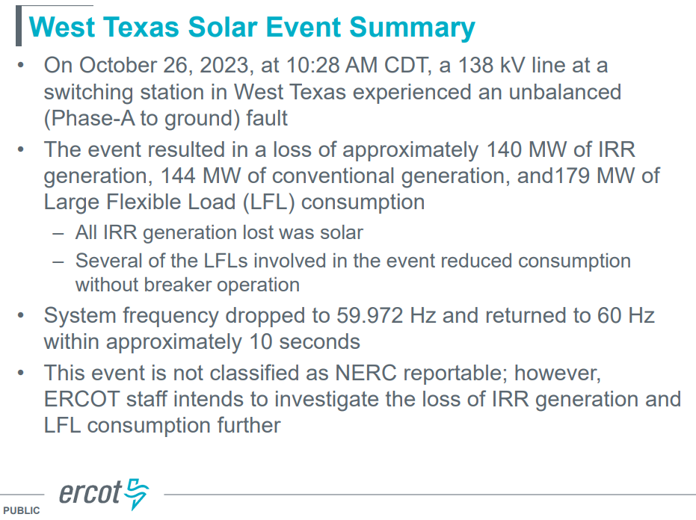

* Past event comparison shown below from slide 5. October 26, 2023 root cause is to be determined.

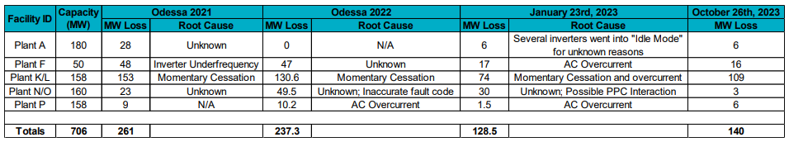

* ERCOT will evaluate the RFI and questionnaire responses and possible follow ups will be conducted with impacted generators and loads

Questions

* Mohammad Albaijat asked if there is an indication of how alarming this event is compared to others in the past. Julia said that it is a little early to say before evaluation is conducted but appears to be a smaller event.
* Kristin Cook (Southern Power) asked if ERCOT has information if LFLs tripped in previous events from slide 5. Julia said that during Odessa 1 and 2, there was no LFLs that tripped.
* Stephen Solis (ERCOT) said that generators should not use telemetered voltage measurement since there is a lag. An error in that measurement could create a problem.

Meeting adjourned at 2:00 pm