October 2023 ERCOT Monthly Operations Report
Reliability and Operations Subcommittee Meeting
December 07, 2023

Table of Contents
1. Report Highlights 2
2. Frequency Control 3
2.1. Frequency Events 3
2.2. ERCOT Contingency Reserve Events 4
2.3. Responsive Reserve Events 4
2.4. Load Resource Events 4
3. Reliability Unit Commitment 5
4. IRR, Wind, and Solar Generation as a Percent of Load 6
5. Largest Net-Load Ramps 7
6. Congestion Analysis 8
6.1. Notable Constraints 8
6.2. Generic Transmission Constraint Congestion 16
6.3. Manual Overrides 16
6.4. Congestion Costs for Calendar Year 2023 16
7. System Events 17
7.1. ERCOT Peak Load 17
7.2. Load Shed Events 17
7.3. Stability Events 18
7.4. Notable PMU Events 18
7.5. DC Tie Curtailment 18
7.6. TRE/DOE Reportable Events 18
7.7. New/Updated Constraint Management Plans 18
7.8. New/Modified/Removed RAS 18
7.9. New Procedures/Forms/Operating Bulletins 18
8. Emergency Conditions 19
8.1. OCNs 19
8.2. Advisories 20
8.3. Watches 20
8.4. Emergency Notices 20
9. Application Performance 20
9.1. TSAT/VSAT Performance Issues 20
9.2. Communication Issues 20
9.3. Market System Issues 20
10. Model Updates 20
Appendix A: Real-Time Constraints 22

Report Highlights
- The unofficial ERCOT peak demand was 71,181 MW for the month of October on 10/04/2023 HE 17:00; this was 5,028 MW more than the previous October record of 66,153 MW set on 10/12/2022 HE 17:00, and 14,293 MW less than the previous all-time record of 85,464 MW set on 8/10/2023 HE 18:00.
- On 10/14/2023 HE 12:00, a solar eclipse occurred.
- There were 3 frequency events.
- There were 1 Watch for DRUC not completing by 1800, due to DAM timeline deviation.
- There were 1 Watch for HRUC failure.
- There was 1 Advisory due to ERCOTs Voltage Security Assessment Tool was not solved in the last 30 minutes.
- There was 1 Advisory for the timeline deviation of the Day Ahead Market.
- There were 3 instances where ERCOT Contingency Reserve Service was released.
- 2 OCN’s due to ERCOT modifying the WESTEX Generic Transmission Constraint due to planned outage topology change.
- 1 OCN due to extreme hot weather forecasted in North Central and South Central weather zones
- 2 AANs due to possible future Emergency Condition of reserve capacity deficiency
- 2 notifications of executing the OSA process due to possible future Emergency Conditions of reserve capacity deficiency projected for OSA periods
- There were 10 HRUC commitments.
- There were 25 days congestion on the North Edinburg to Lobo GTC, 18 days on the Panhandle GTC, 16 days on the Treadwell GTC, 13 days on the West Texas Export GTC, 13 days on the Valley Export GTC, 12 days on the Nelson Sharpe to Rio Hondo GTC, 10 days on the North to Houston GTC, 8 days on the East Texas GTC, and 1 days on the Rio Grande Valley Import GTC. There was no activity on the remaining GTCs during the month.

Frequency Control

Frequency Events
The ERCOT Interconnection experienced 3 frequency events, which resulted from units tripping. The shortest event duration was 00:30 and the longest was 06:34.

A summary of the frequency events is provided below. The reported frequency events meet one of the following criteria: Delta Frequency is 60 MHz or greater; the MW loss is 350 MW or greater; resource trip event triggered ECRS deployment. Frequency events that have been identified as Frequency Measurable Events (FME) for purposes of BAL-001-TRE-2 analysis are highlighted in blue. When analyzing frequency events, ERCOT evaluates PMU data according to industry standards. Events with an oscillating frequency of less than 1 Hz are inter-area, while higher frequencies indicate local events. Industry standards specify that damping ratio for inter-area oscillations should be 3.0% or greater. For the frequency events listed below, the ERCOT system met these standards and transitioned well after each disturbance. In the case of negative delta frequency, the MW Loss column could refer to load loss.

Date and Time | Delta Frequency | Max/Min Frequency | Duration of Event | PMU Data |  | MW Loss | Load | IRR | Inertia
 | (Hz) | (Hz) |  | Oscillation Mode (Hz) | Damping Ratio |  | (MW) | % | (GW-s)
10/5/2023 19:49:59 | 0.087 | 59.897 | 00:06:19 | 0.55 | 11% | 632 | 54,029 | 9% | 301,519
10/25/2023 22:30:46 | 0.078 | 59.900 | 00:00:30 | 0.68 | 13% | 589 | 51,091 | 24% | 260,962
10/28/2023 22:23:26 | 0.053 | 59.934 | 00:06:34 | 0.62 | 12% | 448 | 48,325 | 35% | 250,998

(Note: All data on this graph encompasses frequency event analysis based on BAL-001-TRE-2.)

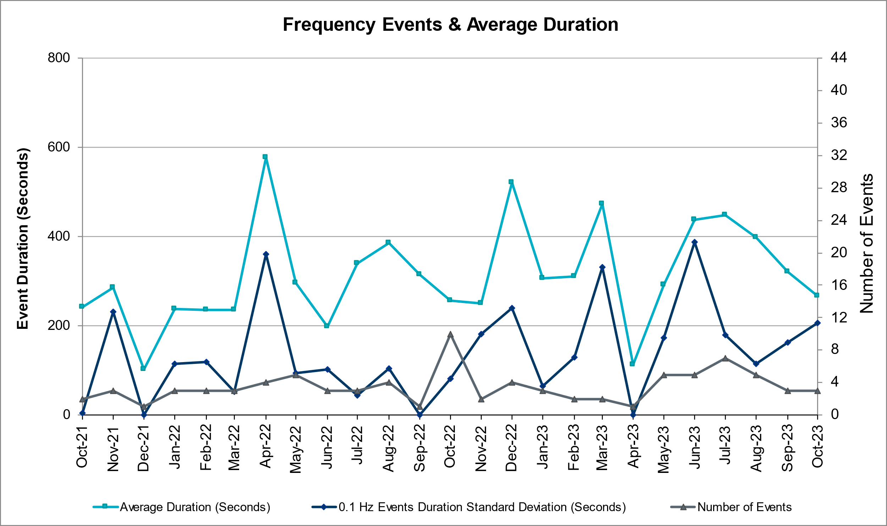

ERCOT Contingency Reserve Events
There were 7 events where ERCOT Contingency Reserve MWs were released to SCED. The events highlighted in blue were related to frequency events reported in Section 2.1 above.

Date and Time Released to SCED | Date and Time Recalled | Duration of Event | Maximum MWs Released | Comments
10/5/2023 19:50 | 10/5/2023 19:56 | 0:06:08 | 498 | Unit Trip
10/19/2023 18:17 | 10/19/2023 18:44 | 0:27:00 | 500 | Insufficient capability for forecasted 10min Ahead Net Load
10/25/2023 22:30 | 10/25/2023 22:31 | 0:00:08 | 651 | Unit Trip

Responsive Reserve Events
There were 0 events where Responsive Reserve MWs were released to SCED.

Date and Time Released to SCED | Date and Time Recalled | Duration of Event | Maximum MWs Released | Comments

Load Resource Events
A manual deployment of NONSPIN that was being supplied by Load Resources was deployed on 10/19/2023 at 18:00 for 1 hour.

Reliability Unit Commitment
ERCOT reports on Reliability Unit Commitments (RUC) monthly. Commitments are reported grouped by operating day and weather zone. The total number of hours committed is the sum of the hours for all the units in the specified region. Additional information on RUC commitments can be found on the MIS secure site at Grid Generation Reliability Unit Commitment.

There were no DRUC commitments.

There were 10 HRUC commitments.

Resource Location | # of Resources | Operating Day | Total # of Hours Committed | Total MWhs | Reason for Commitment
COAST | 1 | 10/20/2023 | 7 | 1,750 | SYSTEM CAPACITY
NORTH | 1 | 10/20/2023 | 6 | 4,377.2 | OSA
COAST | 1 | 10/21/2023 | 5 | 1,250 | Minimum Run Time
NORTH_CENTRAL | 1 | 10/28/2023 | 7 | 2,744 | SYSTEM CAPACITY
SOUTH_CENTRAL | 1 | 10/28/2023 | 6 | 1,380 | SYSTEM CAPACITY
SOUTH_CENTRAL | 1 | 10/28/2023 | 6 | 1,302 | SYSTEM CAPACITY
NORTH_CENTRAL | 1 | 10/28/2023 | 5 | 3,190 | SYSTEM CAPACITY
COAST | 1 | 10/28/2023 | 5 | 760 | SYSTEM CAPACITY
SOUTH_CENTRAL | 1 | 10/30/2023 | 6 | 1,380 | SYSTEM CAPACITY
NORTH_CENTRAL | 1 | 10/30/2023 | 3 | 1,185 | SYSTEM CAPACITY

IRR, Wind, and Solar Generation as a Percent of Load
The graph below shows the maximum, minimum and average aggregate solar, wind and IRR output as a percentage of total ERCOT load when evaluated as 10-minute averaged intervals, over the past 13 months. Current wind and solar generation and penetration records are listed in the footnote below. Maximum IRR penetration for the month was 58.74% on 10/18/2023 interval ending 10:00 and minimum IRR penetration for the month was 2.65% on 10/16/2023 interval ending 19:10.

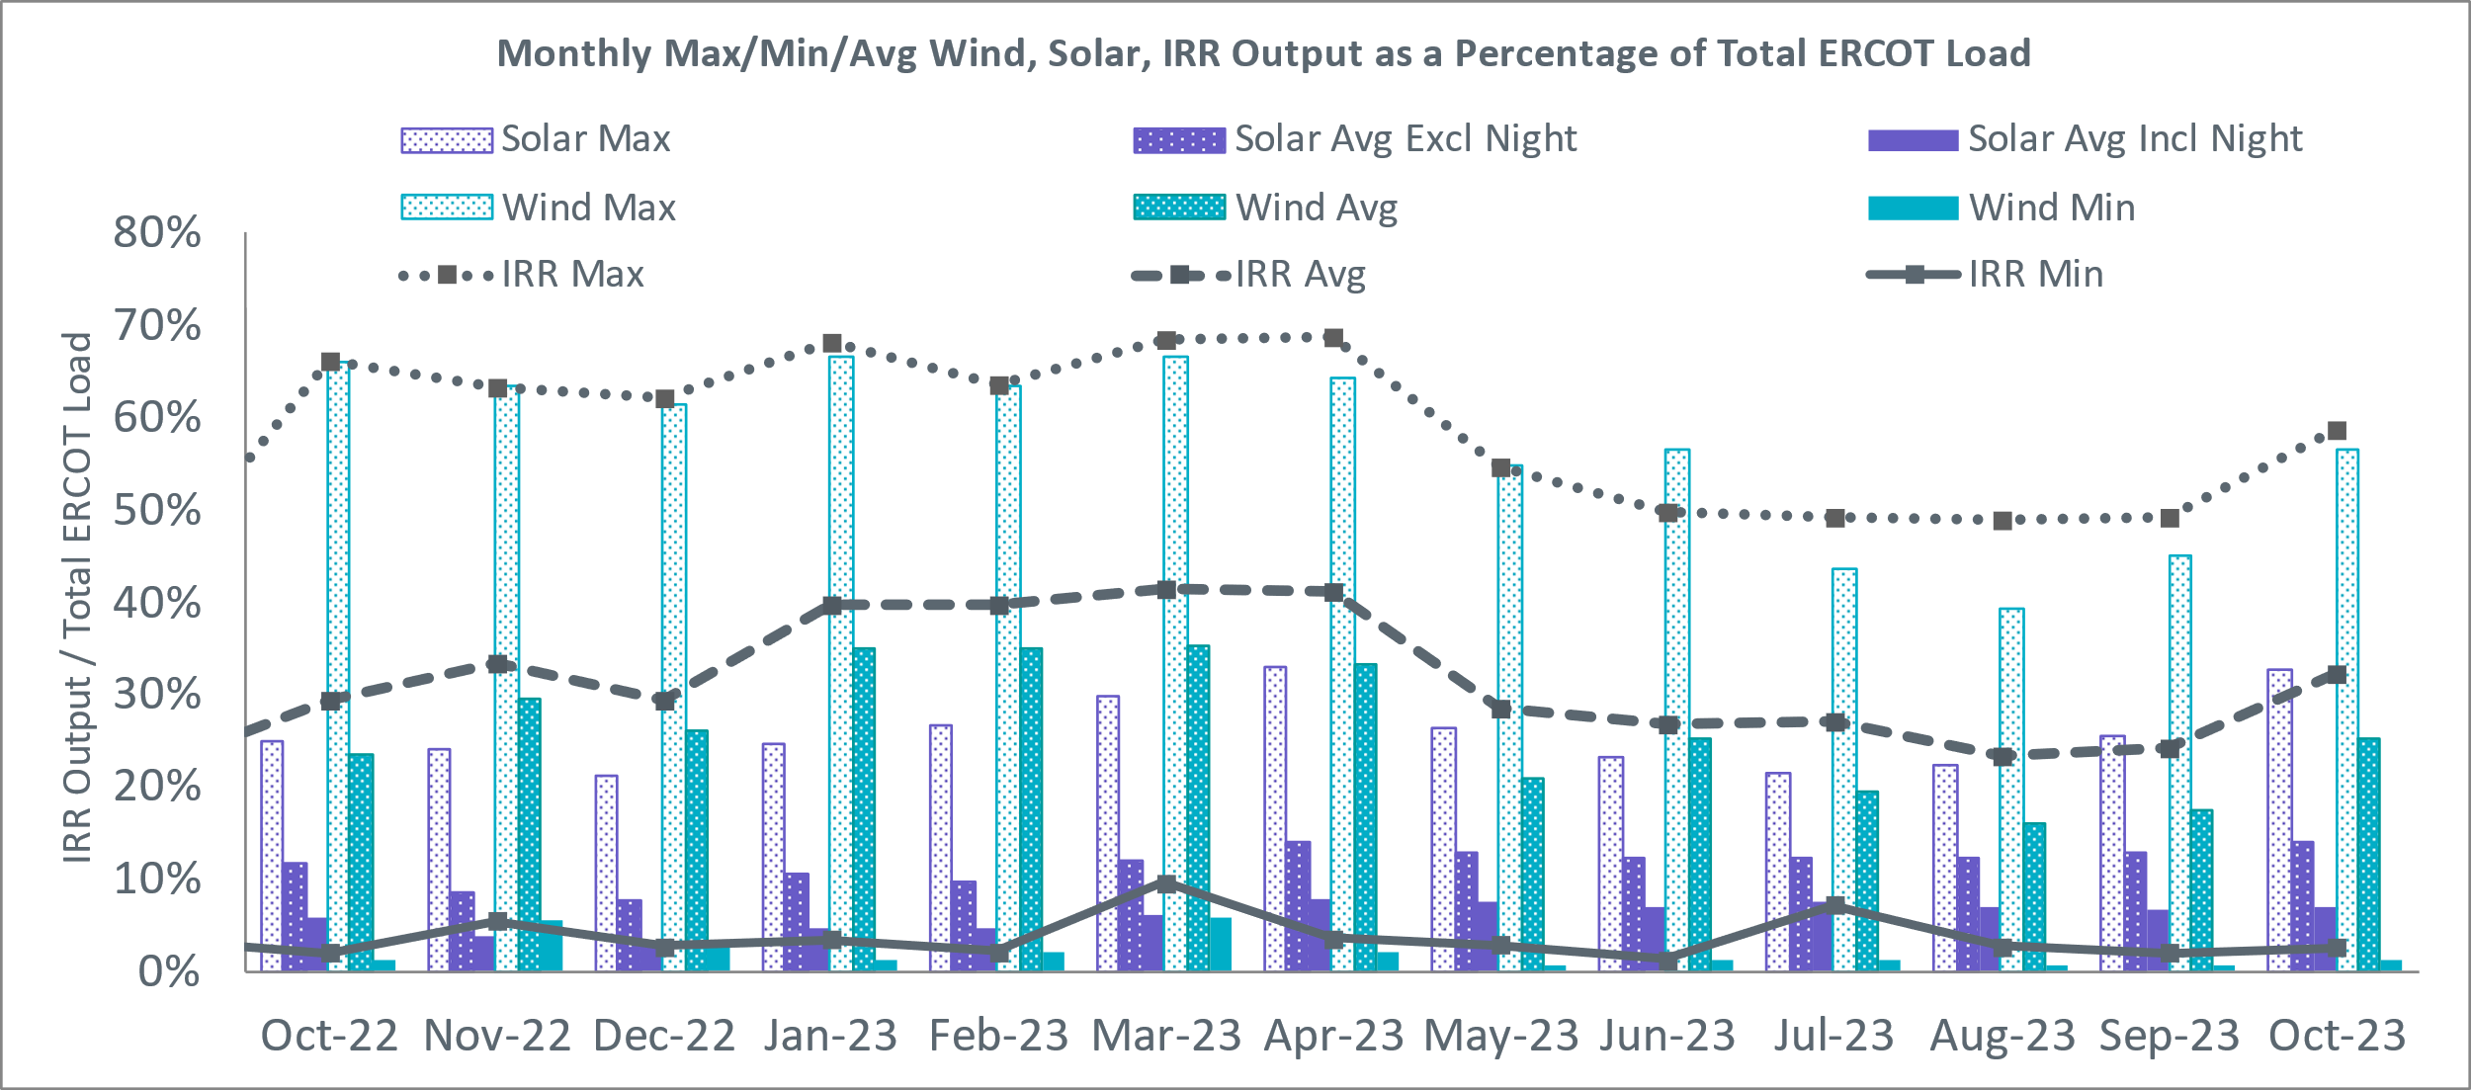

During the hour of peak load for the month, hourly integrated wind generation was 6,133 MW and solar generation was 11,693 MW. The graph below shows the wind and solar penetration percentage during the hour of the peak load in the last 13 months.

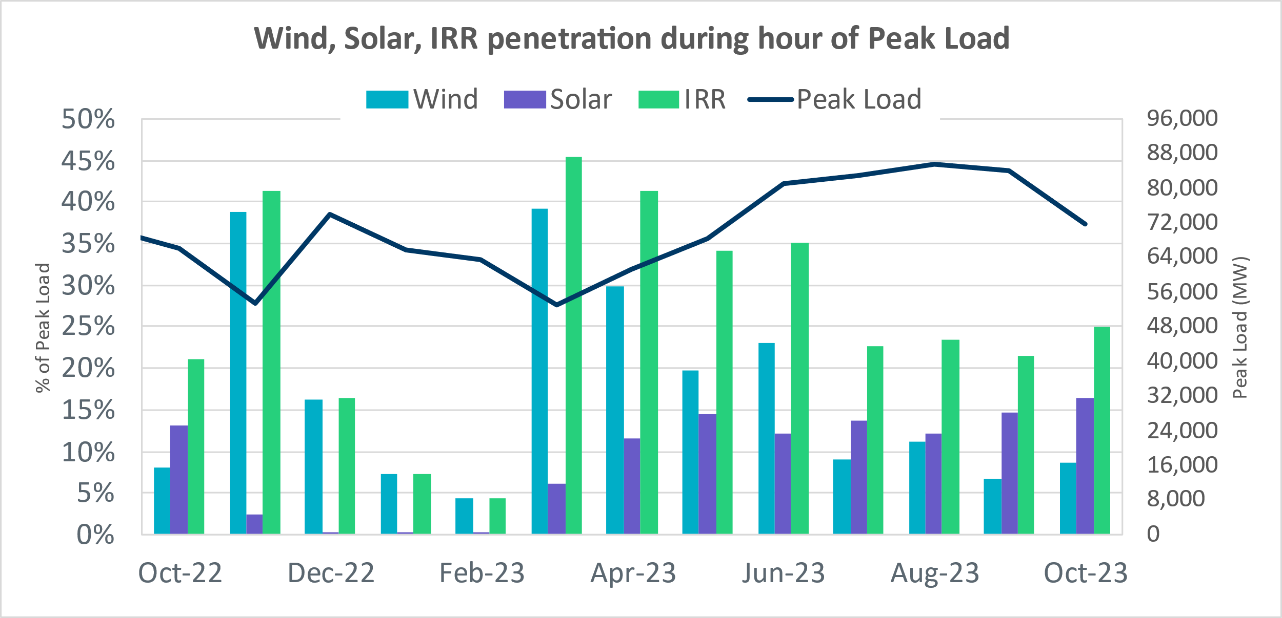

Lastly, the graph below shows the minimum wind, solar and IRR output during the peak load hour as a percentage of the daily peak load for every day in the month.

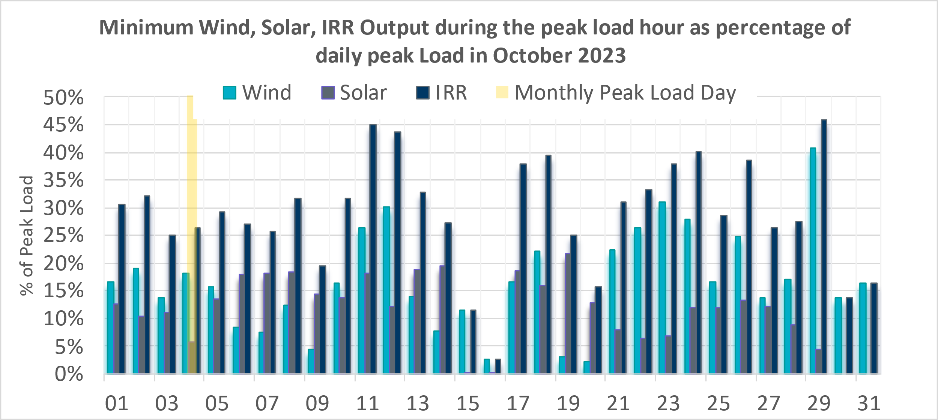

Largest Net-Load Ramps
The net-load ramp is defined as the change in net-load (load minus wind and PVGR generation) during the defined time horizon. Such a variation in net-load needs to be accommodated in grid operations to ensure that the reliability of the grid is satisfactorily maintained. The largest net-load ramp during 5-min, 10-min, 15-min, 30-min, and 60-min in October 2023 is 2789 MW, 3018 MW, 4023 MW, 7209 MW, and 10797 MW, respectively. The comparison with respect to the historical values is given in the table below.

Month and Year | 5 min | 10 min | 15 min | 30 min | 60 min
October 2014 | 780 MW | 1,796 MW | 2,152 MW | 2,780 MW | 4,579 MW
October 2015 | 1,141 MW | 1,553 MW | 1,839 MW | 2,779 MW | 4,606 MW
October 2016 | 863 MW | 1,543 MW | 2,035 MW | 3,213 MW | 5,335 MW
October 2017 | 812 MW | 1,338 MW | 1,820 MW | 3,029 MW | 5,347 MW
October 2018 | 860 MW | 1,386 MW | 1,907 MW | 2,824 MW | 5,346 MW
October 2019 | 1,192 MW | 1,728 MW | 2,465 MW | 3,537 MW | 6,408 MW
October 2020 | 1,048 MW | 1,600 MW | 2,488 MW | 3,578 MW | 6,269 MW
October 2021 | 1,371 MW | 1,949 MW | 2,709 MW | 5,037 MW | 9,438 MW
October 2022 | 925 MW | 1,645 MW | 2,292 MW | 4,366 MW | 7,413 MW
October 2023 | 2,789 MW | 3,018 MW | 4,023 MW | 7,209 MW | 10,797 MW
All months in 2014-2023 | 2,789 MW | 3,018 MW | 4,023 MW | 7,209 MW | 10,797 MW

Congestion Analysis

Notable Constraints
Nodal protocol section 3.20 specifies that ERCOT shall identify transmission constraints that are binding in Real-Time three or more Operating Days within a calendar month. As part of this process, ERCOT reports congestion that meets this criterion to ROS. In addition, ERCOT also highlights notable constraints that have an estimated congestion rent exceeding $1,000,000 for a calendar month. These constraints are detailed in the table below, including approved transmission upgrades from TPIT that may provide some congestion relief based on ERCOT’s engineering judgement. Rows highlighted in blue indicate the congestion was affected by one or more outages. For a list of all constraints activated in SCED, please see Appendix A at the end of this report.

Contingency Name | Overloaded Element | # of Days Constraint Binding | Congestion Rent | Transmission Project
MGSES TO CCRSW 345 AND BTRCK TO MGSES 345 DBLCKT | Tonkawa Switch - Morgan Creek Ses 345kV | 14 | $21,344,698.20
Basecase | PNHNDL GTC | 15 | $15,685,049.98
CONSW-MGSES_and_CONSW-LNGSW_345kV_DBLCKT | Lamesa - Jim Payne Poi 138kV | 18 | $15,422,461.30
Manual Contingency Arroz - El Campo 138 KV | Blessing - Pavlov 138kV | 13 | $9,316,209.97
CONSW-MGSES_and_CONSW-LNGSW_345kV_DBLCKT | Polecat Creek Switch - Dewey Lake Tap 138kV | 22 | $9,263,733.33
BOWMAN SWITCH TRX BOMSW_3_2 345/138 | Fisher Road Switch - Wichita Falls 138kV | 8 | $8,894,697.89
Basecase | EASTEX GTC | 7 | $8,369,719.21
Basecase | WESTEX GTC | 11 | $7,035,661.15
Basecase | NE_LOB GTC | 24 | $6,609,742.02 | The Lower Rio Grande Valley (LRGV) System Enhancement Project (21RPG017) will improve the NorthEd_LoboGTC to support up to 80% of total wind and solar generation capacity in the LRGV area.
Onion-Pilot&Garfield-Hicross 138kV | Lytton Springs 345kV | 2 | $4,528,746.70
Austro-Daffin&Dunlap-Decker 138kV | Gilleland Creek - Mcneil 138kV | 2 | $3,294,775.22
MEADOW to PH ROBINSON LIN A | North Alvin Tnp - Alvin Tnp 138kV | 6 | $3,175,516.46
Hutto-Zorn & Gillcr 345kV | Hutto Switch 345kV | 9 | $3,103,755.02
Mccala-Henne & Zorn 138kV | Lytton Springs 345kV | 1 | $2,747,043.01
FORT WORTH SUBSATION to FORT WORTH SUBSATION LIN 1 | West Denton - Rd Wells Interchange 138kV | 3 | $2,450,822.20
LON HILL to NELSON SHARPE LIN 1 | Nelson Sharpe 345kV | 13 | $1,894,887.86
MEADOW to OASIS LIN A | Monsan Cogen - Petson 138kV | 9 | $1,672,524.24
BAKERSFIELD SWITCHYARD to CEDAR CANYON LIN 1 | Hargrove - Twin Buttes 138kV | 4 | $1,550,798.01
CROSS to CROSS LIN 1 | Pearsall Switching Station 138kV | 13 | $1,515,762.07 | STEC_76790_upgradePearsallAuto (76790)
DOUBLE MOUNTAIN SWITCH to DOUBLE MOUNTAIN SWITCH LIN 1 | Holly Substation - Dunbar Substation 115kV | 3 | $1,371,779.12
GARFIELD AEN to GARFIELD AEN LIN 1 | Onion Creek - Pilot Knob 138kV | 1 | $1,364,923.76
MIDKIFF SWITCH to SKYWEST LIN 1 | Driver - Skywest 138kV | 4 | $1,355,261.98
BAKERSFIELD SWITCHYARD to CEDAR CANYON LIN 1 | San Angelo Concho - San Angelo Lake Nasworthy 69kV | 7 | $1,328,816.53
SAN ANGELO RED CREEK to Weiss LIN 1 | Steamboat - Winters 69kV | 7 | $1,304,780.11
STP SWITCH to Esperanza LIN 1 | Blessing - Pavlov 138kV | 7 | $1,282,924.08
McColl Rd to N Edinburg & N Edinburg to N McAllen | Hidalgo Energy Center - Azteca Sub 138kV | 8 | $1,111,821.12
ODESSA EHV SWITCH to ODESSA EHV SWITCH LIN 1 | Koch Tap - Vealmoor 138kV | 4 | $1,044,762.71
BLACKWATER DRAW SWITCH to DOUBLE MOUNTAIN SWITCH LIN 1 | Mackenzie Substation - Northeast Substation 115kV | 3 | $1,030,294.44
Basecase | VALEXP GTC | 11 | $974,955.44 | The Lower Rio Grande Valley (LRGV) System Enhancement Project (21RPG017) will improve but not eliminate the need for this GTC.
WHITEPOINT TRX 345A 345/138 | Pawnee Switching Station - Tango 345kV | 3 | $856,156.67
DMTSW TO SCOSW 345 DBLCKT | Knapp - Scurry Chevron 138kV | 6 | $761,652.69
CCRSW TO SWESW 345 AND BTRCK TO MGSES 345 DBLCKT | Tonkawa Switch - Morgan Creek Ses 345kV | 5 | $760,304.76
Manual STP to HLJ & Anstrom345 KV DOUBLE | Sea Drift Coke - North Carbide 138kV | 6 | $721,936.12
Manual dbl ckt for NEDIN-BONILLA 345kV & RIOH-PRIM138kV | Burns Sub - Rio Hondo 138kV | 9 | $711,278.89 | STEC_71930_RioHondo_Burns_Upgrade (71930), STEC_71926_Burns_Heidelberg_Upgrade (71926), STEC_71928_Heidelberg_AEPWeslaco_Upgrade (71928)
manual FOWL RTON to LOBO 345 KV | Laredo Vft North - Las Cruces 138kV | 7 | $669,310.97
SALSW TO KLNSW 345 DBLCKT | Harker Heights South - Killeen Switch 138kV | 5 | $626,707.96
manual FOWL RTON to LOBO 345 KV | Catarina - Piloncillo 138kV | 5 | $526,768.90 | AEP_TCC_AshertontoPiloncillo138kVLine_rebuild (73100)
CENTERVILLE ROAD SWITCH to CENTERVILLE ROAD SWITCH LIN 1 | Mesquite Forney Road - Buckner Home 138kV | 3 | $516,428.94
LAS PULGAS to RAYMONDVILLE 2 LIN 1 | Haine Drive - La Palma 138kV | 3 | $489,088.41
DUPONT SWITCH - INGLESIDE to DUPONT SWITCH - INGLESIDE LIN 1 | Dupont Switch - Ingleside - Lge 138kV | 5 | $353,145.94
MEADOW to PH ROBINSON LIN A | Magnolia Tnp - Seminole Tnp 138kV | 3 | $335,288.23 | TNMP_4010_MAG_SEM_G138_10B_REBUILD (4010)
CEDAR BAYOU PLANT to CEDAR BAYOU PLANT LIN 1 | Cedar Bayou Plant - Baytown 138kV | 3 | $316,154.55
Basecase | TRDWEL GTC | 16 | $303,765.36
LON HILL TRX LON_HILL_3_1 345/138 | Nelson Sharpe 345kV | 4 | $285,830.10
Loss of NEDIN train | Burns Sub - Rio Hondo 138kV | 3 | $274,556.51 | STEC_71930_RioHondo_Burns_Upgrade (71930), STEC_71926_Burns_Heidelberg_Upgrade (71926), STEC_71928_Heidelberg_AEPWeslaco_Upgrade (71928)
manual FOWL RTON to LOBO 345 KV | Falfurrias - Premont 69kV | 4 | $270,079.27
Cagnon-Kendal 345 & Cico-Mengcr 138 | Medina Lake - Pipe Creek 138kV | 3 | $267,950.49
FOWLERTON TRX FOWLRTON_AUTO1 345/138 | Catarina - Piloncillo 138kV | 4 | $229,937.21
Loss of DUKE (train) | Burns Sub - Rio Hondo 138kV | 3 | $229,622.72 | STEC_71930_RioHondo_Burns_Upgrade (71930), STEC_71926_Burns_Heidelberg_Upgrade (71926), STEC_71928_Heidelberg_AEPWeslaco_Upgrade (71928)
Cagnon-Kendal 345 & Cico-Comfor 138 | Bergheim - Kendall 345kV | 3 | $224,766.77
BEALS CREEK SUB to BEALS CREEK SUB LIN _A | Big Spring West - Stanton East 138kV | 9 | $218,235.82
Jn-Fd & Ro 138kV | Brays - H O Clarke 138kV | 4 | $200,937.03
Manual Contingency Arroz - El Campo 138 KV | Lane City - Pavlov 138kV | 3 | $193,541.42
FOWLERTON TRX FOWLRTON_AUTO1 345/138 | Falfurrias - Premont 69kV | 3 | $186,562.08
SWESW TO BTRCK AND SWESW TO CCRSW 345 DBLCKT | Tonkawa Switch - Morgan Creek Ses 345kV | 3 | $184,343.67
TWR(345) WAP-WLF64 & CCK-WLY72 | Blessing - Pavlov 138kV | 4 | $119,875.55
ENNIS WEST SWITCH to ENNIS WEST SWITCH LIN _C | Trumbull 138kV | 3 | $119,126.93
COLETO CREEK to COLETO CREEK LIN 1 | Pawnee Switching Station - Tango 345kV | 4 | $104,384.20
FORT LANCASTER to FORT LANCASTER LIN 1 | Hamilton Road - Maxwell 138kV | 3 | $95,650.51 | AEP_TCC_HamiltonRoad-Maxwell(20RPG022, MOD 61396)
Bighil-Kendal 345kV | Hamilton Road - Maxwell 138kV | 3 | $89,979.96 | AEP_TCC_HamiltonRoad-Maxwell(20RPG022, MOD 61396)
Manual for I_DUPS - RESNIK & MCCAMPBE 2 138KV | Whitepoint - Rincon 138kV | 4 | $86,167.93
FT LANCASTER - FRIEND RANCH 138 & FT LANCASTER - ILLINOIS 138 | Hamilton Road - Maxwell 138kV | 4 | $80,362.84 | AEP_TCC_HamiltonRoad-Maxwell(20RPG022, MOD 61396)
PALODURO SUB to PEARSALL SWITCHING STATION LIN 1 | Pearsall Switching Station 138kV | 3 | $77,534.37 | STEC_76790_upgradePearsallAuto (76790)
COLEMAN LAKE IVIE TAP to COLEMAN LAKE IVIE TAP LIN 1 | Santa Anna 138kV | 3 | $72,140.37
AJO to AJO LIN 1 | Las Pulgas - Raymondville 2 138kV | 9 | $71,317.40
Carver to Carver LIN 1 | Maddux - San Angelo Power Station 138kV | 4 | $67,017.87
BLUFF CREEK to NICOLE LIN 1 | Tennyson - Nicole 138kV | 10 | $53,708.87
Rns-Rtw & Sng-Tb 345kV | Th Wharton - Zenith 345kV | 3 | $42,624.33
LAQUINTA to LOBO LIN 1 | Bruni Sub 138kV | 5 | $31,370.14
YELWJCKT - TREADWEL (138) & MENPHTAP (69) | Maddux - San Angelo Power Station 138kV | 3 | $27,687.29
KING RANCH GAS PLANT to FALFURRIAS LIN 1 | Falfurrias - Premont 69kV | 3 | $24,282.76
VICTORIA to LOOP 463 SUB LIN 1 | Kamey Sub - Port Lavaca Sub 69kV | 3 | $21,658.79
COLETO CREEK to VICTORIA LIN 1 | Coleto Creek - Victoria 138kV | 3 | $19,395.81
ZORN - HAYSEN 345KV | Bergheim 138kV | 3 | $17,492.92
HAYS ENERGY to ZORN LIN 1 | Zorn - Hays Energy 345kV | 3 | $15,540.51
Basecase | NELRIO GTC | 8 | $10,396.60 | The Lower Rio Grande Valley (LRGV) System Enhancement Project (21RPG017) will cause there to be no stability constraint for NelsonSharpe_RioHondoGTC under normal conditions.
MADDUX to SAN ANGELO POWER STATION LIN 1 | Maddux - San Angelo Power Station 138kV | 3 | $3,340.21

Generic Transmission Constraint Congestion
There were 25 days congestion on the North Edinburg to Lobo GTC, 18 days on the Panhandle GTC, 16 days on the Treadwell GTC, 13 days on the West Texas Export GTC, 13 days on the Valley Export GTC, 12 days on the Nelson Sharpe to Rio Hondo GTC, 10 days on the North to Houston GTC, 8 days on the East Texas GTC, and 1 days on the Rio Grande Valley Import GTC. There was no activity on the remaining GTCs during the month.

Note: This is how many times a constraint has been activated to avoid exceeding a GTC limit, it does not imply an exceedance of the GTC occurred or that the GTC was binding.

Manual Overrides
There were no overrides for the month of October.

Congestion Costs for Calendar Year 2023
The following table represents the top twenty active constraints for the calendar year based on the estimated congestion rent attributed to the congestion. ERCOT updates this list on a monthly basis.

Contingency | Overloaded Element | # of 5-min SCED | Estimated Congestion Rent (2023)
Elmcreek-Sanmigl 345kV | Pawnee Switching Station - Calaveras 345kV | 9887 | 165023384.8
TWR(345) WAP-WLF64 & WAP-WLY72 | South Texas Project - Wa Parish 345kV | 5163 | 89574495.11
MAN_DBL_MDSSW-ODEHB_and_CONSW-QALSW_345kV_DBLCKT | Midessa South Sw 138kV | 11605 | 79014288.16
Basecase | NE_LOB GTC | 36590 | 64723265.9
MGSES TO CCRSW 345 AND BTRCK TO MGSES 345 DBLCKT | Tonkawa Switch - Morgan Creek Ses 345kV | 9162 | 63785842.23
Basecase | WESTEX GTC | 17202 | 61715483.24
BEVO to BEVO LIN 1 | Hamilton Road - Maverick 138kV | 7549 | 52011887.52
Rattlesnake Rd Switch to LAKE CREEK SES LIN _A | St Johns Switch - Jewett 345kV | 4881 | 45754231.09
SKYWEST to SKYWEST LIN 1 | Consavvy Switch - Cottonfield Sub 138kV | 2909 | 45341291.63
SKYWEST to SKYWEST LIN 1 | South Midland - Consavvy Switch 138kV | 10282 | 41928489.3
Basecase | PNHNDL GTC | 10581 | 40321372.41
HICKS SWITCH to HICKS SWITCH LIN _A | Hicks Switch - Alliance 345kV | 2814 | 40032160.11
SALSW - HUTTO 345KV | Bell County - Salado Switch 138kV | 4538 | 37595853.7
TWR(345) WAP-WLF64 & CCK-WLY72 | South Texas Project - Wa Parish 345kV | 4025 | 34465421.37
BLACKWATER DRAW SWITCH to DOUBLE MOUNTAIN SWITCH LIN 1 | Mackenzie Substation - Northeast Substation 115kV | 9350 | 32319339.95
Austro-Daffin&Dunlap-Decker 138kV | Sim Gideon - Bastrop City 138kV | 2244 | 28796696.82
DMTSW TO SCOSW 345 DBLCKT | Knapp - Scurry Chevron 138kV | 10431 | 27311058.52
Manual_SGL_CONSW-MDSSW_345kV_SglCkt | Quail Switch - Odessa Ehv Switch 345kV | 3594 | 26545479.5
Manual dbl ckt for NEDIN-BONILLA 345kV & RIOH-PRIM138kV | Burns Sub - Rio Hondo 138kV | 10813 | 24587931.47
COLETO CREEK to Euler LIN 1 | Coleto Creek - Rosata Tap 138kV | 7349 | 24015793.92

System Events

ERCOT Peak Load
The unofficial ERCOT peak load for the month was 71,181 MW and occurred on 10/04/2023, during hour ending 17:00.

Load Shed Events
None.

Stability Events
None.

Notable PMU Events
ERCOT analyzes PMU data for any significant system disturbances that do not fall into the Frequency Events category reported in section 2.1. The results are summarized in this section once the analysis has been completed.

There were no PMU events outside of those reported in section 2.1.

DC Tie Curtailment
None.

TRE/DOE Reportable Events

- Oncor Submitted a DOE-417 on 10/04/2023 for Loss of 50,000 customers
- BPUB Submitted a DOE-417 on 10/06/2023 for Physical threat to its facility
- RWE Submitted a EOP-004-4 on 10/07/2023 Damage or destruction of a Facility
- AEN Submitted a DOE-417 on 10/12/2023 Damage or destruction of a Facility
- RWE Submitted a EOP-004-4 on 10/24/2023 Damage or destruction of a Facility

New/Updated Constraint Management Plans

There were 3 CMP modifications: MP_2023_09, MP_2023_13, MP_2023_01

New/Modified/Removed RAS
None.

New Procedures/Forms/Operating Bulletins
Date | Subject | Bulletin No.
10/03/2023 | Real Time Desk V1 Rev 88 | 1100
10/03/2023 | Scripts V1 Rev 51 | 1101
10/03/2023 | Transmission and Security Desk V1 Rev 101 | 1102
10/30/2023 | Communications Protocols V1 Rev 10 | 1103
10/30/2023 | Reliability Risk Desk Operating Procedure V1 Rev 33 | 1104
10/30/2023 | Resource Desk V1 Rev 77 | 1105
10/30/2023 | Real Time Desk V1 Rev 89 | 1106
10/30/2023 | Scripts V1 Rev 52 | 1107
10/30/2023 | Shift Supervisor Desk V1 Rev 91 | 1108
10/30/2023 | Transmission and Security Desk V1 Rev 102 | 1109

Emergency Conditions

OCNs
Date and Time | Message
Oct 16, 2023 15:00 | ERCOT issued an Advanced Action Notice (AAN) due to possible future emergency condition of reserve capacity deficiency on Friday, October 20, 2023 HE19 – HE2000. ERCOT may delay/withdraw accepted Resource Outages. ERCOT may seek up to 1950 MW from an OAE and them make the OSA. On Tuesday, October 17, 2023 at 15:00ERCOT will execute an OAE if deemed necessary.
Oct 17, 2023 15:00 | ERCOT updated an Advanced Action Notice (AAN) due to conditions changing and possible future emergency condition of reserve capacity deficiency beginning October 20, 2023 HE19 – HE2000. ERCOT may delay/withdraw accepted Resource Outages. ERCOT may seek up to 2895 MW from an OAE and them make the OSA. On October 17, 2023 at 15:00, ERCOT will execute an OSA if deemed necessary.
Oct 18,2023 13:30  CPT | ERCOT issued an OCN for extreme hot weather with forecasted temperatures to be up to 94F in the North Central and South Central weather zones from Friday October 20, 2023 until Saturday October 21,2023.
Oct 20, 2023 10:11 | ERCOT has executed the OSA process due to possible future Emergency Conditions of reserve capacity deficiency projected for OSA period Friday October 20, 2023 HE 19 -20. Outages not moved prior to October 17, 2023 have been considered an OSA.
Oct 23, 2023 8:42  CPT | ERCOT issued an OCN for the Westex IROL due planned outage and topology change.
Oct 27, 2023 13:30 | ERCOT issued an AAN due to possible Emergency Conditions of reserve capacity deficiency beginning Tuesday October 31, 2023 through Wednesday November 2, 2023 for HE 0700 – HE 0900 and HE 1900 – HE 2200 (Daily). ERCOT may withdraw/delay approved or accepted Resource Outages. ERCOT may seek up to 6,400 MW from an OAE and then make the OSA. On Saturday October 28, 2023 at 13:30, ERCOT will execute an OAE if deemed necessary.
Oct 28, 2023 12:00 | ERCOT updated an AAN due to conditions changing and a possible future Emergency Condition of reserve capacity deficiency beginning Tues October 31, 2023 through November 2, 2023 for HE 0700 – HE 0900 and HE 1900 -- HE 2200 (Daily). ERCOT may withdraw/delay approved or accepted Resource outages. ERCOT may seek up to 5,168 MW from an OAE and then make OSA. On October 28, 2023 at 13:30, ERCOT will execute an OSA if deemed necessary.
Oct 28, 2023 13:30 | ERCOT executed the OSA process due to possible future Emergency Condition of reserve capacity deficiency projected for OSA period Tuesday October 31, 2023 through November 2, 2023 for HE 0700 – HE 0900 and HE 1900 – HE 2200 (Daily). Outages not moved voluntarily prior to October 29,2023 at 13:30 will be considered an OSA.
Oct 30, 2023 09:36  CPT | ERCOT issued an OCN for the Westex IROL due planned outage and topology change.

Advisories
Date and Time | Message
Oct 04, 2023 12:29  CPT | ERCOT issued an Advisory due to ERCOTs Voltage Security Assessment Tool has not solved in the last 30 minutes.
Oct 22, 2023 17:11  CPT | ERCOT issued an Advisory for the timeline deviation of the Day Ahead Market.

Watches
Date and Time | Message
Oct 22, 2023 14:05  CPT | ERCOT issued a watch for HRUC failure.
Oct 22, 2023 18:11  CPT | ERCOT issued a watch for DRUC not completing by 1800, due to DAM timeline deviation.

Emergency Notices
None.

Application Performance

TSAT/VSAT Performance Issues
None

Communication Issues
None.

Market System Issues
None.

Model Updates
The Downstream Production Change (DPC) process allows ERCOT to make changes in the on-line Network Operations Model without loading a completely new model. The purpose of this process is to allow for reliable grid operations as system conditions change between designated Network Operations Model database loads. The DPC process is limited in scope to just those items listed below, with equipment ratings updates being the most common. ERCOT has seen a rise in the use of the DPC process to make on-line updates to the Network Operations Model in recent years, instead of through the standard Network Operations Model Change Request process.

- Static Line ratings (Interim Update)
- Dynamic Line ratings (non-Interim Update)
- Autotransformer ratings (non-Interim Update)
- Breaker and Switch Normal status (Interim Update)
- Contingency Definitions (Interim Update)
- RAP and RAS changes or additions (Interim Update)
- Net Dependable and Reactive Capability (NDCRC) values (Interim Update)
- Impedance Updates (non-Interim)

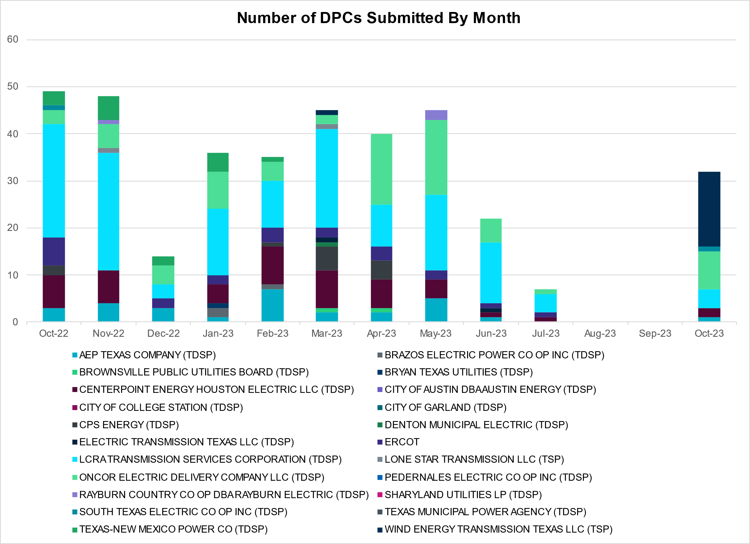

Transmission Operator | Number of DPCs
AEP TEXAS COMPANY (TDSP) | 1
BRAZOS ELECTRIC POWER CO OP INC (TDSP) | 0
BROWNSVILLE PUBLIC UTILITIES BOARD (TDSP) | 0
BRYAN TEXAS UTILITIES (TDSP) | 0
CENTERPOINT ENERGY HOUSTON ELECTRIC LLC (TDSP) | 2
CITY OF AUSTIN DBA AUSTIN ENERGY (TDSP) | 0
CITY OF COLLEGE STATION (TDSP) | 0
CITY OF GARLAND (TDSP) | 0
CPS ENERGY (TDSP) | 0
DENTON MUNICIPAL ELECTRIC (TDSP) | 0
ELECTRIC TRANSMISSION TEXAS LLC (TDSP) | 0
ERCOT | 0
LCRA TRANSMISSION SERVICES CORPORATION (TDSP) | 4
LONE STAR TRANSMISSION LLC (TSP) | 0
ONCOR ELECTRIC DELIVERY COMPANY LLC (TDSP) | 8
PEDERNALES ELECTRIC CO OP INC (TDSP) | 0
RAYBURN COUNTRY CO OP DBA RAYBURN ELECTRIC (TDSP) | 0
SHARYLAND UTILITIES LP (TDSP) | 0
SOUTH TEXAS ELECTRIC CO OP INC (TDSP) | 1
TEXAS MUNICIPAL POWER AGENCY (TDSP) | 0
TEXAS-NEW MEXICO POWER CO (TDSP) | 0
WIND ENERGY TRANSMISSION TEXAS LLC (TSP) | 0

Appendix A: Real-Time Constraints
The following is a complete list of constraints activated in SCED. Full contingency descriptions can be found in the Standard Contingencies List located on the MIS secure site at Grid Generation Reliability Unit Commitment.

Year | Month of the Year | Contingency Name | Overloaded Element | From Station | To Station | Count of Days
2023 | 10 | BASE CASE | NE_LOB | n/a | n/a | 24
2023 | 10 | DCONLNG5 | 14040__A | PCTSW | DEWTP | 23
2023 | 10 | DCONLNG5 | 6095__D | LMESA | JPPOI | 23
2023 | 10 | DMGSBTR5 | 6036__A | TKWSW | MGSES | 20
2023 | 10 | BASE CASE | PNHNDL | n/a | n/a | 18
2023 | 10 | SNATBEA8 | 6144__A | BSPRW | STASW | 17
2023 | 10 | SCROSAN8 | PEARSALL_69_4 | PEARSALL | PEARSALL | 16
2023 | 10 | BASE CASE | TRDWEL | n/a | n/a | 16
2023 | 10 | DMGSBIT5 | 6036__A | TKWSW | MGSES | 15
2023 | 10 | SN_SLON5 | N_SHARPE_XF1 | N_SHARPE | N_SHARPE | 15
2023 | 10 | DMGSCON5 | 6095__D | LMESA | JPPOI | 15
2023 | 10 | SNICBLU8 | NICOLE_TENNYS1_1 | TENNYSON | NICOLE | 13
2023 | 10 | BASE CASE | WESTEX | n/a | n/a | 13
2023 | 10 | DSWECCR5 | 6036__A | TKWSW | MGSES | 13
2023 | 10 | XBOM358 | 6558__B | FSHSW | WFALS | 13
2023 | 10 | SNICBLU8 | NICOLE_TENNYS1_1 | NICOLE | TENNYSON | 13
2023 | 10 | MARREL_8 | BLESSI_PAVLOV1_1 | BLESSING | PAVLOV | 13
2023 | 10 | BASE CASE | NELRIO | n/a | n/a | 12
2023 | 10 | BASE CASE | VALEXP | n/a | n/a | 12
2023 | 10 | DMGSCON5 | 14040__A | PCTSW | DEWTP | 12
2023 | 10 | SBAKCED5 | CONCHO_SANW0_1 | CONCHO | SANW | 11
2023 | 10 | DMTSCOS5 | 6437__F | SCRCV | KNAPP | 11
2023 | 10 | BASE CASE | N_TO_H | n/a | n/a | 10
2023 | 10 | MHARNED5 | BURNS_RIOHONDO_1 | RIOHONDO | MV_BURNS | 10
2023 | 10 | SN_SAJO5 | LASPUL_RAYMND1_1 | LASPULGA | RAYMND2 | 10
2023 | 10 | DHUTHUT5 | HUTTO_MR2H | HUTTO | HUTTO | 9
2023 | 10 | SMDOOAS5 | MSNPET04_A | PET | MSN | 9
2023 | 10 | SCRMSAR8 | STMBOA_WINT1_1 | STMBOAT | WINT | 9
2023 | 10 | MFOWLOB5 | LARDVN_LASCRU1_1 | LARDVNTH | LASCRUCE | 9
2023 | 10 | MRESMCM8 | RINCON_WHITE_2_1 | WHITE_PT | RINCON | 9
2023 | 10 | SSTPESP8 | BLESSI_PAVLOV1_1 | BLESSING | PAVLOV | 8
2023 | 10 | DMCOPHA8 | AZTECA_HEC1_1 | HEC | AZTECA | 8
2023 | 10 | DSTPRED5 | BLESSI_PAVLOV1_1 | BLESSING | PAVLOV | 8
2023 | 10 | BASE CASE | EASTEX | n/a | n/a | 8
2023 | 10 | MSTPANS5 | NCARBI_SEADRF1_1 | NCARBIDE | SEADRFTC | 8
2023 | 10 | DODEMOS5 | 6095__D | LMESA | JPPOI | 8
2023 | 10 | SW_GODE5 | 15060__B | VEALMOOR | KOCHTAP | 7
2023 | 10 | MFOWLOB5 | CATARI_PILONC1_1 | CATARINA | PILONCIL | 7
2023 | 10 | MFOWLOB5 | CATARI_PILONC1_1 | PILONCIL | CATARINA | 7
2023 | 10 | SBONNED5 | BURNS_RIOHONDO_1 | RIOHONDO | MV_BURNS | 6
2023 | 10 | DWPWFCK5 | BLESSI_PAVLOV1_1 | BLESSING | PAVLOV | 6
2023 | 10 | SSKYSB28 | PRONGHRN_SALTF_1 | PRONGHRN | SALTFLAT | 6
2023 | 10 | DWPWFWP5 | BLESSI_PAVLOV1_1 | BLESSING | PAVLOV | 6
2023 | 10 | SBAKCED5 | HARGRO_TWINBU1_1 | TWINBU | HARGROVE | 6
2023 | 10 | SBENS_M8 | BENTS_FRTER_1C_1 | S_MISSIN | RAILROAD | 6
2023 | 10 | SMDOPHR5 | 138_ALV_NAL_1 | TNNALVIN | ALVIN | 6
2023 | 10 | SLGEI_D8 | I_DUPS_LGE1_1 | I_DUPSW | LGE | 6
2023 | 10 | SLGEI_D8 | I_DUPS_LGE1_1 | LGE | I_DUPSW | 6
2023 | 10 | SMDKSBY8 | DRIVER_SKYWEST_1 | SKYWES | DRIVER | 5
2023 | 10 | SKINFAL8 | FALFUR_PREMON1_1 | FALFUR | PREMONT | 5
2023 | 10 | SBWDDBM5 | LPLMK_LPLNE_1 | LPLMK | LPLNE | 5
2023 | 10 | DCC3_NED | BURNS_RIOHONDO_1 | RIOHONDO | MV_BURNS | 5
2023 | 10 | DSALKLN5 | 630__B | KLNSW | HHSTH | 5
2023 | 10 | MFOWLOB5 | FALFUR_PREMON1_1 | FALFUR | PREMONT | 5
2023 | 10 | MARREL_8 | LAN_CT_PAVLOV1_1 | PAVLOV | LAN_CTY | 5
2023 | 10 | DRNS_TB5 | THWZEN71_A | ZEN | THW | 5
2023 | 10 | DCAGCI58 | 255T279_1 | PIPECR | MEDILA | 5
2023 | 10 | DJN_RO28 | BR_HOC09_A | BR | HOC | 5
2023 | 10 | SDBMFID5 | LPLHY_LPLDB_1 | LPLDB | LPLHY | 5
2023 | 10 | SHAYZO25 | 6T227_1 | HAYSEN | ZORN | 5
2023 | 10 | SLAQLOB8 | BRUNI_69_1 | BRUNI | BRUNI | 5
2023 | 10 | SILLFTL8 | HAMILT_MAXWEL1_1 | MAXWELL | HAMILTON | 5
2023 | 10 | DFRIILL8 | HAMILT_MAXWEL1_1 | MAXWELL | HAMILTON | 4
2023 | 10 | SCOLBAL8 | SANA_FMR1 | SANA | SANA | 4
2023 | 10 | SLONLON8 | N_SHARPE_XF1 | N_SHARPE | N_SHARPE | 4
2023 | 10 | SGRICOL5 | PAWNEE_TANGO1_1 | TANGO | PAWNEE | 4
2023 | 10 | SVEAW_L5 | 6217__A | WLVSW | GAILS | 4
2023 | 10 | MFOWLOB5 | ASHERT_CATARI1_1 | CATARINA | ASHERTON | 4
2023 | 10 | SCARFRI8 | ATSO_SONR1_1 | SONR | ATSO | 4
2023 | 10 | MARRLAN8 | BLESSI_PAVLOV1_1 | BLESSING | PAVLOV | 4
2023 | 10 | XFOW58 | FALFUR_PREMON1_1 | FALFUR | PREMONT | 4
2023 | 10 | SCARLVO8 | MADDUX_SAPOWE1_1 | MADDUX | SAPOWER | 4
2023 | 10 | XWHI58 | PAWNEE_TANGO1_1 | TANGO | PAWNEE | 4
2023 | 10 | DCC1DUKE | BURNS_RIOHONDO_1 | RIOHONDO | MV_BURNS | 4
2023 | 10 | SCEDHI_5 | HARGRO_TWINBU1_1 | TWINBU | HARGROVE | 4
2023 | 10 | SNICBLU8 | ORNT_TENNYS1_1 | TENNYSON | ORNT | 4
2023 | 10 | MFOWLOB5 | ASHERT_CATARI1_1 | ASHERTON | CATARINA | 4
2023 | 10 | XFOW58 | CATARI_PILONC1_1 | PILONCIL | CATARINA | 4
2023 | 10 | DZORHAY5 | BERGHE_AT1L | BERGHE | BERGHE | 4
2023 | 10 | SVICCO28 | COLETO_VICTOR2_1 | COLETO | VICTORIA | 4
2023 | 10 | SMADSAP8 | MADDUX_SAPOWE2_1 | MADDUX | SAPOWER | 4
2023 | 10 | SKLELOY8 | LOYOLA_69_1 | LOYOLA | LOYOLA | 4
2023 | 10 | SMCCCNR5 | 1390__F | MESFR | BCKHM | 3
2023 | 10 | SRAYRI38 | HAINE__LA_PAL1_1 | LA_PALMA | HAINE_DR | 3
2023 | 10 | SMGIENW8 | TRU_UAT1 | TRU | TRU | 3
2023 | 10 | SFTWTEA8 | WD_RDWELLS_1 | W_DENT | RDWELLS | 3
2023 | 10 | SKEYWLV8 | 15060__B | VEALMOOR | KOCHTAP | 3
2023 | 10 | SCEDHI_5 | CONCHO_SANW0_1 | CONCHO | SANW | 3
2023 | 10 | SMDOPHR5 | G138_10B_1 | SEMINOLE | MAGNO_TN | 3
2023 | 10 | SCBYCBY8 | BT_CBY88_A | CBY | BT | 3
2023 | 10 | DHUTHUT5 | HUTTO_MR2L | HUTTO | HUTTO | 3
2023 | 10 | MSTPANG5 | NCARBI_SEADRF1_1 | NCARBIDE | SEADRFTC | 3
2023 | 10 | DCAGCO58 | 656T656_1 | KENDAL | BERGHE | 3
2023 | 10 | DBIGKEN5 | HAMILT_MAXWEL1_1 | MAXWELL | HAMILTON | 3
2023 | 10 | SL_4VIC8 | KAM_PRTL_1 | PRTLAVS | KAMEYS | 3
2023 | 10 | DYELME89 | MADDUX_SAPOWE1_1 | MADDUX | SAPOWER | 3
2023 | 10 | DCOLFA59 | PAWNEE_TANGO1_1 | TANGO | PAWNEE | 3
2023 | 10 | SENWSHK8 | 940__C | ENWSW | WXHCH | 3
2023 | 10 | SW_SDIV5 | CRTVLE_EINSTEN_1 | EINSTEIN | CRTRVLLE | 3
2023 | 10 | SBATPEA8 | PEARSALL_69_4 | PEARSALL | PEARSALL | 3
2023 | 10 | DAUSDUN8 | 211T147_1 | GILLCR | MCNEIL_ | 3
2023 | 10 | BASE CASE | MDOPHR99_A | MDO | PHR | 3
2023 | 10 | SLWVLWS8 | 588_A_1 | LWSVW | LWVTI | 2
2023 | 10 | DMGSCON5 | 6471__C | MGSES | NAVIG | 2
2023 | 10 | SILLFTL8 | CARVER_TINSLE1_1 | CARVER | TINSLEY | 2
2023 | 10 | SBAKCED5 | CEDRHI_SILT1_1 | CEDRHILL | SILT | 2
2023 | 10 | SCO2EUL8 | COLETO_ROSATA1_1 | COLETO | ROSATA | 2
2023 | 10 | SCOLBAL8 | CONAN_SANA1_1 | SANA_TAP | CONAN | 2
2023 | 10 | DYELHE89 | HEARTL_KATEMC1_1 | HEARTLAN | KATEMCY | 2
2023 | 10 | SMCEESK8 | LONGWR_ROBY1_1 | LONGWRTH | ROBY | 2
2023 | 10 | SNICBLU8 | ORNT_REDCRE1_1 | ORNT | REDCREEK | 2
2023 | 10 | DTVWCPS5 | 6000__A | BNBSW | SYCRK | 2
2023 | 10 | DELMSTP5 | BLESSI_PAVLOV1_1 | BLESSING | PAVLOV | 2
2023 | 10 | SBGLTWI8 | CONCHO_SANW0_1 | CONCHO | SANW | 2
2023 | 10 | DCALBEC8 | U2_X3_1 | BRAUNIG | X3 | 2
2023 | 10 | SPOCTE28 | WD_RDWELLS_1 | W_DENT | RDWELLS | 2
2023 | 10 | DSCOTKW5 | 15060__B | VEALMOOR | KOCHTAP | 2
2023 | 10 | SRRDLCS5 | 235__A | SJNSW | JEWET | 2
2023 | 10 | SW_GODE5 | 6095__D | LMESA | JPPOI | 2
2023 | 10 | DWAP_JN5 | BI_WAP50_A | WAP | BI | 2
2023 | 10 | SLOBSA25 | CATARI_PILONC1_1 | CATARINA | PILONCIL | 2
2023 | 10 | DWPWFCK5 | LAN_CT_PAVLOV1_1 | PAVLOV | LAN_CTY | 2
2023 | 10 | DBECKIR8 | U2_X3_1 | BRAUNIG | X3 | 2
2023 | 10 | DKENCA58 | 255T279_1 | PIPECR | MEDILA | 2
2023 | 10 | DCAGCI58 | 656T656_1 | KENDAL | BERGHE | 2
2023 | 10 | DENWSTE8 | 943__B | ENWSW | SHKSW | 2
2023 | 10 | SLOBSA25 | CATARI_PILONC1_1 | PILONCIL | CATARINA | 2
2023 | 10 | MARRLAN8 | LAN_CT_PAVLOV1_1 | PAVLOV | LAN_CTY | 2
2023 | 10 | SBAKCED5 | 6095__D | LMESA | JPPOI | 2
2023 | 10 | SLOBSA25 | ASHERT_CATARI1_1 | ASHERTON | CATARINA | 2
2023 | 10 | DBLBYWF5 | BLESSI_PAVLOV1_1 | BLESSING | PAVLOV | 2
2023 | 10 | DSTPRED5 | LAN_CT_PAVLOV1_1 | PAVLOV | LAN_CTY | 2
2023 | 10 | SCROSAN8 | POT_PEAR_1 | PEARSALL | POTEETS | 2
2023 | 10 | SAIRNCA8 | REFUG_VICTO_1C_1 | VICTORIA | OCONNOR | 2
2023 | 10 | DGIBZEN5 | SNGZEN98_A | SNG | ZEN | 2
2023 | 10 | XBAL89 | STMBOA_WINT1_1 | STMBOAT | WINT | 2
2023 | 10 | DMTSCOS5 | 6437__A | KNAPP | BCKSW | 2
2023 | 10 | SMCEESK8 | 6780__A | LONGWRTH | ESKSW | 2
2023 | 10 | DVANEDN8 | BLESSI_MIDFIE1_1 | BLESSING | MIDFIELD | 2
2023 | 10 | DELMSAN5 | PAWNEE_SPRUCE_1 | CALAVERS | PAWNEE | 2
2023 | 10 | DMTSCOS5 | 6240__C | SACRC | DPCRK | 2
2023 | 10 | DKENCA58 | 656T656_1 | KENDAL | BERGHE | 2
2023 | 10 | SMCEESK8 | 6780__A | ESKSW | LONGWRTH | 2
2023 | 10 | DMCEBUT8 | 6940__C | SWTWR | PLOWB | 2
2023 | 10 | MSTPANS5 | BLESSI_LOLITA1_1 | BLESSING | LOLITA | 2
2023 | 10 | SSANFOW5 | CATARI_PILONC1_1 | PILONCIL | CATARINA | 2
2023 | 10 | SFORYEL8 | HEXT_MASONS1_1 | MASONSW | HEXT | 2
2023 | 10 | SMCEESK8 | LONGWR_ROBY1_1 | ROBY | LONGWRTH | 2
2023 | 10 | DONIPIL8 | LYTTON_S_AT2H | LYTTON_S | LYTTON_S | 2
2023 | 10 | MWHILON5 | NCARBI_SEADRF1_1 | NCARBIDE | SEADRFTC | 2
2023 | 10 | SNOECED5 | HARGRO_TWINBU1_1 | TWINBU | HARGROVE | 2
2023 | 10 | DBIGKEN5 | TREADW_YELWJC1_1 | TREADWEL | YELWJCKT | 2
2023 | 10 | MFOWLOB5 | LASCRU_MILO1_1 | LASCRUCE | MILO | 1
2023 | 10 | SBWDDBM5 | LPLNE_LPLDB_1 | LPLNE | LPLDB | 1
2023 | 10 | SHA2MAX8 | MADDUX_SAPOWE1_1 | MADDUX | SAPOWER | 1
2023 | 10 | SCOMHA38 | MAXWEL_WHITIN1_1 | MAXWELL | WHITING | 1
2023 | 10 | MNEDLON5 | MV_YUT_RAYMND1_1 | MV_YUTT | RAYMND2 | 1
2023 | 10 | SMV_ALB8 | VAL_VERD_WSLCO_1 | MV_VALV4 | WESLACO | 1
2023 | 10 | SFTWW_D8 | WD_RDWELLS_1 | W_DENT | RDWELLS | 1
2023 | 10 | DCAGCI58 | 460T460_1 | MEDILA | W1 | 1
2023 | 10 | XBSP89 | 6685__A | CGRSW | CLCTY | 1
2023 | 10 | SABNABN8 | ATBR_MILES1_1 | MILES | ATBR | 1
2023 | 10 | XBSP89 | CEDRHI_SILT1_1 | CEDRHILL | SILT | 1
2023 | 10 | SORLPAU8 | CHLC_V_VERN1_1 | VERN | CHLC_VER | 1
2023 | 10 | BASE CASE | CP_MVCNT_1 | MV_CNTRA | COFFPORT | 1
2023 | 10 | SN_SAJO5 | HAINE__LA_PAL1_1 | LA_PALMA | HAINE_DR | 1
2023 | 10 | SNOERAN5 | HARGRO_TWINBU1_1 | TWINBU | HARGROVE | 1
2023 | 10 | SFORYEL8 | HEXT_YELWJC1_1 | HEXT | YELWJCKT | 1
2023 | 10 | BASE CASE | MADDUX_SAPOWE1_1 | MADDUX | SAPOWER | 1
2023 | 10 | SFORYEL8 | MASNPH_MASN1_1 | MASN | MASNPHT | 1
2023 | 10 | SL_4RAY8 | RAYBURN_69_2 | RAYBURN | RAYBURN | 1
2023 | 10 | DCE_RIO5 | RGCIT_ROMAS_1C_1 | ROMA_SW | ROMA | 1
2023 | 10 | SPHAWES8 | VAL_VERD_WSLCO_1 | MV_VALV4 | WESLACO | 1
2023 | 10 | SVANRAY8 | VND_PLCE_1 | PLCEDOS | VANBLT69 | 1
2023 | 10 | DCAGCO58 | 122T122_1 | COMFOR | RAYBAR | 1
2023 | 10 | SBAKCED5 | 14040__A | PCTSW | DEWTP | 1
2023 | 10 | SW_GW_L5 | 15060__B | VEALMOOR | KOCHTAP | 1
2023 | 10 | SKLNSAL5 | 271__A | KLNSW | SALSW | 1
2023 | 10 | DCAGTA58 | 289T244_1 | CICO | MENGCR | 1
2023 | 10 | DCONLNG5 | 6046__A | MGSES | FLCNS | 1
2023 | 10 | SRICGRS8 | 6840__B | NVKSW | ANARN | 1
2023 | 10 | SRIOZAP8 | BATES_LISTON1_1 | LISTON | BATES | 1
2023 | 10 | DLYTTUR8 | CKT_948_1 | ONION | PILOT | 1
2023 | 10 | DCONLNG5 | CONCHO_SANW0_1 | CONCHO | SANW | 1
2023 | 10 | SRUSBIG8 | CONCHO_SANW0_1 | CONCHO | SANW | 1
2023 | 10 | SSTLEIN8 | CRTVLE_EINSTEN_1 | EINSTEIN | CRTRVLLE | 1
2023 | 10 | MLONOR58 | FALFUR_PREMON1_1 | FALFUR | PREMONT | 1
2023 | 10 | SMIDLO28 | FALFUR_PREMON1_1 | FALFUR | PREMONT | 1
2023 | 10 | SPOTPAN9 | GUS_HAS_1 | GUSTINE | HAS | 1
2023 | 10 | DCAGTA58 | H3_K0_1 | K0 | H3 | 1
2023 | 10 | DCC3_NED | HAINE__LA_PAL1_1 | LA_PALMA | HAINE_DR | 1
2023 | 10 | BASE CASE | HAMILT_MAVERI1_1 | HAMILTON | MAVERICK | 1
2023 | 10 | DCAGTA58 | K0_MNGR_1 | MENGCR | K0 | 1
2023 | 10 | DYELHE89 | KATEMC_MASN1_1 | MASN | KATEMCY | 1
2023 | 10 | XFOW58 | LARDVN_LASCRU1_1 | LARDVNTH | LASCRUCE | 1
2023 | 10 | SVANRAY8 | NUR_FORT_1 | NURSRYS | FORTRSW | 1
2023 | 10 | SCOLPAW5 | PAWNEE_TANGO1_1 | TANGO | PAWNEE | 1
2023 | 10 | DBIGKEN5 | REDCRE_WEISS1_1 | REDCREEK | WEISS | 1
2023 | 10 | MNEDLON5 | RGCIT_ROMAS_1C_1 | ROMA_SW | ROMA | 1
2023 | 10 | DCDHMCS8 | 3150__A | CDCSW | OKCLS | 1
2023 | 10 | SL_4VIC8 | ALO_WAR_1 | WARBURTN | ALOES | 1
2023 | 10 | BASE CASE | APPALOSA_TL_1 | APPALOSA | PALOUSE | 1
2023 | 10 | DZORHAY5 | BERGHE_AT1H | BERGHE | BERGHE | 1
2023 | 10 | SOWLBIG8 | BISON_STRS1_1 | STRS | BISON | 1
2023 | 10 | DSWELNC5 | BLUF_C_MULBER1_1 | BLUF_CRK | MULBERRY | 1
2023 | 10 | DTWIDIV5 | BLUF_C_MULBER1_1 | MULBERRY | BLUF_CRK | 1
2023 | 10 | SVEAW_L5 | CEDRHI_SILT1_1 | CEDRHILL | SILT | 1
2023 | 10 | XBAL89 | COLJ_SANA1_1 | SANA | COLJ | 1
2023 | 10 | DTWIDIV5 | CRTVLE_EINSTEN_1 | EINSTEIN | CRTRVLLE | 1
2023 | 10 | SSTLEST8 | CRTVLE_EINSTEN_1 | EINSTEIN | CRTRVLLE | 1
2023 | 10 | SMCEESK8 | HAMLIN_PLST1_1 | HAMLIN | PLST | 1
2023 | 10 | SMCEESK8 | HAMLIN_PLST1_1 | PLST | HAMLIN | 1
2023 | 10 | BASE CASE | HOCKB_90_A | HOC | KB | 1
2023 | 10 | DHENZOR8 | LYTTON_S_AT2H | LYTTON_S | LYTTON_S | 1
2023 | 10 | SSCLWF28 | NVKSW_FMR1 | NVKSW | NVKSW | 1
2023 | 10 | SBIGSCH5 | PALOUS_WOLFCA1_1 | PALOUSE | WOLFCAMP | 1
2023 | 10 | MANGWHI5 | PAWNEE_TANGO1_1 | TANGO | PAWNEE | 1
2023 | 10 | SVANRAY8 | RAYBURN_69_2 | RAYBURN | RAYBURN | 1
2023 | 10 | XFOW58 | RGCIT_ROMAS_1C_1 | ROMA_SW | ROMA | 1
2023 | 10 | MLONOR58 | SND_ORAN_1 | SNDIEGS | ORNGROV | 1
2023 | 10 | SZENTH35 | THWZEN71_A | ZEN | THW | 1
2023 | 10 | MDBCRGP5 | 1300__B | COWSW | TMPCR | 1
2023 | 10 | MDKLRGP5 | 1300__B | COWSW | TMPCR | 1
2023 | 10 | DCAGCO58 | 450T450_1 | HENLY | DRIPSP | 1
2023 | 10 | DCRLLW18 | 588_A_1 | LWSVW | LWVTI | 1
2023 | 10 | MCONLNG5 | 6095__D | LMESA | JPPOI | 1
2023 | 10 | SGDNTEL5 | ACSSW_AX2L | ACSSW | ACSSW | 1
2023 | 10 | SSANFOW5 | ASHERT_CATARI1_1 | ASHERTON | CATARINA | 1
2023 | 10 | SOWLBIG8 | BISON_STRS1_1 | BISON | STRS | 1
2023 | 10 | DWAP_JN5 | BI_SMR98_A | SMITHERS | BI | 1
2023 | 10 | DDELGA58 | CATARI_PILONC1_1 | PILONCIL | CATARINA | 1
2023 | 10 | DONIPIL8 | CKT_979_1 | MAGPLANT | NORTHLAN | 1
2023 | 10 | DCONLNG5 | CRTVLE_EINSTEN_1 | EINSTEIN | CRTRVLLE | 1
2023 | 10 | SVEAW_L5 | CRTVLE_EINSTEN_1 | EINSTEIN | CRTRVLLE | 1
2023 | 10 | SW_SBRN5 | CRTVLE_EINSTEN_1 | EINSTEIN | CRTRVLLE | 1
2023 | 10 | SGILHUT5 | HUTTO_MR2H | HUTTO | HUTTO | 1
2023 | 10 | DMCCHIL8 | 103T262_1 | RATTLE | REDWOO | 1
2023 | 10 | DPHRAL58 | 138_ALV_NAL_1 | TNNALVIN | ALVIN | 1
2023 | 10 | DGIBSNG5 | 240__A | JEWET | SNG | 1
2023 | 10 | SBCESND5 | 421__A | BCESW | SNDSW | 1
2023 | 10 | SELBBUL8 | 6470__D | MCDLD | GLSCN | 1
2023 | 10 | MFOWLOB5 | BRUNI_69_1 | BRUNI | BRUNI | 1
2023 | 10 | SFDJN8 | BR_HOC09_A | BR | HOC | 1
2023 | 10 | DELMSTP5 | CKT_3124_1 | STP | HLJ | 1
2023 | 10 | SHICGAR8 | CKT_948_1 | ONION | PILOT | 1
2023 | 10 | SJOSBRO8 | GREENL_WEAVER1_1 | WEAVERRD | GREENLK | 1
2023 | 10 | SNOECED5 | HARGRO_PUMPJA1_1 | HARGROVE | PUMPJACK | 1
2023 | 10 | SSCHNOE5 | HARGRO_TWINBU1_1 | TWINBU | HARGROVE | 1
2023 | 10 | DLONWEI8 | KOCH_H_LON_HI1_1 | LON_HILL | KOCH_HF | 1
2023 | 10 | DGBY_KG5 | LA_RU_95_A | LA | RU | 1
2023 | 10 | DGARHIC8 | LYTTON_S_AT2H | LYTTON_S | LYTTON_S | 1
2023 | 10 | MSTPANS5 | PAWNEE_TANGO1_1 | TANGO | PAWNEE | 1
2023 | 10 | STITSCA8 | SCARBI_STILLM1_1 | SCARBIDE | STILLMAN | 1
2023 | 10 | MPEAMOO8 | UVALDE_W_BATE1_1 | W_BATESV | UVALDE | 1
2023 | 10 | DCAGCI58 | V3_W1_1 | W1 | V3 | 1
2023 | 10 | DKENCA58 | 460T460_1 | MEDILA | W1 | 1
2023 | 10 | SSCLWF28 | 6840__A | ANARN | CRDSW | 1
2023 | 10 | DMCCHIL8 | 725T725_1 | MCCALA | RATTLE | 1
2023 | 10 | DCONLNG5 | CEDRHI_SILT1_1 | CEDRHILL | SILT | 1
2023 | 10 | SCEDHI_5 | CEDRHI_SILT1_1 | CEDRHILL | SILT | 1
2023 | 10 | DMCNMAG8 | CKT_948_1 | ONION | PILOT | 1
2023 | 10 | SBUNHO28 | HOCKB_90_A | HOC | KB | 1
2023 | 10 | SGRILON5 | KATOEN_LON_HI1_1 | KATOEN | LON_HILL | 1
2023 | 10 | DONIPIL8 | LYTTON_S_AT2L | LYTTON_S | LYTTON_S | 1
2023 | 10 | DCPSES12 | MADDUX_SAPOWE1_1 | MADDUX | SAPOWER | 1
2023 | 10 | DYELHE89 | MADDUX_SAPOWE1_1 | MADDUX | SAPOWER | 1
2023 | 10 | MLONOR58 | MV_YUT_RAYMND1_1 | RAYMND2 | MV_YUTT | 1
2023 | 10 | DCENRI35 | RGCIT_ROMAS_1C_1 | ROMA_SW | ROMA | 1
2023 | 10 | MDBWRGP5 | 1300__B | COWSW | TMPCR | 1
2023 | 10 | DCAGCO58 | 583T583_1 | BANDER | MASOCR | 1
2023 | 10 | SLWVLKP8 | 588_A_1 | LWSVW | LWVTI | 1
2023 | 10 | SLWVLWS8 | 591_B_1 | LWVTI | LKPNT | 1
2023 | 10 | DCONLNG5 | 6470__D | MCDLD | GLSCN | 1
2023 | 10 | SMGIENW8 | 943__B | ENWSW | SHKSW | 1
2023 | 10 | MSTPANG5 | BLESSI_LOLITA1_1 | BLESSING | LOLITA | 1
2023 | 10 | SL_4RAY8 | KAM_PRTL_1 | PRTLAVS | KAMEYS | 1
2023 | 10 | STRECFL8 | MADDUX_SAPOWE1_1 | MADDUX | SAPOWER | 1
2023 | 10 | MSTPANS5 | MELONC_SEADRF1_1 | SEADRFTC | MELONCRE | 1
2023 | 10 | DCALBEC8 | N4_X3_1 | X3 | CALAVERS | 1
2023 | 10 | SBLESTP5 | NAD_ELCM_1 | NADAS | ELCMPOS | 1
2023 | 10 | SFTLMES8 | PALOUS_WOLFCA1_1 | PALOUSE | WOLFCAMP | 1
2023 | 10 | BASE CASE | VALIMP | n/a | n/a | 1
2023 | 10 | XWHT58 | WHTNY_MR2L | WHTNY | WHTNY | 1
2023 | 10 | DLHSPRC8 | 3671__A | LHSES | CNRSW | 1
2023 | 10 | SSCLWF28 | 6840__B | NVKSW | ANARN | 1
2023 | 10 | DMCOPHA8 | AZTECA_CLOSNE1_1 | AZTECA | CLOSNER | 1
2023 | 10 | SMDOOAS5 | BI_KB_37_A | BI | KB | 1
2023 | 10 | SELCRIC9 | BLESSI_MIDFIE1_1 | BLESSING | MIDFIELD | 1
2023 | 10 | SMDOOAS5 | BR_HOC09_A | BR | HOC | 1
2023 | 10 | SCARBU28 | CKT_979_1 | MAGPLANT | NORTHLAN | 1
2023 | 10 | DWHICOT5 | FARMLAND_LONGD_1 | FARMLAND | W_LD_345 | 1
2023 | 10 | MHARNED5 | HAINE__LA_PAL1_1 | LA_PALMA | HAINE_DR | 1
2023 | 10 | DHOCGV89 | HOCKB_90_A | HOC | KB | 1
2023 | 10 | SWEILON8 | KOCH_H_LON_HI1_1 | LON_HILL | KOCH_HF | 1
2023 | 10 | SSTPESP8 | LAN_CT_PAVLOV1_1 | PAVLOV | LAN_CTY | 1
2023 | 10 | DMCEBUT8 | LONGWR_ROBY1_1 | LONGWRTH | ROBY | 1
2023 | 10 | SBRAUVA8 | MADDUX_SAPOWE1_1 | MADDUX | SAPOWER | 1
2023 | 10 | XYEL88 | MADDUX_SAPOWE1_1 | MADDUX | SAPOWER | 1
2023 | 10 | MLONOR58 | MV_YUT_RAYMND1_1 | MV_YUTT | RAYMND2 | 1
2023 | 10 | SBIGSCH5 | SANTAR_WOLFCA1_1 | WOLFCAMP | SANTARIT | 1

Current Wind Generation Record: 27,044 MW on 05/29/2022 at 22:36 | Current Wind Penetration Record: 69.15% on 04/10/2022 at 01:43 Current Solar Generation Record: 13,735 MW on 08/16/2023 at 12:28 | Current Solar Penetration Record: 32.93% on 04/30/2023 at 09:24

