**IBRWG Report To ROS**

**November 2023**

**Chair: Mohammad Albaijat, Vice-Chair: Julia Matevosyan**

**IBRWG met on November 10th, 2023 (Webex, Open Meeting)**

**November 10th meeting summary:**

**Review of the poll on the topics related to NOGRR245 implementation**

Stephen Solis (ERCOT) reviewed the Slide poll results from the October IBRWG meeting.

* Topics were focused on testing and verification.
* If additional topics need added to the list, people can reach out to the IBRWG Chair or Vice-Chair.

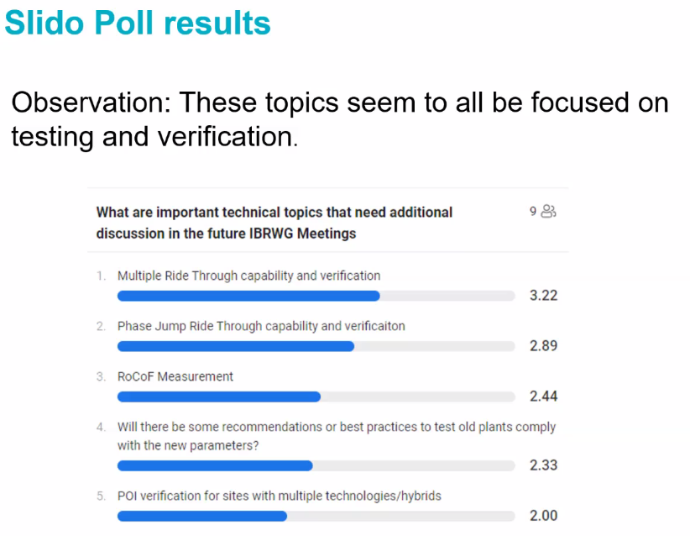

**OEM perspective on NOGRR245 and potential benefits of BESS**

Ravi Dodballapur (SMA) presented on SMA’s perspective on NOGRR245

* Comments in reference to August 18th NOGRR245

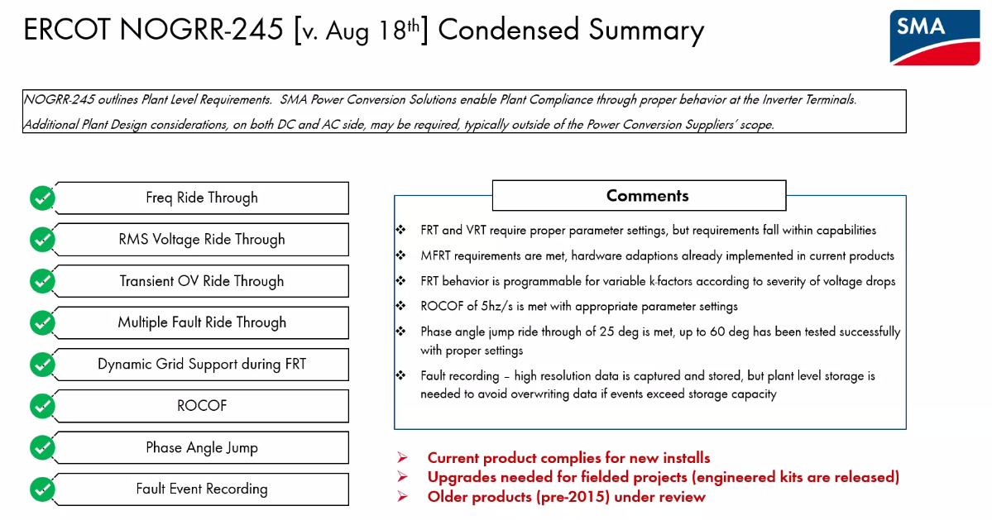

Frank Berring presented on the potential benefits of BESS

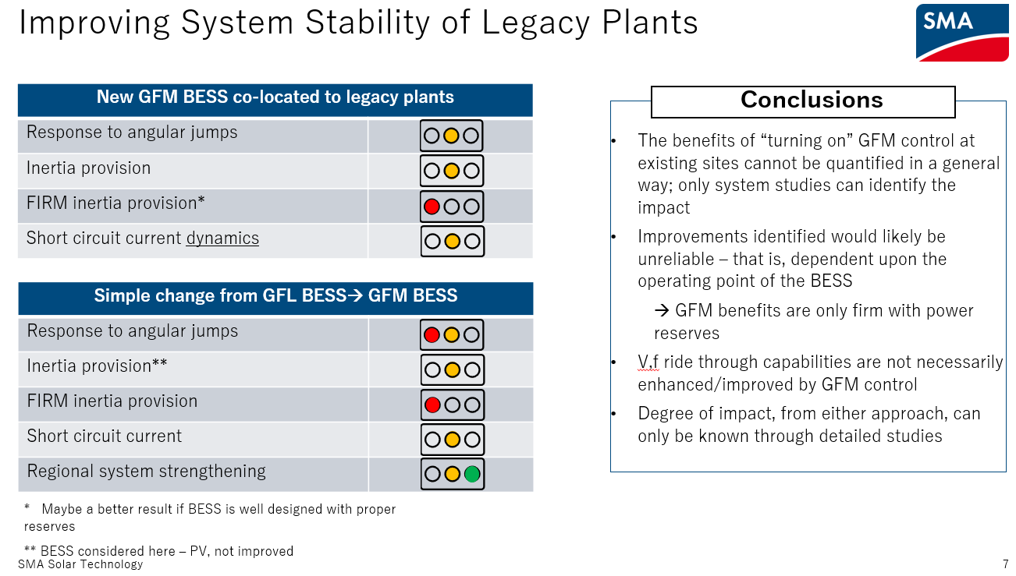

**MISO Update on IEEE 2800 adoption efforts**

Patrick Dalton (MISO) presented on MISO’s IEEE 2800 adoption efforts

* MISO has relatively low levels of solar and moderate levels of wind with a total of 35 GW (wind + solar) within 190 GW total generation capacity
* MISO’s interconnection queue is almost all IBRs
* MISO began IEEE 2800 adoption efforts in 2022. Patrick said that approach has been similar to ERCOT’s and they performed a gap analysis as well
* MISO included top priority requirements shown below from slide 9
* MISO contemplated the various IEEE 2800 adoption approaches and decided to pursue a Detailed Reference approach
* MISO is proposing offering exceptions to some IEEE 2800 capabilities and requirements through 1/1/2025. Patrick said that this is specific to MISO context and every region has different needs due to system and resource mix differences.
* MISO will be investigating potential GFM requirements in the future and will be paying attention to NERC recommendations

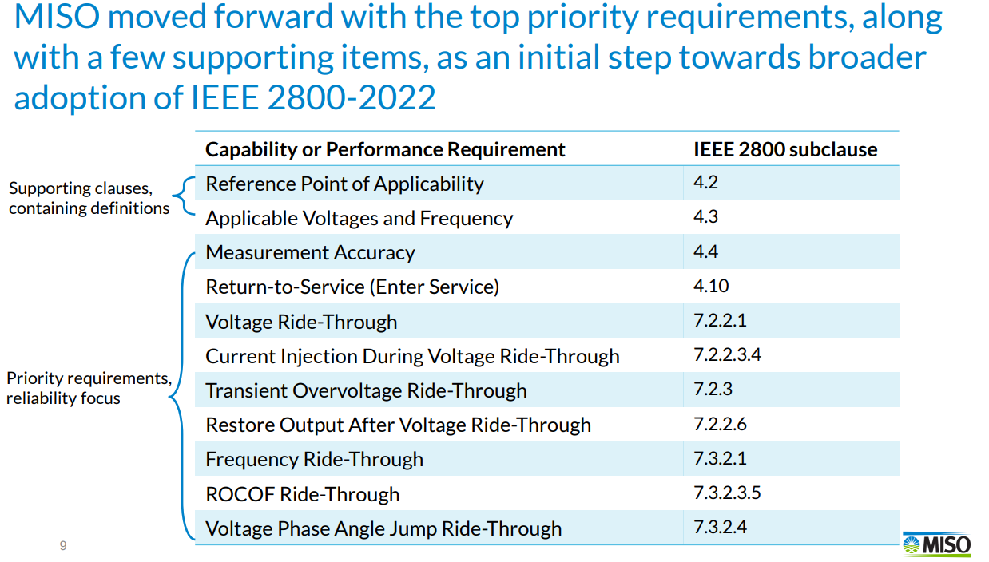

**Nighttime reactive power support from solar inverters**

Aminul Huque (EPRI) presented on solar PV inverter potential for providing nighttime reactive power support.

* Can solar PV inverters provide nighttime reactive power support?
  + The PV inverter tested was able to maintain the reactive power absorption continuously during the daytime to nighttime transitions and vice versa
* What is the cost of providing nighttime reactive power support?
  + Active power demand. A field demonstration and performance assessment was conducted and the active power “cost” is shown below from slide 11

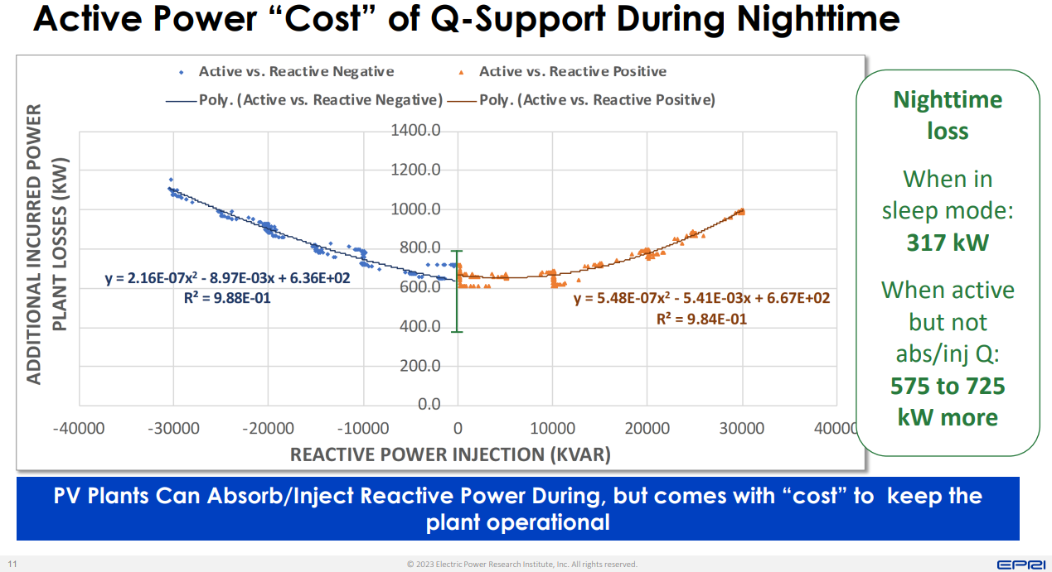

**Phase jump and RoCoF ride-through capability and conformity assessment**

Dustin Howard (GE) presented on the OEM perspective of Phase Jump equipment, protection, and testing aspects. Slide 3 shown below.

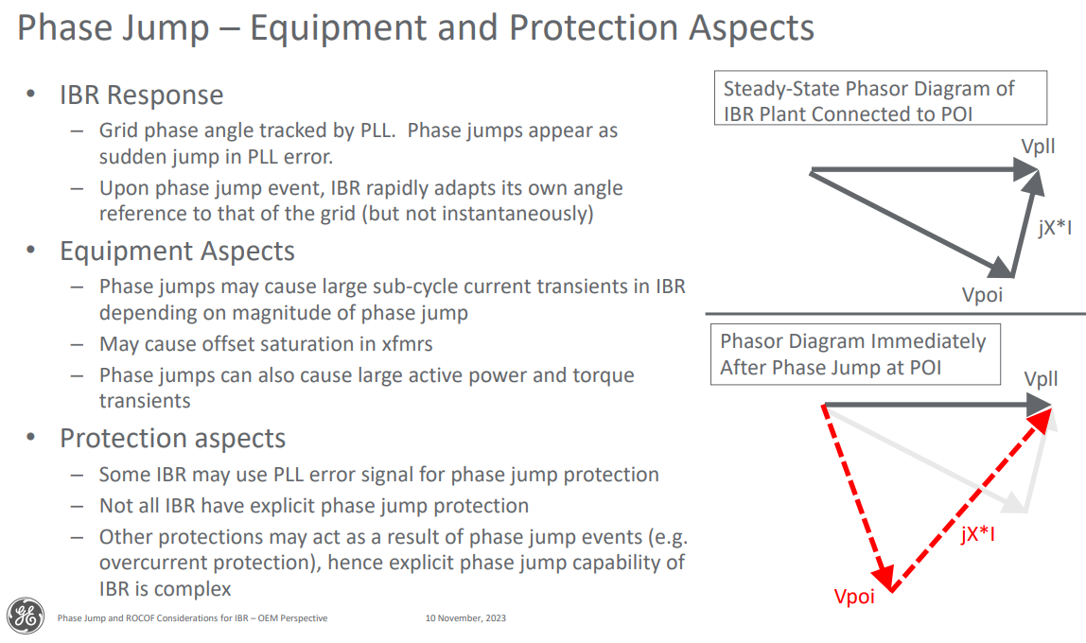

* Phase jump hardware testing takes place in state of the art lab testing facilities
* Phase jump tests in the field are impractical due to lack of testing equipment

Dustin also presented on ROCOF equipment, measurement, mitigation approaches, and risks

* Not all IBR have ROCOF protection
* Some regional grid requirements have been adopted to mitigate: active current priority control and fast active power recovery after fault. These mitigations could increase risk in weaker systems.

**OEM perspective on NOGRR245**

Miguel Cova Acosta (Vestas) presented on Vestas Perspective on NOGRR245

* Miguel said that NOGRR245 is only a short section of IEEE 2800.
* Vestas is concerned that over the years each region would implement their own version of IEEE 2800 requirements. There will be some necessary differences between regions, especially in the case of ERCOT. Miguel said that we should try to prevent different interpretations of the same requirements in each region.
* The majority of Vestas turbines in ERCOT are Type 3 and 4
* Vestas Type 3 turbines were assessed to pass NOGRR245
* Vestas Type 4 turbines were assessed to pass NOGRR245, with the exception of VRT curves
* Vestas Type 1 and 2 turbines were assessed to fail NOGRR245
* Vestas Legacy Type 3 and 4 turbines were not assessed
* Vestas plant life cycle is shown below

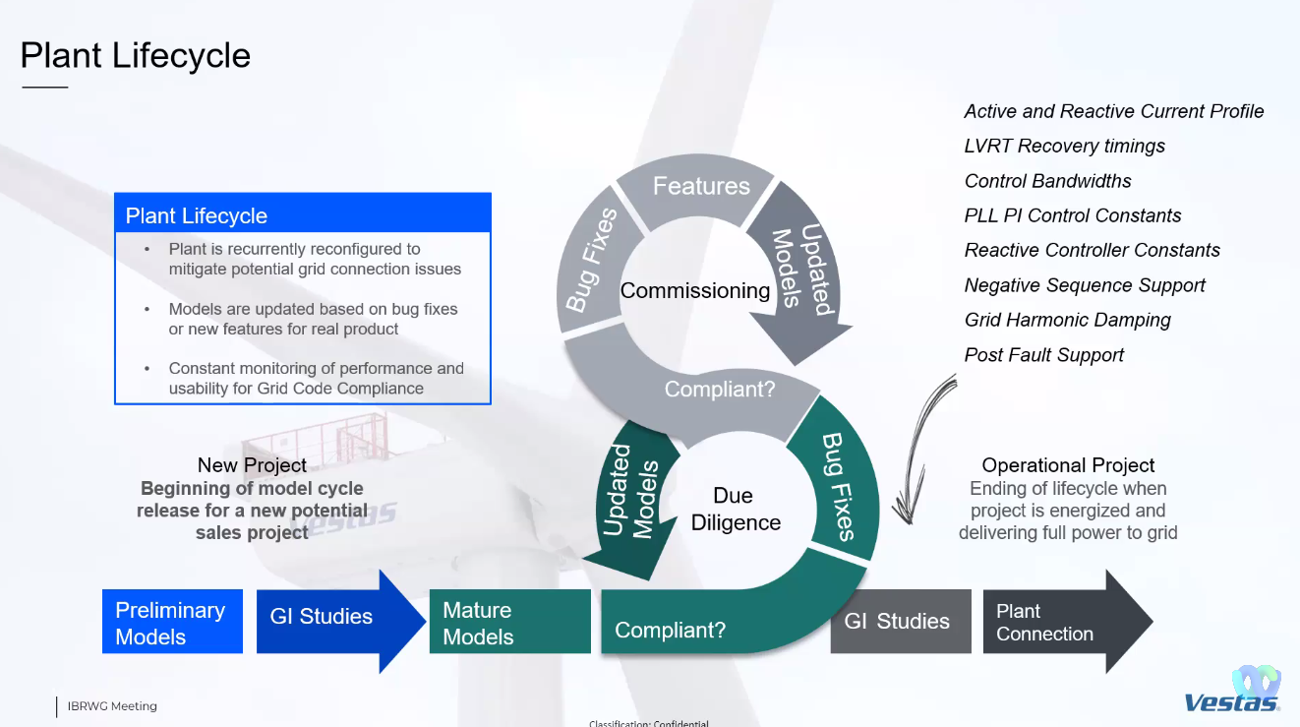

* Multiple FRT is essential for maintaining grid stability. However, requirements should consider exemptions for energy dissipation, depending on the specific configuration of the project. Balance of multiple FRT and voltage stability is needed.
* Phase jump ride through is beneficial for maintaining grid stability. However, requirements should consider exemptions for site specific PLL tuning to maintain control stability under very weak grid conditions. Balance between phase jump requirement and control stability is needed.
* Vestas requires clarifications on test conditions and deliverables for evaluating various requested features.
* Vestas notes that NOGRR245 verification process should be in accordance with IEEE 2800.2

**NOGRR245 Update**

Stephen Solis (ERCOT) presented a NOGRR245 update

* ERCOT has received RFI responses from all OEMs except TMEIC (expecting this week) which represents 57 GW of capacity
* ERCOT has received RFI responses from 292 of 349 REs
* Preliminary aggregation of OEM RFI responses from slide 3:



* ERCOT will bring additional aggregations of RFI results to the December TAC meeting.
* ERCOT will have an updated Impact Analysis prior to the TAC meeting based on the ROS approved version of NOGRR 245
* NOGRR 245 as proposed by ERCOT in their August 18, 2023 comments addresses/aligns with multiple directives in FERC Order 901.
* ERCOT may submit comments prior to the December TAC as well.

**Stephen Solis (ERCOT) presented a NOGRR255 update**

* ERCOT submitted comments on November 1, 2023: Addresses some minor issues and consistencies on top of ONCOR’s edits. ERCOT has agreed to defer the PMU streaming requirements to a future NOGRR but this still remains an important issue to address to allow support real-time situational awareness.
* ERCOT would like to have ROS approve NOGRR 255 in December to allow it to continue moving forward.
* Expecting comments from at least one TSP and generator(s) prior to December ROS
* PRC-028-1 did not pass its initial ballot.

**New ERCOT disturbance event**

Julia Hariharan presented on a West Texas Solar and LFL Event from October 26, 2023

* Event summary shown below from slide 2

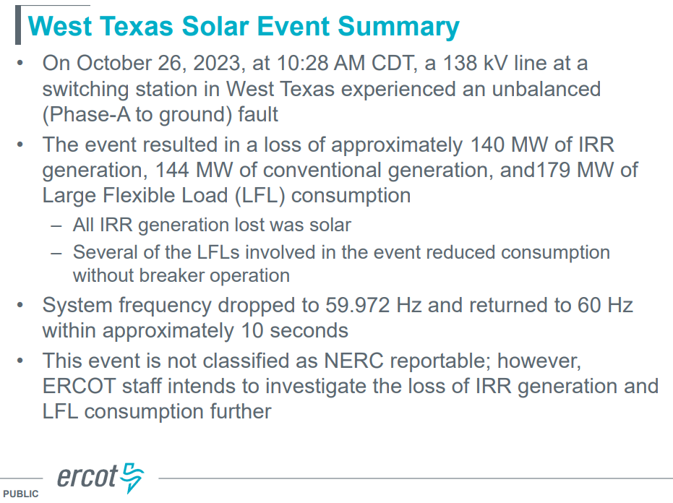

* Past event comparison shown below from slide 5. October 26, 2023 root cause is to be determined.

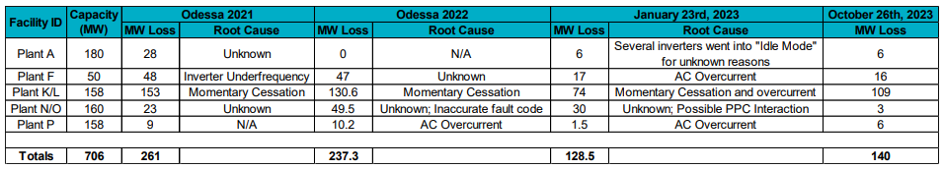

* ERCOT will evaluate the RFI and questionnaire responses and possible follow ups will be conducted with impacted generators and loads

Meeting adjourned at 2:00 pm