IBRWG Meeting Minutes
Leadership Discussion
- Mohammad Albaijat has served as a chair since the inception of IBRTF and would like to step down
- Nominated Julia Matevosyan (current vice-chair) for the chair position, nomination supported by Freddy Garcia (ERCOT) and Stephen Solis (ERCOT). No other nominations for the chair position have been voiced.
- Freddy Garcia (ERCOT) nominated Miguel Angel Cova Acosta (Vestas) for the vice-chair position. No other nominations for the vice-chair position have been voiced.
- Freddy Garcia will inform Chase Smith (ROS chair) about these proposed changes in IBRWG leadership.
Stephen Solis once again strongly encouraged IE and REs to actively participate in future IBRWG meetings!
TSAT Modeling Update
Ken Donahoo (representing APA) raised the following questions asking for feedback from ERCOT’s staff:
Validation Improvement:
- What type of simulation is ERCOT working on for model validation and/or the definition of specifications for model and performance requirements?
- What are the roadblocks regarding IBR projects achieving model validation?
- How can APA and IBRs help ERCOT in advancing the validation process more expeditiously?
Status:
- The last status update presentation that stakeholders received was the April 2023 Report. Could ERCOT please provide an update like this report? Here is the link to the April 2023 Report: https://www.ercot.com/files/docs/2023/05/02/05-tsat_update_ros_05042023.pdf.
- What is the status of the projects that are not compliant? Could ERCOT please provide details regarding reasons for non-compliance?
- What percentage of capacity compliance is needed for ERCOT to move forward with TSAT? Is it 100%, 95% or 90%? Where are we at this time regarding meeting this threshold?
Timeline:
- Glad to hear that the EMS is fully implemented, what is the timeline for expected implementation of TSAT? We are specifically interested in knowing the TSAT implementation timeline for Panhandle, South and West GTCs?
- Is there any bridge proposal that could be implemented prior to TSAT go-live? For example, is ERCOT considering calculating GTCs during different times of day or the year to reflect solar generating hours more accurately?
Operations:
- How will TSAT be implemented in operations and application of the resulting limits? How will TSAT limits and calculated GTC limits be applied in operations? What is the decision process when selecting the limit for operations?
ERCOT is actively performing offline TSAT tests for all the applicable GTCs with all the accepted TSAT models. Noted that although all applicable GTCs are included in the TSAT offline test, results for some GTCs may only be for reference due to lack of sufficient TSAT models. Need to test in various system conditions to identify if there any new issues could not be identified in the model quality tests. So far, issues have been identified for some UDMs even it may pass the model quality tests. We are also working with the REs, IBR vendors, and software vendor to resolve those issues.
In terms of the implementation schedule, ERCOT doesn’t have a defined deadline but is very actively working this effort. The goal is to have reliable tool and models to provide reasonable results. Also, given the complexity and first time deployment of online TSAT with IBRs included, ERCOT expects to implement a subset of GTCs initially and start to add other GTCs as appropriate.
Ken recommends running TSAT in parallel with existing tools and asking how frequent the runs will be?
Fred Huang (ERCOT) responds that the expectation is to run intra-hourly (more frequently) subject to computation burden limitations.
Ken: how it will be implemented in operations, what the process will be in selecting the limit, how it will be used together with current process on identifying GTLs
Fred: The process will be similar to the existing process but using the online TSAT results.. Will be similar to how VSAT is being ran and used today.
Ken: will you pick TSAT limit or GTC limit.
Fred: ERCOT will use TSAT to determine the GTC limit and fall back to offline GTL tables (that are used today) in case the TSAT tool has issues. Again, similar to how VSAT is used today. in general, real time tool is the one to determine the limit, with VSAT offline table to be as a fall back in case online tool fails.
Miguel (Vestas) question about model acceptance table issued in April. Vestas didn’t understand why some models were not acceptable.
Fred responded that ERCOT will provide a TSAT status update to the next ROS or IBRWG (or both)
Fred also explained that ERCOT sometimes could reach out to OEMs directly and work with them to address the model issues However, once the model is updated, the RE is still responsible for providing that updated model back to ERCOT, all the parties need to acknowledge the change had been made to the model.
Stephen goes back to Ken’s discussion and comments to clarify the difference between GTL and GTC. The GTL is the limit (i.e. a MW number), while GTC generally is interface over which the limit, i.e. GTL, is calculated. GTCs are identified from dynamic studies, offline. The offline studies are also used to create GTL tables for different contingency and topology situations. Once ERCOT has online capability to run the studies (i.e. TSAT tool up and running) the GTL can be determined in real time. This MW limit value will be used unless something is wrong with the TSAT tool and there’s a reason not to trust the result, then ERCOT will fall back to offline GTL tables. Additionally, if VSAT and TSAT calculating limit over the same interface in real time, the lowest number will be selected as the GTL for that GTC.
Julia (ESIG) askes about computational burden of running dynamic studies in real time (using TSAT), are there differences if there are generic models or UDM models to represent IBRs in the cases?
Fred comments, it’s a function of computational power ERCOT has. The existing set up for VSAT cannot determine GTLs on all GTCs for all contingencies, but ERCOT doesn’t anticipate to implement all GTCs initially, so will try to concentrate computational efforts on the GTCs that apply at the moment and continue to improve the computation capability along with adding more GTCs to the online TSAT. VSAT definitely runs faster. The question about UDMs is a good point. It depends on the vendor some UDMs are developed their models efficiently, and computational impact is similar to generic models but some UDMs even on the setting part require tremendous effort to just make it work and ERCOT then sees impact on the computation time as well. This is not to say that UDMs are bad, they are good and preferred as they are specific to equipment installed in the field, but ERCOT is looking for more efficient UDMs that will not put additional computation burden on the real time runs.
Raphael Carvalho (Serena) asked for ERCTO to provide report to ROS and include responses to Ken’s questions (above). Would like to have more specifics on GTCs that are lagging (in terms of available IBR models) and what REs need to provide models. Serena was surprised with Yunzhi’s presentation at ROS meeting yesterday showing small impact on the GTLs between day and nighttime cases and would like to see more details to understand the result better.
Fred: after yesterday’s discussion at ROS, discussed internally about confusion regarding the results and working to see if they can provide more detail on the topic at the next ROS. For the first question it’s not going to be a report, but it will be similar status update as they provide to ROS regularly related to TSAT, in the same format.
Serena and Vestas asked for an internal meeting with ERCOT to see how they can help to bring the rest of the models up to speed.
Stephen commented that if additional education is needed for the stakeholders, ERCOT may consider doing something like that outside of the IBRWG and ROS
GFM BESS Activities Update
3 key points
- Related to GFM activities, as reported previously to ROS, ERCOT is engaging with industrial consultant/expert to help ERCOT develop performance requirements for grid forming (GFM) that would suit ERCOT system need. The schedule for the performance requirements to be completed is Q2-Q3 of 2024. Sequentially or in parallel with this work, the requirements will need to be added to the relevant sections of ERCOT’s protocols. Next step, regardless of adoption/incentivizing path, a GFM resource will need to have these capabilities as defined in the requirements.
- ERCOT sees the benefit of GFM BESS in certain areas with active GTCs. Potentially, GFM Resources can improve stability performance in areas behind GTCs and, potentially, improve GTL. Currently there are no projects developing in ERCOT footprint with grid forming capabilities, but, on the other hand, there is no restrictions from ERCOT’s side for such development.
So, if IE / RE is interested to improve GTC/GTL, look into building a grid forming ERS instead of grid following or modify the existing one to be GFM capable. ERCOT can work with the developers to look into these benefits during interconnection process.
For now ERCOT may use recently published NERC whitepaper recommending functional specifications and simulation tests for grid forming BESS https://www.nerc.com/comm/RSTC_Reliability_Guidelines/White_Paper_GFM_Functional_Specification.pdf tests. ERCOT has reviewed the paper internally and planning to use these tests in interim as the consult is working on the ERCOT-specific requirements.
- When working on GFM study the question was how ERCOT is going to implement the requirement for grid forming. For now it is TBD, expect to have some discussion in this area in 2024.
Billy Yancey (EPE) comments that system conditions are changing, what to foresee for the early grid forming technology adopters, thinking that they may need to retrofit in the future. ERCOT doesn’t see barriers for current adopters, but sees Billy’s point that there may be a concern for early adopters and will keep it in mind while working on the requirements.
IBR plant model development and Developer/OEM/ERCOT interactions and gaps
This is a very important and timely topic. EPE is a consulting firm that works with REs, developers and utilities and very much involved in the process. The process at glance is shown below:
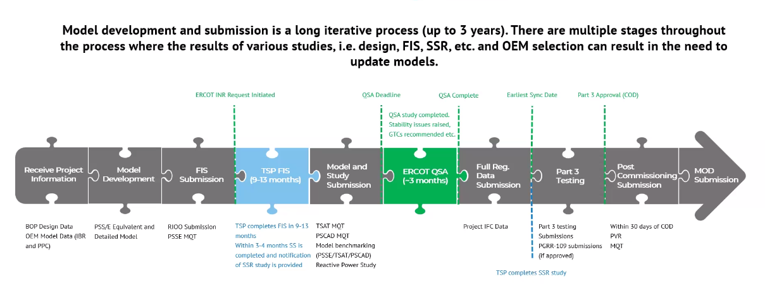
The first 3 pieces take the most time. Challenges summarized on the next slide (below). This is the observation from EPE specifically and others may see different challenges.
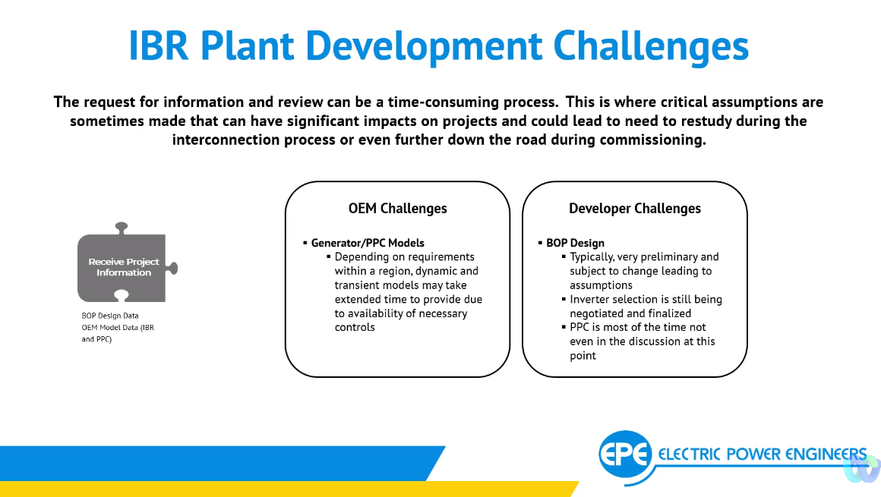
There are challenge with changing requirements overtime, both related to interconnection requirements and to modeling requirements, play very important role in being ready for QSA date. Power Plant Controller (PPC) is unknown at the point of receiving project data information.
Stephen Solis says it’s a good overview, but particularly interested in the things that “change hands” (meaning between different developer, developers and ultimate owners of the plant). As we put new IBRs and things are getting more complex, the need for making sure that PPC controls and coordinated with FACTs devices on the grid and other IBRs near by is very critical, but sems like this is only happening during Part 3. This seems to be late in the game, all studies are done by then and now models are changing and project might have “changed hands” between the developer and RE.
Billy: there are a couple of areas that will be discussed later in the presentation. This basically comes up during stability assessment. There is a lot that can be done by tuning controllers to achieve stability and a lot can be gained from coordination with other IBRs in the area, but currently it is challenging.
Bob Wittmeyer asked if 3 years timeline is common. Billey responds that it varies project by project, the shortest can be 20 month but 2-3 years is what they are saying in their work.
Julia comments in the chat that ERCOT Resource interconnection timelines are the shortest in the country.
Billy continues presenting the next set of challenges in the slide below.
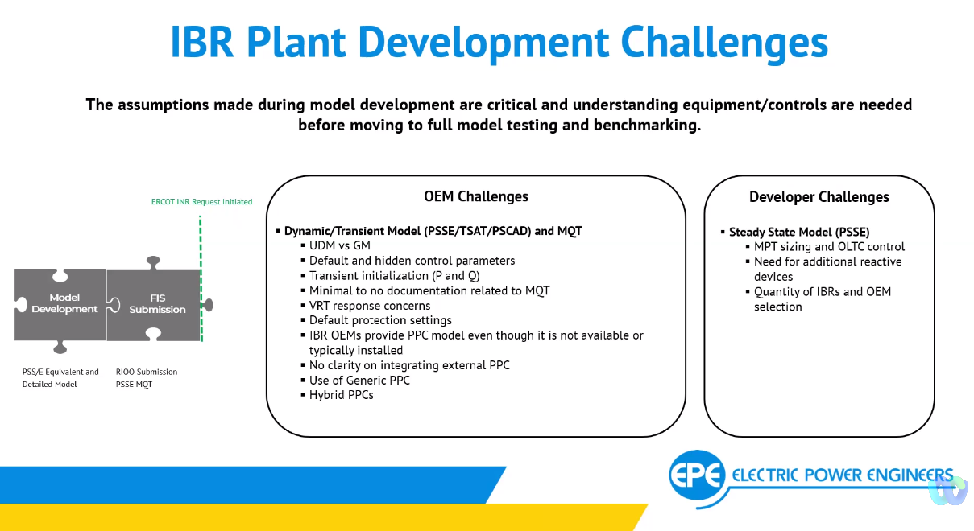
Concerns are around deciding between UDM or Generic Model. This is also driven by recent TSAT model requirements; it’s harder to get UDMs for TSAT. VRT is the next big concern. Choice of PPC is another issue. Usually, PPC is decided later in the process. Solar manufacturers usually don’t produce PPCs. So, at this stage default PPC model is chosen but, in reality, PPC has a lot of impact in stability assessment so this is a big gap/issue as the results of the stability assessment may change based on PPC selection.
Next set of challengesin the next slide:
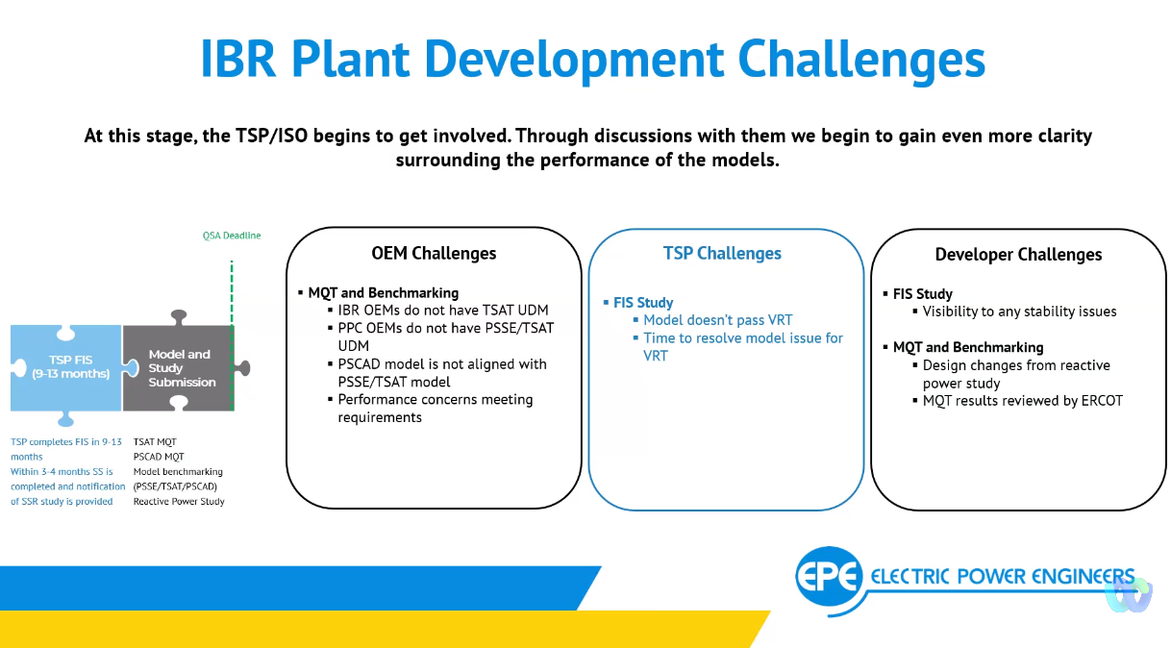
Inclusion of PPC into a vendors UDM may be a big challenge for projects that have PPC provided by another vendor.
Fred: You mentioned several times about TSAT model not being available that could drive a developer to adapt generic models. On ERCOT side we are not restricted to UDM vs GM, but the model needs to accurately represent actual plant performance. It is concerning, if the model is not available, that the developer may go for a model that is available but may not represent actual response of a plant. That will have reliability impacts, because as the system is changing, and GMs may have limitations and odd behavior in cases that may not have been previously studied during interconnection process.
Billy: that’s a great point. And it’s totally accurate and current. What has been seen up to this point that GMs are trying to accurately represent the response, benchmarking against PSCAD model is then becoming very challenging. GMs are very limiting and it’s challenging to match with PSCAD.
Julia: is IBR plant design evaluation, as being discussed in IEEE2800.2 subgroup 3 generally, where the entire plant is being presented and assessed for its capabilities and conformity with ERCOT’s interconnection requirements by the developer during plant design stage or is the process more geared towards producing an aggregated model and passing ERCOT’s MQT?
Billy: It is currently not happening in PSACAD and to the full scope at IEEE2800.2 is envisioning but there is some of it in PSS/E, with regard to PRC-24 compliance, to see if each individual inverter within a plant performs as expected. Still, this is work in progress in terms of actual benchmarking a detailed dynamic model vs aggregate but more momentum.
Mohammad: How long the studies remain valid, if there are delays in financing.
Billy: delays between FIS and QSA are where the challenge would be, if COD gets moved there is going to be a lot of challenges on the financial standpoint and such. If a project changes hands before FIS, the process as per the earlier slide needs to start all over again on RE side because a lot of equipment selections may change.
Next step on the following slide:
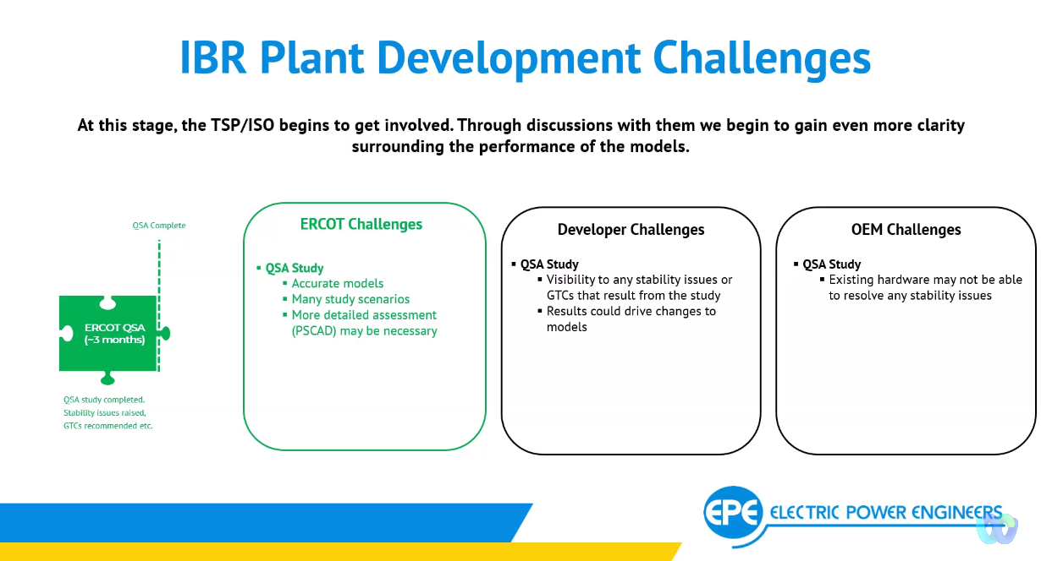
The more collaboration between ERCOT, OEMs and developers at this time, the better as it ensure forming resolution of issues in the best way.
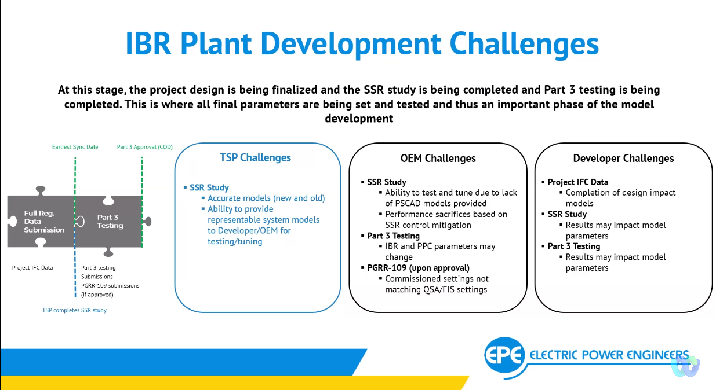
SSR, same comment about the model and collaboration as above but note again that the models may change here and be turned a bit more to implement mitigation.
During Part 3 a lot of changes in the model what’s commissioned vs what was studied are identified.
Miguel (Vestas): once SSR mitigations are identified, will the RE be exempt from MQT? Billy said no there may be addition MQT if the parameters have changed. But, either way, post-COD there is another MQT once the updated model is submitted.
Miguel: but SSR study will change MQT performance? Billy said he’ll get to it in his presentation.
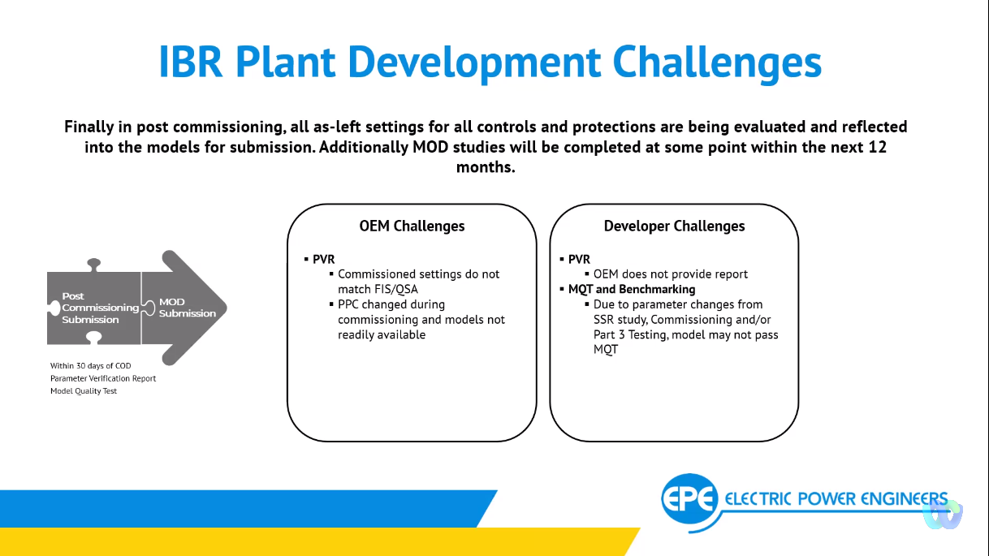
Projects after SSR mitigation might have sacrificed some of the other plant performance and lead to not passing MQT under some conditions like VRT. This is one of the most challenging pieces as the project crossed the finish line, but things now have changed compared to previous studies performed. May need to go back and redo some of the studies (Julia’s note: but not being done today?).
Final throughs. Modeling an IBR plant through interconnection process is a very long meticulous and tedious process. Many things may change along the way. Need to start early the discussion with OEMs, having the requirements readily available helps. OEM involvement in industry working groups like NERC IRPS, IEEE2800.2 helps as they are working on the next generation of the equipment and can learn about requirements in these processes. Share more about stability issues with REs and OEMs, share with the groups of projects where IBRs can collaborate and tune their resources to achieve better performance for all. May be look for the way to share dynamic models between these smaller groups of stakeholders.
Update on NOGRR245
Stephen, presenting summary of recent FERC Oder 901 directing NERC to develop IBR standards to mitigate issues seen in the recent disturbance events. Reiterating that ERCOT is already on the path very well aligned with the direction of FERC Order and NERC.
Recent RFI results highlight most challenged requirements from OEM perspective and difference between OEM and RE assessments. ROS approved language would require much higher levels of exemptions and residual system risk.
On FRT, pre 2014 models of GE turbines and a few others have some challenges. One OEM has challenges on current injection settings but other than that the numbers are pretty consistent where mostly only oldest of the old of Type1 and 2 can’t meet the requirements. With 3 requirements having low compliance rates: RoCoF requirement, Multiple excursion requirement, Phase angle jump requirement
Most responses ERCOT got as a “No” from RE means that there’s insufficient information to say yes or no answer from an OEM rather than a known limitation. ERCOT’s is proposing changes based on the RFI results (copy pasted from Stephen’s slides below).
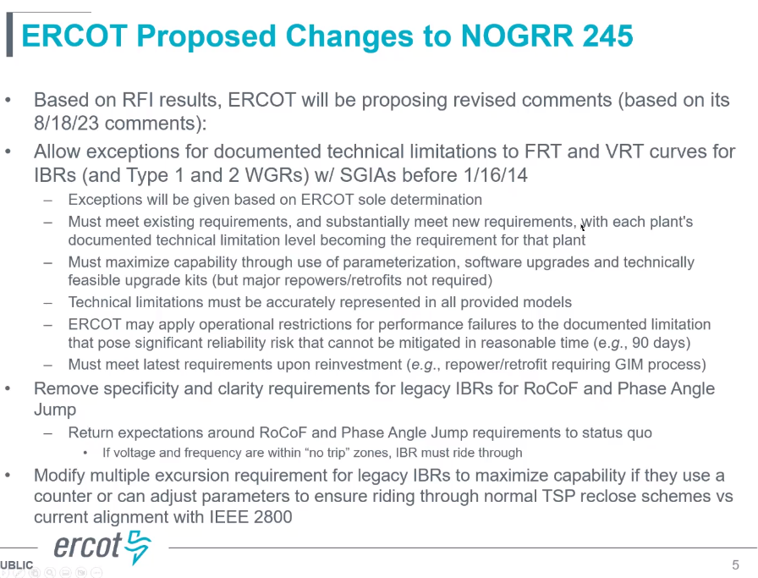
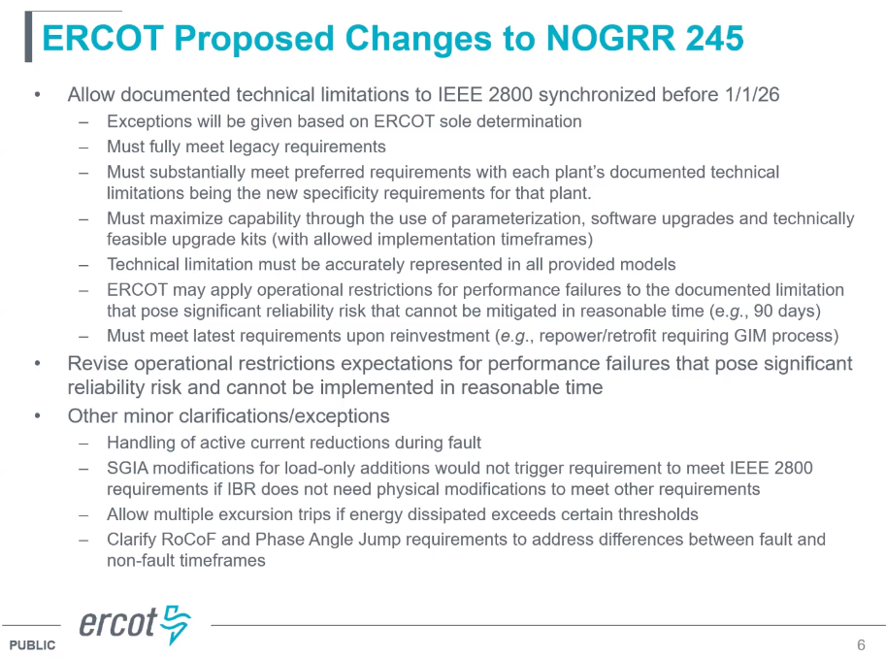
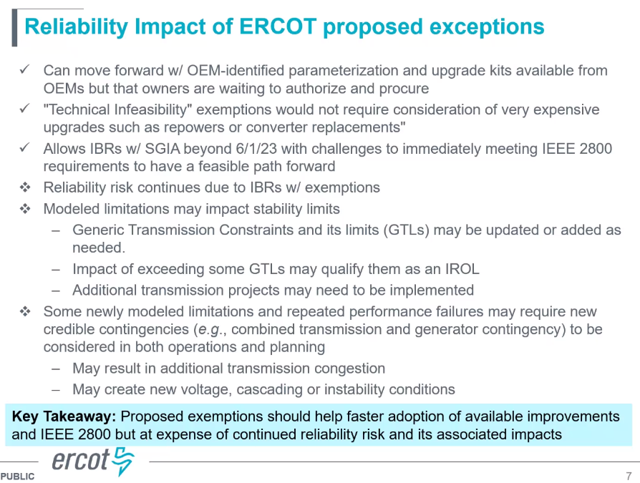
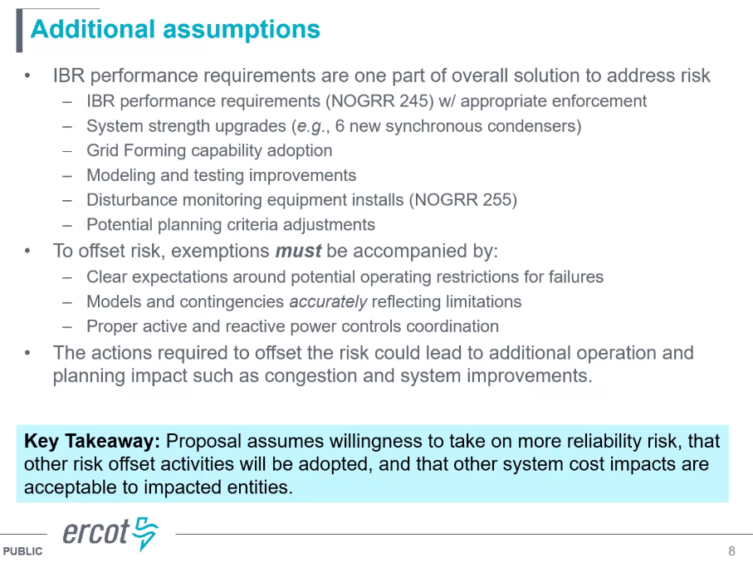
Proposed timeline is below:
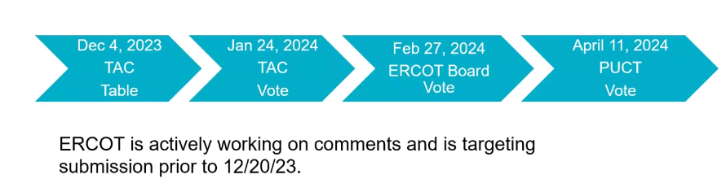
More details of the RFI responses in the appendix of the slide deck.
Update on NOGRR255
Again Stephen reflected on FERC Order 901 directing NERC to develop standards for disturbance monitoring equipment and saying it aligns well with NOGRR255 and PRC-002 and PRC-028 changes that NERC Standard Drafting Team is currently working on.
Slide below shows some of the recent changes to NOGRR255 in response to stakeholder comments.
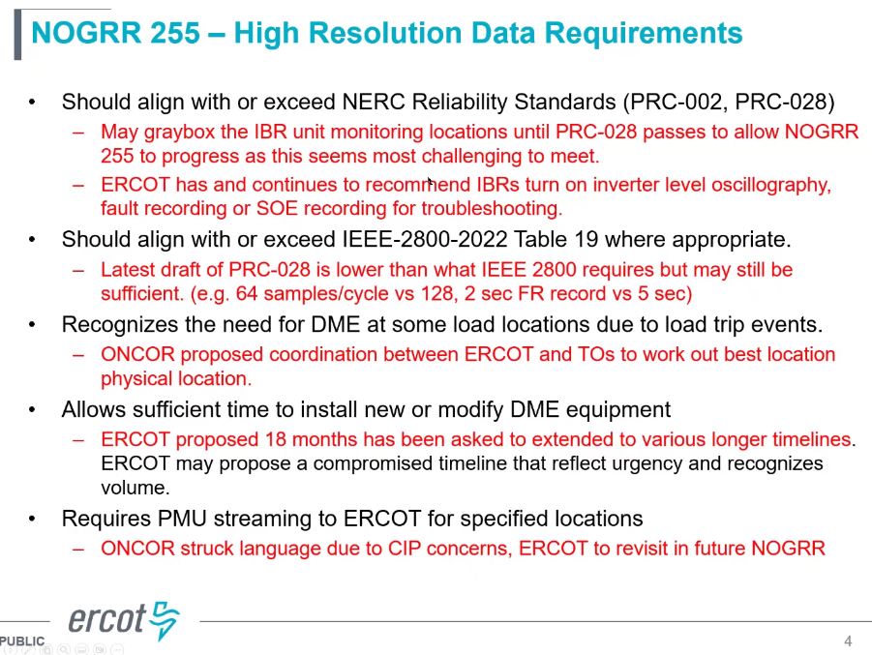
Bret Burford (AEP) made a comment about relay limitations and inability to capture data at 128 samples/cycle for 2 seconds. Unless we have the capability to pull the data out, it will be overwritten.
Comments in the chat:
Melvin Joseph - Black & Veatch: FYI - SEL is working on updating the 300 series platform according to my information from them.
Todd Chwialkowski: Many of us are using the SEL-351 model across the legacy fleet.
Bret Burford-AEP: this was the 351-5,-6,-7 models
Todd Chwialkowski: I concur with the recommendation to have SEL provide us with a presentation.
Further changes below:
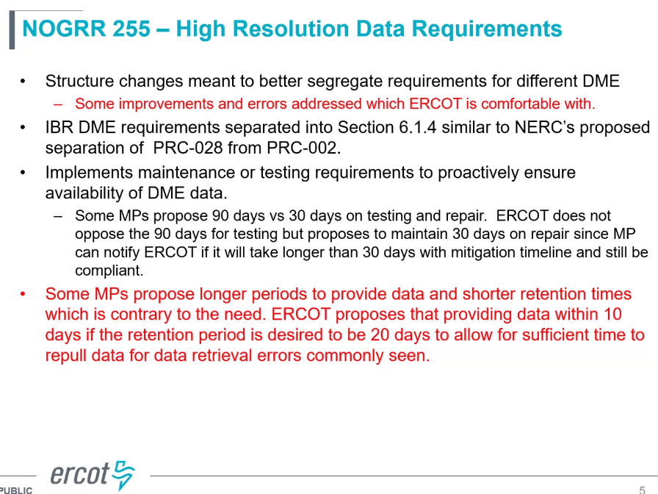
FERC Order 901 and NERC Level 2 Alert Update
David Penny presented NERC Alert Key findings. These are very concerning and well aligned with what we are seeing in ERCOT. The NERC Alert Report is calling for mitigations that NOGRR245 and 255 are trying to address.
2260 MW of BES-connected solar facilities have VRT setting inside “no trip zones”. Others have settings right on the VRT curve, rather than set based on equipment capabilities. Voltage protection settings are set at inverter terminals and not compensated for the POI, where the requirements actually apply.
About a quarter of resources are still using momentary cessation or reduce MW injection to 0 while providing dynamic reactive support during faults. This is not a recommended practice.
Key takeaways are on the slide below, more details in the slide deck.
Stephen asked if it’s against NERC standard to be set on the setting of VRT curve and David said as per PRC-24 it is allowed if equipment has limitations.
David also presented a high-level summary of FERC Order 901 and NERC implementation plan and timeline, summarized from his slides.
