NPRR Number | 1224 | NPRR Title | ECRS Manual Deployment Triggers
Date |  | May 20, 2024
Submitter’s Information
Name |  | Michele Richmond, Blake Holt, and Bob Helton
E-mail Address |  | michele@competitivepower.org, blake.holt@lcra.org, Robert.helton@engie.com
Company |  | TCPA, LCRA, and Engie (“Joint Commenters”)
Phone Number
Cell Number |  | 512-653-7447, 512-578-2003, 832-435-7815
Market Segment |  | N/A, Cooperative, Independent Generator

Comments

Joint Commenters respectfully offer these comments in response to the May 15 and May 17, 2024 comments of Potomac Economics serving as the Independent Market Monitor (IMM), and to urge the Technical Advisory Committee (TAC) to vote to endorse the Protocol Revision Subcommittee (PRS) Report of Nodal Protocol Revision Request (NPRR) 1224 to the ERCOT Board.

Joint Commenters appreciate the IMM’s comments and engagement on this topic. Through those discussions, it appears that there are at least two fundamental differences between the approach to NPRR1224 recommended to TAC in the PRS Report and the approach that the IMM has suggested. The first is whether price reversal is appropriate when Ancillary Service reserves are released for energy. The second is how to reflect the value of foregone Ancillary Service reserves. Joint Commenters contend that price reversal is not appropriate in the first instance and that the PRS Report reflects a better (though admittedly imperfect) approximation of how foregone ERCOT Contingency Reserve Service (ECRS) under NPRR1224 would be valued under Real-Time Co-optimization (RTC) than the approach recommended in the IMM comments.

As a threshold matter, Joint Commenters disagree with the characterization of ERCOT’s current ECRS procurement and deployment practices as causing “artificial shortage pricing.” Rather, ERCOT’s increased demand for operating reserves means that there is a real shortage of supply to serve energy demand while also maintaining sufficient Ancillary Service reserves to address system risks and contingencies. Therefore, if Real-Time Market (RTM) wholesale electricity prices exceed the values embedded in the current Operating Reserve Demand Curve (ORDC), it means that reliability had been undervalued and is not adequately reflected in the ORDC. This stands in contrast to the IMM’s implication that the ORDC is the only source of “legitimate shortage pricing.” Resolving this difference in perspective is not necessary for NPRR1224 to move forward, though; Joint Commenters simply include this commentary to provide a more robust record on this topic given it has been central to the discussion about ECRS over the last several months.

Returning to the two key differences identified above, the first issue of price reversal has a long history in ERCOT, and the overwhelming policy precedent is that price reversal due to operator action should be eschewed. This fundamental market design principle is embedded in multiple ERCOT market policies – the floor for On-Line Non-Spinning Reserve (Non-Spin); the reversal of price distortions from Reliability Unit Commitments (RUCs), Reliability Must-Run (RMR) unit commitments, and Emergency Response Service (ERS) deployments through the Reliability Deployment Price Adder (RDPA); offsetting firm Load shed in the RDPA; and both critically and prospectively, reflecting the opportunity cost of foregone Ancillary Service revenues in RTC, as reflected in the Ancillary Service Demand Curves (ASDCs). As the IMM noted in its May 15 comments, “in the future, when ERCOT implements [RTC] of reserves and energy, the ECRS capacity will be visible to the RTM and optimally utilized.” Joint Commenters would simply add that optimal utilization in that context should include energy prices reflecting the reliability value of foregoing ECRS reserves when releasing ECRS for energy, as determined by the ASDCs. This means that release of ECRS for energy under RTC should not result in price reversal. The PRS Report of NPRR1224 upholds this principle by establishing a price floor at the level that ERCOT would manually release ECRS based on the Power Balance Penalty Curve (PBPC) which is approximated roughly to the ASDC price corresponding 500 MW of manually released ECRS. The price floor is set at this ASDC price level so that the energy prices would approach the energy price in RTC that would reflect the market’s opportunity cost of foregone ECRS when it is converted to energy.

The second issue is how to appropriately reflect the value of foregone Ancillary Service reserves. The IMM’s May 15 comments proposed three options, the most comparable of which to the NPRR1224 framework is to use a value of X=5 MW, which corresponds to ~$250/MWh on the PBPC (compared to X=40 MW in the PRS Report, which corresponds to ~$1000/MWh on the PBPC). Again, Joint Commenters point to the RTC ASDCs for guidance. Leveraging an ERCOT presentation of the RTC ASDCs over a range of time periods, the below overlays what a 500 MW shortage (e.g., release) of ECRS would look like on the RTC ASDC in yellow, and compares against the IMM’s X=5 MW recommendation in red and the PRS report’s X=40 MW recommendation in green:
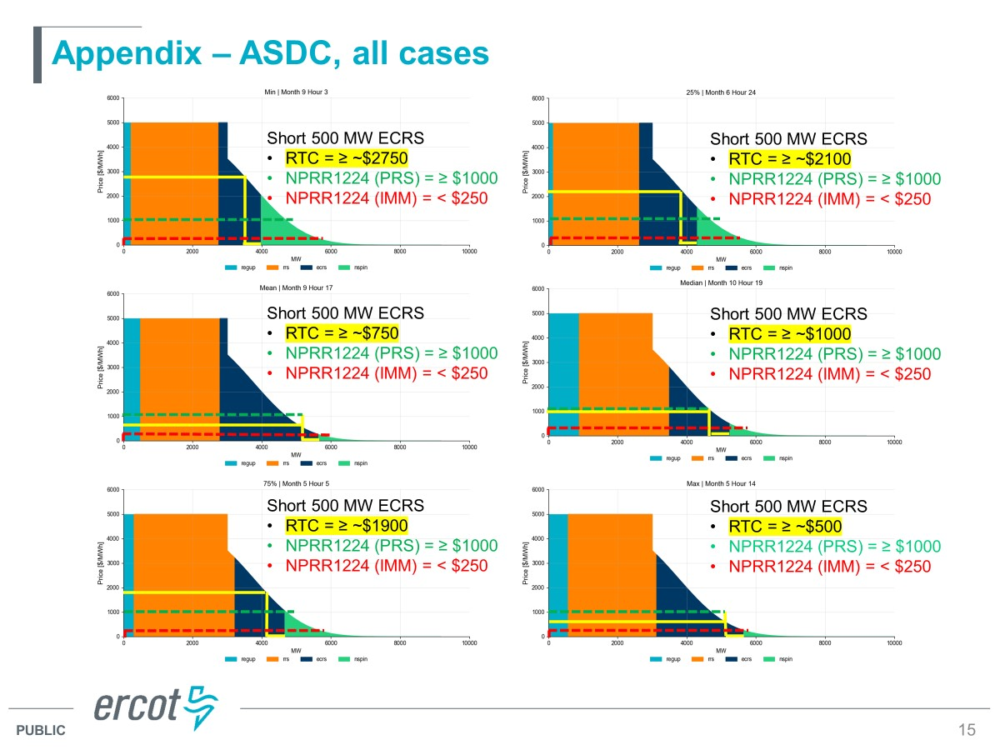

The takeaway from this visual should be clear: under RTC, releasing 500 MW of ECRS has a value that is well above the level recommended in the IMM’s May 15 comments – and in most cases (though not exclusively) is at or above the PRS Report’s recommended level. Most simply, when ERCOT goes short 500 MW of ECRS under RTC, the ASDC will require that energy prices do not go below the yellow line, whereas the IMM’s recommendation would drive prices below the red dashed line. And on balance, the PRS Report’s green dashed line falls somewhere reasonably in the middle (setting aside other considerations, detailed in TCPA’s April 20 comments, such as the current ASDC not fully reflecting ERCOT’s operational preferences and other changes implemented after the current ASDC framework was approved prior to Winter Storm Uri) – reflecting the best path for regulatory certainty and continuity going forward.

Revised Cover Page Language
None
Revised Proposed Protocol Language
None

NRG has not joined these comments.
See https://www.ercot.com/files/docs/2024/02/13/ASDC%20Overview%20-%20RTCBTF%20-%2002212024.pptx presented at the February 21, 2024 RTC+B Task Force Meeting, slide 15. Out of abundance of caution in attribution, Joint Commenters note that the addition of the green/yellow/red lines and text are not part of the original ERCOT document; rather Joint Commenters have leveraged those as an existing public representation of the value of ECRS during different operating hours under RTC.

