NPRR Number | 1224 | NPRR Title | ECRS Manual Deployment Triggers
Date |  | June 10, 2024
Submitter’s Information
Name |  | Michele Richmond, Blake Holt, Bob Helton
E-mail Address |  | michele@competitivepower.org, blake.holt@lcra.org , Robert.helton@engie.com
Company |  | Texas Competitive Power Advocates (TCPA), LCRA, & Engie (“Joint Commenters”)
Phone Number
Cell Number |  | 512-653-7447, 254-913-8096 & 832-435-7815
Market Segment |  | Independent Generator, Independent Power Marketer (IPM), Cooperative

Comments
Joint Commenters respectfully offer these comments for the Board’s consideration in support of the Technical Advisory Committee (TAC) Report of Nodal Protocol Revision Request (NPRR) 1224 to the ERCOT Board (NPRR1224 TAC Report). Joint Commenters encourage the Board to endorse the NPRR1224 TAC Report to the Public Utility Commission and in turn for the Public Utility Commission to approve NPRR1224.

The NPRR1224 TAC Report is rooted in the principles of Real-Time Co-optimization (RTC) of energy and Ancillary Services, which is the appropriate approach if an early release of ERCOT Contingency Reserve Service (ECRS) is to be implemented prior to RTC implementation in 2026. The manual release of Ancillary Service reserves to the Security-Constrained Economic Dispatch market optimization program (SCED) is a short-term bridge between two states of the world:
- Today’s market framework
  - Operating reserves are valued equally regardless of their quality under the Operating Reserve Demand Curve (ORDC)
  - ORDC is an adder to wholesale energy prices
  - Ancillary Service capacity is assigned in the Day-Ahead Market (DAM) and reserved across the operating hour in the Real-Time Market (RTM) unless a release to SCED is triggered or instructed by ERCOT
- The RTC market framework
  - Operating reserves are valued depending on their quality under the Ancillary Service Demand Curves (ASDCs), which value “faster” reserves higher than “slower” reserves
  - Ancillary Service capacity is assigned in the RTM during each SCED run and reserved across the ~5-minute SCED run unless a release is triggered or the Ancillary Service capacity is foregone (e.g., automatically “released”) in favor of assigning an energy base point
  - If Ancillary Service capacity is “released” for energy, the ASDC for that Ancillary Service effectively sets a floor for wholesale energy prices, reflecting the price and value to the system of foregoing those Ancillary Service reserves

The underlined provisions are critical; NPRR1224 is designed to release ECRS not to address an actual system contingency, but rather to release it based on wholesale market energy price outcome preferences. This is the precise function that the RTC ASDCs are designed to do: establish a floor value for the release of Ancillary Service reserves for energy. Therefore, aligning NPRR1224 with RTC principles to the extent possible is appropriate – even if for no other reason than policy consistency/regulatory certainty, given that the RTC directive from policymakers has been in place since 2018 and ERCOT is currently in the midst of implementing it.

Joint Comments submitted on May 20, 2024 included the following visual comparing the [then PRS Report’s; now TAC’s] recommended ECRS release (and floor) values vs. the levels recommended in the IMM’s May 15, 2024 comments against a sampling of ASDC constructions over a range of time periods. The visual overlays what a 500 MW shortage (e.g., release) of ECRS would look like on the RTC ASDC in yellow, and compares against the IMM’s X=5 MW recommendation in red and the [then PRS report’s; now TAC’s] X=40 MW recommendation in green. The differences between what is shown here vs. what is before the Board is de minimis, and the key takeaway is the same: under RTC, releasing 500 MW of ECRS has a value that is well above the level recommended in the IMM comments – and in most cases (though not exclusively) is at or above even the NPRR1224 TAC Report’s recommended level. More simply put, when ERCOT goes short 500 MW of ECRS under RTC, the ASDC will require that energy prices do not go below the yellow line, whereas the IMM’s recommendation would drive prices below the red dashed line.

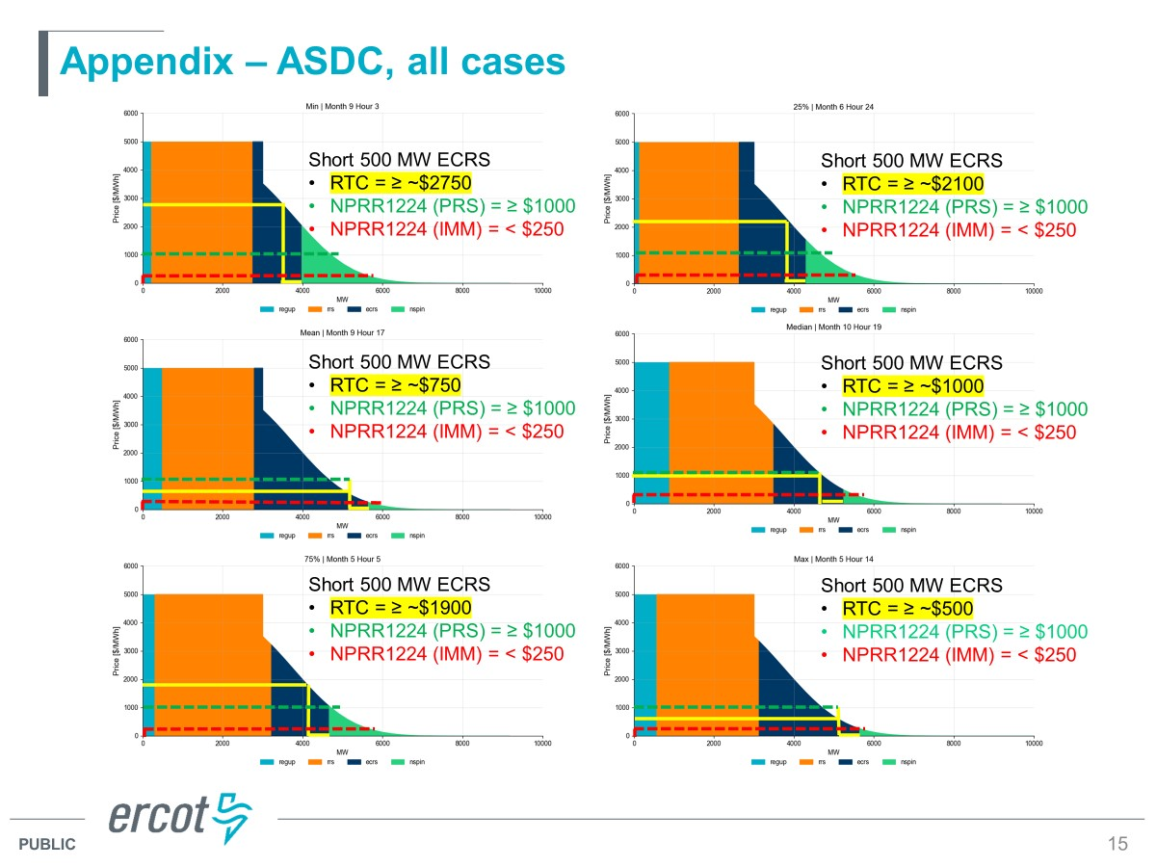

Analysis of the 2024 AS requirements shows that the ASDC price level corresponding to 500 MW of release of ECRS (i.e., ASDC corresponding to Regulation requirement + RRS requirement + ECRS requirement – 500 MW) is above the price level recommended by the IMM for all hours of 2024 as shown in the chart below. The average ASDC price level over all the hours in 2024 corresponding to 500 MW of ECRS release is $1,506/MWh. The value is below $750 for only 19.8% of the hours. However, for those hours the total reserve levels are greater than 7GW and ECRS – 500 MW level is greater than 5 GW. Hence those values are not relevant when analyzing the pricing during tight conditions when ECRS will be released. For all the hours that are more reflective of tighter conditions (when ECRS – 500 MW is less than 4 GW), the ASDC price level corresponding to 500 MW of ECRS release is greater than $2347.8/MWh. Even if ERCOT is releasing less than 500 MW of ECRS, the average price level for 2024 is much higher than the price level recommended by the IMM. The average ASDC price level over all the hours in 2024, if we only release a single MW of ECRS release, is $923.6/MWh. These data points show that the compromised $750/MWh level is a very conservative low-end price level.

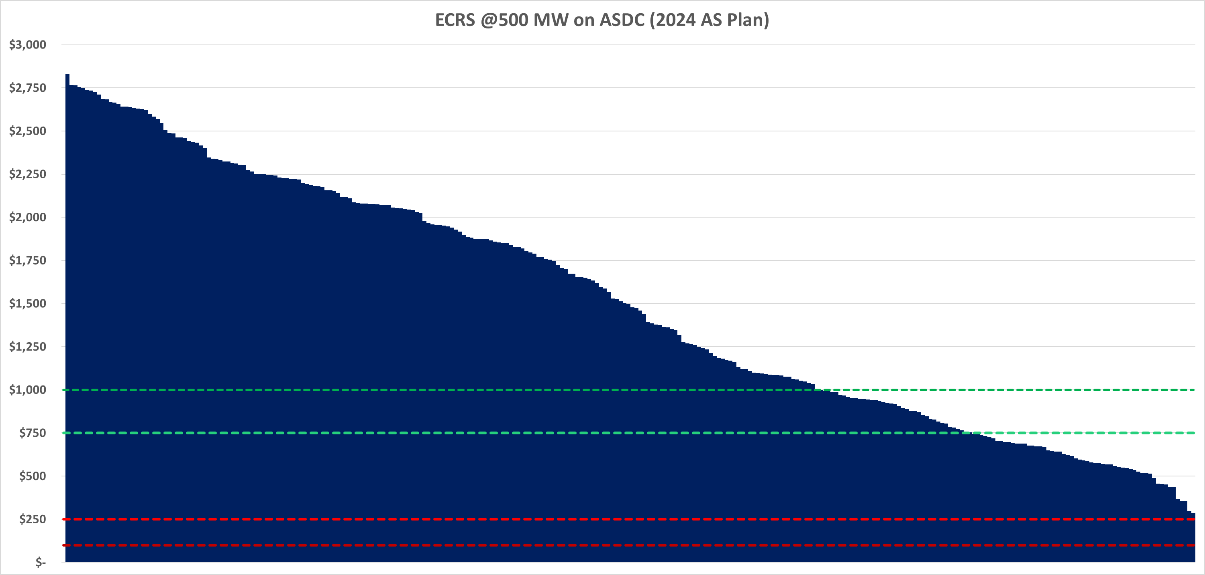

Entities opposing the NPRR1224 TAC Report, on the other hand, seem to anchor to two a priori assumptions that are asserted as fact: (1) that ERCOT’s current procurement and deployment practices for ECRS cause “artificial shortage pricing,” and (2) that the ORDC framework should override ERCOT’s revealed operating preferences. This seems to lead to a conclusion that ECRS reserves do not have value during tight grid conditions, and that there is no loss of operational value to ERCOT from releasing ECRS (and therefore price reversal upon ECRS release is appropriate) during tight conditions.

Joint Commenters and others have consistently rejected the first claim, instead recognizing that there is a real shortage of supply when ERCOT cannot serve energy demand while also maintaining sufficient Ancillary Service reserves to address system risks and contingencies. Similarly, Joint Commenters recognize that if ERCOT’s revealed preferences for operating reserves exceeds the bounds of the ORDC, that simply means that the ORDC is undervaluing ERCOT’s actual demand for operating reserves. To that end, Joint Commenters do have concerns that the current RTC ASDCs also undervalue ERCOT’s revealed preferences for operating reserves – but note that the NPRR1224 TAC Report has not attempted to correct for that undervaluation and simply reflects the currently-approved RTC ASDC framework.

It is also worth noting that the mechanics of TAC approved NPRR1224, which ERCOT supports, would not trigger an ECRS deployment until SCED determines it is more economical to borrow from Regulation than to dispatch more expensive energy for three consecutive SCED executions (i.e., X = 40MW, Y = 10 minutes). The energy price point considered in this tradeoff decision is at least $1,000/MWh. Conservatively, this effectively sets the price of energy at $1,000/MWh for 10 minutes, and only at that point would ERCOT be willing to convert a portion of its held ECRS capacity to energy. In any other venture, it is reasonable to assume that one would not convert or sell a product until they believe its value has been realized. When viewing NPRR1224 through that lens, a price floor of $750/MWh falls well below the conversion value of the ECRS product, and further highlights that it should be considered a reasonable level for a floor.

From the above, it should be clear that, while the NPRR1224 TAC Report does reflect multiple compromises (first on the need for manual release of ECRS at all; second, on the manual release trigger; third on the price floor), those compromises are, to the extent possible, well-rooted both analytically and in market principles. It should also be clear that any accusation that the NPRR1224 TAC Report lacked analysis for the selected price floor level lacks merit, as the selected floor price was clearly within the range of values indicated by the ECRS ASDC examples (more than 80% of the hours in 2024 with higher than $750/MWh for 500 MW release and an average value over all the hours between $923.6/MWh & $1506/MWh for 1MW to 500 MW release of ECRS) and well below the tradeoff value that ERCOT would consider when converting ECRS capacity to energy. The TAC Report of NPRR1224 furthermore received unanimous support from 5 out of 7 stakeholder market segments. This reflects the kind of compromise that the stakeholder process is designed to yield, which should be encouraged.

Revised Cover Page Language
None
Revised Proposed Protocol Language
None

NRG has not joined the comments.
That is, 1 MW from a battery with 5 minutes’ remaining state of charge, a fast start/fast ramping gas plant with onsite backup fuel, and a slow-ramping plant sitting at its low sustained limit but that could not ever realistically reach its high sustained limit within the ORDC’s 30-minute timeframe are all currently counted the same towards the ORDC’s Real-Time Online Capacity (RTOLCAP) and Real-Time Offline Capacity (RTOFFCAP). There is gray-boxed language from OBDRR017 to discount batteries’ contributions to RTOLCAP based on their state of charge, but it is not implemented (linked to NPRR987) and according to recent reports to the Protocol Revision Subcommittee, NPRR987 is not going to be implemented until after RTC go-live. See generally Section 2.2.1 in the Other Binding Document Methodology for Implementing Operating Reserve Demand Curve (ORDC) to Calculate Real-Time Reserve Price Adder as well as May 2024 PRS Project Update.
See RTC Key Principle 1.1(1): “The ORDC price adders and the associated process of determining those price adders in Real-Time are eliminated under Real-Time Co-optimization (RTC). Instead, the Real-Time market (RTM) optimization will use ASDCs as input and determine Market Clearing Prices for Capacity (MCPCs) for each of the individual AS products.” (https://www.ercot.com/files/docs/2020/02/06/KP1.1_012920_TAC_APPROVED.docx).
See RTC Key Principle 1.3(8): “During each execution, RTC awards for energy (Base Points) and AS will be based on taking a fresh look at the pool of Resources available to provide energy and AS.” (https://www.ercot.com/files/docs/2020/02/06/KP1.3_012920_TAC_APPROVED.docx).
See RTC Key Principle 1.5(10): “Under scarcity conditions, energy to be served is given priority and smaller amounts of each Ancillary Service will be procured. This will result in scarcity prices being set by the demand curves and reflected in energy prices and MCPCs.” (https://www.ercot.com/files/docs/2020/02/06/KP1.5_012920_TAC_APPROVED.doc). Under scarcity conditions, for the marginal resource that is providing energy and ancillary service to be indifferent to providing energy and AS, the profit from Energy and AS should be same. That is reflected in the RTC optimization as the LMP – Energy offer = AS MCPC- AS offer. The AS MCPC will be set by ASDC. Assuming (Energy offer – AS offer) to be positive, the ASDC for that AS effectively sets a floor for wholesale energy prices
See https://www.ercot.com/files/docs/2024/05/20/1224NPRR-12%20Joint%20Commenters%20Comments%20052024.docx
See https://www.ercot.com/files/docs/2024/02/13/ASDC%20Overview%20-%20RTCBTF%20-%2002212024.pptx presented at the February 21, 2024 RTC+B Task Force Meeting, slide 15. Out of abundance of caution in attribution, Joint Commenters note that the addition of the green/yellow/red lines and text are not part of the original ERCOT document; rather Joint Commenters have leveraged those as an existing public representation of the value of ECRS during different operating hours under RTC.
Based on ERCOT’s posted AS requirements for 2024 and ASDC created by ERCOT based on regression model for the ORDC.

