

System Planning

**Monthly Status Report**

Report Highlights

* ERCOT is currently reviewing proposed transmission improvements with a total estimated cost of $2.831 billion as of May 31, 2024.
* Transmission Projects endorsed in 2024 total $1.125 billion as of May 31, 2024.
* All projects (in engineering, routing, licensing, and construction) total approximately $13.933 billion[1] as of February 1, 2024.
* Transmission Projects energized in 2024 total approximately $789.5 million[2] (as of February 1, 2024).

Regional Planning Group Reviews

RPG Projects under Review:

* Oncor has submitted the West Texas 345-kV Infrastructure Rebuild Project (RPG Project ID: 23RPG034). This is a Tier 1 project that is estimated to cost $1.120 billion. ERCOT has completed the independent review on May 16, and the recommended project is estimated to cost $1.120 billion. TAC voted unanimously to endorse the project on May 22, 2024. ERCOT will present the recommendation for Board of Directors endorsement on June 18.
* Oncor has submitted the Temple Area Project (RPG Project ID: 24RPG001). This is a Tier 1 project that is estimated to cost $120.70 million. This project is currently under ERCOT’s independent review.
* CPS Energy has submitted the Eastside 345/138-kV Switching Station Project (RPG Project ID: 24RPG003). This is a Tier 1 project that is estimated to cost $158.00 million. This project is currently under ERCOT’s independent review.
* CPS Energy has submitted the Omicron Reliability Project (RPG Project ID: 24RPG004). This is a Tier 2 project that is estimated to cost $42.50 million. This project is currently under ERCOT’s independent review.
* REC has submitted the Canton Area Loop Project (RPG Project ID: 24RPG007). This is a Tier 2 project that is estimated to cost $22.61 million. This project is currently under ERCOT’s independent review.
* AEPSC has submitted the Brownsville Area Improvements Transmission Project (RPG Project ID: 24RPG008). This is a Tier 1 project that is estimated to cost $387.70 million. This project is currently under ERCOT’s independent review.
* Oncor has submitted the Delaware Basin Stages 3 and 4 Project (RPG Project ID: 24RPG010). This is a Tier 1 project that is estimated to cost $202.20 million. This project is currently under ERCOT’s independent review.
* CNP has submitted the Clute to Velasco ckt 26 Upgrades Project (RPG Project ID: 24RPG012). This is a Tier 3 project that is estimated to cost $68.23 million. The RPG review of this project was completed on May 2, and ERCOT will not issue an acceptance letter for this project, as it is needed to solely meet Centerpoint Energy Transmission System Design Criteria.
* LCRA TSC and AEN have submitted the FPP Yard 2 to Lytton Springs Transmission Line Overhaul Project (RPG Project ID: 24RPG013). This is a Tier 3 project that is estimated to cost $60.00 million. The RPG review of this project was completed on May 3. Pursuant to the Protocol Section 3.11.4.3.1 (d), this project has been reclassified as a Tier 4 neutral project.
* LCRA TSC has submitted the Sim Gideon to Cedar Hill Transmission Line Upgrade Project (RPG Project ID: 24RPG014). This is a Tier 3 project that is estimated to cost $77.90 million. The RPG review of this project was completed on May 24, and ERCOT will issue an acceptance letter.
* Oncor has submitted the Delaware Basin State 5 Project (RPG Project ID: 24RPG015). This is a Tier 1 project that is estimated to cost $744.60 million. This project is currently in the RPG study mode.
* REC has submitted the Rand Area Loop Project (RPG Project ID: 24RPG016). This is a Tier 2 project that is estimated to cost $32.20 million. This project is currently in the RPG comment period.

RPG Project Reviews Completed in 2024:

|  |  |  |  |  |  |
| --- | --- | --- | --- | --- | --- |
| RPG Project ID | RPG Project Name | Submitted Entity | Tier | Estimated Cost  ($ Millions) | Review Completion Month |
| 24RPG002 | Rockhound 345/138-kV Switch and Grey Well Draw to Buffalo 2nd 138-kV Circuit Project | Oncor | Tier 3 | 97.00 | February |
| 23RPG028 | Rio Medina Project | STEC | Tier 2 | 71.70 | February |
| 23RPG023 | Pecos County Transmission Improvement Project | TNMP | Tier 1 | 114.80 | February |
| 24RPG005 | Montfort Switch to Shankle Switch 138-kV Line Project | Oncor | Tier 3 | 33.80 | February |
| 24RPG006 | Prairieland 345/138-kV Switch and Prairieland Switch to Quartz Sand Switch/Hog Mountain Pod 138-kV Line Project | Oncor | Tier 3 | 56.00 | March |
| 23RPG032 | San Antonio South Reliability II Project  (San Miguel to Marion 345-KV Project) | BEC | Tier 1 | 435.00 | April |
| 24RPG009 | Sonora to Uvalde to Campwood to Bandera Area Transmission Project | AEPSC, LCRA TSC & BEC | Reclassified from Tier 3 to Tier 4 per Protocol | 76.00 | April |
| 24RPG011 | Gonzales STATCOM Transmission Project | AEPSC | Reclassified from Tier 3 to Tier 4 per Protocol | 34.50 | April |
| 24RPG012 | Clute to Velasco ckt 26 Upgrades Project | CNP | Tier 3 | 68.23 | May |
| 24RPG013 | FPP Yard 2 to Lytton Springs Transmission Line Overhaul Project | LCRA TSC & AEN | Reclassified from Tier 3 to Tier 4 per Protocol | 60.00 | May |
| 24RPG014 | Sim Gideon to Cedar Hill Transmission Line Upgrade Project | LCRA TSC | Tier 3 | 77.90 | May |

More information on current and past RPG projects can be found on the ERCOT MIS Secure (digital certificate required): https://mis.ercot.com/secure/data-products/grid/regional-planning

Past email communication on RPG projects can be found on the ERCOT listserv by signing up for the REGPLANGROUP list: <http://lists.ercot.com/scripts/wa-ERCOT.exe?A0=REGPLANGROUP>

Planning Model Activities

The short-term calendar of major planning model events is as follows:

* By June 7, 2024 24SSWG Cases and TPIT will be posted
* By June 21, 2024 24SSWG Contingencies and Data Dictionary will be posted

The following table shows interconnection projects that met Planning Guide section 6.9(1) and 6.9(2) and were modeled in the SSWG cases as a full model or as a simple model in accordance with Planning Guide section 6.9.





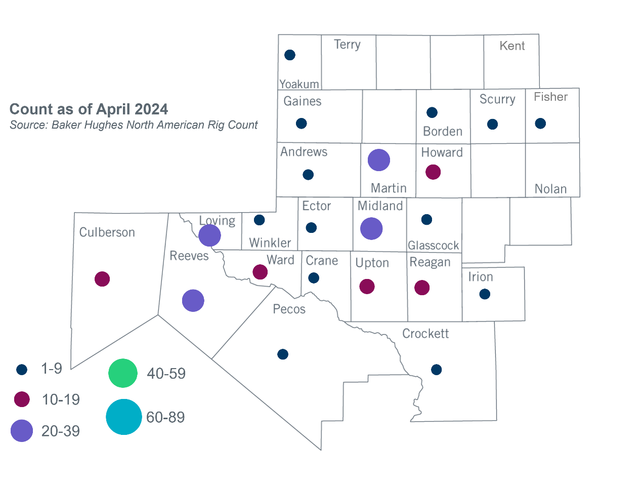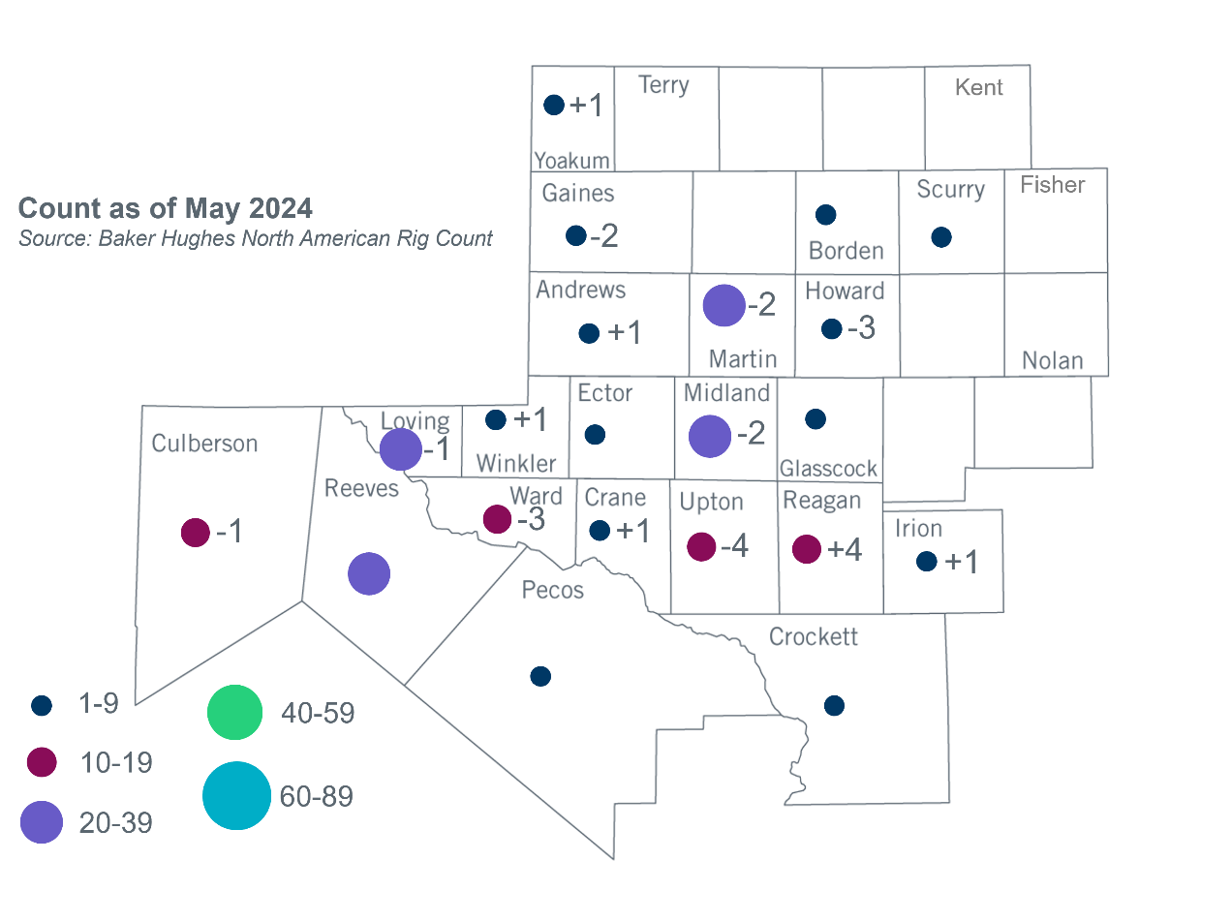Permian Basin Oil Rig Count[3]Other Notable Activities

* ERCOT is working on the Permian Basin reliability plan study as directed by HB5066 and by the PUC.
* ERCOT presented the 2024 Regional Transmission Plan (RTP) large load types and generation hubs update at the May 2024 RPG meeting.

1. Based on the Total Project Estimated Cost for all future projects listed in the Transmission Project Information and Tracking (TPIT) report. TPIT is updated three times each year based on information TSPs provide in Model on Demand (MOD) as specified in the ERCOT Steady State Working Group Procedure Manual. The latest TPIT is available at https://www.ercot.com/gridinfo/planning.
2. Based on the Total Project Estimated Cost for all completed projects with Projected In-Service Dates in 2023 listed in the TPIT.
3. +/- symbol indicates the increase or decrease from the previous month in oil rigs present in each county. There are 205 rigs, including a decrease of 10 oil rigs, in the Permian Basin from April to May 2024.