Market Trials and Transition Planning Document
V0.3 June 14 2024 Working Draft

There are six major areas of Market Trial and Transition Activity. Each of these activities will have:
- Defined Objective(s) for each Activity
- Entry Criteria (for both ERCOT and QSEs) prior to starting activity
- Defined Key activities during trial for ERCOT and QSE
- Exit Criteria

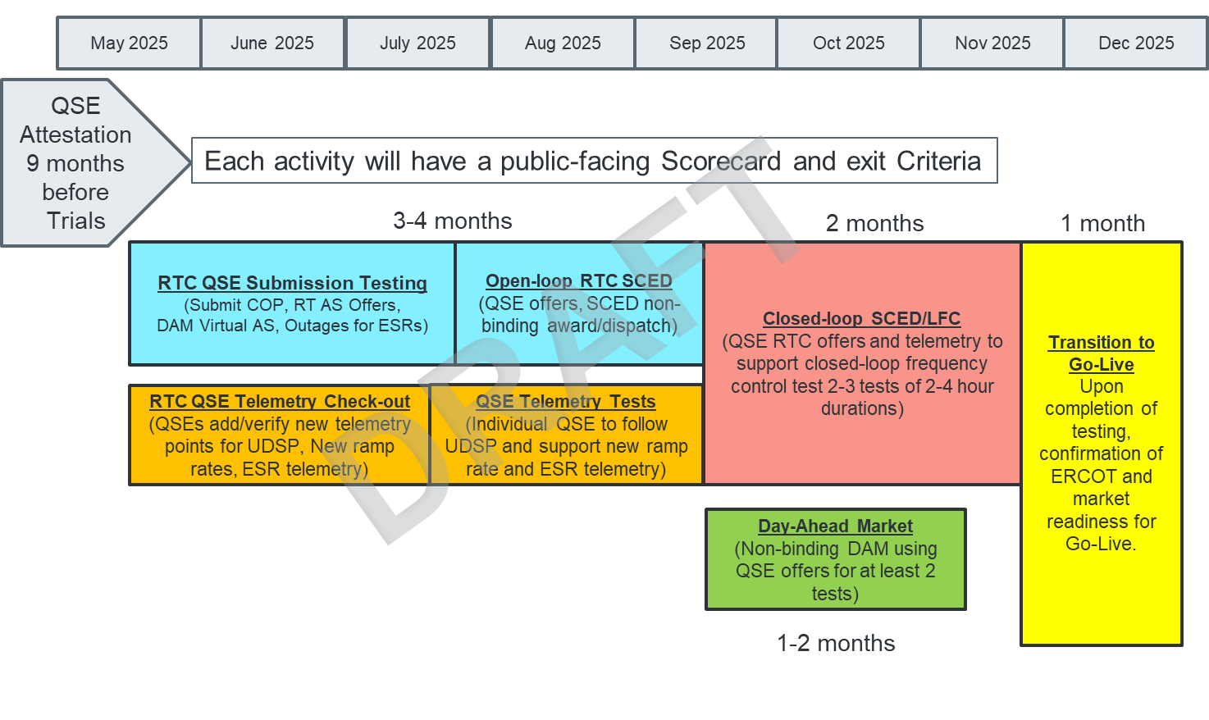

1.0 QSE ATTESTATION
QSE identifies Accountable Executive for QSEs with Resources and provides Attestation that QSE is aware of and committed to developing the necessary systems changes to be ready to engage the RTC+B Market Trial activities leading up to Cut-Over and Go-Live.
ERCOT would request this attestation after releasing the interface specifications and at least 9 months prior to initiating market trials.

2.0 QSE MARKET SUBMISSION TESTING
1. Defined Objectives:
- ERCOT will deploy RTC+B Code into a market facing trials environment
  - MMS-API, MMS-UI, OS-API, OS-UI
  - This test will be similar to MOTE testing, limited to receiving data from QSE
- QSE will test their market submissions for defined transactions (including COP, RT AS Offers, RT Energy Offers, DAM AS Only Offers, 3 Part Supply Offers)
- ERCOT will maintain scorecard of QSE participation as defined in Handbook
- Goal is for 95% of QSEs to demonstrate successful submissions, and have mitigation plans in place for remaining 5% to address in next trial phase.
2. Entry Criteria:
- 2.1 ERCOT Entry Criteria
  - Publish technical changes to EIP Interface Specification, XSDs, and Market Submission Whitepaper (at least 9 months prior to market trial)
  - Publish Business Process flows summary of changes for context of technical change (at least 8 months prior to market trial- may be met by Market Submission Whitepaper)
  - Publish “Trials Handbook” with details of specific functionality and testing (at least 3 months prior to market trial)
    - Scope of functional testing (and for clarity, out of scope items, eg reports)
    - Duration of Activity
    - Required market participation and Market Readiness Scorecard specifics (expected progression from 0%-100% and mitigation if not complete)
    - Details of access to environment (eg, Digital Certificates)
  - Systems Testing and Readiness
    - FAT testing and initial iTest Testing of MMS-API, MMS-UI, OS-API, OS-UI
    - Deployed into Market Trials environment
- 2.2 QSE Entry Criteria
  - QSE systems ready to connect to ERCOT systems and submit defined transactions
  - QSE assigned staff for attending weekly market trials WebEx meetings and submitting data to ERCOT per the applicable Handbook
3. Key Activities during Market Trial:
- QSEs participate in weekly WebEx meetings
- QSEs demonstrate successful Market Submissions testing and meet readiness criteria
- ERCOT is responsive in supporting QSE questions and issues
4. Exit Criteria
- Goal is for 95% of QSEs to demonstrate successful submissions, and mitigation plans in place for remaining 5% to address in next trial phase.

3.0 QSE TELEMETRY POINT CHECK-OUT
1. Defined Objectives:
- ERCOT will deploy RTC+B Code into a market facing trials environment
  - EMS SCADA/ICCP
  - This test window is for QSEs to set-up new telemetry points
  - QSEs will not follow telemetry points in this phase
- QSE will add telemetry points for EMS/ICCP system interface with ERCOT (UDSP, New Ramp Rates, and ESR Telemetry)
- ERCOT will maintain scorecard of QSE participation as defined in Handbook
- Goal is for 98% of QSEs to demonstrate successful submissions, and mitigation plans in place for remaining 2% to address in next trial phase.
2. Entry Criteria:
- 2.1 ERCOT Entry Criteria
  - Publish technical changes to ICCP changes (at least 9 months prior to market trial)
  - Publish Business Process flows summary of changes for context of technical change (at least 8 months prior to market trial)
  - Publish “Trials Handbook” with details of specific functionality and testing (at least 3 months prior)
    - Scope of functional testing (and for clarity, out of scope items, eg reports)
    - Duration of Activity
    - Required market participation and Market Readiness Scorecard specifics (expected progression from 0%-100% and mitigation if not complete)
  - Systems Testing and Readiness
    - FAT testing and initial iTest Testing of EMS, SCADA
    - Deployed into Market Trials environment
- 2.2 QSE Entry Criteria
  - QSE Systems ready to connect to ERCOT systems and submit defined telemetry
  - QSE assigned staff for attending weekly market trials WebEx meetings and submitting data to ERCOT per the applicable Handbook
3. Key Activities during Market Trial:
- QSEs participate in weekly calls.
- ERCOT and QSE agree to individual testing schedule.
- QSEs demonstrate successful addition of telemetry point testing and ability to follow ICCP values, such as UDSP
4. Exit Criteria
- Goal is for 98% of QSEs to demonstrate successful submissions, and mitigation plans in place for remaining 2% to address in next trial phase.

4.0 QSE TELEMETRY FOLLOWING TESTS
1. Defined Objectives:
- ERCOT will deploy RTC+B Code into a market facing trials environment
  - EMS SCADA/ICCP, RLC, LFC
  - This test window is for coordinating individual ERCOT/QSEs tests for following new UDSP telemetry points.
- ERCOT will coordinate individual QSE testing for subset of resources to follow UDSP signal.
- QSE will have ability to support live-production-quality telemetry for existing and added telemetry points (UDSP, New Ramp Rates, and ESR Telemetry)- note this is needed to support reasonable OpenLoop-RTC-SCED that will receiving new telemetry from QSE and pushing out telemetry the QSE, but not be followed except during individual QSE testing.
- ERCOT will maintain scorecard of QSE participation as defined in Handbook
- Goal is for 98% of QSEs to demonstrate successful submissions, and mitigation plans in place for remaining 2% to address in next trial phase.
2. Entry Criteria:
- 2.1 ERCOT Entry Criteria
  - Publish technical changes to ICCP changes (at least 9 months prior to market trial)
  - Publish Business Process flows summary of changes for context of technical change (at least 8 months prior to market trial)
  - Publish “Trials Handbook” with details of specific functionality and testing (at least 3 months prior)
    - Scope of functional testing (and for clarity, out of scope items, eg reports)
    - Duration of Activity
    - Required market participation and Market Readiness Scorecard specifics (expected progression from 0%-100% and mitigation if not complete)
  - Systems Testing and Readiness
    - FAT testing and initial iTest Testing of EMS, SCADA, RLC, LFC
    - Deployed into Market Trials environment
- 2.2 QSE Entry Criteria
  - QSE Systems ready to connect to ERCOT systems and submit defined telemetry
  - QSE assigned staff for attending weekly market trials WebEx meetings and submitting data to ERCOT per the applicable Handbook
3. Key Activities during Market Trial:
- QSEs participate in weekly calls.
- ERCOT and QSE agree to individual testing schedule.
- QSEs demonstrate successful addition of telemetry point testing and ability to follow ICCP values, such as UDSP
4. Exit Criteria
- Goal is for 98% of QSEs to demonstrate successful submissions, and mitigation plans in place for remaining 2% to address in next trial phase.
5.0 OPEN LOOP RTC SCED
1. Defined Objectives:
- ERCOT will deploy RTC+B Code into a market facing trials environment
  - RTC-SCED, MMS-UI, MMS-API, EMS, SCADA, RLC, LFC
  - Three CDR Reports: RTC LMPs, RTC AS prices, and SCED Binding Constraints
- QSE will build upon prior tests and begin supporting “parallel production” telemetry and entering market submissions to support RTC SCED for windows of time to observe, but not follow, non-binding RTC energy and A/S awards and dispatch.
- ERCOT will maintain scorecard of QSE participation as defined in Handbook
- Goal is for 100% of QSEs to demonstrate successful submissions and support new and existing telemetry reflective of actual production, and mitigation plans in place for any outliers.
2. Entry Criteria:
- 2.1 ERCOT Entry Criteria
  - Publish “Trials Handbook” with details of specific functionality and testing (at least 3 months prior)
    - Details of market submissions expected (quality and timing of submissions)
    - Scope of functional testing
    - Duration of Activity
    - Required market participation and Market Readiness Scorecard specifics
  - Systems Testing and Readiness
    - FAT testing and initial iTest Testing of RTC-SCED, EMS, SCADA, RLC, LFC
    - Deployed into Market Trials environment
- 2.2 QSE Entry Criteria
  - QSE Systems ready to connect to ERCOT systems and submit defined transactions
  - QSE assigned staff for attending weekly market trials meetings and submitting data to ERCOT per the applicable Handbook
3. Key Activities during Market Trial:
- QSEs participate in weekly WebEx calls.
- ERCOT provides guidance on values of data to be submitted and timing.
- QSEs demonstrate successful support of RTC-SCED submissions and telemetry.
4. Exit Criteria
  - Goal is for 100% of QSEs to demonstrate successful submissions, and mitigation plans for any outliers.

6.0 CLOSED LOOP RTC SCED
1. Defined Objectives:
- ERCOT will support RTC+B functionality in market facing environment in a manner that is equivalent to production level systems and support.
  - RTC-SCED, MMS-UI, MMS-API, EMS, SCADA, RLC, LFC
  - Three CDR Reports: RTC LMPs, RTC AS prices, and SCED Binding Constraints
- QSE will support RTC+B functionality in a manner that is equivalent to production level systems and support.
- ERCOT and QSE will conduct multiple live-production tests of RTC-SCED and Load Frequency Control to ensure effective RTC-SCED dispatch and Frequency Control prior to go-live.
- Dispatch during the tests will be binding to manage the reliable operations of the grid.
- Settlement during these tests will be performed with the current Settlement systems and leveraging Emergency Base point or Testing logic to ensure all QSEs are paid for energy dispatched during tests.
- ERCOT will maintain scorecard of QSE participation as defined in Handbook
- Goal is for 100% of QSEs to demonstrate successful submissions and telemetry, and mitigation plans in place for any outliers.
2. Entry Criteria:
- 2.1 ERCOT Entry Criteria
  - Publish “Trials Handbook” with details of specific functionality and testing (at least 3 months prior)
    - Details of QSE operations expected for production level support
    - Scope of functional testing
    - Duration of Activity
    - Control Room communications before and during tests
    - Required market participation and Market Readiness Scorecard specifics
  - Systems Testing and Readiness
    - iTest Testing of RTC-SCED, EMS, SCADA, RLC, LFC
    - Deployed into Market Trials environment
- 2.2 QSE Entry Criteria
  - QSE Systems ready to connect to ERCOT systems and submit defined transactions
  - QSE assigned staff for attending weekly market trials meetings and submitting data to ERCOT per the applicable Handbook
3. Key Activities during Market Trial:
- QSEs participate in weekly calls.
- ERCOT provides guidance on values of data to be submitted and timing of test windows.
  - Closed loop RTC-LFC test is to test reliability and frequency control.
  - Settlements will use current S&B systems and meter readings to settle days that include RTC-LFC test windows.
  - To minimize financial impacts to QSEs during tests, QSEs will be required to submit RTC energy offers that are identical to current production, and will translate current A/S responsibility into AS Offers and telemetry so as to maintain similar RTC A/S dispatch (ERCOT will help provide guidance on process).
  - During test, ERCOT would allow exemptions from Base Point Deviation charge.
  - If QSE financially harmed during test, can submit dispute for consideration to be processed via emergency settlement.
- QSEs demonstrate successful support of production RTC-SCED submissions and telemetry, follow RTC telemetry, and ERCOT successfully controls frequency.
4. Exit Criteria
- Goal is for 100% of QSEs to demonstrate successful submissions, and mitigation plans for any outliers.
- ERCOT to successfully control frequency during the test
- No issues identified by ERCOT in test that would create reliability risks for grid.

7.0 DAY-AHEAD MARKET (Optional Testing for all QSEs)
1. Defined Objectives:
- ERCOT will deploy Day-Ahead Market into a market facing environment
  - RTC-DAM, MMS-UI, MMS-API
    - MMS-UI and MMS-API will support publishing awards to QSEs
  - # CDR Reports: DAM AS Obligations, DAM AS Demand Curves, DAM Awards, DAM LMPs, DAM AS prices, etc
- QSE will test their market submissions for defined transaction (AS Self-Arrangement, DAM AS Only Offers, and normal DAM submissions)
- ERCOT will execute and publish at least two Day-Ahead Markets
- Does DAM participation need to be required? RTC DAM is essentially voluntary and includes much broader QSE population (traders and load-only QSE).
2. Entry Criteria:
- 2.1 ERCOT Entry Criteria
  - Publish Business Process flows summary of changes for context of technical change (at least 8 months prior to market trial- may be met by Market Submission Whitepaper)
  - Publish “Trials Handbook” with details of specific functionality and testing (at least 3 months prior)
    - Scope of functional testing (and for clarity, out of scope items, eg reports)
    - Duration of Activity
    - Required market participation and Market Readiness Scorecard specifics
    - Details of access to environment
  - Systems Testing and Readiness
    - FAT testing and initial iTest Testing of MMS-API, MMS-UI, DAM
    - Deployed into Market Trials environment
- 2.2 QSE Entry Criteria
  - QSE Systems ready to connect to ERCOT systems and submit defined transactions
  - QSE assigned staff for attending weekly market trials meetings and submitting data to ERCOT per the applicable Handbook
3. Key Activities during Market Trial:
- QSEs participate in weekly WebEx calls
- QSEs demonstrate successful Market Submissions testing and meet readiness criteria
- ERCOT is responsive in supporting QSE questions and issues
4. Exit Criteria
- Optional, or goal for x% of QSEs to demonstrate successful submissions in DAM?

