VCMRR Number | 041 | VCMRR Title | SO₂ and NO_{X} Emission Prices Used in Verifiable Cost Calculations
Date |  | July 30, 2024
Submitter’s Information
Name |  | Ino Gonzalez / Marcelo Magarinos
E-mail Address |  | Ino.Gonzalez@ercot.com / Marcelo.Magarinos@ercot.com
Company |  | ERCOT
Phone Number |  | 512-248-3954 / 512-248-6724
Cell Number
Market Segment |  | Not Applicable

Comments
ERCOT submits these comments to offer Wholesale Market Subcommittee (WMS) members a recommendation. As previously discussed at WMS and at the Resource Cost Working Group (RCWG), annual prices for sulfur dioxide (SO₂) and nitrogen oxide (NOx) have not change significantly since January 2017, as shown in the graph below. ERCOT uses the Cross-State annual price indices to calculate Resource emissions costs.
As described in Verifiable Cost Manual Revision Request (VCMRR) 041, SO₂ and NO_{X} Emission Prices Used in Verifiable Cost Calculations, ERCOT recommends eliminating the requirement of an annual emission price index, purchased through a subscription, to calculate monthly emissions costs. Rather, ERCOT would use fixed prices for SO₂ and NO_{X} set at $2/short ton and $3/short ton, respectively to calculate emissions costs, which are the same values used by ERCOT over the last several years. ERCOT proposes that fixed prices be used either until (1) new Environmental Protection Agency (EPA) requirements substantially affecting SO_{2,} and NO_{X} emissions prices go into effect, (2) ERCOT determines that a competitive market for SO₂ and NO_{X} exists, or (3) as directed by the Technical Advisory Committee (TAC).
Given that ERCOT will need to decide early in 2025 whether to continue with the annual emission price index subscription, ERCOT recommends that WMS either approve or reject VCMRR041 at its August 8, 2024 meeting. Delaying a decision most likely will result in ERCOT subscribing to this service for another year.

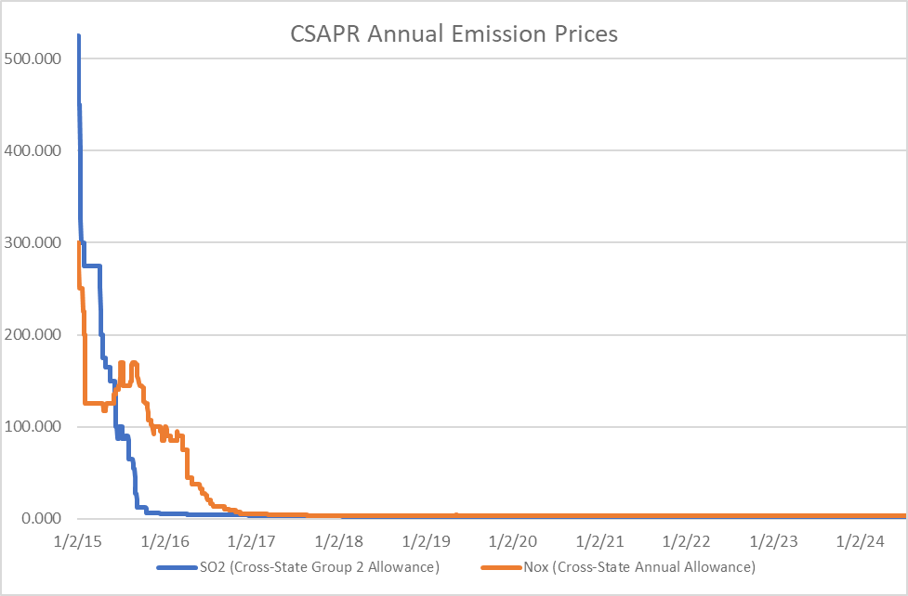

Revised Cover Page Language
None
Revised Proposed Manual Language
None

