**TDTMS**

**July 17, 2024 @ 9:30AM**

**WebEx only**

|  |  |  |  |  |  |  |
| --- | --- | --- | --- | --- | --- | --- |
| Attendee | Company | Attendee | Company | | Attendee | Company |
| Amy Sue Stirland | LP&L | Amanda Ghormley | | Calpine | Kyle Patrick | NRG |
| Jordan Troublefield | ERCOT | Bill Snyder | | AEP | Monica Jones | CNP |
| Tammy Stewart | ERCOT | Sam Pak | | Oncor | Eric Lotter | GridMonitor |
| Sheri Wiegand | Vistra | Mick Hanna | | ERCOT | Kathy Scott | CNP |
| Marty Allen | Oncor | Steven Pliler | | Vistra | Cesar Ordaz | AEP |
| Dee Lowerre | NRG | Debbie McKeever | | Oncor | Crystal Brown | LP&L |
| Rob Bevill | TNMP | Donna Tan | | LP&L |  |  |

Sheri Wiegand opened the meeting with the Antitrust Admonition and introductions of those noted on the WebEx were made.

Meeting minutes from the June 12th meeting were reviewed and approved.

**ERCOT System Instances & MarkeTrak Monthly Performance Review -**

* Market SLAs met for June. Q1 SLAs were not met, however Q2 targets were achieved. MarkeTrak performance remains well within SLO.
  + Will MT performance change with TXSET v5.0? Not expected as the changes are code related.
* 2025 SLOs and scheduled releases are being finalized and will review at the next TDTMS
* Listservs – no issues, unsubscribes were provided on weather moratorium distribution
* **Market Notice Archives** – Web development still reviewing . No update.

**SCR 817 MarkeTrak Validations –**

* Testing is going well – no questions for the business.
* WSDL Updates & Posting – MarkeTrak Information page has proposed WSDL changes posted. All API users received information via email. Currently testing WSDLs and may have corrections depending on the testing.
* User’s Guide Updates – Cancel w/Approval – no comments were received
* RMTE Availability – goal is to activate within 6 -8 weeks to allow enough time for market participants to test new IGL functionality. Targeting a date of 9/23. Tammy will provide notice on availability.
* Communication of Transition Plan – transition of open IGLs during November “cutover” week- calendar was developed and presented at the past RMS and will continue to be presented up until transition.
* TRAINING: In depth SCR817 changes training is proposed for the following dates to align with RMTE availability and closer to go-live:
  + **9/18** during the TDTMS meeting – the training will be held followed by the regularly scheduled TDTMS meeting
  + **10/24** during the TDTMS meeting – closer to go-live
* On line modules updates – Tammy has been working with Matt Tschetter of Training to update the modules. The updates will be reviewed at RMTTF.
* A call on July 30th to finalize TXSET transition plan.

**MarkeTrak Subtypes Volume for 2023**

Reviewed Cancel w/Approval, Usage & Billing- Dispute, and Usage & Billing – Missing results. Sam presented the data in a new graphical format which will be used to present to TDTMS. Below is matrix format of the results:

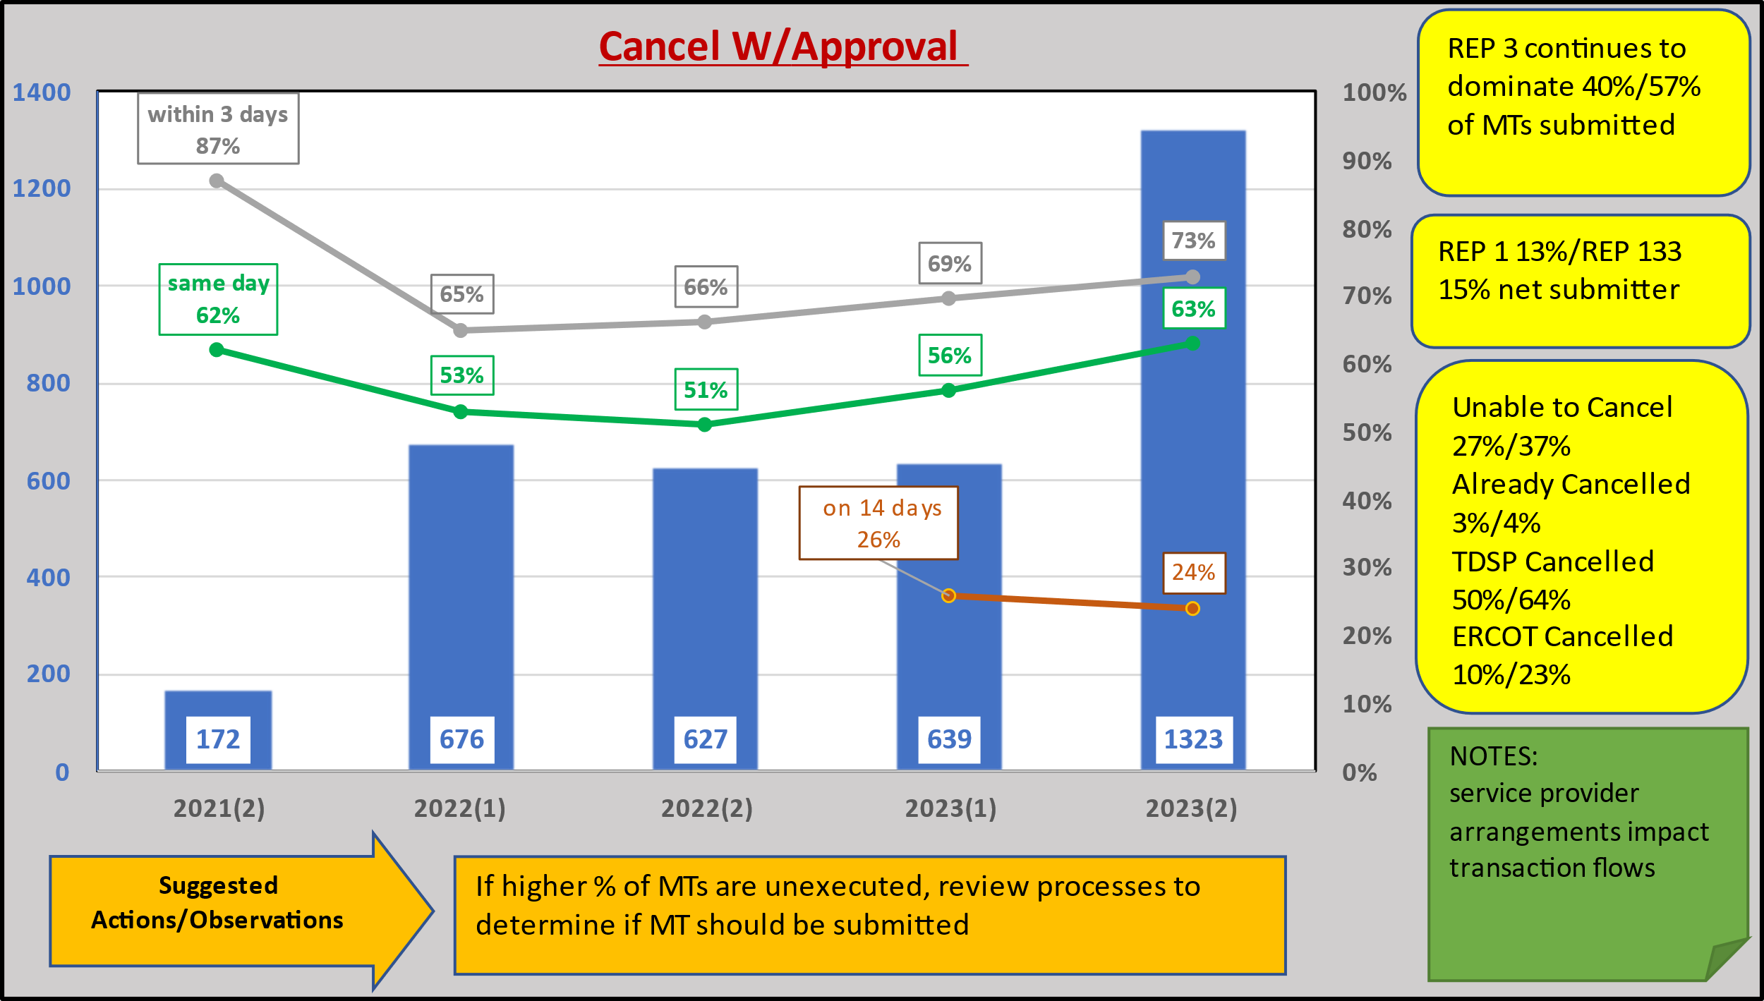

**NEXT MEETING** **Wednesday, August 14th @ 9:30 AM** **WebEx Only**

**DRAFT AGENDA**

* ERCOT Reports
  + System Instances & MT Performance
  + Listserv
  + Market Notice Archives – any updates
* SCR817 Business Requirements discussion
  + User’s Guide Updates
  + Communicating Transition Plan updates
    - On line module availability
    - RMTE availability
    - Detailed SCR817 training schedule
* MT Subtypes Volume Analysis – 2023 – results
  + Switch Holds
  + Inadvertent Gains/Losses
  + Rescissions