|  |  |  |  |
| --- | --- | --- | --- |
| NPRR Number | [1230](https://www.ercot.com/mktrules/issues/NPRR1230) | NPRR Title | Methodology for Setting Transmission Shadow Price Caps for an IROL in SCED |
|  | |  | |
| Date | | August 12, 2024 | |
|  | |  | |
| Submitter’s Information | | | |
| Name | | Keith Collins | |
| E-mail Address | | [keith.collins@ercot.com](mailto:keith.collins@ercot.com) | |
| Company | | ERCOT | |
| Phone Number | | 512-248-6707 | |
| Cell Number | |  | |
| Market Segment | | Not applicable | |

|  |
| --- |
| Comments |

ERCOT submits these comments to provide additional data for the Reliability & Markets (R&M) Committee and ERCOT Board of Directors’ consideration of Nodal Protocol Revision Request (NPRR) 1230. The NPRR was recommended for approval by the Technical Advisory Committee (TAC) on July 31, 2024. As indicated at TAC, ERCOT supports NPRR1230.

NPRR1230 was filed to allow ERCOT to raise the Shadow Price cap on certain transmission constraints whose exceedance would be a high reliability risk to the system. Such constraints are called Interconnection Reliability Operating Limits (IROLs). Under normal conditions, the current Shadow Price caps are sufficient to allow Security-Constrained Economic Dispatch (SCED) to manage flows under transmission limits (where there is a feasible dispatch solution). However, in some cases, especially during near-scarcity conditions when system prices are very high (either due to scarcity pricing or very high offers for remaining Resources), the current Shadow Price caps may not be sufficient to allow SCED to use all available Resources to resolve exceedances of some IROLs. Because of the risk to the entire system associated with exceeding these IROLs, ERCOT must take manual actions to either change the output of these Resources or, in some cases, shed load to avoid these exceedances. However, raising the shadow price cap on this type of transmission constraint, as proposed in NPRR1230, would allow SCED to go further in resolving the exceedances in an automated and efficient manner.

Because the initial known use of the higher Shadow Price cap under NPRR1230 would be associated with the new South Texas Export limit, TAC asked ERCOT to perform a backcast of the impact of this NPRR on several days (20) when this limit was violated last summer. ERCOT presented the results of that analysis at the July 31, 2024 TAC meeting.

There are some caveats for this backcast analysis. The South Texas Export limit was not an IROL during summer 2023 and the system would have been operated differently if it had been an IROL. The Transmission Operator (TO) of one of the key transmission lines has instituted a dynamic rating that was not in place in 2023 and it is not possible to replicate this new dynamic rating limit in the backcast analysis. The backcast analysis uses the calculated limits from March to June 2024, once the IROL was implemented on the South Texas Export limit. Additionally, there have been other plans developed to improve the limit that were not in place in 2023.

ERCOT reran SCED for intervals where the South Texas Export limit was violated during summer 2023 with the Shadow Price cap set at $19,751/MW for the South Texas Export constraint for two scenarios:

* **Scenario 1** – Average historical limits of South Texas Export IROLs in Real-Time (March – June 2024) when binding.
* **Scenario 2** – 25th percentile of limits on South Texas Export IROLs in Real-Time (March – June 2024) when binding; illustrates impacts of operating to more conservative limits.

For each scenario, the analysis computes a corresponding baseline based on the current Shadow Price cap of $5,251/MW and respective limits defined for the scenario. This approach isolates the specific impact of changing the shadow price cap (i.e., NPRR1230), as opposed to capturing any impacts from simply having the new IROLs in place. For these reruns, the release of Ancillary Services was not adjusted, and the manual deployments of generation were reversed.

The results of these runs show that the increase in the Shadow Price cap for this constraint significantly reduces the magnitude and frequency of violations of the IROL, as shown in the graph below.

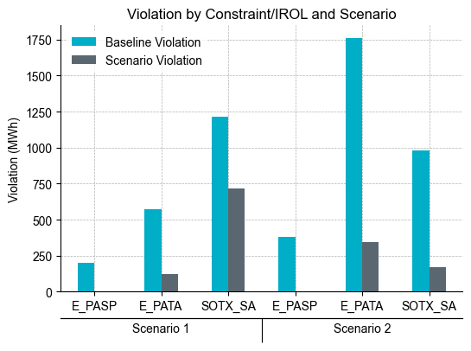

The reduction in the number of violations is significant. If the other mitigation plans that have been put in place since last summer are not sufficient to mitigate the remaining violations, under similar conditions, ERCOT would have to shed Load to avoid any remaining exceedances.

The backcast analysis also provides an estimate of the impact of increasing the Shadow Price cap on the value of energy resulting from system dispatch, which is a function of Real-Time Load and Settlement prices for each zone.[1] The analysis calculates prices and energy values relative to the baseline scenario for intervals in which the limit was violated for the respective Operating Day.

While both scenarios increase the value of energy relative to the baseline when viewed at both the systemwide and Load Zone levels, this result is expected given that SCED will have more opportunity to provide an economic solution. Notwithstanding the increase in the value of energy, both ERCOT and the IMM support the methodology proposed in NPRR1230 and its adoption as a market-based, more-efficient solution to manage these transmission constraints.

Systemwide:

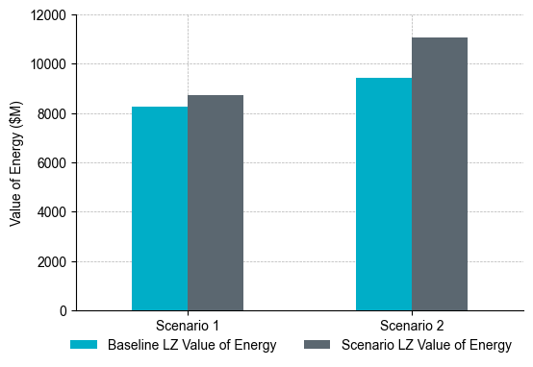

By Load Zone:

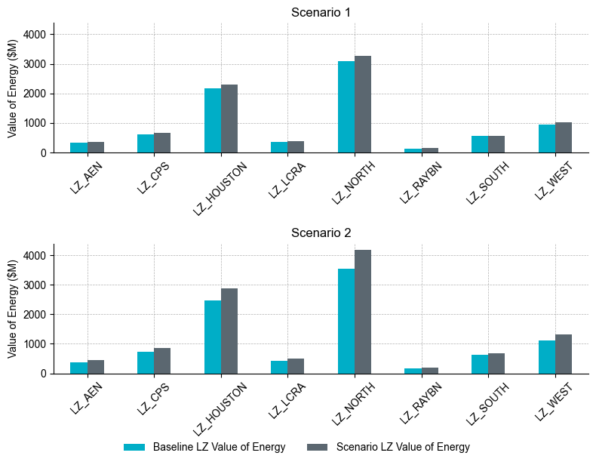

|  |
| --- |
| Revised Cover Page Language |

None

|  |
| --- |
| Revised Proposed Protocol Language |

None

1. Load Zone value of energy is defined as the product of the 15-minute Load Zone Settlement Point Price in the Real-Time Market and its associated Real-Time Adjusted Metered Load.