

System Planning

**Monthly Status Report**

Report Highlights

* ERCOT is currently reviewing proposed transmission improvements with a total estimated cost of $2.001 billion as of July 31, 2024.
* Transmission Projects endorsed in 2024 total $2.518 billion as of July 31, 2024.
* All projects (in engineering, routing, licensing, and construction) total approximately $14.183 billion[1] as of June 1, 2024.
* Transmission Projects energized in 2024 total approximately $2.160 billion[2] (as of June 1, 2024).

Regional Planning Group Reviews

RPG Projects under Review:

* Oncor has submitted the West Texas 345-kV Infrastructure Rebuild Project (RPG Project ID: 23RPG034). This is a Tier 1 project that is estimated to cost $1.120 billion. ERCOT has completed the independent review on May 16, and the recommended project is estimated to cost $1.120 billion. TAC voted unanimously to endorse the project on May 22, 2024. The ERCOT Board of Directors endorsed the project on June 18, 2024, and ERCOT has issued the ERCOT endorsement letter.
* Oncor has submitted the Temple Area Project (RPG Project ID: 24RPG001). This is a Tier 1 project that is estimated to cost $120.70 million. ERCOT has completed the independent review on July 26, and the recommended project is estimated to cost $272.60 million. TAC voted unanimously to endorse the project on July 31, 2024. ERCOT will present the recommendation for Board of Directors endorsement on August 20.
* CPS Energy has submitted the Eastside 345/138-kV Switching Station Project (RPG Project ID: 24RPG003). This is a Tier 1 project that is estimated to cost $158.00 million. ERCOT has completed the independent review on July 26, and the recommended project is estimated to cost $47.00 million. Pursuant to the Protocol Section 3.11.4.3.1(c), this project has been reclassified as a Tier 3 project, and ERCOT will issue an acceptance letter.
* CPS Energy has submitted the Omicron Reliability Project (RPG Project ID: 24RPG004). This is a Tier 2 project that is estimated to cost $42.50 million. ERCOT completed the independent review on July 26, and the recommended project is estimated to cost $45.70 million. ERCOT will issue the ERCOT endorsement letter.
* REC has submitted the Canton Area Loop Project (RPG Project ID: 24RPG007). This is a Tier 2 project that is estimated to cost $22.61 million. This project is currently under ERCOT’s independent review.
* AEPSC has submitted the Brownsville Area Improvements Transmission Project (RPG Project ID: 24RPG008). This is a Tier 1 project that is estimated to cost $387.70 million. This project is currently under ERCOT’s independent review.
* Oncor has submitted the Delaware Basin Stages 3 and 4 Project (RPG Project ID: 24RPG010). This is a Tier 1 project that is estimated to cost $202.20 million. This project is currently under ERCOT’s independent review.
* Oncor has submitted the Delaware Basin State 5 Project (RPG Project ID: 24RPG015). This is a Tier 1 project that is estimated to cost $744.60 million. This project is currently under ERCOT’s independent review.
* REC has submitted the Rand Area Loop Project (RPG Project ID: 24RPG016). This is a Tier 2 project that is estimated to cost $32.20 million. This project is currently under ERCOT’s independent review.
* Oncor has submitted the Venus Switch to Sam Switch 345-kV Line Project (RPG Project ID: 24RPG017). This is a Tier 1 project that is estimated to cost $118.90 million. This project is currently under ERCOT’s independent review.
* Oncor has submitted the Salado Switch to Hutto Switch 138-kV Line Project (RPG Project ID: 24RPG018). This is a Tier 3 project that is estimated to cost $87.60 million. The RPG review of this project was completed on July 8, and ERCOT will issue an acceptance letter.
* Oncor has submitted the Vineyard Switch to Cypress Waters 138-kV Circuit Addition Project (RPG Project ID: 24RPG019). This is a Tier 3 project that is estimated to cost $93.04 million. The RPG review of this project was completed on July 8, and ERCOT will not issue an acceptance letter for this project, as it is not dictated by NERC or ERCOT planning criteria and is solely needed to meet Oncor’s developed guideline to serve critical loads.
* Oncor has submitted the Connell 345/138-kV Switch and Connell to Rockhound 345-kV Double-Circuit Line Project (RPG Project ID: 24RPG020). This is a Tier 1 project that is estimated to cost $110.62 million. This project is currently under ERCOT’s independent review.
* Oncor has submitted the Forney 345/138-kV Switch Rebuild Project (RPG Project ID: 24RPG021). This is a Tier 1 project that is estimated to cost $103.50 million. This project is currently under ERCOT’s independent review.
* Oncor has submitted the Wilmer 345/138-kV Switch Project (RPG Project ID: 24RPG022). This is a Tier 1 project that is estimated to cost $158.20 million. This project is currently under ERCOT’s independent review.

RPG Project Reviews Completed in 2024:

|  |  |  |  |  |  |
| --- | --- | --- | --- | --- | --- |
| RPG Project ID | RPG Project Name | Submitted Entity | Tier | Estimated Cost  ($ Millions) | Review Completion Month |
| 24RPG002 | Rockhound 345/138-kV Switch and Grey Well Draw to Buffalo 2nd 138-kV Circuit Project | Oncor | Tier 3 | 97.00 | February |
| 23RPG028 | Rio Medina Project | STEC | Tier 2 | 71.70 | February |
| 23RPG023 | Pecos County Transmission Improvement Project | TNMP | Tier 1 | 114.80 | February |
| 24RPG005 | Montfort Switch to Shankle Switch 138-kV Line Project | Oncor | Tier 3 | 33.80 | February |
| 24RPG006 | Prairieland 345/138-kV Switch and Prairieland Switch to Quartz Sand Switch/Hog Mountain Pod 138-kV Line Project | Oncor | Tier 3 | 56.00 | March |
| 23RPG032 | San Antonio South Reliability II Project  (San Miguel to Marion 345-KV Project) | BEC | Tier 1 | 435.00 | April |
| 24RPG009 | Sonora to Uvalde to Campwood to Bandera Area Transmission Project | AEPSC, LCRA TSC & BEC | Reclassified from Tier 3 to Tier 4 per Protocol | 76.00 | April |
| 24RPG011 | Gonzales STATCOM Transmission Project | AEPSC | Reclassified from Tier 3 to Tier 4 per Protocol | 34.50 | April |
| 24RPG012 | Clute to Velasco ckt 26 Upgrades Project | CNP | Tier 3 | 68.23 | May |
| 24RPG013 | FPP Yard 2 to Lytton Springs Transmission Line Overhaul Project | LCRA TSC & AEN | Reclassified from Tier 3 to Tier 4 per Protocol | 60.00 | May |
| 24RPG014 | Sim Gideon to Cedar Hill Transmission Line Upgrade Project | LCRA TSC | Tier 3 | 77.90 | May |
| 23RPG034 | West Texas 345-kV Infrastructure Rebuild Project | Oncor | Tier 1 | 1,120.00 | June |
| 23RPG003 | Energy Eastside 345/138-kV Switching Station Project | CPS Energy | Reclassified from Tier 1 to Tier 3 per Protocol | 47.00 | July |
| 23RPG004 | Omicron Reliability Project | CPS Energy | Tier 2 | 45.70 | July |
| 24RPG018 | Salado Switch to Hutto Switch 138-kV Line Project | Oncor | Tier 3 | 87.60 | July |
| 24RPG019 | Vineyard Switch to Cypress Waters 138-kV Circuit Addition Project | Oncor | Tier 3 | 93.04 | July |

More information on current and past RPG projects can be found on the ERCOT MIS Secure (digital certificate required): https://mis.ercot.com/secure/data-products/grid/regional-planning

Past email communication on RPG projects can be found on the ERCOT listserv by signing up for the REGPLANGROUP list: <http://lists.ercot.com/scripts/wa-ERCOT.exe?A0=REGPLANGROUP>

Planning Model Activities

The short-term calendar of major planning model events is as follows:

* By October 15, 2024 24SSWG_U1 Cases and TPIT will be posted
* By November 8, 2024 24SSWG_U1 Contingencies and Data Dictionary will be posted

The following table shows interconnection projects that met Planning Guide section 6.9(1) and 6.9(2) and were modeled in the SSWG cases as a full model or as a simple model in accordance with Planning Guide section 6.9.





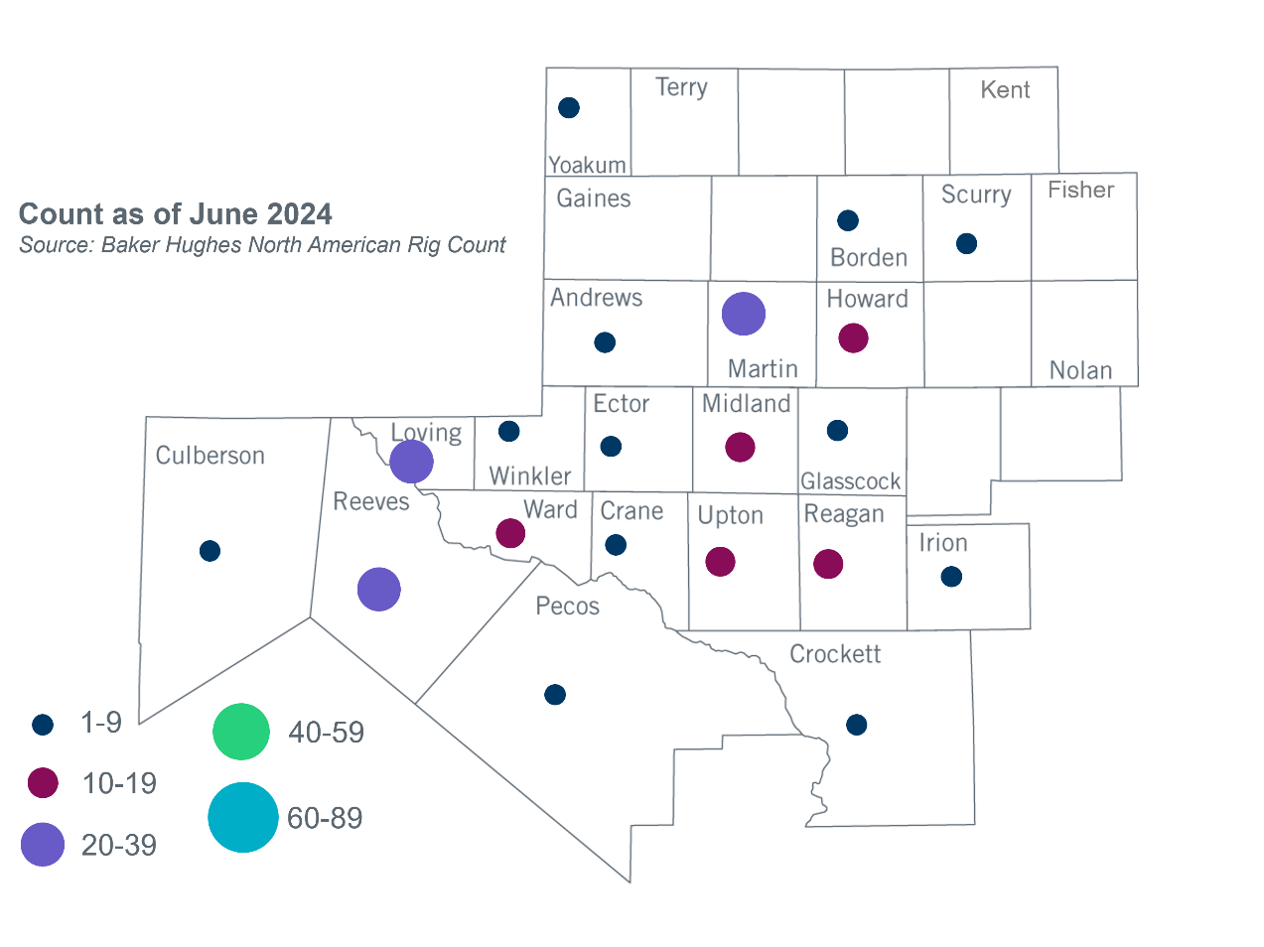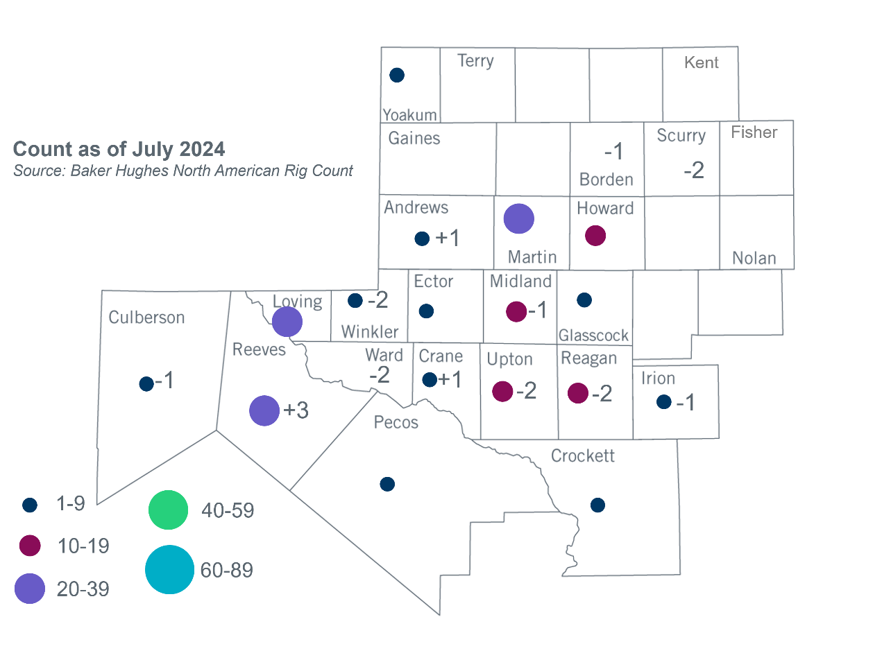Permian Basin Oil Rig Count[3]Other Notable Activities

* ERCOT completed and filed the Permian Basin reliability plan study on July 25, 2024, with the PUCT.
* ERCOT presented the 2024 Regional Transmission Plan (RTP) economic study stability interface limits at the July 2024 RPG meeting.

1. Based on the Total Project Estimated Cost for all future projects listed in the Transmission Project Information and Tracking (TPIT) report. TPIT is updated three times each year based on information TSPs provide in Model on Demand (MOD) as specified in the ERCOT Steady State Working Group Procedure Manual. The latest TPIT is available at https://www.ercot.com/gridinfo/planning.
2. Based on the Total Project Estimated Cost for all completed projects with Projected In-Service Dates in 2023 listed in the TPIT.
3. +/- symbol indicates the increase or decrease from the previous month in oil rigs present in each county. There are 191 rigs, including a decrease of 8 oil rigs, in the Permian Basin from June to July 2024.