*RTC+B Ancillary Service Demand Curve (ASDC) Issue*

*9/13/2024*

**Executive Summary**:

This paper offers an explanation on the historical need and processes for development of ASDCs for implementation of the Real-Time Co-optimization plus Batteries (RTC+B) Program. Although current approved protocols already define the ASDCs from the work done in 2019, there is concern with whether these curves should be modified prior to RTC+B implementation.

The purpose of AS Demand Curves is to create a value (price) on reserves when they become scarce. Per protocol, “A curve that reflects the value of each Ancillary Service product by price/quantity pairs for each hour of the Operating Day.”

**Background:**

After Nodal go-live in 2010, the real-time market was observed to have low real-time energy prices, even when capacity and reserves were scarce. The lack of higher price signals during these shortages was resolved by implementing an Operating Reserve Demand Curve (ORDC). Note that during the development of the single ORDC, there was recognition that most other markets had Real-Time Co-optimization and AS demand curves.

Years later in 2019, as [key principles](https://www.ercot.com/files/docs/2020/02/20/RTC_KeyPrinciples_Combined_v20200211.doc) for RTC were being developed by ERCOT and stakeholders, the PUCT was asked to weigh in on some key RTC design elements, including what the value of ASDCs should be for RTC. In June 2019, PUCT Chairman Walker filed a [memo](https://interchange.puc.texas.gov/search/documents/?controlNumber=48540&itemNumber=59) with direction on certain RTC design elements, including the ASDCs.

*‘Staff recommends that the design of the ASDCs replicate, as closely as possible, the*

*pricing outcomes of the ORDC, in order to preserve the existing Market Equilibrium Reserve*

*Margin, and that the set of ancillary services approved by the ERCOT Board of Directors in*

*Nodal Protocol Revision Request 863 form the basis of the ASDC design.'*

With this direction, ERCOT proposed to the RTC Task Force that the AS Demand Curves be defined as slices of reserves under the ORDC curve, with the highest valued AS being Regulation-Up (URS), followed by Responsive Reserve Service (RRS), followed by ERCOT Contingency Reserve Service (ECRS), and lastly Non-Spinning Reserve Service (NSRS). These curves were interspersed with lower value services to create some ramp shape to each service (see graphic). The ramp values were derived from the Power Balance Penalty curve (working documents in Key Principle 1 at [link](https://www.ercot.com/mktrules/puctDirectives/rtCoOptimization)).

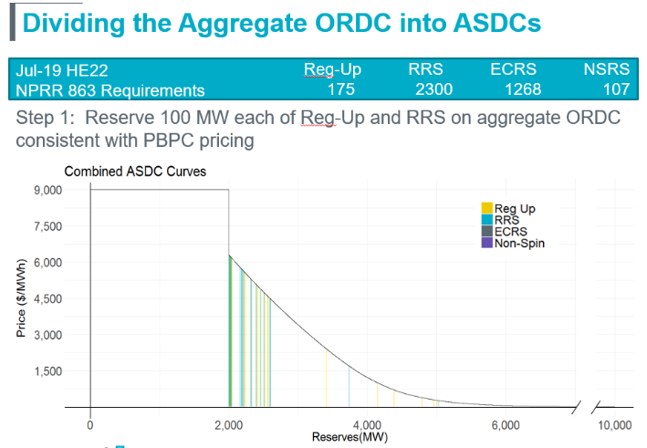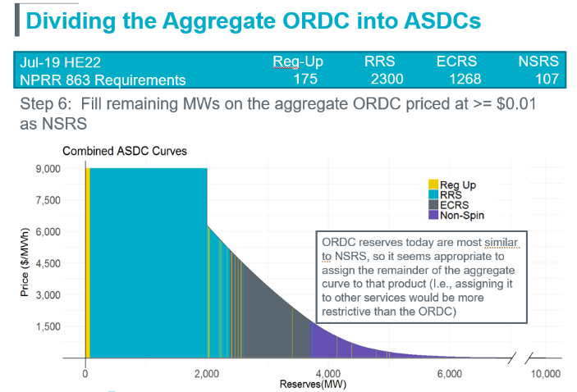

In response to ERCOT’s proposal, Dr. Shams Siddiqi proposed a simpler design with the idea that the different AS products should be separate and district curves without a dispersing the values across other products.

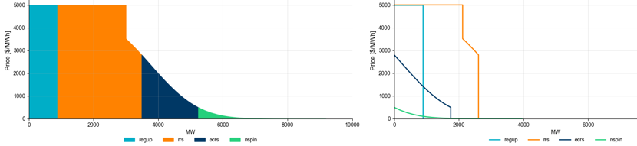

After considerable discussion in Real-Time Co-optimization Task Force (RTCTF) meetings, the ASDCs as proposed by Dr. Siddiqi were unanimously approved at the September 25, 2019 TAC meeting within Key Principle 1.1, and were incorporated in the approve RTC protocols in 2020 with NPRR1008 and specifically Protocol Section 4.4.12:

*(6) ERCOT shall disaggregate the AORDC developed pursuant to paragraph (5) above into individual ASDCs for each Ancillary Service product as follows:*

*(a) The ASDC for all Reg-Up in the Ancillary Service Plan shall use the highest price portion of the AORDC;*

*(b) The ASDC for all RRS in the Ancillary Service Plan shall use the highest price portion of the remaining AORDC after removing the portion of the AORDC that was used for the Reg-Up ASDC;*

*(c) The ASDC for all ECRS in the Ancillary Service Plan shall use the highest price portion of the remaining AORDC after removing the portions of the AORDC that were used for the Reg-Up and RRS ASDCs;*

*(d) The ASDC for Non-Spin shall use the remaining portion of the remaining AORDC after removing the portions of the AORDC that were used for the Reg-Up, RRS, and ECRS ASDCs.*

*(7) Each ASDC will be represented by a 100-point linear approximation to the corresponding part of the AORDC. Fewer points may be used for cases where it would not result in decreased accuracy in representing the corresponding part of the AORDC.*

This policy decision was settled in 2020, but revisited beginning in February 2024 as ERCOT provided examples of the ASDC values using this protocol requirement, and more recently by the IMM in meetings with ERCOT in August 2024.

As of 9/13/2024, the current issues in discussion at the RTCBTF can be summarized as:

ERCOT’s understanding is that there are two ORDC/ASDC issues being discussed: 1) that the current ORDC shape is not accurate due to the impacts of “conservative operations” and should be changed for RTC, and 2) that the shape of the ASDCs under the ORDC need to be changed.

Issue #1- Regarding the shape of the existing ORDC: ERCOT is currently analyzing and preparing the ORDC biennial study to file with the PUC by November 1. That analysis may identify areas for potential change; however, to date, ERCOT has not observed any operational or market concerns with the ORDC (current observations shared by ERCOT at June 14, 2024 RTCBTF meeting). During discussion at the RTCBTF, Vistra (through Texas Competitive Power Advocates (TCPA) comments) raised concerns that the ORDC is not accurate but has not made a specific proposal for consideration.

Issue #2- Regarding the shape of the ASDCs: Stakeholders on both sides of the issue (including the IMM) have raised concerns that the ASDCs may not reflect the value of each AS product in today’s environment.

For example, the IMM believes a ramp-in for the ASDCs is key to avoid the first MW of RegUp pricing at $5,000. The IMM has not yet proposed an alternative.

Also note that Shell (through TCPA comments to RTCBTF) proposed to re-distribute some parts of the ASDC curves.

Next Steps:

ERCOT is planning to have the RTC Simulator available in October 2024 for running pricing studies for historical days and could provide analysis capability for studying changes to ASDCs.

Although improvements may be considered, absent any approved changes in the near future, ERCOT does have a current ORDC and ASDC design approved in protocols for implementation.