TDTMS
August 14th, 2024 @ 9:30AM
WebEx only
Attendee | Company | Attendee | Company |  | Attendee | Company
Jesse Macias | AEP | Amanda Ghormley |  | Calpine | Kyle Patrick | NRG
Cindy Juarez | AEP | Bill Snyder |  | AEP | Monica Jones | CNP
Dave Michelson | ERCOT | Sam Pak |  | Oncor | Eric Lotter | GridMonitor
Sheri Wiegand | Vistra | Richard Rawlinson |  | Oncor | Kathy Scott | CNP
Marty Allen | Oncor | Steven Pliler |  | Vistra | Cesar Ordaz | AEP
Dee Lowerre | NRG | Debbie McKeever |  | Oncor | Mark Hensley | Oncor

Dee Lowerre opened the meeting with the Antitrust Admonition and introductions of those on the WebEx were made.
Meeting minutes from the July 17th meeting were reviewed and approved.

ERCOT System Instances & MarkeTrak Monthly Performance Review -
- Market SLAs met for July. MarkeTrak performance remains well within SLO.
  - Question asked about the slight upward trend on Query List values - per ERCOT, the response time is a reflection of volume and seasonal volumes are evident
- Listservs – no issues, unsubscribes were provided on weather moratorium distribution and this slide will remain in ERCOT’s updates
- Proposed 2025 Retail Release Calendar will be the same structure as 2024 – more frequent, yet shorter duration, with one longer retail release.
  - Redlined document will be forthcoming
  - Goal: schedule will be finalized in September with an RMS approval in October
- Dave continued discussion from RMS regarding ERCOT’s request to move retail releases to align with other production releases and be performed during the week
  - The goal is to remain in sync with cyber protection on all systems – currently, other systems are updated during the week, with retail releases occurring on weekends leaving slight vulnerabilities during the out of sync time frames
  - Mid week releases could impact intermittent activity of Find MIS, Find Transactions, and MarkeTrak applications
    - REPs expressed reservations with MT platform being impacted for an hour during normal business hours
  - Dave indicated discussions are beginning and ERCOT would need to update Protocols (15) to align with noted response times
  - It was suggested the new approach not be considered for 2025 Retail Release calendar for now, however, once any protocol revisions were in place, RMS/TDTMS could revisit the calendar for any updates, possibly mid-year 2025
  - This item will be kept on the agenda for any updates on framework revisions to ensure all impacted protocols are reviewed.

SCR 817 MarkeTrak Validations –
- WSDL Updates & Posting –Currently testing WSDLs and thus far no changes have been identified – any questions from market participants should be directed to Retail Operations at ERCOT
- New version of Business Requirements – posted to MCT page
- RMTE Availability – confirmed second weekend in September 14th – 15th; market notice will be distributed
- TRAINING: In depth SCR817 changes training is confirmed for the following dates to align with RMTE availability and closer to go-live:
  - 9/18 @ 9:30 AM
  - 10/24 @ 9:30 AM
- TDTMS meetings will be moved to the afternoons on the above dates – ACTION: Sheri will confirm with ERCOT to move the start times for TDTMS at 1:00 PM and add two new training sessions for the above dates and times
- On line modules updates – ERCOT is progressing on updates and are on target for completion. The updates will be reviewed at RMTTF.
- Communication of IGL MarkeTrak Transition Schedule – the calendar was tweaked by adding a few times and notes “Any MTs processed 11/4 – 11/8 will need to follow the new workflow with (BD)MVIs submitted on 11/11 or after”

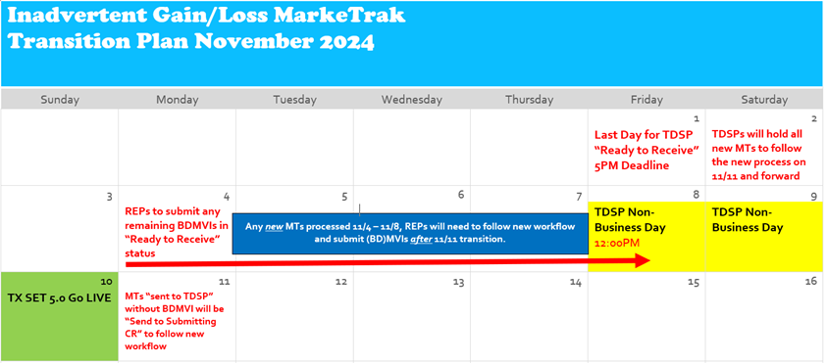

MarkeTrak Subtype Volume for 2023
- Noted Sam was still working on a Switch Hold graph.
- Additional data results will be available once the small group meets again – should have additional results by next meeting.
- ACTION: request additional 2024(1) “data dump” of MT information for further analysis
  - With the addition of LP&L will we need to re-shuffle the TDSPs #s for anonymity
- With the data, how are we pushing the information to the REPs who do not participate in market meetings?
  - Client Services has provided outreach to all REPs offering their anonymous REP# and directing them to at least IGL data provided monthly
  - TDTMS will collaborate with RMTTF to incorporate data into MarkeTrak training for awareness
  - Will communicate at the next RMS update the reason for the analysis and what REPs can do with the data:
    - Goal is to reduce the volumes of MarkeTraks
    - View performance relative to peers
    - Opportunities to enhance internal business processes
    - Reduce unnecessary MTs
  - Question if REP#s can be provided to TDUs? Per ERCOT, Legal team is not comfortable providing information directly to TDUs. REPs would have to provide their respective #s to the TDUs

NEXT MEETING Wednesday, September 18th @ 1:00 PM WebEx Only

DRAFT AGENDA
- ERCOT Reports
  - System Instances & MT Performance
  - Listserv
  - Market Notice Archives – any updates
  - 2025 Retail Release Calendar Proposed Revisions
  - Retail Release Calendars aligning with Production Releases
- SCR817 Business Requirements discussion
  - Updates
  - Communicating Transition Plan updates
    - On line module availability
    - RMTE availability – any questions
    - SCR817 training feedback
- MT Subtypes Volume Analysis – 2023 – results
  - Inadvertent Gains/Losses
  - Rescissions

