**TDTMS**

**September 18, 2024 @ 1:00 PM**

**WebEx only**

|  |  |  |  |  |  |  |
| --- | --- | --- | --- | --- | --- | --- |
| Attendee | Company | Attendee | Company | | Attendee | Company |
| Jesse Macias | AEP | Janet Gorman | | TNMP | Kyle Patrick | NRG |
| Jordan Troublefield | ERCOT | Bill Snyder | | AEP | Monica Jones | CNP |
| Dave Michelson | ERCOT | Sam Pak | | Oncor | Eric Lotter | GridMonitor |
| Sheri Wiegand | Vistra | Mick Hanna | | ERCOT | Kathy Scott | CNP |
| Tammy Stewart | ERCOT | Steven Pliler | | Vistra | Amy Sue Stirland | LP&L |
| Dee Lowerre | NRG | Debbie McKeever | | Oncor | Dheena | LP&L |
| Juan Alegria | Champion | Randi Flowers | | Champion | Shanette Solomon | Champion |
|  |  |  | |  |  |  |

Monica Jones opened the meeting with the Antitrust Admonition and introductions of those on the WebEx were made.

Meeting minutes from the August 14th meeting were reviewed noting one minor change in the date of the meeting. Notes will be corrected and reposted to the meeting page.

**ERCOT System Instances & MarkeTrak Monthly Performance Review -**

* Market SLAs met for August. MarkeTrak performance remains well within SLO.
* Listservs – no issues, unsubscribes were provided on weather moratorium distribution and this slide will remain in ERCOT’s updates; Oncor removals are associated with internal system configuration and Oncor is working with ERCOT to correct
* Proposed 2025 Retail Release Calendar will be the same structure as 2024 – more frequent, yet shorter duration, with one longer retail release.
  + Redlined document will be forthcoming to align with dates in presentation
  + 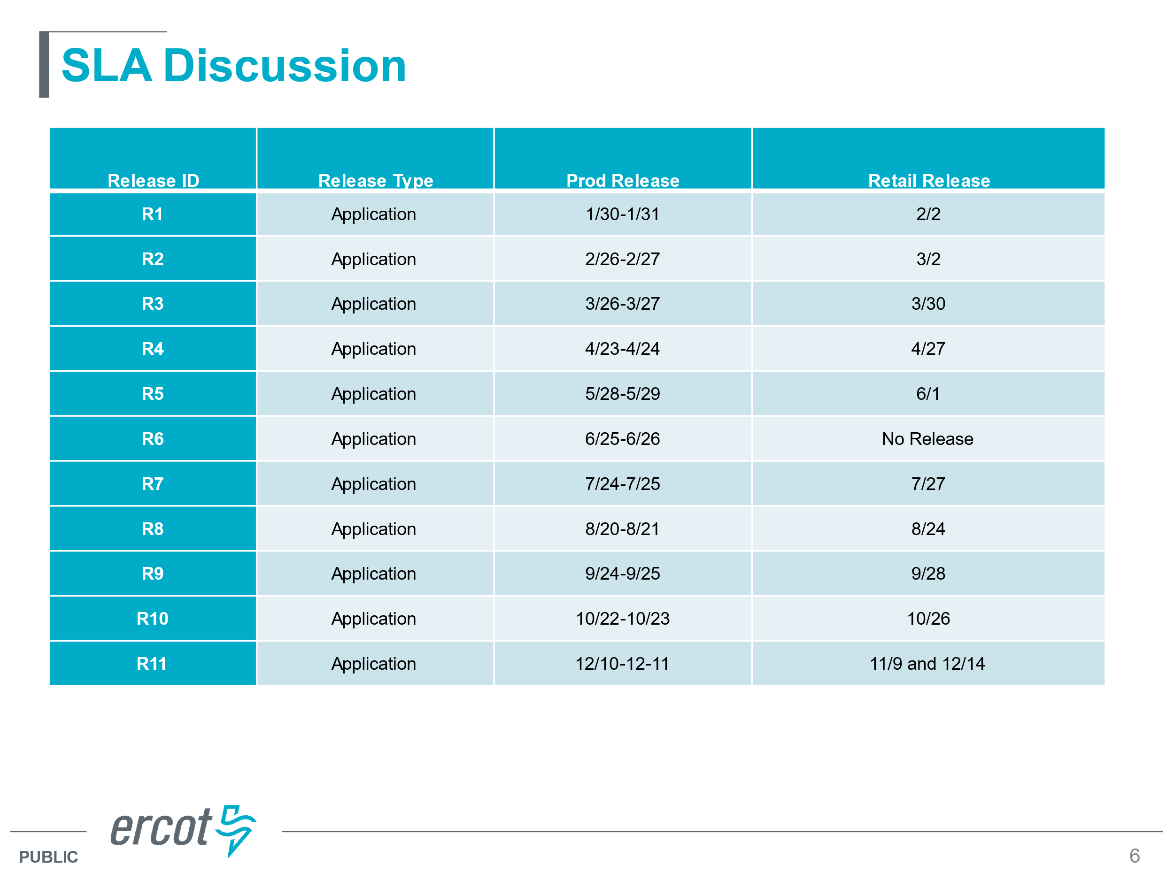
  + Goal: the approach will be consistent with 2024, yet begin moving toward alignment of production releases with retail releases where one hour outages would occur mid-week; NAESB outages will remain for the non-business days
  + 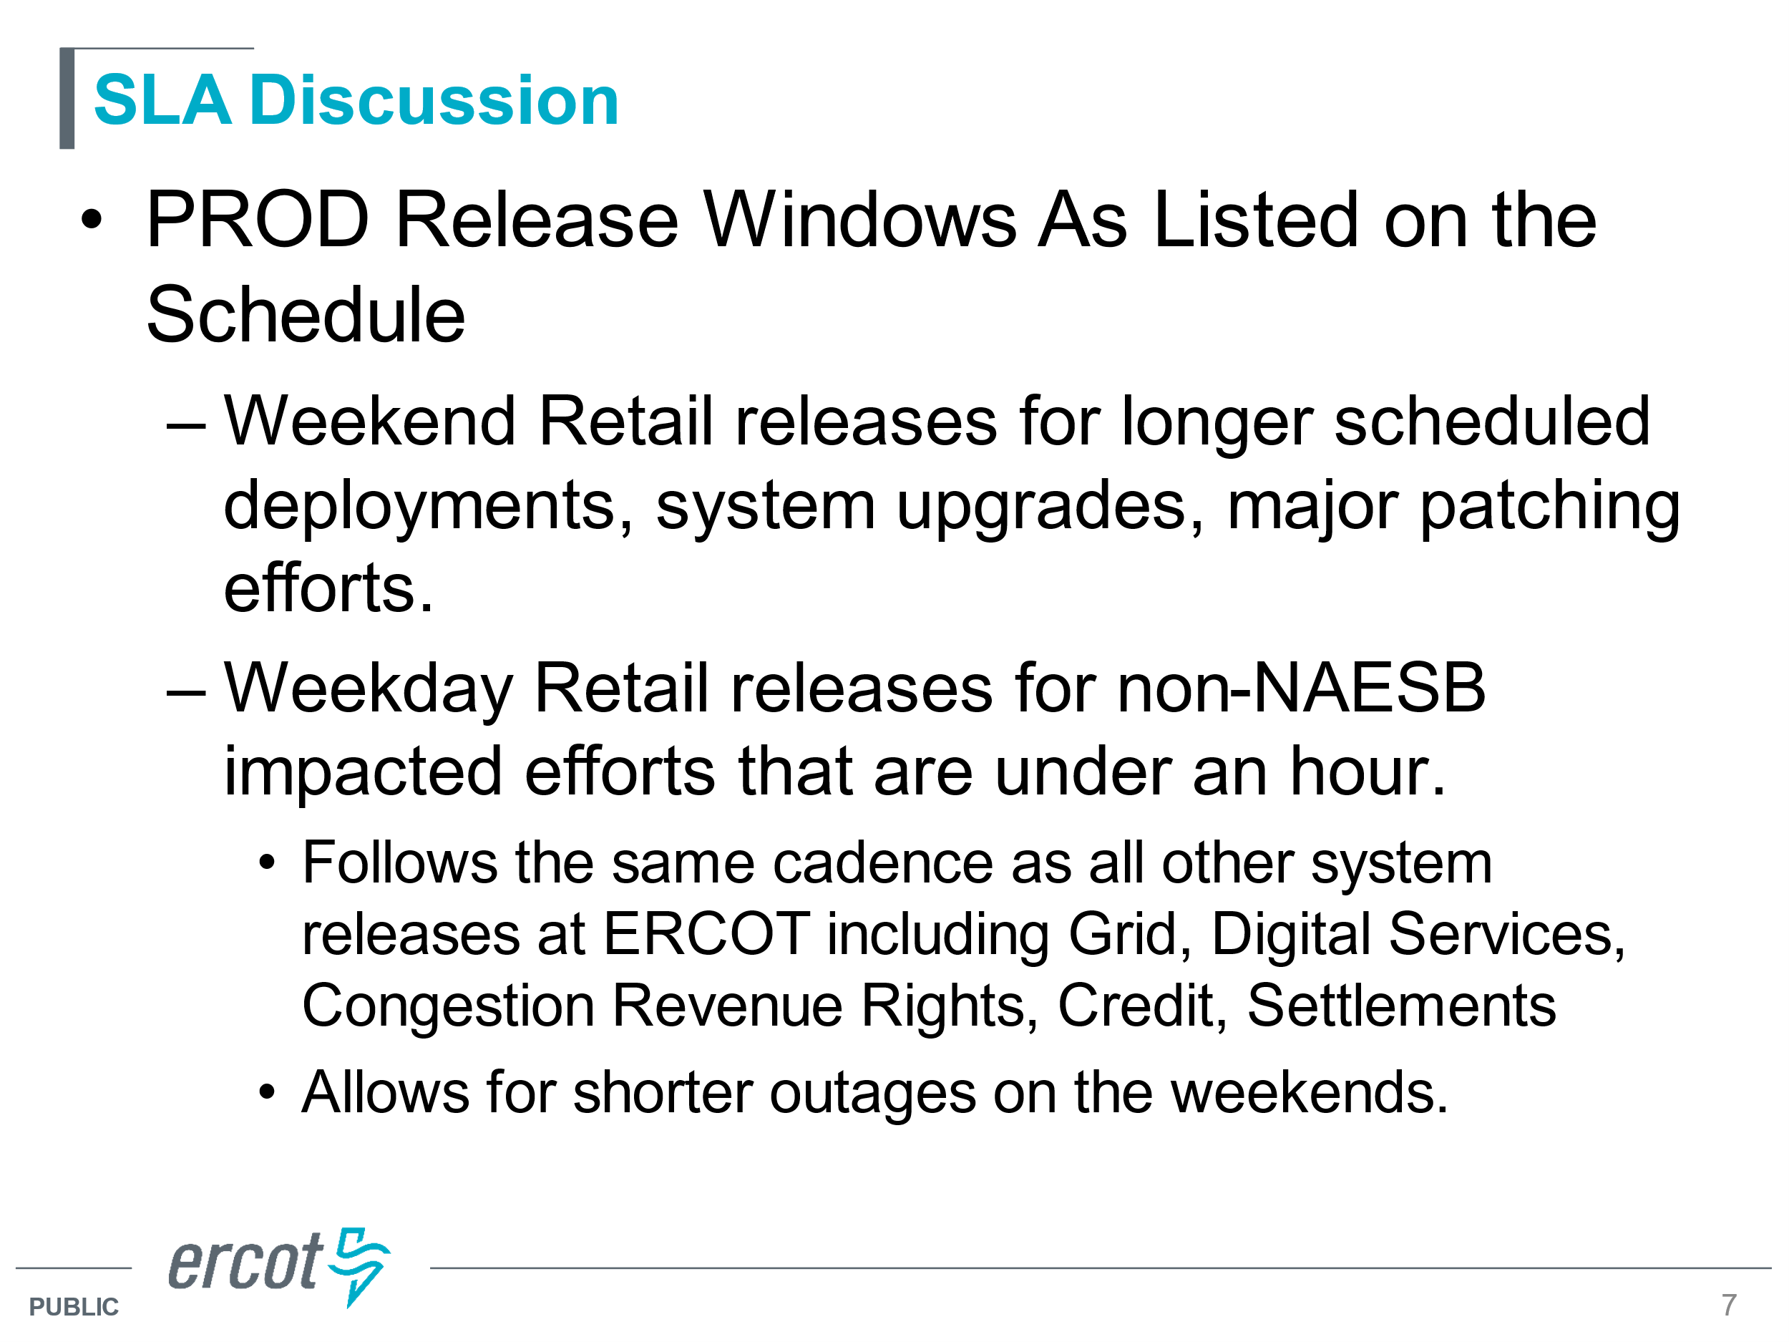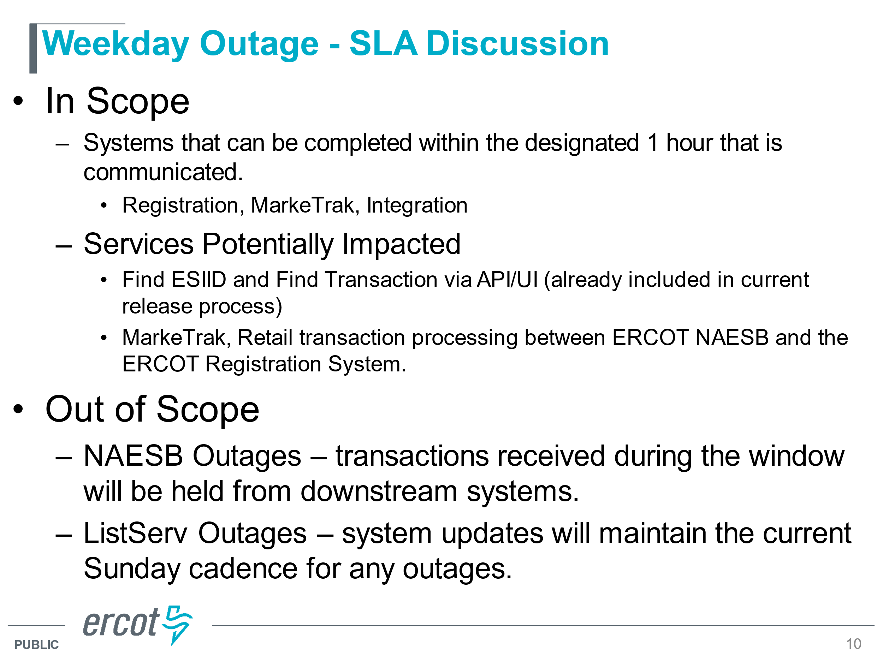
  + 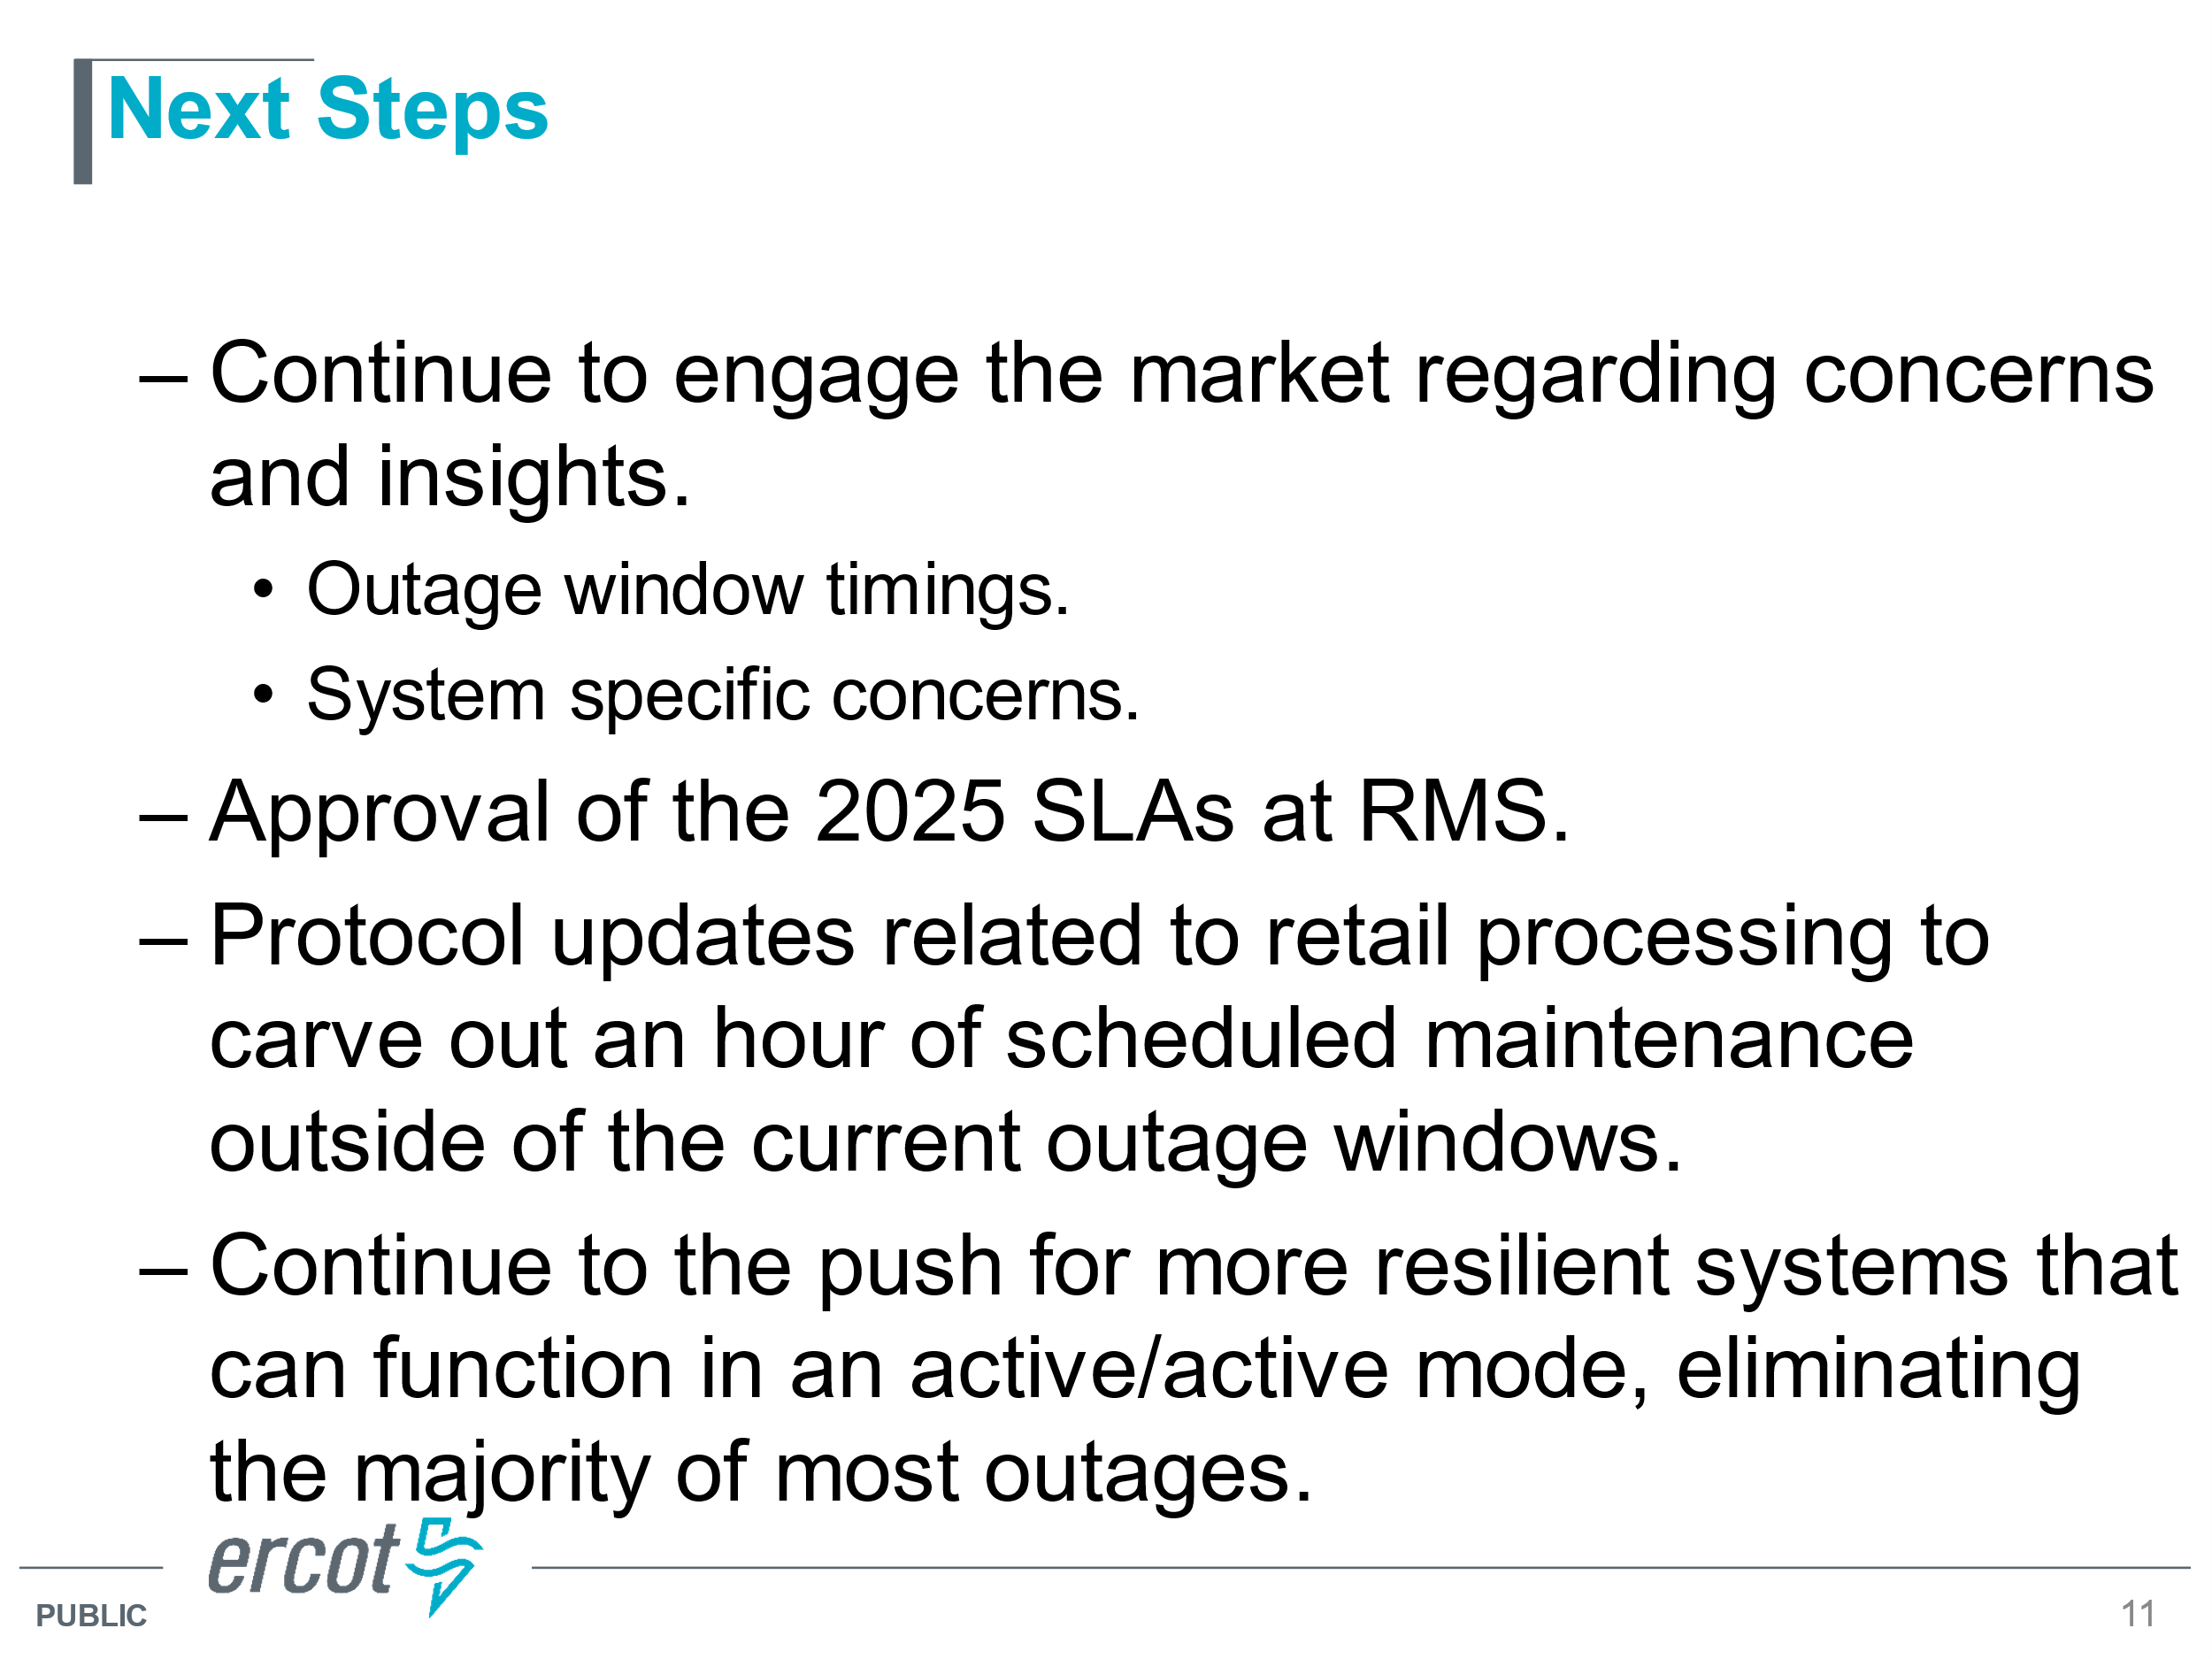
* Mick and Dave explained the reason for the pivot and all agreed with synching the security. The concerns were the around the “hour” of the outage. Market participants suggested 5PM which would not impact MarkeTrak operations and the time-sensitive switch holds. ERCOT is taking all suggestions under consideration yet wanted to remain open to a 4:30 start.
  + Dave discussed the Protocols (15) which would need to be updated to align with noted response times.
  + Market notices were highly encouraged with ‘real time’ notifications on advance notice, progress of outage, and completion.
  + Once any protocol revisions were in place, RMS/TDTMS could revisit the calendar for any updates, possibly mid-year 2025
  + This item will be kept on the agenda for any updates on framework revisions to ensure all impacted protocols are reviewed.
* ACTION: Mick will provide updated SLAs with possible better times that will be reviewed again at October’s TDTMS and then November’s RMS.

**SCR 817 MarkeTrak Validations –**

* Training held in the morning for SCR817 changes was a success! Attendance topped at 163 call ins. Productive Q&A occurred. Many accolades provided to Tammy for her valuable information and excellent presentation of the material.
  + ACTION: Sheri was to provide a list of the changes recommended in the presentation for next month’s training session. The revised deck will be posted to the training page when complete.
  + ACTION: TDSPs were to provide input on the options presented for **Service Address** submissions of County Name changes. Tammy was to send screen shots and examples of the different options and TDUs would respond with their preference
  + TRAINING: final training session will be held on **10/24** @ 9:30 AM via WebEx. Another market notice will be distributed
* RMTE was made available over the weekend of 9/14- 9/15
* On line modules and User’s Guide updates will be made available on 11/11 at Go Live!
* Communication of IGL MarkeTrak Transition Schedule – presented at each RMS until go live as reminders. The enhanced timeline will be posted to the revised training.

* In discussing **Service Address** MTs the question came up regarding the submission of a possible large volume of MTs after County Name is uploaded to the first TDSP extract available Tuesday, November 12th. Once REPs review, may suggest working outside of MT system to correct. Oncor noted they use GPS coordinates of the physical meter to determine the County.

**MarkeTrak Subtype Volume for 2023**

* The revised matrix of the “other subtypes” was presented to review initial data for first half of 2024.
* Additional data results will be available once the small group meets again – should have additional results by next meeting.
* Sam will “clean up” the graphs for presentation



**NEXT MEETING** **Thursday, October 24th @ 1:00 PM** **WebEx Only**

**DRAFT AGENDA**

* ERCOT Reports
  + System Instances & MT Performance
  + Listserv
  + 2025 Retail Release Calendar Proposed Revisions
  + Retail Release Calendars aligning with Production Releases
* SCR817 Business Requirements discussion
  + Updates – Service Address approach
  + Communicating Transition Plan updates
    - SCR817 training feedback
    - On line module & User’s Guide’s availability
* MT Subtypes Volume Analysis – 2024 – results
  + Usage & Billing – Missing
  + Switch Hold