

September 2024 ERCOT Monthly Operations Report

Reliability and Operations Subcommittee Meeting

November 07, 2024

Table of Contents

1. Report Highlights 2

2. Frequency Control 3

2.1. Frequency Events 3

2.2. ERCOT Contingency Reserve Events 4

2.3. Responsive Reserve Events 4

2.4. Load Resource Events 5

3. Reliability Unit Commitment 5

4. IRR, Wind, and Solar Generation as a Percent of Load 6

5. Largest Net-Load Ramps 8

6. Congestion Analysis 9

6.1. Notable Constraints 9

6.2. Generic Transmission Constraint Congestion 17

6.3. Manual Overrides 18

6.4. Congestion Costs for Calendar Year 2024 18

7. System Events 20

7.1. ERCOT Peak Load 20

7.2. Load Shed Events 20

7.3. Stability Events 21

7.4. Notable PMU Events 21

7.5. DC Tie Curtailment 21

7.6. TRE/DOE Reportable Events 21

7.7. New/Updated Constraint Management Plans 21

7.8. New/Modified/Removed RAS 21

7.9. New Procedures/Forms/Operating Bulletins 21

8. Emergency Conditions 21

8.1. OCNs 21

8.2. Advisories 22

8.3. Watches 22

8.4. Emergency Notices 22

9. Application Performance 22

9.1. TSAT/VSAT Performance Issues 22

9.2. Communication Issues 22

9.3. Market System Issues 22

10. Model Updates 22

Appendix A: Real-Time Constraints 24

# Report Highlights

* The unofficial ERCOT peak demand was 77,780 MW for the month of September on 9/19/2024 HE 17:00; this is 6,690 MW less than the September 2023 peak demand of 84,470 MW on 9/8/2023 HE 17:00.
* A Solar Generation Record of 21,667 MW was set on 9/8/2024 at interval ending 14:03.
* There was 1 frequency event.
* There was no ERCOT Contingency Reserve Service (ECRS) events.
* There were no Responsive Reserve Service (RRS) events.
* There was 1 DC Tie Curtailment.
* There were 26 HRUC commitments.
* There was 1 OCN issued for the possibility of Tropical Cyclone Six expected to increase into Tropical Storm Francine and making landfall or impacting the ERCOT region.
* There were Advisories issued for Geomagnetic disturbance of [K-7] or Higher.
* There was 1 Advisory for tropical storm Francine for the possibility of impacting the ERCOT region.
* The following GTCs saw congestion in September:

|  |  |
| --- | --- |
| GTC | Days Congestion |
| Panhandle GTC | 7 |
| West Texas Export | 7 |
| Wharton County | 13 |
| South Texas Export (E_PASP) | 6 |
| Nelson Sharpe to Rio Hondo | 9 |
| Valley Export | 6 |
| Zapata Starr | 10 |
| North Edinburg to Lobo | 7 |
| South Texas Export (E_PATA) | 10 |
| South Texas Import (I_KALO) | 4 |
| North to Houston | 3 |

# Frequency Control

## Frequency Events

The ERCOT Interconnection experienced 1 frequency event, which resulted from a unit tripping. The event duration was 00:07:17.

A summary of the frequency event is provided below. The reported frequency event meets one of the following criteria: Delta Frequency is 60 mHz or greater; the MW loss is 350 MW or greater; resource trip event triggered ECRS deployment. Frequency events that have been identified as Frequency Measurable Events (FME) for purposes of BAL-001-TRE-2 analysis are highlighted in blue. When analyzing frequency events, ERCOT evaluates PMU data according to industry standards. Events with an oscillating frequency of less than 1 Hz are inter-area, while higher frequencies indicate local events. Industry standards specify that damping ratio for inter-area oscillations should be 3.0% or greater. For the frequency event listed below, the ERCOT system met these standards and transitioned well after the disturbance. In the case of negative delta frequency, the MW Loss column could refer to load loss.

|  |  |  |  |  |  |  |  |  |  |
| --- | --- | --- | --- | --- | --- | --- | --- | --- | --- |
| **Date and Time** | **Delta Frequency** | **Max/Min Frequency** | **Duration of Event** | **PMU Data** | | **MW Loss** | **Load** | **IRR** | **Inertia** |
| **(Hz)** | **(Hz)** | **Oscillation Mode (Hz)** | **Damping Ratio** | **(MW)** | **%** | **(MW-s)** |
| 9/23/2024 16:12:49 | 0.054 | 59.943 | 00:07:17 | 0.67 | 16% | 499 | 45,476 | 15% | 279,186 |

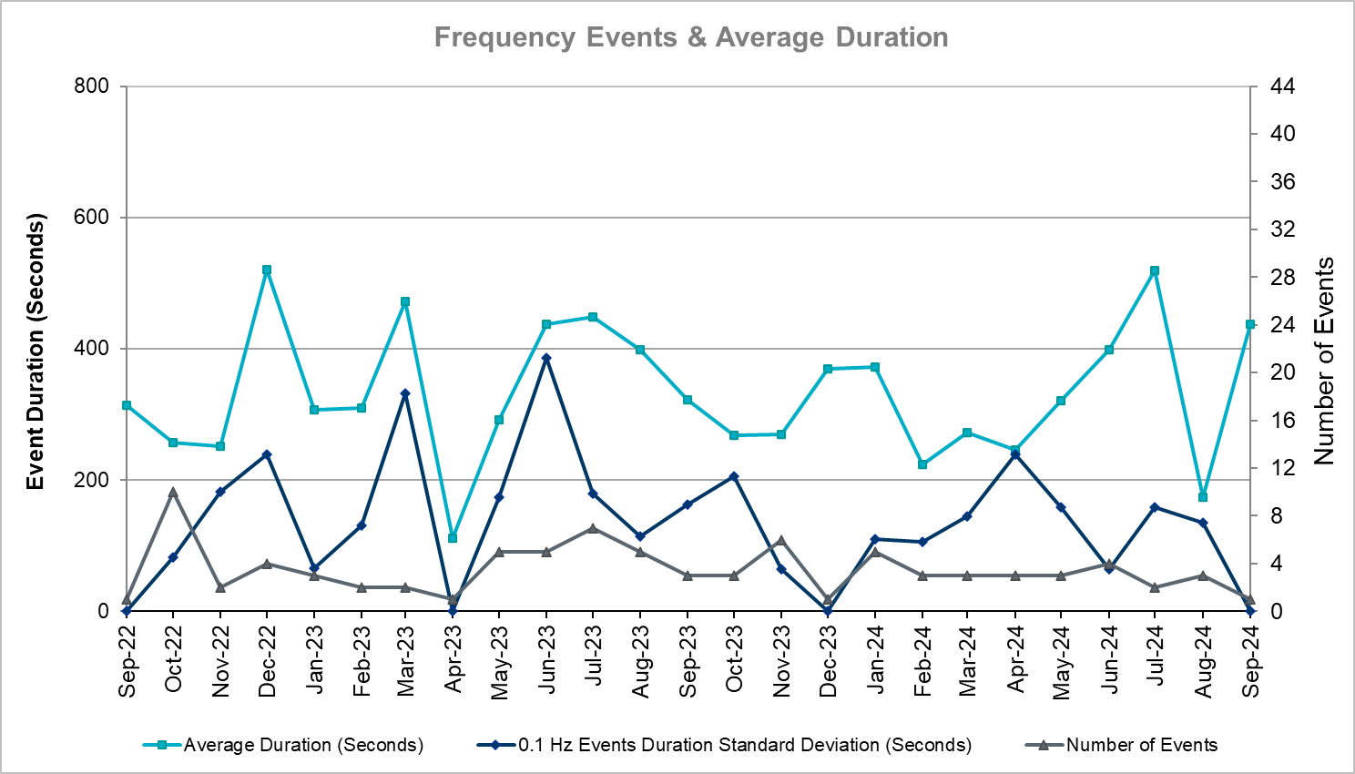

(Note: All data on this graph encompasses frequency event analysis based on BAL-001-TRE-2.)

## ERCOT Contingency Reserve Events

There were no events where ERCOT Contingency Reserve MWs were released to SCED. The events highlighted in blue were related to frequency events reported in Section 2.1 above.

|  |  |  |  |  |
| --- | --- | --- | --- | --- |
| **Date and Time Released to SCED** | **Date and Time Recalled** | **Duration of Event** | **Maximum MWs Released** | **Comments** |
| N/A | N/A | N/A | N/A | N/A |

## Responsive Reserve Events

There were no events where Responsive Reserve MWs were released to SCED.

|  |  |  |  |  |
| --- | --- | --- | --- | --- |
| **Date and Time Released to SCED** | **Date and Time Recalled** | **Duration of Event** | **Maximum MWs Released** | **Comments** |
| N/A | N/A | N/A | N/A | N/A |

## Load Resource Events

There were no events where Load Resources that are controlled by Under-Frequency Relays were deployed for an Emergency Condition.

# Reliability Unit Commitment

ERCOT reports on Reliability Unit Commitments (RUC) monthly. Commitments are reported grouped by operating day and weather zone. The total number of hours committed is the sum of the hours for all the units in the specified region. Additional information on RUC commitments can be found on the MIS secure site at Grid 🡪 Generation 🡪 Reliability Unit Commitment.

There were no DRUC commitments.

There were 26 HRUC commitments.

|  |  |  |  |  |  |
| --- | --- | --- | --- | --- | --- |
| **Resource Location** | **# of Resources** | **Operating Day** | **Total # of Hours Committed** | **Total MWhs** | **Reason for Commitment** |
| NORTH_CENTRAL | 1 | September 5, 2024 | 3 | 687 | DSALKLN5 |
| NORTH_CENTRAL | 1 | September 9, 2024 | 2 | 784 | E_PASP, System Capacity |
| NORTH_CENTRAL, SOUTH_CENTRAL | 2 | September 10, 2024 | 9 | 2,871 | E_PASP |
| COAST, EAST, NORTH, NORTH_CENTRAL | 5 | September 16, 2024 | 21 | 5,860 | System Capacity |
| NORTH_CENTRAL, SOUTH_CENTRAL | 4 | September 19, 2024 | 24 | 2,964 | System Capacity |
| EAST, NORTH_CENTRAL, SOUTH_CENTRAL | 4 | September 23, 2024 | 20 | 3,389 | System Capacity |
| COAST, EAST, NORTH_CENTRAL, SOUTH_CENTRAL | 5 | September 24, 2024 | 26 | 4,112 | DWAP_JN5, System Capacity |
| NORTH_CENTRAL | 2 | September 26, 2024 | 6 | 2,212 | System Capacity |
| NORTH_CENTRAL | 2 | September 27, 2024 | 10 | 2,790 | System Capacity |

# IRR, Wind, and Solar Generation as a Percent of Load

The graph below shows the maximum, minimum and average aggregate solar, wind and IRR output as a percentage of total ERCOT load when evaluated as 10-minute averaged intervals, over the past 13 months. Current wind and solar generation and penetration records are listed in the footnote below[1]. Maximum IRR penetration for September 2024 was 56.86% on 9/13/2024 interval ending 10:30 and minimum IRR penetration for the month was 1.97% on 9/1/2024 interval ending 3:30.

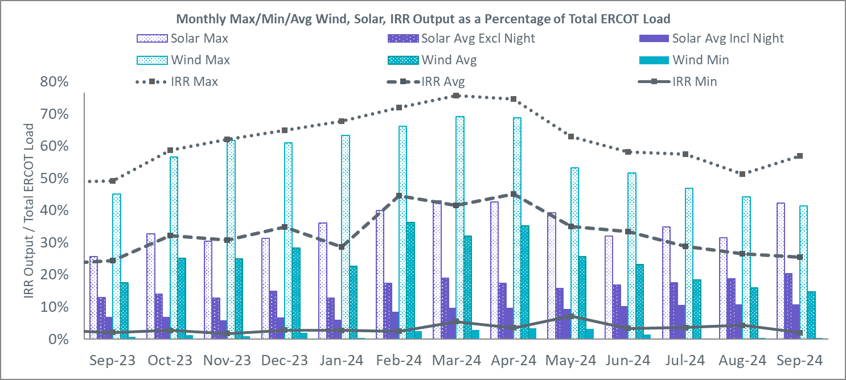

During the hour of peak load for the month, hourly integrated wind generation was 11,823 MW and solar generation was 17,887 MW. The graph below shows the wind and solar penetration percentage during the hour of the peak load in the last 13 months.

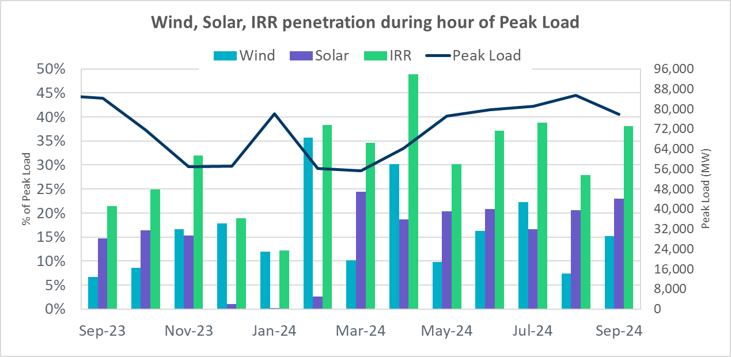

Lastly, the graph below shows the minimum wind, solar, and IRR output during the peak load hour as a percentage of the daily peak load for every day in the month.

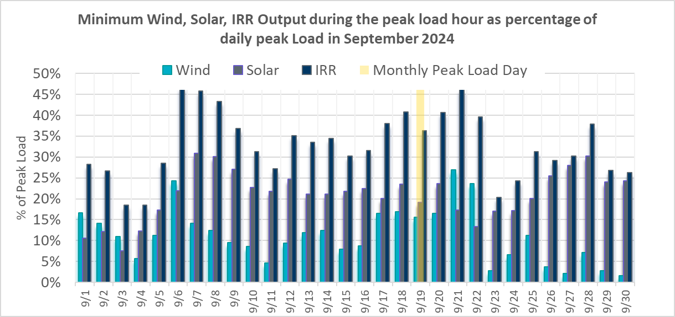

# Largest Net-Load Ramps

The net-load ramp is defined as the change in net-load (load minus wind and PVGR generation) during the defined time horizon. Such a variation in net-load needs to be accommodated in grid operations to ensure that the reliability of the grid is satisfactorily maintained. The largest net-load ramp during 5-min, 10-min, 15-min, 30-min, and 60-min in September 2024 was 2,163 MW, 3,028 MW, 3,456 MW, 5,918 MW, 10,401 MW, respectively. The comparison with respect to the historical values is given in the table below.

|  |  |  |  |  |  |
| --- | --- | --- | --- | --- | --- |
| **Month and Year** | **5 min** | **10 min** | **15 min** | **30 min** | **60 min** |
| September 2014 | 1,054 MW | 1,531 MW | 1,695 MW | 2,628 MW | 4,898 MW |
| September 2015 | 993 MW | 1,457 MW | 1,779 MW | 2,952 MW | 5,659 MW |
| September 2016 | 827 MW | 1,260 MW | 1,688 MW | 2,880 MW | 5,464 MW |
| September 2017 | 730 MW | 1,251 MW | 1,758 MW | 3,298 MW | 5,716 MW |
| September 2018 | 1,129 MW | 1,991 MW | 2,372 MW | 3,391 MW | 6,015 MW |
| September 2019 | 867 MW | 1,207 MW | 1,643 MW | 3,134 MW | 5,716 MW |
| September 2020 | 776 MW | 1,285 MW | 1,763 MW | 2,728 MW | 5,087 MW |
| September 2021 | 1,251 MW | 1,655 MW | 1,972 MW | 3,519 MW | 6,629 MW |
| September 2022 | 887 MW | 1,391 MW | 1,818 MW | 3,099 MW | 5,351 MW |
| September 2023 | 1,018 MW | 1,642 MW | 2,416 MW | 4,129 MW | 7,947 MW |
| September 2024 | 2,163 MW | 3,028 MW | 3,456 MW | 5,918 MW | 10,401 MW |
| All months in 2014-2024 | 2,163 MW | 3,107 MW | 4,588 MW | 8,901 MW | 16,522 MW |
| 9/22/2024 | 1/29/2024 | 1/29/2024 | 1/29/2024 | 1/29/2024 |
| (IE 19:35) | (IE 17:05) | (IE 17:10) | (IE 17:11) | (IE 17:17) |

# Congestion Analysis

## Notable Constraints

Nodal protocol section 3.20 specifies that ERCOT shall identify transmission constraints that are binding in Real-Time three or more Operating Days within a calendar month. As part of this process, ERCOT reports congestion that meets this criterion to ROS. In addition, ERCOT also highlights notable constraints that have an estimated congestion rent exceeding $1,000,000 for a calendar month. These constraints are detailed in the table below, including approved transmission upgrades from TPIT that may provide some congestion relief based on ERCOT’s engineering judgement. Rows highlighted in blue indicate the congestion was affected by one or more outages. For a list of all constraints activated in SCED, please see Appendix A at the end of this report.

## 

|  |  |  |  |  |  |  |
| --- | --- | --- | --- | --- | --- | --- |
| **Contingency Name** | **Overloaded Element** | **Contingency Name** | **Overloaded Element** | **# of Days Constraint Binding** | **Congestion Rent** | **Transmission Project** |
|  |
| DMGSCON5 | 6471__C | MGSES-LNGSW_and_MGSES-CONSW_345_DBLCKT | Morgan Creek Ses - Navigation Sub 138kV | 20 | $20,767,495.92 | Oncor_FW_5436 Morgan Creek_McDonald Rd 138 kV Line (23RPG011, MOD 5436) |  |
| DWLFMOS5 | 6520__E | WLFSW-MOSSW 345&WLFSW-ODEHV 345____TRPLCKT-1of3 | Odessa Ehv Switch - Yarbrough Sub 138kV | 13 | $11,160,038.20 |  |  |
| SBWDDBM5 | LPLYH_T3P | BLACKWATER DRAW SWITCH to DOUBLE MOUNTAIN SWITCH LIN 1 | Yellow House Canyon Substation 345kV | 17 | $10,315,911.67 |  |  |
| DBIGKEN5 | FORTMA_YELWJC1_1 | Bighil-Kendal 345kV | Yellow Jacket - Fort Mason 138kV | 18 | $9,147,673.23 |  |  |
| DSALTM58 | 610__B | SALSW TO KNBSW 345 AND TMPSW TO BELCNTY 138 DBLCKT | Temple Switch - Temple Southeast 138kV | 9 | $8,550,691.17 |  |  |
| DSALGA58 | 610__B | SALSW TO KNBSW 345 AND SALSW TO BELCNTY 138 DBLCKT | Temple Switch - Temple Southeast 138kV | 6 | $4,983,058.05 |  |  |
| DWPWFWP5 | STPWAP39_1 | TWR(345) WAP-WLF64 & WAP-WLY72 | South Texas Project - Wa Parish 345kV | 16 | $3,013,289.00 |  |  |
| DSALKLN5 | 610__B | SALSW TO KLNSW 345 DBLCKT | Temple Switch - Temple Southeast 138kV | 7 | $3,006,281.50 |  |  |
| DBAKCED5 | HARGRO_TWINBU1_1 | BAKESW-CEDACA 345kV & BAKESW-CEDACA 345kV | Hargrove - Twin Buttes 138kV | 9 | $2,022,151.70 |  |  |
| SBAKCED5 | HARGRO_TWINBU1_1 | BAKERSFIELD SWITCHYARD to CEDAR CANYON LIN 1 | Hargrove - Twin Buttes 138kV | 5 | $1,860,431.21 |  |  |
| SCOLPAW5 | COLETO_ROSATA1_1 | COLETO CREEK to COLETO CREEK LIN 1 | Coleto Creek - Rosata Tap 138kV | 11 | $1,840,153.25 |  |  |
| XDIL89 | DILLEYSW_69A1 | DILLEY SWITCH AEP TRX 69_1 138/69 | Dilley Switch Aep 138kV | 6 | $1,414,032.15 |  |  |
| DCDHTVW5 | 310__A | TVWSW TO CDHSW 345 AND CDHSW TO VENSW 345 DBLCKT | Liggett Switch - Norwood Switch 345kV | 5 | $1,361,565.58 |  |  |
| DVLSPAC5 | 870__A | VLSES-PACSW 345&PRSSW-VLYSO 345 DBLCKT | Commerce Switch - Commerce South 138kV | 11 | $1,185,539.30 |  |  |
| DODEMOS5 | 6513__A | ODEHV-MOSSW 345&ODEHV-WLFSW 345_DBLCKT | Odessa North - Odessa 138kV | 3 | $1,177,343.31 |  |  |
| DWAP_JN5 | OB_WAP99_A | TWR (345) JN-WAP64 & JN-WAP72 | Wa Parish - Obrien 345kV | 3 | $1,022,254.18 |  |  |
| BASE CASE | PNHNDL | Basecase | PNHNDL GTC | 5 | $1,012,070.08 |  |  |
| MLOBFOR5 | CATARI_PILONC1_1 | manual double Lobo to fowlerton 1&2 345 | Catarina - Piloncillo 138kV | 5 | $1,008,217.94 |  |  |
| BASE CASE | WESTEX | Basecase | WESTEX GTC | 4 | $1,005,898.86 |  |  |
| DWLFMOS5 | 6485__A | WLFSW-MOSSW 345&WLFSW-ODEHV 345____TRPLCKT-1of3 | Wolf Switching Station - Penwell Pod 138kV | 5 | $999,649.47 |  |  |
| BASE CASE | WHARTN | Basecase | WHARTN GTC | 13 | $967,179.65 |  |  |
| DFOWSMG5 | LARDVN_LASCRU1_1 | FOWLRTON TO SAN MIGUEL DOUBLE CIRCUIT CONTINGENCY | Laredo Vft North - Las Cruces 138kV | 7 | $915,540.12 | AEP_TCC_Laredo VFT North - Las Cruces 138 kV Line Rebuild (58008), AEP_TCC_Las Cruces - Milo Rebuild (76076), AEP_TCC_Milo - Mines Road Rebuild (76078), AEP_TCC_Mines Road - North Laredo SW Rebuild (76080) |  |
| DTOKJK_5 | 260_A_1 | Toksw-Gibcrk & Jk_Ck 345kV | Jewett - Singleton 345kV | 3 | $910,358.02 |  |  |
| DDILCOT8 | DILLEYSW_69A1 | Dilleysw-Sanmgsw&Cotulas 138kV | Dilley Switch Aep 138kV | 16 | $780,750.31 |  |  |
| DCAGCI58 | 656T656_1 | Cagnon-Kendal 345 &Cico-Mengcr 138 | Bergheim - Kendall 345kV | 4 | $710,448.82 |  |  |
| DKRWLWS5 | 107__A | KRWSW TO WDENT 345 AND KRWSW TO LWSSW 345 DBLCKT | Roanoke Switch - Hicks Switch 345kV | 5 | $672,535.60 |  |  |
| DMCOPHA8 | AZTECA_HEC1_1 | McColl Rd to N Edinburg & N Edinburg to N McAllen | Hidalgo Energy Center - Azteca Sub 138kV | 5 | $634,997.66 |  |  |
| SMCEABS8 | CAPELL_MERK1_1 | ABILENE SOUTH to ABILENE SOUTH LIN 1 | Capella - Merkel 69kV | 3 | $613,355.33 |  |  |
| DTWIDIV5 | PALOUS_WOLFCA1_1 | TWINBU-DVIDE 345KV | Palouse - Wolfcamp 138kV | 5 | $606,791.38 |  |  |
| BASE CASE | E_PASP | Basecase | E_PASP GTC | 5 | $570,859.77 |  |  |
| MCEDBAK5 | HARGRO_TWINBU1_1 | Manual BAKRFLD_CEDCA2 345kV Phase 1 | Hargrove - Twin Buttes 138kV | 3 | $531,263.42 |  |  |
| DCONLNG5 | 6095__G | CONSW-MGSES_and_CONSW-LNGSW_345kV_DBLCKT | Alkali Lake - Jim Payne Poi 138kV | 8 | $514,358.35 | Oncor_FW_52332_Lamesa - Paul Davis Tap 138 kV Line Section (52332) |  |
| MLOBFOR5 | ASHERT_CATARI1_1 | manual double Lobo to fowlerton 1&2 345 | Asherton - Catarina 138kV | 3 | $465,214.94 |  |  |
| SZENTH35 | THWZEN71_A | TH WHARTON to Zenith LIN A | Th Wharton - Zenith 345kV | 3 | $420,230.56 |  |  |
| DSALKLN5 | 610__A | SALSW TO KLNSW 345 DBLCKT | Temple South - Belton 138kV | 5 | $384,060.10 |  |  |
| SW_LVLT5 | 15060__B | wett_long_draw to Volta LIN 1 | Koch Tap - Vealmoor 138kV | 4 | $369,454.14 | Oncor_FW_Expanse - Tredway 138 kV Line (81305) |  |
| SHCKRNK5 | 106__A | HICKS SWITCH to HICKS SWITCH LIN _A | Hicks Switch - Alliance 345kV | 3 | $357,717.61 |  |  |
| SVLSANA5 | 404__A | ANNA SWITCH to VALLEY SES LIN _A | Farmersville Switch - Valley South 345kV | 4 | $314,433.01 |  |  |
| DVLSPAC5 | 1561__A | VLSES-PACSW 345&PRSSW-VLYSO 345 DBLCKT | Rivercrest Ses - Deport Rea 138kV | 5 | $290,871.86 |  |  |
| BASE CASE | NELRIO | Basecase | NELRIO GTC | 8 | $286,663.25 | The Lower Rio Grande Valley (LRGV) System Enhancement Project (21RPG017) will cause there to be no stability constraint for NelsonSharpe_RioHondoGTC under normal conditions. |  |
| SES2FRI8 | MIDW_OZONA1_1 | Esmeralda to Esmeralda LIN 1 | Midway Lane - Ozona 69kV | 3 | $277,570.14 |  |  |
| DVLSPAC5 | 871__E | VLSES-PACSW 345&PRSSW-VLYSO 345 DBLCKT | Paris Switch - Enloe Tap 138kV | 5 | $274,216.62 |  |  |
| SLENFLT8 | 6635__G | Flat Creek Switch to Flat Creek Switch LIN _A | Morton Valley (Oncor) - Eastland 69kV | 3 | $268,114.91 |  |  |
| DNOECED5 | HARGRO_TWINBU1_1 | NOELKE - CEDAR CANYON & NOELKE- CEDAR CANYON 2 | Hargrove - Twin Buttes 138kV | 3 | $249,942.77 |  |  |
| XPEA89 | DILLEYSW_69A1 | PEARSALL SWITCHING STATION TRX 69_4 138/69 | Dilley Switch Aep 138kV | 5 | $246,045.44 |  |  |
| SPEBTRU8 | 940__A | GAMMA to GAMMA LIN _D | Ennis West Switch - Templeton 138kV | 9 | $245,708.68 | Oncor_ME_71156_Ennis West Switch-Waxahachie Switch 138 kV Line (71156) |  |
| SKINODE5 | PALOUS_WOLFCA1_1 | KING MOUNTAIN SWITCHYARD to ODESSA EHV SWITCH LIN 1 | Palouse - Wolfcamp 138kV | 5 | $237,122.74 |  |  |
| DBIGSCH5 | PALOUS_WOLFCA1_1 | Big Hill - Schneeman Draw & Big Hill - Schneeman Draw 2 | Palouse - Wolfcamp 138kV | 4 | $228,858.33 |  |  |
| MLOBFOR5 | LARDVN_LASCRU1_1 | manual double Lobo to fowlerton 1&2 345 | Laredo Vft North - Las Cruces 138kV | 4 | $227,040.45 | AEP_TCC_Laredo VFT North - Las Cruces 138 kV Line Rebuild (58008), AEP_TCC_Las Cruces - Milo Rebuild (76076), AEP_TCC_Milo - Mines Road Rebuild (76078), AEP_TCC_Mines Road - North Laredo SW Rebuild (76080) |  |
| MCEDBAK5 | CROSSO_PALOUS1_1 | Manual BAKRFLD_CEDCA2 345kV Phase 1 | Crossover - Palouse 138kV | 3 | $200,758.42 |  |  |
| BASE CASE | VALEXP | Basecase | VALEXP GTC | 4 | $189,153.28 | The Lower Rio Grande Valley (LRGV) System Enhancement Project (21RPG017) will improve but not eliminate the need for this GTC. |  |
| MHARNED5 | BURNS_RIOHONDO_1 | Manual dbl ckt for NEDIN-BONILLA 345kV & RIOH-PRIM138kV | Burns Sub - Rio Hondo 138kV | 5 | $179,767.71 | STEC_71930_RioHondo_Burns_Upgrade (71930), STEC_71926_Burns_Heidelberg_Upgrade (71926), STEC_71928_Heidelberg_AEPWeslaco_Upgrade (71928) |  |
| DSTVSTN8 | 6635__G | STEPHENVILLE (ONCOR) to STEPHENVILLE BEPC and LINGLEVILLE TAP | Morton Valley (Oncor) - Eastland 69kV | 3 | $178,402.51 |  |  |
| SKLELOY8 | LOYOLA_69_1 | KLEBERG AEP to KLEBERG AEP LIN 1 | Loyola Sub 138kV | 4 | $169,219.31 | STEC_76816_upgradeLoyolaAuto (76816) |  |
| SHONMOO8 | BIG_FO_PLEASA1_1 | MOORE SWITCHING STATION to HONDO CREEK SWITCHING STATION LIN 1 | Big Foot - Pleasanton 138kV | 6 | $155,880.34 |  |  |
| DSALHUT5 | 1710__C | SALSW - HUTTO 345KV | Bell County - Salado Switch 138kV | 7 | $150,421.47 | ONCOR_SE_87695_Bell_County_138 kV Switch (24RPG001, MOD 87695), ONCOR_SE_87673_Salado_Bell_County_138 kV Line (24RPG001, MOD 87673) |  |
| DFOWSMG5 | CATARI_PILONC1_1 | FOWLRTON TO SAN MIGUEL DOUBLE CIRCUIT CONTINGENCY | Catarina - Piloncillo 138kV | 3 | $148,440.70 |  |  |
| SMDOOAS5 | OB_WAP99_A | MEADOW to OASIS LIN A | Wa Parish - Obrien 345kV | 4 | $122,814.42 |  |  |
| DFOWSMG5 | ASHERT_CATARI1_1 | FOWLRTON TO SAN MIGUEL DOUBLE CIRCUIT CONTINGENCY | Asherton - Catarina 138kV | 5 | $119,830.06 |  |  |
| MLOBFOR5 | ASHERT_CATARI1_1 | manual double Lobo to fowlerton 1&2 345 | Asherton - Catarina 138kV | 3 | $113,279.33 |  |  |
| DCONLNG5 | 6471__C | CONSW-MGSES_and_CONSW-LNGSW_345kV_DBLCKT | Morgan Creek Ses - Navigation Sub 138kV | 5 | $108,639.55 | Oncor_FW_5436 Morgan Creek_McDonald Rd 138 kV Line (23RPG011, MOD 5436) |  |
| DJEWSNG5 | RPR_GIBC_1 | JEWET TO SNG 345 DBLCKT | Roans Prairie Bepc - Gibbons Creek 138kV | 3 | $100,998.31 |  |  |
| SBRAPIN8 | HAMILT_MAVERI1_1 | BRACKETTVILLE to BRACKETTVILLE LIN 1 | Hamilton Road - Maverick 138kV | 7 | $99,531.52 | Escondido to Hamilton Road 138 kV Line Rebuild Project (22RPG044) |  |
| MHARNED5 | HAINE__LA_PAL1_1 | Manual dbl ckt for NEDIN-BONILLA 345kV & RIOH-PRIM138kV | Haine Drive - La Palma 138kV | 3 | $97,090.82 |  |  |
| SBRAHAM8 | ESCOND_GANSO1_1 | BRACKETTVILLE to HAMILTON ROAD LIN 1 | Escondido - Ganso 138kV | 5 | $95,960.67 |  |  |
| SFOWLOB5 | CATARI_PILONC1_1 | AVANZADA to FOWLERTON LIN 1 | Catarina - Piloncillo 138kV | 3 | $74,356.01 |  |  |
| DBWNAMO5 | SAPOWE_SAST1_1 | Twinbu-Sarc&Amoscr 345kV | San Angelo Power Station - San Angelo South Tap 138kV | 3 | $67,540.68 |  |  |
| SMOUMIL8 | 231T323_1 | MILLER CREEK to MILLER CREEK LIN 1 | Marshall Ford - Paleface 138kV | 4 | $55,743.72 |  |  |
| SCOLPAW5 | LOOP_VICTORIA_1 | COLETO CREEK to COLETO CREEK LIN 1 | Loop 463 Sub - Victoria 138kV | 3 | $51,841.89 |  |  |
| BASE CASE | ZAPSTR | Basecase | ZAPSTR GTC | 7 | $50,464.15 |  |  |
| SMADSAP8 | MADDUX_SAPOWE2_1 | MADDUX to SAN ANGELO POWER STATION LIN 1 | Maddux - San Angelo Power Station 138kV | 6 | $47,525.16 |  |  |
| BASE CASE | NE_LOB | Basecase | NE_LOB GTC | 3 | $45,749.02 | The Lower Rio Grande Valley (LRGV) System Enhancement Project (21RPG017) will improve the NorthEd_LoboGTC to support up to 80% of total wind and solar generation capacity in the LRGV area. |  |
| SHAYZO25 | 6T227_1 | HAYS ENERGY to ZORN LIN 1 | Zorn - Hays Energy 345kV | 3 | $31,053.95 |  |  |
| DTWIDIV5 | CROSSO_NORTMC1_1 | TWINBU-DVIDE 345KV | North Mccamey - Crossover 138kV | 4 | $28,323.48 |  |  |
| SN_SAJO5 | LASPUL_RAYMND1_1 | AJO to AJO LIN 1 | Las Pulgas - Raymondville 2 138kV | 4 | $27,620.46 |  |  |
| DTOKJK_5 | RPR_GIBC_1 | Toksw-Gibcrk & Jk_Ck 345kV | Roans Prairie Bepc - Gibbons Creek 138kV | 3 | $26,411.31 |  |  |
| BASE CASE | E_PATA | Basecase | E_PATA GTC | 5 | $23,156.32 |  |  |
| MLOFOW25 | CATARI_PILONC1_1 | manual Lobo to Fowlerton #2 345 | Catarina - Piloncillo 138kV | 3 | $17,332.66 |  |  |
| DVLSPAC5 | 389__A | VLSES-PACSW 345&PRSSW-VLYSO 345 DBLCKT | Monticello Ses - Woodard Switch 345kV | 5 | $16,157.34 |  |  |
| SWRDYN8 | LAN_CT_PAVLOV1_1 | CANEY to CANEY LIN A | Lane City - Pavlov 138kV | 3 | $9,513.18 |  |  |
| SMDOPHR5 | G138_10B_1 | MEADOW to PH ROBINSON LIN A | Magnolia Tnp - Seminole Tnp 138kV | 3 | $5,906.93 | TNMP_87427_MAG-SEM_Rebuild (87427) |  |
| SRICGRS8 | 6840__B | GRAHAM SES to RICE SWITCH LIN _A | Anarene - Navy Kickapoo Switch 69kV | 4 | $5,849.21 |  |  |
| SSTAWIC8 | 138_IH2_COT_1 | STAGHORN TNP to WICKETT TNP LIN 1 | Ih 20 Tnp - Collie Field Tap Tnp 138kV | 11 | $5,821.56 |  |  |
| DCASRAF8 | BIG_FO_PLEASA1_1 | CASTRVLL-QUIHI&RAFTER | Big Foot - Pleasanton 138kV | 3 | $4,219.48 |  |  |
| DSLKSOL5 | 138_FLT_FXT_1 | Sand Lake - Solstice line 1 and 2 | Foxtail Tnp - Flat Top Tnp 138kV | 3 | $2,445.11 |  |  |
| DBIGKEN5 | FORTMA_YELWJC1_1 | Bighil-Kendal 345kV | Yellow Jacket - Fort Mason 138kV | 18 | $2,422.52 |  |  |
| SELMTH25 | 1020__A | ELM MOTT to ELM MOTT LIN _A | Elm Mott - Mclennan County East 138kV | 3 | $1,169.41 |  |  |

## Generic Transmission Constraint Congestion

|  |  |
| --- | --- |
| GTC | Days Congestion |
| Panhandle GTC | 7 |
| West Texas Export | 7 |
| Wharton County | 13 |
| South Texas Export (E_PASP) | 6 |
| Nelson Sharpe to Rio Hondo | 9 |
| Valley Export | 6 |
| Zapata Starr | 10 |
| North Edinburg to Lobo | 7 |
| South Texas Export (E_PATA) | 10 |
| South Texas Import (I_KALO) | 4 |
| North to Houston | 3 |

There was no activity on the remaining GTCs during the month.

Note: This is how many times a constraint has been activated to avoid exceeding a GTC limit, it does not imply an exceedance of the GTC occurred or that the GTC was binding.

## Manual Overrides

None

## Congestion Costs for Calendar Year 2024

The following table represents the top twenty active constraints for the calendar year based on the estimated congestion rent attributed to the congestion. ERCOT updates this list on a monthly basis.

|  |  |  |  |
| --- | --- | --- | --- |
| **Contingency** | **Overloaded Element** | **# of 5-min SCED** | **Estimated Congestion Rent (2024)** |
| Basecase | WESTEX GTC | 18475 | $ 94,641,527.55 |
| MGSES TO CCRSW 345 AND BTRCK TO MGSES 345 DBLCKT | Tonkawa Switch - Morgan Creek Ses 345kV | 7456 | $ 87,576,954.87 |
| MGSES-LNGSW_and_MGSES-CONSW_345_DBLCKT | Morgan Creek Ses - Navigation Sub 138kV | 10407 | $ 78,670,280.67 |
| SALSW - HUTTO 345KV | Bell County - Salado Switch 138kV | 9131 | $ 47,644,986.82 |
| BAKERSFIELD SWITCHYARD to CEDAR CANYON LIN 1 | Hargrove - Twin Buttes 138kV | 6420 | $ 40,760,686.90 |
| Basecase | NE_LOB GTC | 23421 | $ 32,447,472.44 |
| Manual dbl ckt for NEDIN-BONILLA 345kV & RIOH-PRIM138kV | Burns Sub - Rio Hondo 138kV | 14719 | $ 32,004,313.71 |
| CONSW-MGSES_and_CONSW-LNGSW_345kV_DBLCKT | Morgan Creek Ses - Navigation Sub 138kV | 9906 | $ 29,958,921.00 |
| WLFSW-MOSSW 345&WLFSW-ODEHV 345____TRPLCKT-1of3 | Odessa Ehv Switch - Yarbrough Sub 138kV | 11767 | $ 29,692,359.42 |
| Basecase | PNHNDL GTC | 21857 | $ 27,485,231.95 |
| BLACKWATER DRAW SWITCH to DOUBLE MOUNTAIN SWITCH LIN 1 | Northwest Substation - Mcdonald Substation 115kV | 4834 | $ 26,523,546.74 |
| NAAMAN to NAAMAN LIN 1 | College - Jupiter 138kV | 2485 | $ 19,241,454.25 |
| AUSTROP to DAFFIN GIN LIN 1 | Decker Power Plant - Aen Dunlap 138kV | 1316 | $ 16,416,974.49 |
| Bighil-Kendal 345kV | Yellow Jacket - Fort Mason 138kV | 3207 | $ 16,376,272.71 |
| manual double NEDIN to PALMITO 345 & NEDIN to STEWART 345 | Burns Sub - Rio Hondo 138kV | 1833 | $ 15,606,001.64 |
| Basecase | I_KALO GTC | 1493 | $ 14,548,366.61 |
| BLACKWATER DRAW SWITCH to DOUBLE MOUNTAIN SWITCH LIN 1 | Yellow House Canyon Substation 345kV | 2393 | $ 14,465,667.23 |
| CONSW-MGSES_and_CONSW-LNGSW_345kV_DBLCKT | Falcon Seaboard - Morgan Creek Ses 345kV | 7469 | $ 13,836,944.25 |
| SALSW TO KNBSW 345 AND TMPSW TO BELCNTY 138 DBLCKT | Temple Switch - Temple Southeast 138kV | 1278 | $ 13,637,317.84 |
| HICKS SWITCH to HICKS SWITCH LIN _A | Hicks Switch - Alliance 345kV | 3171 | $ 13,327,337.00 |

# System Events

## ERCOT Peak Load

The unofficial ERCOT peak load for September 2024 was 77,780 MW and occurred on 9/19/2024, during hour ending 17:00. Instantaneous peak was 78,437 MW. Actual peak for the same month last year was 84,470 MW.

## Load Shed Events

None.

## Stability Events

None.

## Notable PMU Events

ERCOT analyzes PMU data for any significant system disturbances that do not fall into the Frequency Events category reported in section 2.1. The results are summarized in this section once the analysis has been completed.

There were no PMU events outside of those reported in section 2.1.

## DC Tie Curtailment

There was 1 event of DC curtailment on 9/10/2024 10:16.

|  |  |
| --- | --- |
| **Date and Time** | **Message** |
| Sep 10, 2024, 10:16 CST | The DC_E (East) DC Tie is being curtailed, a DC Tie Curtailment Notice (DCTCN) is active due to one or more transmission security violations that would be fully or partially resolved by the curtailment of DC Tie Load. |

## TRE/DOE Reportable Events

ONCOR submitted an EOP-004-4 for 09/11/2024 – Damage or destruction of a Facility.

ONCOR submitted a DOE-417 for 09/11/2024 – Damage or destruction of a Facility.

## New/Updated Constraint Management Plans

None.

## New/Modified/Removed RAS

None.

## New Procedures/Forms/Operating Bulletins

|  |  |  |
| --- | --- | --- |
| **Date** | **Subject** | **Bulletin No.** |
| 9/30/2024 | Transmission and Security Desk V1 Rev 114 | 1154 |
| 9/30/2024 | Shift Supervisor Desk V1 Rev 97 | 1153 |
| 9/30/2024 | Scripts V1 Rev 59 | 1152 |
| 9/30/2024 | Reliability Risk Desk Operating Procedure V1 Rev 36 | 1151 |

# Emergency Conditions

## OCNs

|  |  |
| --- | --- |
| **Date and Time** | **Message** |
| Sep 08, 2024, 20:31 CST | At 20:30, ERCOT is issuing an OCN for Potential Tropical Cyclone Six expected to increase into Tropical Storm Francine and potentially impact or making landfall in the ERCOT Region as early as Monday, September 9, 2024. |

## Advisories

|  |  |
| --- | --- |
| **Date and Time** | **Message** |
| Sep 09, 2024, 11:00 CST | At 11:00, ERCOT is issuing an Advisory for Tropical Storm Francine in the Gulf of Mexico which has a potential impact to the ERCOT Region from Monday, September 9, 2024, through Wednesday, September 11, 2024. |
| Sep 12, 2024, 10:03 CST | Advisory issued for a geomagnetic disturbance of K-7 until September 12, 2024. 1600. |
| Sep 16, 2024, 20:44 CST | Advisory issued for a geomagnetic disturbance of K-7 until 0700 CST on 9/16/24. |
| Sep 16, 2024, 21:42 CST | Advisory issued for a geomagnetic disturbance of K-7 until 0700 CST on 9/17/24. |
| Sep 16, 2024, 22:18 CST | Advisory issued for a geomagnetic disturbance of K-8 until 0700 CST on 9/17/24. |

## Watches

None.

## Emergency Notices

None.

# Application Performance

## TSAT/VSAT Performance Issues

None

## Communication Issues

None.

## Market System Issues

None.

# Model Updates

The Downstream Production Change (DPC) process allows ERCOT to make changes in the one-line Network Operations Model without loading a completely new model. The purpose of this process is to allow for reliable grid operations as system conditions change between designated Network Operations Model database loads. The DPC process is limited in scope to just those items listed below, with equipment ratings updates being the most common. ERCOT has seen a rise in the use of the DPC process to make on-line updates to the Network Operations Model in recent years, instead of through the standard Network Operations Model Change Request process.

* Static Line ratings (Interim Update)
* Dynamic Line ratings (non-Interim Update)
* Autotransformer ratings (non-Interim Update)
* Breaker and Switch Normal status (Interim Update)
* Contingency Definitions (Interim Update)
* RAP and RAS changes or additions (Interim Update)
* Net Dependable and Reactive Capability (NDCRC) values (Interim Update)
* Impedance Updates (non-Interim)

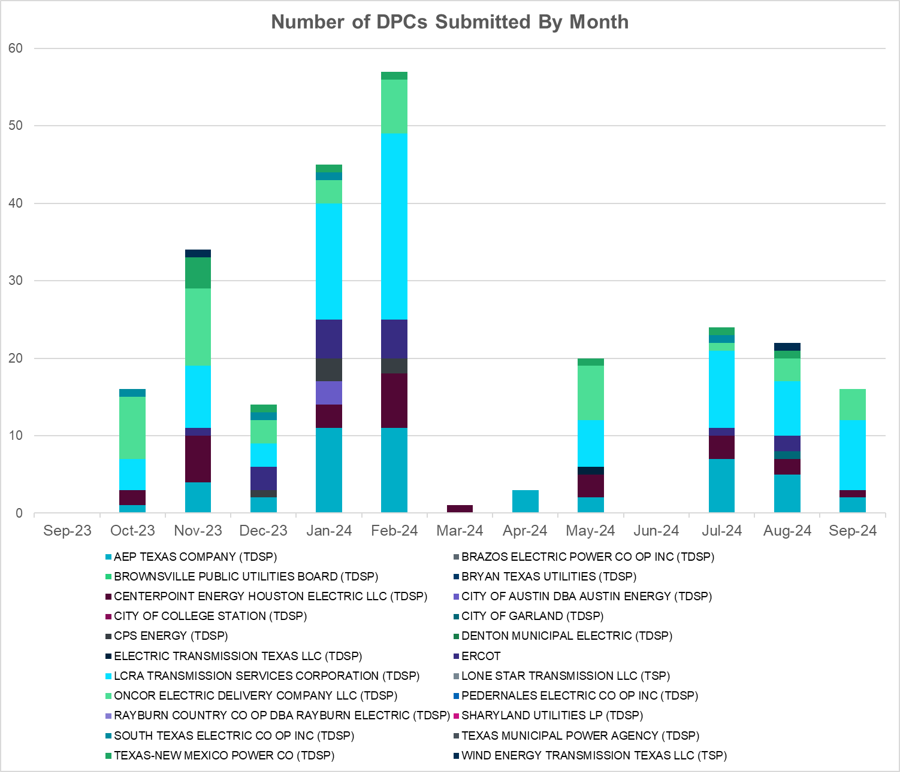

|  |  |
| --- | --- |
| **Transmission Operator** | **Number of DPCs** |
| AEP TEXAS COMPANY (TDSP) | 2 |
| BRAZOS ELECTRIC POWER CO OP INC (TDSP) | 0 |
| BROWNSVILLE PUBLIC UTILITIES BOARD (TDSP) | 0 |
| BRYAN TEXAS UTILITIES (TDSP) | 0 |
| CENTERPOINT ENERGY HOUSTON ELECTRIC LLC (TDSP) | 1 |
| CITY OF AUSTIN DBA AUSTIN ENERGY (TDSP) | 0 |
| CITY OF COLLEGE STATION (TDSP) | 0 |
| CITY OF GARLAND (TDSP) | 0 |
| CPS ENERGY (TDSP) | 0 |
| DENTON MUNICIPAL ELECTRIC (TDSP) | 0 |
| ELECTRIC TRANSMISSION TEXAS LLC (TDSP) | 0 |
| ERCOT | 0 |
| LCRA TRANSMISSION SERVICES CORPORATION (TDSP) | 9 |
| LONE STAR TRANSMISSION LLC (TSP) | 0 |
| ONCOR ELECTRIC DELIVERY COMPANY LLC (TDSP) | 4 |
| PEDERNALES ELECTRIC CO OP INC (TDSP) | 0 |
| RAYBURN COUNTRY CO OP DBA RAYBURN ELECTRIC (TDSP) | 0 |
| SHARYLAND UTILITIES LP (TDSP) | 0 |
| SOUTH TEXAS ELECTRIC CO OP INC (TDSP) | 0 |
| TEXAS MUNICIPAL POWER AGENCY (TDSP) | 0 |
| TEXAS-NEW MEXICO POWER CO (TDSP) | 0 |
| WIND ENERGY TRANSMISSION TEXAS LLC (TSP) | 0 |

# Appendix A: Real-Time Constraints

The following is a complete list of constraints activated in SCED. Full contingency descriptions can be found in the Standard Contingencies List located on the MIS secure site at Grid 🡪 Generation 🡪 Reliability Unit Commitment.

|  |  |  |  |  |  |  |
| --- | --- | --- | --- | --- | --- | --- |
| Year | Month | Contingency Name | Overloaded Element | From Station | To Station | Count of Days |
| 2024 | September | DMGSCON5 | 6471__C | MGSES | NAVIG | 25 |
| 2024 | September | DBIGKEN5 | FORTMA_YELWJC1_1 | YELWJCKT | FORTMA | 19 |
| 2024 | September | DBIGKEN5 | FORTMA_YELWJC1_1 | FORTMA | YELWJCKT | 19 |
| 2024 | September | SBWDDBM5 | LPLYH_T3P | LPLYH | LPLYH | 19 |
| 2024 | September | DDILCOT8 | DILLEYSW_69A1 | DILLEYSW | DILLEYSW | 18 |
| 2024 | September | DWPWFWP5 | STPWAP39_1 | STP | WAP | 18 |
| 2024 | September | DWLFMOS5 | 6520__E | ODEHV | YARBR | 14 |
| 2024 | September | BASE CASE | WHARTN | n/a | n/a | 13 |
| 2024 | September | DCONLNG5 | 6095__G | JPPOI | ALKLK | 12 |
| 2024 | September | DVLSPAC5 | 870__A | COMSW | COMSO | 12 |
| 2024 | September | SSTAWIC8 | 138_IH2_COT_1 | IH20 | TNCOLIET | 11 |
| 2024 | September | DCONLNG5 | 6471__C | MGSES | NAVIG | 11 |
| 2024 | September | DWPWFCK5 | STPWAP39_1 | STP | WAP | 11 |
| 2024 | September | SCOLPAW5 | COLETO_ROSATA1_1 | COLETO | ROSATA | 11 |
| 2024 | September | DSALTM58 | 610__B | TMPSW | TMPSE | 10 |
| 2024 | September | BASE CASE | ZAPSTR | n/a | n/a | 10 |
| 2024 | September | BASE CASE | E_PATA | n/a | n/a | 10 |
| 2024 | September | BASE CASE | NELRIO | n/a | n/a | 9 |
| 2024 | September | SSTAPYO8 | 138_IH2_COT_1 | IH20 | TNCOLIET | 9 |
| 2024 | September | SSTAPYO8 | 138_IH2_COT_1 | TNCOLIET | IH20 | 9 |
| 2024 | September | SPEBTRU8 | 940__A | ENWSW | TMPTN | 9 |
| 2024 | September | DBAKCED5 | HARGRO_TWINBU1_1 | TWINBU | HARGROVE | 9 |
| 2024 | September | SBRAPIN8 | HAMILT_MAVERI1_1 | HAMILTON | MAVERICK | 8 |
| 2024 | September | DSALKLN5 | 610__B | TMPSW | TMPSE | 8 |
| 2024 | September | MLOBFOR5 | LARDVN_LASCRU1_1 | LARDVNTH | LASCRUCE | 8 |
| 2024 | September | DSALGA58 | 610__B | TMPSW | TMPSE | 8 |
| 2024 | September | SWORBRD8 | 138_WIC_STG_1 | WICKETT | STAGHORN | 8 |
| 2024 | September | DSALHUT5 | 1710__C | BELCNTY | SALSW | 8 |
| 2024 | September | BASE CASE | WESTEX | n/a | n/a | 7 |
| 2024 | September | DCDHTVW5 | 310__A | LIGSW | NORSW | 7 |
| 2024 | September | SMADSAP8 | MADDUX_SAPOWE2_1 | MADDUX | SAPOWER | 7 |
| 2024 | September | DFOWSMG5 | ASHERT_CATARI1_1 | ASHERTON | CATARINA | 7 |
| 2024 | September | XDIL89 | DILLEYSW_69A1 | DILLEYSW | DILLEYSW | 7 |
| 2024 | September | BASE CASE | PNHNDL | n/a | n/a | 7 |
| 2024 | September | SW_LVLT5 | 15060__B | VEALMOOR | KOCHTAP | 7 |
| 2024 | September | DFOWSMG5 | ASHERT_CATARI1_1 | CATARINA | ASHERTON | 7 |
| 2024 | September | BASE CASE | NE_LOB | n/a | n/a | 7 |
| 2024 | September | DFOWSMG5 | LARDVN_LASCRU1_1 | LARDVNTH | LASCRUCE | 7 |
| 2024 | September | DWLFMOS5 | 6485__A | PWPOD | WLFSW | 6 |
| 2024 | September | DBLBYWF5 | STPWAP39_1 | STP | WAP | 6 |
| 2024 | September | SBAKCED5 | HARGRO_TWINBU1_1 | TWINBU | HARGROVE | 6 |
| 2024 | September | DFOWSMG5 | CATARI_PILONC1_1 | PILONCIL | CATARINA | 6 |
| 2024 | September | MLOBFOR5 | CATARI_PILONC1_1 | CATARINA | PILONCIL | 6 |
| 2024 | September | DNOECED5 | HARGRO_TWINBU1_1 | TWINBU | HARGROVE | 6 |
| 2024 | September | DBIGSCH5 | PALOUS_WOLFCA1_1 | PALOUSE | WOLFCAMP | 6 |
| 2024 | September | BASE CASE | VALEXP | n/a | n/a | 6 |
| 2024 | September | SHONMOO8 | BIG_FO_PLEASA1_1 | BIG_FOOT | PLEASANT | 6 |
| 2024 | September | BASE CASE | E_PASP | n/a | n/a | 6 |
| 2024 | September | DVLSPAC5 | 1561__A | DPREA | RCSES | 6 |
| 2024 | September | DNOESGT5 | HARGRO_TWINBU1_1 | TWINBU | HARGROVE | 6 |
| 2024 | September | SCOLPAW5 | LOOP_VICTORIA_1 | VICTORIA | L_463S | 6 |
| 2024 | September | DTWIDIV5 | PALOUS_WOLFCA1_1 | PALOUSE | WOLFCAMP | 6 |
| 2024 | September | MLOBFOR5 | CATARI_PILONC1_1 | PILONCIL | CATARINA | 6 |
| 2024 | September | DELMSAN5 | BIG_FO_PLEASA1_1 | BIG_FOOT | PLEASANT | 6 |
| 2024 | September | SMOUMIL8 | 231T323_1 | PALEPE | MARSFO | 6 |
| 2024 | September | DVLSPAC5 | 389__A | WDDSW | MNSES | 6 |
| 2024 | September | DVLSPAC5 | 871__E | PRSSW | ENLOT | 6 |
| 2024 | September | SBRAHAM8 | ESCOND_GANSO1_1 | ESCONDID | GANSO | 6 |
| 2024 | September | SN_SAJO5 | LASPUL_RAYMND1_1 | LASPULGA | RAYMND2 | 6 |
| 2024 | September | XPEA89 | DILLEYSW_69A1 | DILLEYSW | DILLEYSW | 6 |
| 2024 | September | DKRWLWS5 | 107__A | HCKSW | RNKSW | 5 |
| 2024 | September | DMCOPHA8 | AZTECA_HEC1_1 | HEC | AZTECA | 5 |
| 2024 | September | MHARNED5 | BURNS_RIOHONDO_1 | RIOHONDO | MV_BURNS | 5 |
| 2024 | September | DTWIDIV5 | CROSSO_NORTMC1_1 | NORTMC | CROSSOVE | 5 |
| 2024 | September | DCAGCI58 | 656T656_1 | KENDAL | BERGHE | 5 |
| 2024 | September | SBRAPIN8 | ESCOND_GANSO1_1 | GANSO | ESCONDID | 5 |
| 2024 | September | SMDOOAS5 | OB_WAP99_A | WAP | OB | 5 |
| 2024 | September | SHAYZO25 | 6T227_1 | HAYSEN | ZORN | 5 |
| 2024 | September | SBROALP9 | FTST_69T1 | FTST | FTST | 5 |
| 2024 | September | SKLELOY8 | LOYOLA_69_1 | LOYOLA | LOYOLA | 5 |
| 2024 | September | SKINODE5 | PALOUS_WOLFCA1_1 | PALOUSE | WOLFCAMP | 5 |
| 2024 | September | DMTSCOS5 | 6437__F | SCRCV | KNAPP | 5 |
| 2024 | September | SBRAPIN8 | ESCOND_GANSO1_1 | ESCONDID | GANSO | 5 |
| 2024 | September | DSALKLN5 | 610__A | BLTON | TMSTH | 5 |
| 2024 | September | SWRDYN8 | BLESSI_PAVLOV1_1 | PAVLOV | BLESSING | 4 |
| 2024 | September | DTOKJK_5 | 260_A_1 | JEWET | SNG | 4 |
| 2024 | September | SMDOPHR5 | G138_10B_1 | SEMINOLE | MAGNO_TN | 4 |
| 2024 | September | DSGTSCH5 | HARGRO_TWINBU1_1 | TWINBU | HARGROVE | 4 |
| 2024 | September | DSALGA58 | 610__D | TMPSE | SANDW | 4 |
| 2024 | September | DMCCI_D8 | HECKER_RESNIK1_1 | RESNIK | HECKER | 4 |
| 2024 | September | MLOBFOR5 | ASHERT_CATARI1_1 | ASHERTON | CATARINA | 4 |
| 2024 | September | MLOFOW25 | LARDVN_LASCRU1_1 | LARDVNTH | LASCRUCE | 4 |
| 2024 | September | SVLSANA5 | 404__A | VLYSO | FMRVL | 4 |
| 2024 | September | BASE CASE | I_KALO | n/a | n/a | 4 |
| 2024 | September | MLOBFOR5 | ASHERT_CATARI1_1 | CATARINA | ASHERTON | 4 |
| 2024 | September | SBRAHAM8 | GANSO_MAVERI1_1 | GANSO | MAVERICK | 4 |
| 2024 | September | DCONLNG5 | 6046__A | MGSES | FLCNS | 4 |
| 2024 | September | SRICGRS8 | 6840__B | NVKSW | ANARN | 4 |
| 2024 | September | SFOWLOB5 | ASHERT_CATARI1_1 | CATARINA | ASHERTON | 4 |
| 2024 | September | DBIGSCH5 | HARGRO_TWINBU1_1 | TWINBU | HARGROVE | 4 |
| 2024 | September | SCOLPAW5 | KENEDS_ROSATA1_1 | ROSATA | KENEDSW | 4 |
| 2024 | September | SHCKRNK5 | 106__A | HCKSW | ALLNC | 4 |
| 2024 | September | DODEMOS5 | 6513__A | ODESA | ODNTH | 3 |
| 2024 | September | DWAP_JN5 | OB_WAP99_A | WAP | OB | 3 |
| 2024 | September | SLENFLT8 | 6635__G | MRVLY | ESTLD | 3 |
| 2024 | September | MANSSTP5 | BLESSING_1382 | BLESSING | BLESSING | 3 |
| 2024 | September | MLOFOW25 | CATARI_PILONC1_1 | PILONCIL | CATARINA | 3 |
| 2024 | September | SKINODE5 | CROSSO_NORTMC1_1 | NORTMC | CROSSOVE | 3 |
| 2024 | September | MCEDBAK5 | CROSSO_PALOUS1_1 | PALOUSE | CROSSOVE | 3 |
| 2024 | September | SWRDYN8 | LAN_CT_PAVLOV1_1 | LAN_CTY | PAVLOV | 3 |
| 2024 | September | SES2FRI8 | MIDW_OZONA1_1 | MIDW | OZONA | 3 |
| 2024 | September | DSLKSOL5 | 138_FLT_FXT_1 | TNFXTAIL | FLAT_TOP | 3 |
| 2024 | September | DKENCA58 | 656T656_1 | KENDAL | BERGHE | 3 |
| 2024 | September | SCARFRI8 | ATSO_SONR1_1 | SONR | ATSO | 3 |
| 2024 | September | SCARFRI8 | FDR_OZNC_1 | FRIEND_R | OZNC | 3 |
| 2024 | September | MHARNED5 | HAINE__LA_PAL1_1 | LA_PALMA | HAINE_DR | 3 |
| 2024 | September | DJEWSNG5 | RPR_GIBC_1 | RPR | GIBCRK | 3 |
| 2024 | September | DBWNAMO5 | SAPOWE_SAST1_1 | SAPOWER | SAST | 3 |
| 2024 | September | DBIGKEN5 | TREADW_YELWJC1_1 | TREADWEL | YELWJCKT | 3 |
| 2024 | September | SELMTH25 | 1020__A | ELMOT | MCTYE | 3 |
| 2024 | September | SFOWLOB5 | CATARI_PILONC1_1 | PILONCIL | CATARINA | 3 |
| 2024 | September | MCEDBAK5 | HARGRO_TWINBU1_1 | TWINBU | HARGROVE | 3 |
| 2024 | September | SPALFRO8 | FRONTE_MAYBER1_1 | FRONTERA | MAYBERRY | 3 |
| 2024 | September | DHUTGEA8 | 1710__C | BELCNTY | SALSW | 3 |
| 2024 | September | DELMTEX5 | BLESSING_1382 | BLESSING | BLESSING | 3 |
| 2024 | September | SBAKCED5 | LAKENA_SAMATH1_1 | LAKENASW | SAMATHIS | 3 |
| 2024 | September | BASE CASE | N_TO_H | n/a | n/a | 3 |
| 2024 | September | SCARFRI8 | ATSO_SONR1_1 | ATSO | SONR | 3 |
| 2024 | September | MBONNED5 | BURNS_RIOHONDO_1 | RIOHONDO | MV_BURNS | 3 |
| 2024 | September | SMCEABS8 | CAPELL_MERK1_1 | CAPELLA | MERK | 3 |
| 2024 | September | MCEDBAK5 | CROSSO_PALOUS1_1 | CROSSOVE | PALOUSE | 3 |
| 2024 | September | DTOKJK_5 | RPR_GIBC_1 | RPR | GIBCRK | 3 |
| 2024 | September | DSALTM58 | SEA_AAT1 | SEA | SEA | 3 |
| 2024 | September | DCASRAF8 | BIG_FO_PLEASA1_1 | BIG_FOOT | PLEASANT | 3 |
| 2024 | September | SZENTH35 | THWZEN71_A | ZEN | THW | 3 |
| 2024 | September | DGRMGRS8 | 6830__B | CRDSW | OLNEY | 3 |
| 2024 | September | DSTVSTN8 | 6635__G | MRVLY | ESTLD | 3 |
| 2024 | September | SMCCRAT8 | 230T230_1 | STRAHAT1 | SANMAR | 2 |
| 2024 | September | DCAGCO58 | 656T656_1 | KENDAL | BERGHE | 2 |
| 2024 | September | XFTS89 | ALPINE_BRONCO1_1 | BRONCO | ALPINE | 2 |
| 2024 | September | SMV_RI28 | CP_MVCNT_1 | MV_CNTRA | COFFPORT | 2 |
| 2024 | September | XPEA89 | DILLEYSW_69_1 | DILLEYSW | DILLEYSW | 2 |
| 2024 | September | SBRAPIN8 | GANSO_MAVERI1_1 | GANSO | MAVERICK | 2 |
| 2024 | September | MLOBFOR5 | LASCRU_MILO1_1 | LASCRUCE | MILO | 2 |
| 2024 | September | SBEDIOL8 | RPR_GIBC_1 | RPR | GIBCRK | 2 |
| 2024 | September | SSUNMGS8 | SNYDR_FMR1 | SNYDR | SNYDR | 2 |
| 2024 | September | DCONLNG5 | 6045__A | FLCNS | MDLNE | 2 |
| 2024 | September | SPEBTRU8 | 940__B | TMPTN | WXHCH | 2 |
| 2024 | September | DHONHON8 | BIG_FO_PLEASA1_1 | BIG_FOOT | PLEASANT | 2 |
| 2024 | September | SDAFAUS8 | CKT_1027_1 | DUNLAP | DECKER | 2 |
| 2024 | September | DSGTSCH5 | HARGRO_PUMPJA1_1 | HARGROVE | PUMPJACK | 2 |
| 2024 | September | SNEDNED8 | 480T480_1 | N_MERCED | HARLNSW | 2 |
| 2024 | September | DZORHAY5 | 85T329_1 | BERGHE | DEVIHI | 2 |
| 2024 | September | DVLSPAC5 | 874__A | CRSSW | COMSW | 2 |
| 2024 | September | SEBHUG8 | LAN_CT_PAVLOV1_1 | LAN_CTY | PAVLOV | 2 |
| 2024 | September | MLOFOW25 | LASCRU_MILO1_1 | LASCRUCE | MILO | 2 |
| 2024 | September | MHARNED5 | LASPUL_RAYMND1_1 | LASPULGA | RAYMND2 | 2 |
| 2024 | September | SBWDDBM5 | LPLYH_T3S | LPLYH | LPLYH | 2 |
| 2024 | September | DHJWFCK5 | STPWAP39_1 | STP | WAP | 2 |
| 2024 | September | SGODTAN5 | VICTO_WARBU_1A_1 | VICTORIA | WARBURTN | 2 |
| 2024 | September | SABRSPR8 | 584__A | KRMSW | ARGYL | 2 |
| 2024 | September | DTOMTEC5 | 6025__A | MULBERRY | LNCRK | 2 |
| 2024 | September | SECRDMT8 | 6474__A | MGSES | SUNSW | 2 |
| 2024 | September | SBRAPIN8 | GANSO_MAVERI1_1 | MAVERICK | GANSO | 2 |
| 2024 | September | DCC3_NED | HAINE__LA_PAL1_1 | LA_PALMA | HAINE_DR | 2 |
| 2024 | September | DCAGCI58 | 255T279_1 | PIPECR | MEDILA | 2 |
| 2024 | September | DKENCA58 | 255T279_1 | PIPECR | MEDILA | 2 |
| 2024 | September | SFMRRY25 | 381__A | FMRVL | RYSSW | 2 |
| 2024 | September | DBAKCED5 | 6056__A | LNGSW | CONSW | 2 |
| 2024 | September | DODEMOS5 | 6095__G | JPPOI | ALKLK | 2 |
| 2024 | September | DMCEBUT8 | CAPELL_MERK1_1 | CAPELLA | MERK | 2 |
| 2024 | September | SSHIMC28 | CNT_MCCR_1 | MCCREE | CENTRVIL | 2 |
| 2024 | September | SVICCO28 | COLETO_VICTOR2_1 | COLETO | VICTORIA | 2 |
| 2024 | September | SHASTNN8 | G138_8B_1 | HDNLAKES | LEAGCITY | 2 |
| 2024 | September | SCOLPAW5 | RAY_L_46_1 | L_463S | RAYBURN | 2 |
| 2024 | September | DCAGCO58 | 583T583_1 | BANDER | MASOCR | 2 |
| 2024 | September | DBIGKEN5 | HAMILT_MAXWEL1_1 | MAXWELL | HAMILTON | 2 |
| 2024 | September | SSTAWIC8 | 138_COT_BPT_1 | TNCOLIET | BRDSPRYT | 2 |
| 2024 | September | DCDHMCS8 | 3160__A | CDCSW | OKCLS | 2 |
| 2024 | September | XEIN58 | 6471__C | MGSES | NAVIG | 2 |
| 2024 | September | DDMTBCK8 | 6474__A | MGSES | SUNSW | 2 |
| 2024 | September | MANGSTP5 | BLESSING_1382 | BLESSING | BLESSING | 2 |
| 2024 | September | DHUGWR_8 | LANCTY_LAN_CT1_1 | LAN_CTY | LANCTYPM | 2 |
| 2024 | September | SEBHUG8 | LANCTY_LAN_CT1_1 | LAN_CTY | LANCTYPM | 2 |
| 2024 | September | SJNWA1P5 | OB_WAP99_A | WAP | OB | 2 |
| 2024 | September | DENTSCS5 | 1350__E | NCSTP | LFKSW | 2 |
| 2024 | September | SRRDLCS5 | 235__B | BALSW | JEWET | 2 |
| 2024 | September | SDMTSC15 | 6437__F | SCRCV | KNAPP | 2 |
| 2024 | September | DD1RAZ_8 | BIG_FO_PLEASA1_1 | BIG_FOOT | PLEASANT | 2 |
| 2024 | September | SPEAX28 | BIG_FO_PLEASA1_1 | BIG_FOOT | PLEASANT | 2 |
| 2024 | September | DTOKJK_5 | GOOD_DAN_1 | GOODLAND | DANSBY | 2 |
| 2024 | September | SSANFER8 | CORONA_AT4 | CORONA | CORONA | 1 |
| 2024 | September | SHINDIL8 | DILLEYSW_69A1 | DILLEYSW | DILLEYSW | 1 |
| 2024 | September | DBIGSCH5 | HARGRO_PUMPJA1_1 | HARGROVE | PUMPJACK | 1 |
| 2024 | September | DNOESGT5 | HARGRO_PUMPJA1_1 | HARGROVE | PUMPJACK | 1 |
| 2024 | September | SSTILOM8 | LA_PAL_VCAVAZ1_1 | LA_PALMA | VCAVAZOS | 1 |
| 2024 | September | DBWN_AM5 | REDCRE_WEISS1_1 | REDCREEK | WEISS | 1 |
| 2024 | September | DBIGSCH5 | SANTAR_WOLFCA1_1 | WOLFCAMP | SANTARIT | 1 |
| 2024 | September | SKATLON5 | VICTO_WARBU_1A_1 | VICTORIA | WARBURTN | 1 |
| 2024 | September | SCARFRI8 | ATSO_OZNC1_1 | OZNC | ATSO | 1 |
| 2024 | September | SCO2EUL8 | COLETO_ROSATA1_1 | COLETO | ROSATA | 1 |
| 2024 | September | SSCJFS8 | GP_TNK94_A | TNK | GP | 1 |
| 2024 | September | DFRIILL8 | HAMILT_MAXWEL1_1 | MAXWELL | HAMILTON | 1 |
| 2024 | September | SLOPREV8 | LARDVN_LASCRU1_1 | LARDVNTH | LASCRUCE | 1 |
| 2024 | September | DHWIND89 | MORRIS_NUECES1_1 | NUECES_B | MORRIS | 1 |
| 2024 | September | SILLFTL8 | PALOUS_WOLFCA1_1 | PALOUSE | WOLFCAMP | 1 |
| 2024 | September | BASE CASE | RANDAD_ZAPATA1_1 | RANDADO | ZAPATA | 1 |
| 2024 | September | BASE CASE | RPR_GIBC_1 | RPR | GIBCRK | 1 |
| 2024 | September | DKRWLWS5 | 106__A | HCKSW | ALLNC | 1 |
| 2024 | September | DRILKRW5 | 107__A | HCKSW | RNKSW | 1 |
| 2024 | September | SHAYBER5 | 201T201_1 | ZORN | BEBACK | 1 |
| 2024 | September | SECRDMT8 | 6695__A | CGRSW | AMOTP | 1 |
| 2024 | September | DDILPE89 | BIG_FO_PLEASA1_1 | BIG_FOOT | PLEASANT | 1 |
| 2024 | September | DWAP_JN5 | BI_WAP50_A | WAP | BI | 1 |
| 2024 | September | DGARHIC8 | CKT_1027_1 | DUNLAP | DECKER | 1 |
| 2024 | September | SFTLMES8 | CROSSO_NORTMC1_1 | NORTMC | CROSSOVE | 1 |
| 2024 | September | SSPUASP8 | GIRA_T_SPUR1_1 | SPUR | GIRA_TAP | 1 |
| 2024 | September | SPOTPAN9 | GUS_HAS_1 | GUSTINE | HAS | 1 |
| 2024 | September | DNOESGT5 | LAKENA_SAMATH1_1 | LAKENASW | SAMATHIS | 1 |
| 2024 | September | MCEDBAK5 | LAKENA_SAMATH1_1 | LAKENASW | SAMATHIS | 1 |
| 2024 | September | DFOWSMG5 | LASCRU_MILO1_1 | LASCRUCE | MILO | 1 |
| 2024 | September | DAMOBOW5 | REDCRE_WEISS1_1 | REDCREEK | WEISS | 1 |
| 2024 | September | SBNDRYS5 | WYL_NEVA_1 | NEVADA | WYLIESW | 1 |
| 2024 | September | SKRWBDG5 | 106__A | HCKSW | ALLNC | 1 |
| 2024 | September | SALLHCK5 | 107__A | HCKSW | RNKSW | 1 |
| 2024 | September | SSTAWIC8 | 138_HRT_BPT_1 | BRDSPRYT | HARPOONT | 1 |
| 2024 | September | SBELTMP8 | 1680__A | RRWES | GEORSO | 1 |
| 2024 | September | SHENMCC8 | 201T201_1 | ZORN | BEBACK | 1 |
| 2024 | September | SREDRAT8 | 230T230_1 | STRAHAT1 | SANMAR | 1 |
| 2024 | September | STHSVE65 | 35050__B | FTSSW | VENSW | 1 |
| 2024 | September | SFMRRYS5 | 400__A | FMRVL | RYSSW | 1 |
| 2024 | September | BASE CASE | 6095__G | JPPOI | ALKLK | 1 |
| 2024 | September | SMCEESK8 | CAPELL_MERK1_1 | CAPELLA | MERK | 1 |
| 2024 | September | DCE_RIO5 | DEL_MA_LAREDO1_1 | LAREDO | DEL_MAR | 1 |
| 2024 | September | SSANFOW5 | DILLEYSW_69_1 | DILLEYSW | DILLEYSW | 1 |
| 2024 | September | DWHICOT5 | FARMLAND_LONGD_1 | FARMLAND | W_LD_345 | 1 |
| 2024 | September | DRYSFOR5 | FORSW_MR3H | FORSW | FORSW | 1 |
| 2024 | September | SSHAFRO8 | FRONTE_PALMHR1_1 | FRONTERA | PALMHRTP | 1 |
| 2024 | September | SBAKCED5 | JERRY_PUMPJA1_1 | PUMPJACK | JERRY | 1 |
| 2024 | September | DLCRKIN8 | LCRANE_RIOPEC1_1 | RIOPECOS | LCRANE | 1 |
| 2024 | September | SBTPBNT8 | MYRA_VAL_1 | MYRA | VALYVIEW | 1 |
| 2024 | September | DBWN_AM5 | ORNT_REDCRE1_1 | REDCREEK | ORNT | 1 |
| 2024 | September | SBTPBNT8 | SPR_VALY_1 | VALYVIEW | SPR | 1 |
| 2024 | September | DKRWLWS5 | 106__B | ALLNC | RNKSW | 1 |
| 2024 | September | SJCKBDG5 | 106__B | ALLNC | RNKSW | 1 |
| 2024 | September | DLYTZOR5 | 201T201_1 | ZORN | BEBACK | 1 |
| 2024 | September | SHAYZOR5 | 388T388_1 | HAYSEN | ZORN | 1 |
| 2024 | September | XNED258 | 480T480_1 | N_MERCED | HARLNSW | 1 |
| 2024 | September | DBYRBOW5 | 6025__A | MULBERRY | LNCRK | 1 |
| 2024 | September | DMGSCON5 | 6095__G | JPPOI | ALKLK | 1 |
| 2024 | September | DTESQAL5 | 6512__B | ODEHV | TROTP | 1 |
| 2024 | September | DVLSPAC5 | 870__C | CMBTP | CLKPT | 1 |
| 2024 | September | DFRIILL8 | CROSSO_NORTMC1_1 | NORTMC | CROSSOVE | 1 |
| 2024 | September | BASE CASE | DEL_MA_LAREDO1_1 | LAREDO | DEL_MAR | 1 |
| 2024 | September | DFOWSMG5 | DILLEYSW_69_1 | DILLEYSW | DILLEYSW | 1 |
| 2024 | September | SILLFTL8 | HAMILT_MAXWEL1_1 | MAXWELL | HAMILTON | 1 |
| 2024 | September | DNOECED5 | HARGRO_PUMPJA1_1 | HARGROVE | PUMPJACK | 1 |
| 2024 | September | DMCEBUT8 | MKLT_TRNT1_1 | TRNT | MKLT | 1 |
| 2024 | September | SGODKAT5 | VICTO_WARBU_1A_1 | VICTORIA | WARBURTN | 1 |
| 2024 | September | DTRIASH8 | 211T147_1 | GILLCR | MCNEIL_ | 1 |
| 2024 | September | DTOKJK_5 | 240__A | JEWET | SNG | 1 |
| 2024 | September | DNOECED5 | 6056__A | LNGSW | CONSW | 1 |
| 2024 | September | DLYTTUR8 | CKT_943_1 | LYTTON_S | PILOT | 1 |
| 2024 | September | SSTAPYO8 | 138_COT_BPT_1 | TNCOLIET | BRDSPRYT | 1 |
| 2024 | September | DTMPBE58 | 1660__C | HUTTO | RRNES | 1 |
| 2024 | September | DTMPBE58 | 1680__A | RRWES | GEORSO | 1 |
| 2024 | September | DRAZSA89 | 2585_1 | DOWNIES | MOORE | 1 |
| 2024 | September | DMCCHIL8 | 261T272_1 | TURNER | CROSSWI | 1 |
| 2024 | September | DSALTM58 | 610__D | TMPSE | SANDW | 1 |
| 2024 | September | DGRSPKR5 | 6377__A | BRTSW | ORANS | 1 |
| 2024 | September | SCMNCPS5 | 651__B | CMNSW | CMNTP | 1 |
| 2024 | September | SSPUASP8 | ASPM_SWEN1_1 | SWEN | ASPM | 1 |
| 2024 | September | DCENZAP5 | CENIZO_TIEMPO1_1 | TIEMPO | CENIZO | 1 |
| 2024 | September | SBROALP9 | COCS_FTST1_1 | FTST | COCS | 1 |
| 2024 | September | DKENBA89 | COLETO_ROSATA1_1 | COLETO | ROSATA | 1 |
| 2024 | September | STILREV8 | DILLEYSW_69_1 | DILLEYSW | DILLEYSW | 1 |
| 2024 | September | STANPAW5 | LON_HI_WHITE_1_1 | LON_HILL | WHITE_PT | 1 |
| 2024 | September | SBIRGON8 | LULING_AT1 | LULING | LULING | 1 |
| 2024 | September | DBIGKEN5 | ORNT_REDCRE1_1 | REDCREEK | ORNT | 1 |
| 2024 | September | SIOLKEI8 | RPR_GIBC_1 | RPR | GIBCRK | 1 |
| 2024 | September | SWORBRD8 | 138_PYT_STG_1 | STAGHORN | PYOTE | 1 |
| 2024 | September | SSTAPYO8 | 138_WOR_HRT_1 | HARPOONT | WORSHAM | 1 |
| 2024 | September | DPRSHWK8 | 1535__B | TNSKA | TCOSW | 1 |
| 2024 | September | DLYTTUR8 | 201T201_1 | ZORN | BEBACK | 1 |
| 2024 | September | SHENCO28 | 201T201_1 | ZORN | BEBACK | 1 |
| 2024 | September | SPACVLS5 | 403__A | PRSSW | VLYSO | 1 |
| 2024 | September | SWALWLN8 | 568__A | RYSSW | NEVADA | 1 |
| 2024 | September | DTVWSH35 | 6300__H | OAKT2 | OAKHL | 1 |
| 2024 | September | DGRSPKR5 | 6375__A | GRSES | GRMES | 1 |
| 2024 | September | SSCLWF18 | 6840__A | ANARN | CRDSW | 1 |
| 2024 | September | SCOCBAR9 | ALPINE_BRONCO1_1 | BRONCO | ALPINE | 1 |
| 2024 | September | DBYUMRN8 | CK_FT_95_A | CK | FT | 1 |
| 2024 | September | DBIGSCH5 | CROSSO_NORTMC1_1 | NORTMC | CROSSOVE | 1 |
| 2024 | September | DRAFTX_8 | E3_X2_1 | E3 | X2 | 1 |
| 2024 | September | SPOTPAN9 | GUS_HAS_1 | HAS | GUSTINE | 1 |
| 2024 | September | MCEDBAK5 | JERRY_PUMPJA1_1 | PUMPJACK | JERRY | 1 |
| 2024 | September | DHUGWR_8 | LAN_CT_PAVLOV1_1 | LAN_CTY | PAVLOV | 1 |
| 2024 | September | SFOWLOB5 | LARDVN_LASCRU1_1 | LARDVNTH | LASCRUCE | 1 |
| 2024 | September | DSEGDEE8 | LULING_AT1 | LULING | LULING | 1 |
| 2024 | September | SESMFRI8 | MIDW_OZONA1_1 | MIDW | OZONA | 1 |
| 2024 | September | MLOBFOR5 | NLARSW_PILONC1_1 | NLARSW | PILONCIL | 1 |
| 2024 | September | DRAZSA89 | READIN_UVALDE1_1 | UVALDE | READING | 1 |
| 2024 | September | SDRISK28 | RKYROAD_STILES_1 | RCKYROAD | STILES | 1 |
| 2024 | September | DRAZSA89 | UVALDE_W_BATE1_1 | UVALDE | W_BATESV | 1 |
| 2024 | September | SHCKRNK5 | 106__B | ALLNC | RNKSW | 1 |
| 2024 | September | SKRWBDG5 | 106__B | ALLNC | RNKSW | 1 |
| 2024 | September | SLPRGDL8 | 1485__A | LPRSW | TRSES | 1 |
| 2024 | September | SRAZDRY8 | 2585_1 | DOWNIES | MOORE | 1 |
| 2024 | September | DCLETEC5 | 6025__A | MULBERRY | LNCRK | 1 |
| 2024 | September | SKLNSAL5 | 610__B | TMPSW | TMPSE | 1 |
| 2024 | September | SKNBSAL5 | 610__B | TMPSW | TMPSE | 1 |
| 2024 | September | DSCOTKW5 | 6215__A | BCKSW | CGRSW | 1 |
| 2024 | September | MLOFOW25 | ASHERT_CATARI1_1 | CATARINA | ASHERTON | 1 |
| 2024 | September | SBROALP9 | COCS_FTST1_1 | COCS | FTST | 1 |
| 2024 | September | SCOLBAL8 | COLJ_SANA1_1 | SANA | COLJ | 1 |
| 2024 | September | SPHRHDN8 | G138_10B_1 | SEMINOLE | MAGNO_TN | 1 |
| 2024 | September | SFOWLOB5 | LASCRU_MILO1_1 | LASCRUCE | MILO | 1 |
| 2024 | September | SGODTAN5 | NCARBI_SEADRF1_1 | NCARBIDE | SEADRFTC | 1 |
| 2024 | September | DFRIILL8 | PALOUS_WOLFCA1_1 | PALOUSE | WOLFCAMP | 1 |
| 2024 | September | DTWIDIV5 | SANTAR_WOLFCA1_1 | WOLFCAMP | SANTARIT | 1 |
| 2024 | September | DWLFHLJ5 | STPWAP39_1 | STP | WAP | 1 |
| 2024 | September | DLONOR58 | VICTO_WARBU_1A_1 | VICTORIA | WARBURTN | 1 |
| 2024 | September | DVENFTS5 | 235__B | BALSW | JEWET | 1 |
| 2024 | September | DBIGKEN5 | 6025__A | MULBERRY | LNCRK | 1 |
| 2024 | September | DSALTM58 | 610__C | SANDW | TMSTH | 1 |
| 2024 | September | SECRDMT8 | 6695__B | AMOTP | SNYDR | 1 |
| 2024 | September | SSCLWF18 | 6840__B | NVKSW | ANARN | 1 |

1. Current Wind Generation Record: 27,881 MW on 06/17/2024 at 21:15 | Current Wind Penetration Record: 69.15% on 04/10/2022 at 01:43

   Current Solar Generation Record: 21,667 MW on 09/08/2024 at 14:03 | Current Solar Penetration Record: 42.98% 03/28/2024 at 11:27