NPRR Number | 1247 | NPRR Title | Incorporation of Congestion Cost Savings Test in Economic Evaluation of Transmission Projects
Date |  | October 28, 2024
Submitter’s Information
Name |  | Monica Jha; Ned Bonskowski
E-mail Address |  | monica.jha@vistracorp.com; ned.bonskowski@vistracorp.com
Company |  | Luminant Generation Company LLC
Phone Number
Cell Number |  | 832-215-5713 (Monica); 214-288-2456 (Ned)
Market Segment |  | Independent Generator

Comments

Luminant Generation Company LLC (Luminant) respectfully submits these comments in response to ERCOT’s October 23, 2024 comments. Luminant is submitting these responses in writing prior to the October 29, 2024 Special Planning Working Group (PLWG) meeting to: 1) establish the stakeholder procedural history of the development of the congestion cost savings test; 2) provide support for Reliant’s October 18, 2024 comments; 3) share concerns identified while reviewing the Nodal Protocol Revision Request (NPRR) and filed comments last week; and 4) suggest reasonable next steps, considering ERCOT’s intended use of the test even in advance of full stakeholder review and Public Utility Commission of Texas (PUCT) approval. Luminant recognizes that there is stated policymaker interest in moving this NPRR forward expeditiously but is concerned that the extremely accelerated path taken to deliver this NPRR risks unintended consequences. Given the recent Technical Advisory Committee (TAC) discussions about providing the ERCOT Board and the PUCT Commissioners with a robust record to help with decision making, the need for additional details in the NPRR itself, the non-binding white paper recently issued, and the need for clarification in a subsequent Planning Guide Revision Request (PGRR), Luminant suggests that this NPRR warrants providing more time for stakeholders to more thoroughly vet this proposal, or else risk pertinent information not being discussed in the stakeholder process, which would be a detriment to policymakers as they define some of the critical elements of this new test. Luminant submits that this can still be done on an expedited basis, but that rushing delivery to the December 3, 2024 Board meeting could yield suboptimal outcomes that prove costly to both consumers and to Resource owners.

Development of the new economic test. In light of the stated urgency to adopt this NPRR, a brief history of the procedural process may shed some light on why stakeholder involvement has thus far been limited in developing the details of how the test is defined and implemented.

Updates to 16 TAC § 25.101, Certification Criteria, Adopted by the Commission (Project No. 53403) | November 30, 2022
Energy and Environmental Economics, Inc. (E3) Presentation to PLWG | September 19, 2023
ERCOT files NPRR1247 | August 9, 2024
ERCOT presents concepts of NPRR1247 to PLWG | August 13, 2024
PRS voted to table and refer NPRR1247 to Reliability and Operations Subcommittee (ROS) | September 12, 2024
PLWG discussed NPRR1247 (ahead of formal referral) | September 24, 2024
ROS tabled and formally referred to PLWG | October 3, 2024
PLWG discussed NPRR1247 (first time after referral) | October 16, 2024
Special PLWG meeting for NPRR 1247 only | October 29, 2024

This timeline hopefully shows that there are issues that are not fully fleshed out in such a manner that stakeholders could be reasonably expected to approve the NPRR on such an expedited basis. Further, the time between the original presentation of the proposal to the submission of the NPRR also demonstrates the need for adequate time to more fully evaluate the impacts of the test, its proposed implementation language, and to further understand its practical application.

Support for Reliant’s comments. Luminant appreciates ERCOT’s willingness to publish feasible, non-confidential modeling inputs, assumptions, and outputs, and supports that approach. Luminant also agrees with Reliant’s concern that many of the critical elements of the next test are still unknown. More specifically, Luminant supports Reliant’s revisions to paragraph (4) of Section 3.11.2, Planning Criteria, with regard to the impact of assumed generation additions to the congestion cost savings test. If the addition of the generation is the primary driver of the economic criteria being met, then Luminant agrees that a transmission project should not be approved based on the assumption-distorted economic criteria. ERCOT requests that this be handled in a separate PGRR, but the simulated generation siting dynamic Reliant describes can have significant impact on congestion and therefore the result of the congestion cost savings test. Hence, this topic warrants further discussion and Luminant suggests that PLWG restore Reliant’s proposed language in its report to ROS.

Additional concerns. In reviewing this NPRR and the comments filed, Luminant has also developed some general concerns about the potential for overbuilding of transmission under the proposed congestion cost savings test, which would result in regulated costs accumulating for ratepayers when competitive market solutions could yield an overall more cost-effective solution to the same objective: serving Load. Luminant notes that the test ERCOT has proposed appears to consider total energy cost reductions and not congestion cost reductions. The small nuance could result in meaningful market outcomes as it will count both the production cost and the congestion cost reductions in a single test – effectively biasing towards building more transmission while simultaneously cutting twice against the incentives to build and maintain generation capacity to produce the energy that the transmission lines are intended to carry. It is also important to better understand ERCOT’s modeling – for instance, ERCOT should include Energy Storage Resources (ESRs) so that if an issue can be addressed by dispatching batteries that already exist in the market, for example, the model will pick that up and not suggest that transmission be built to address an issue that an existing ESR can and does, which would result in savings to the market. Luminant also notes that the assumption of a 2% inflation rate in the economic project evaluation is an inappropriate assumption, as consumer price index-measured inflation has not been at that level since 2020 and, moreover, it is unclear to Luminant why a consumer price index-based inflation rate is the appropriate discount rate to use in the first place, as it only incorporates one element of the time-value of money (consumer purchasing power) and ignores others (such as opportunity cost). An after-tax weighted average cost of capital would be more appropriate, since that would represent the financing cost that ratepayers would bear.

Reasonable next steps. ERCOT has indicated an intent to include this new test in its December Regional Transmission Plan, with or without stakeholder and PUCT approval (or the similar generator revenue test could continue to be used). Without the benefit of seeing the results of the test in the upcoming Regional Transmission Plan, the scope of the number of recommended economic transmission projects is unknown. It is also unlikely that Transmission Service Providers (TSPs) will be filing projects within the next couple of months immediately following the issuance of the Regional Transmission Plan on the basis of the new economic planning criterion. This is the only practical impact of the test not being put in place by December.

There are several other projects underway to relieve congestion across the state that should be taken into consideration and that serve to mitigate the need for this NPRR. First, the Commission has already taken significant action to satisfy transmission needs in critical areas of the state that should help to alleviate congestion, notably the recent approval of the Permian Basin Reliability Plan and the Commission’s directive to improve transmission capacity in the Rio Grande Valley (Project No. 52682, Project For Commission Ordered Transmission Facilities). Second, one of the stated benefits of Real-Time Co-optimization (RTC) (which ERCOT is targeting for go-live on December 5, 2025) is a significant reduction in congestion and ERCOT’s improved ability to reallocate Ancillary Services around specific transmission constraints (as shown in the example below).

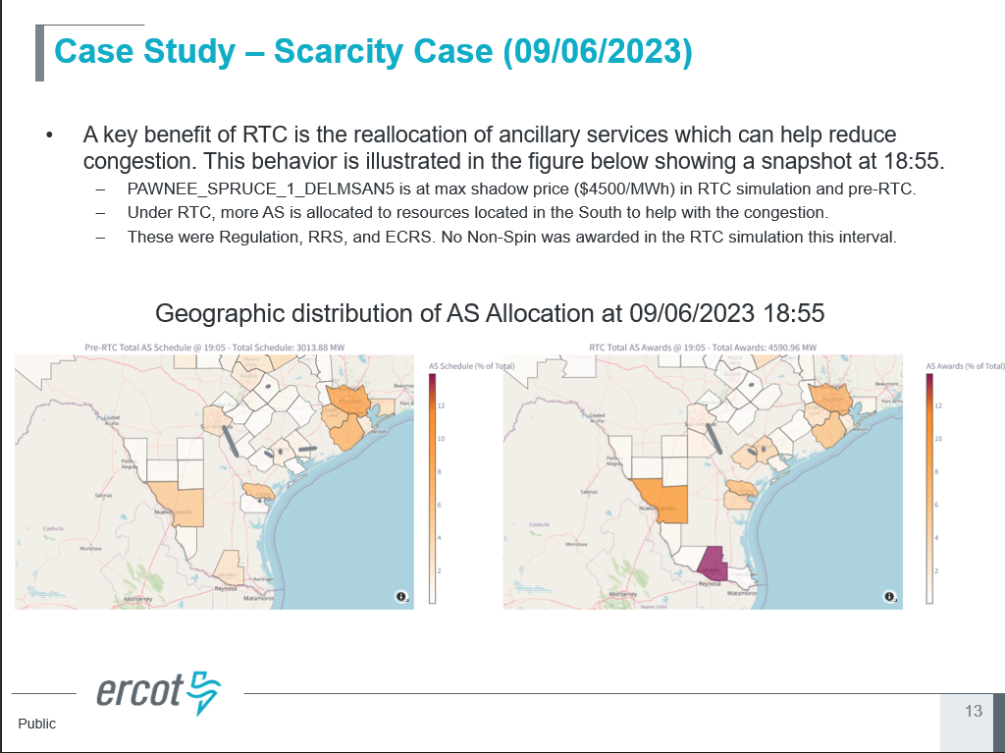

Given ERCOT’s decision to include the proposed test in the 2024 Regional Transmission Plan and other projects underway to relieve congestion, it is reasonable for stakeholders to have the benefit of more time to review this NPRR, white paper, and the PGRR that should follow shortly without overly aggressive time constraints. We look forward to discussing this NPRR with other stakeholders at the October 29 Special PLWG and November 7 ROS meetings.

Revised Cover Page Language
None

Revised Proposed Protocol Language

3.11.2 Planning Criteria
(1) ERCOT and Transmission Service Providers (TSPs) shall evaluate the need for transmission system improvements and shall evaluate the relative value of alternative improvements based on established technical and economic criteria.
(2) The technical reliability criteria are established by the Planning Guide, Operating Guides, and the North American Electric Reliability Corporation (NERC) Reliability Standards. ERCOT and TSPs shall strongly endeavor to meet these criteria, identify current and future violations thereof and initiate solutions necessary to ensure continual compliance.
(3) ERCOT shall attempt to meet these reliability criteria as economically as possible and shall actively study the need for economic projects to meet this goal.
(4) For economic projects, the net economic benefit of a proposed project, or set of projects, will be assessed over the project’s life based on the net benefit that is reasonably expected to accrue from the project as demonstrated through the production cost savings test or the congestion cost savings test.
The current set of financial assumptions upon which the revenue requirement calculations for these tests are based will be reviewed annually, updated as necessary by ERCOT, and posted on the Market Information System (MIS) Secure Area. The expected economic benefits are based on chronological simulations of the security-constrained unit commitment and economic dispatch of the generators connected to the ERCOT Transmission Grid to serve the expected ERCOT System Load over the planning horizon, comparing simulations with and without the project. These market simulations are intended to provide a reasonable representation of how the ERCOT System is expected to be operated over the simulated time period. From a practical standpoint, it is not feasible to perform these simulations for the entire 30 to 40 year expected life of the project. Therefore, the economic benefits are projected over the period for which simulations are feasible, which is the planning horizon established in Planning Guide Section 3.1.1.2, Regional Transmission Plan, and a qualitative assessment is made of whether the factors driving the economic benefits due to the project can reasonably be expected to continue. If ERCOT must add generation to the planning models that does not satisfy the requirements of Planning Guide Section 6.9, Addition of Proposed Generation to the Planning Models, in order to address a supply and demand deficiency, no transmission project can be approved either through the production cost savings test or the congestion cost savings test if the addition of that generation is the primary reason for either economic criterion being met.
[NPRR1183: Replace paragraph (4) above with the following upon system implementation:]
(4) For economic projects, the net economic benefit of a proposed project, or set of projects, will be assessed over the project’s life based on the net benefit that is reasonably expected to accrue from the project as demonstrated through the production cost savings test or the congestion cost savings test. The current set of financial assumptions upon which the revenue requirement calculations for these tests are based will be reviewed annually, updated as necessary by ERCOT, and posted on the ERCOT website. The expected economic benefits are based on chronological simulations of the security-constrained unit commitment and economic dispatch of the generators connected to the ERCOT Transmission Grid to serve the expected ERCOT System Load over the planning horizon, comparing simulations with and without the project. These market simulations are intended to provide a reasonable representation of how the ERCOT System is expected to be operated over the simulated time period. From a practical standpoint, it is not feasible to perform these simulations for the entire 30 to 40 year expected life of the project. Therefore, the economic benefits are projected over the period for which simulations are feasible, which is the planning horizon established in Planning Guide Section 3.1.1.2, Regional Transmission Plan, and a qualitative assessment is made of whether the factors driving the economic benefits due to the project can reasonably be expected to continue. If ERCOT must add generation to the planning models that does not satisfy the requirements of Planning Guide Section 6.9, Addition of Proposed Generation to the Planning Models, in order to address a supply and demand deficiency, no transmission project can be approved either through the production cost savings test or the congestion cost savings test if the addition of that generation is the primary reason for either economic criterion being met.

(5) To determine the economic benefits of a proposed project under the production cost savings test, the revenue requirement of the capital cost of the project is compared to the expected savings in system production costs resulting from the project over the expected life of the project. Outputs from the market simulations described in paragraph (4) above will be used to provide an estimate of the expected reduction in total system-wide production cost due to the project. Other adequately quantifiable and ongoing direct and indirect costs and benefits to the transmission system attributable to the project may be considered as appropriate. If the levelized ERCOT-wide annual production cost savings equals or exceeds the first-year annual revenue requirement of the transmission project, the project will be deemed to demonstrate sufficient economic benefit and will be recommended. ERCOT will publish requested non-confidential modeling inputs, assumptions, and outputs utilized in the production cost savings test if that information can be feasibly provided.
(6) To determine the economic benefits of a proposed project under the congestion cost savings test, the revenue requirement of the capital cost of the project is compared to the expected system-wide consumer energy cost reduction resulting from the project over the expected life of the project. Outputs from the market simulations described in paragraph (4) above will be used to provide an estimate of the expected reduction in total system-wide consumer energy cost due to the project. In the market simulations, system-wide consumer energy cost will be calculated using hourly load in MWh multiplied by hourly load nodal energy prices in $/MWh. Other adequately quantifiable and ongoing direct and indirect costs and benefits to the transmission system attributable to the project may be considered as appropriate. If the levelized system-wide consumer energy cost reduction equals or exceeds the average of the first three years’ annual revenue requirement for the project, the project will be deemed to demonstrate sufficient economic benefit and will be recommended. ERCOT will publish requested non-confidential modeling inputs, assumptions, and outputs utilized in the congestion cost savings test if that information can be feasibly provided.

See RTC Simulator Update, RTCBTF October 22, 2024: 2024-10-22_rtc_sim_tool_case_studies.pptx (live.com).

