

Overshoot Analysis Due to Large Load(s) Loss Scope

**Version 1.0**

November 2024

Document Revisions

|  |  |  |  |
| --- | --- | --- | --- |
| Date | Version | Description | Author(s) |
| November 14, 2024 | 1.0 | First draft | Operations Planning |

Purpose

The purpose of this document is to establish the study scope for frequency overshoot analysis due to loss of large load(s).

Background

One of the main sources of growing demand for power in ERCOT is large-scale computing facilities such as data centers and cryptocurrency mining operations, although their future demands are uncertain. In the latest Short-Term Energy Outlook (STEO) from The U.S. Energy Information Administration (EIA), it is expected that the electricity demand from customers identified by ERCOT as large flexible load (LFL) will total 54 billion kilowatt-hours (kWh) in 2025, up almost 60% from expected demand in 2024. This expected demand from LFL customers would represent about 10% of total forecast electricity consumption on the ERCOT grid next year. These facilities consume large amounts of electricity, both to run their computing equipment and to keep them cool. Some of the larger facilities can consume as much electricity as a medium-sized power plant.

There are new LFL interconnection requests coming into ERCOT queue some sized above 1000 MW. These loads do not have voltage ride through capability. During real time operations we have seen several events wherein multiple large loads have tripped during transmission faults. During such events steady state system frequency may increase. If frequency overshoot reaches 60.6 Hz, there is a possibility for the over-frequency relays for generation resources or energy storage resources (ESR) to be activated.

# Study Objective

The purpose of this study is to analyze the impact of large load loss and determine the MW load loss level (cumulative) at which the frequency reaches 60.6 Hz for different inertia levels. And recommend operations procedure changes, operating limits, if any, are necessary for loss of large load(s) in the system.

# Study Setup

The loss of large loads could cause a frequency overshoot. It is considered as a reliability concern if the frequency overshoot is too high, leading to a cascading effect by tripping generator(s) on over-speed protections and/or tripping load(s) on over voltage (momentary) protections. The magnitude of frequency overshoot depends on system inertia level, number of generators with governor response capability, and the capacity available to provide downward frequency response.

Several dynamic simulations will be conducted to examine the effect of the frequency overshoot because of large load(s) loss. As such, the base case (power flow) from a previous operation condition on 03/29/2024 4:00 AM will be used and modified to study different scenarios. Detailed base case information is summarized in Table 1.

Table 1. Base Case Information

|  |  |  |  |  |
| --- | --- | --- | --- | --- |
| Time Stamp | Inertia (GW*s) | Load (MW) | Wind  (MW) | Dispatchable Gen (MW) |
| 03/29/2024 4:00 AM | 133 | 41,062 | 25,804 | 16,825 |

# Scenarios

The above-mentioned case will be considered as a base case. Different scenarios will be created using this base case by modifying the resource mix. Based on historical low yearly inertia levels shown in Table 2, scenarios shown in Table 3 with different inertia levels and resource levels/mix (e.g. High wind, low wind, etc) will be analyzed. Other scenarios may be considered as the study progresses. Figure 1 shows the total inertia levels from 2018 to 2024. Figure 2 shows the lowest 100 hours of inertia from 2018 to 2024.

Figure 1. Total Inertia by Year 2018 to 2024

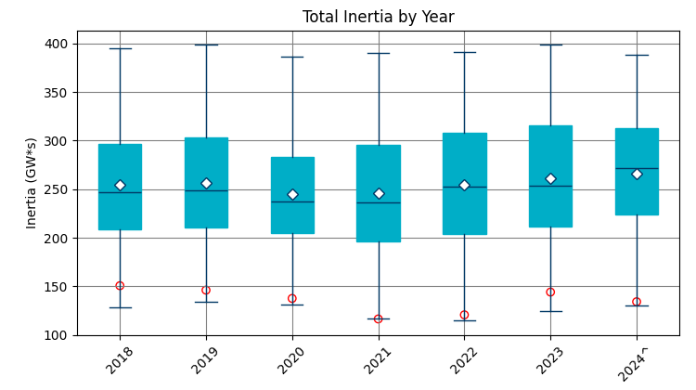

Table 2. Historical Low Yearly Inertia Levels 2018 to 2024

|  |  |  |  |  |  |  |  |
| --- | --- | --- | --- | --- | --- | --- | --- |
| Year | 2018 | 2019 | 2020 | 2021 | 2022 | 2023 | 2024 |
| Date and Time | 11/03  3:30 | 3/27 1:00 | 5/01  3:00 | 03/22  1:00 | 03/21  2:00 | 04/18  3:00 | 03/29  4:00 |
| Min synch. Inertia (GW*s) | 128.8 | 134.5 | 131.1 | 116.6 | 115 | 124.3 | 129.9 |

Figure 2. Lowest 100 Hours of Inertia for 2018 to 2024

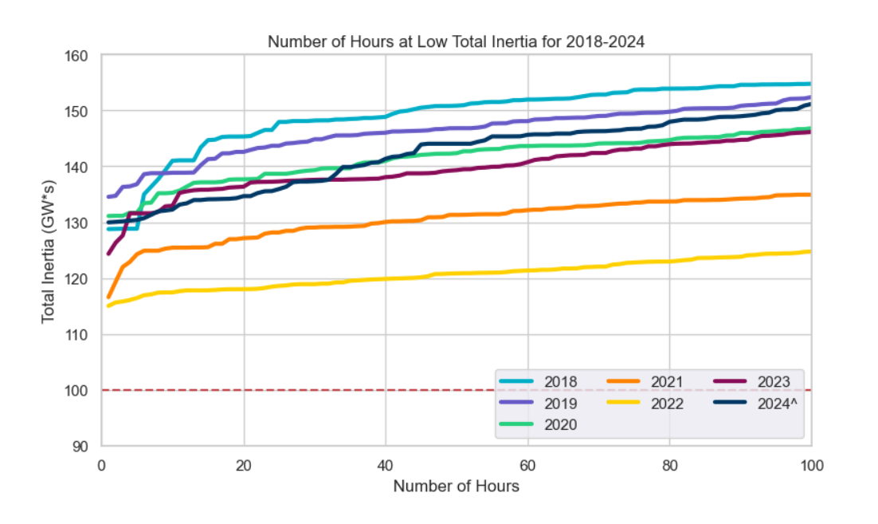

Table 3. Scenarios

|  |  |  |  |
| --- | --- | --- | --- |
| Inertia (GW*s) | Load (MW) | Wind (MW) | Dispatchable Gen (MW) |
| 133 | 41,062 | 25,804 | 16,825 |
| 130 | 41,062 | 24,900 | 16,825 |
| 126 | 40,800 | 23,500 | 16,400 |
| 124 | 40,000 | 22,000 | 15,600 |