RMTTF Meeting

Friday, October 18, 2024

9:30 AM

Centerpoint Energy Plaza

Houston, TX

This meeting is being held in person also WebEx.

Melinda Earnest Chaired the meeting. Melenda welcomed everyone, thanked Kathy and Centerpoint for hosting and proceeded with reading the antitrust statement. Introductions followed.

**Introductions included:**

* Kathy Scott Centerpoint
* Debbie McKeever Oncor
* Melinda Earnest AEP
* Sheri Wiegand TXU
* Monica Jones Centerpoint
* Art Deller ERCOT
* Jordan Troublefield ERCOT
* Angela Ghormley Calpine
* Eric lotter GridMonitor
* Bill Snyder AEP
* Jesse Macias AEP
* Amy Sue Stirland LP&L
* Viviana Valdez LP&L

**Meeting Agenda**

Melinda read the agenda. No questions were asked. No changes were made.

**Meeting Notes**

Meeting notes from the last meeting were reviewed. No changes were requested. None of the leadership received requests for changes. Meeting notes are considered final.

**LMS Stats**

Tomas volunteered to be the “driver” today. Tomas read the stats in the table above.

There’s an increase in several different training modules. Retail 101 still has high numbers.

Art said that the count for Retail 101 training is good.

Those registered for the Retail 101, November 15th training – current count is over 30.

Tomas said that he thinks Art usually sets the attendance around 30. Art said that he has increased it before. Registration is still open.

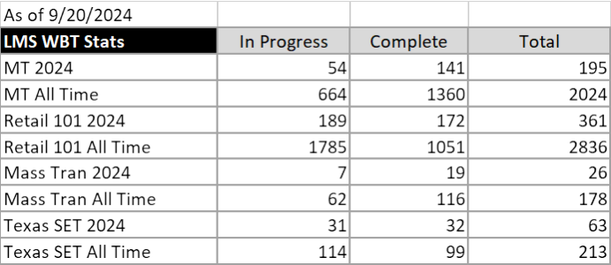

**Update from MCT and TX SET as well as the Implementation Timeline**

Kathy provided an update regarding the status including that the majority of the work is complete and has been communicated to the Market and RMS has approved the last version of the timeline.

Testing is nearly complete. Has been completed as much as possible except for some finishing up the IBANK01.

Kathy said we should be able to get some update on the status today from ERCOT.

TDSPs have been meeting with ERCOT and for the REPs that haven’t completed testing…those are all on the Banking script (no other script), which usually takes several days and has in each of the Flights.

If those REPs don’t finish the script by end of week, ERCOT will be discussing with them if they can help or if they need to come in the next flight.

Tomas asked if there is a high level of confidence that the REPs understand that the CR and IA codes must be in the 814_16 transaction and if they don’t backdate and instead use current date would just flow through.

The last MarkeTrak SCR817 training had a total of 163 attendees.

Sheri will also send out a market notice the last week in October 28th of a reminder to “clean up your MarkeTraks”. This reminder will be included during the October 24th training.

Sheri will send out a market notice on November 4th as a reminder “no more ready to receive…critical to send your backdated move ins “. Very important!

Make sure that your transactions must have the IA and CR codes.

October 24th – this will be the second training and the last training presented by Tammy. There will not be any future training by Tammy.

As an alert TDTMS is trying to find a way to put a “ribbon” or alert in MarkeTrak to make sure everyone is reminded of the upcoming changes.

MarkeTrak user guide – Tammy won’t be finished with the User Guide until November 11th.

The test environment is still available for those that want to test the MarkeTrak changes.

**Status of the updates to the Online Modules**

Art said that all the changes have been approved by Tammy. He is pressed for time due to resource constraints. Two of his employees are out right now.

Sheri said that she thinks one of the answers on the TX SET sheet is incorrect. She thinks it’s “move in with a cancel”. RMTTF reviewed the transaction flow and discussed how the REP would know the date changed. After discussion it was confirmed that the process doesn’t need to be changed on the slide. It will be a point made during the training…what happens on a date change.

To verify the modules, Melinda suggested that each of us take one of the 5 modules to review.

Assignments include:

* Tomas IAG
* Melinda and Monica Switch Hold
* Melinda and Amy Sue Cancel with Approval Melinda and Amy Sue
* Monica Bulk Insert
* Sheri Missing enrollment transactions

Those reviewing should note that when reviewing and find something that’s “nice to have or needs a modification”, put it down and we will talk about at our next meeting.

If there’s something wrong – put in the comments because we need to get the critical info out and the “nice to haves” can wait.

Everyone should finish their review by end of day Tuesday.

Melinda stated that we need to work on our training presentations and finish those ASAP.

**Instructor Led Training – slide changes**

Changes were noted or made during the meeting.

Switch Hold;

Action item;

Slide 58 - “AMS LSE Disputes” – we just need a screen shot.

Sheri has the action item to add screen shot and dispute reasons.

Kathy asked if Meter Cycle change is in day 1 or day 1. It’s in day 1 presentation.

Inadvertent Gain;

Comments include;

Tomas is adding a new slide explaining “TDSP ready to receive” is no longer included in the process.

IAGs are now a total of 52% of all MarkeTraks.

**Dates for Retail Training**

As discussed at the last meeting.

Retail 101 – next instructor led training date is November 12th. WebEx only.

All noted below will be held 3 times in 2025 –

Retail 101

Provided and presented by ERCOT for Instructor Led

February 11, 2025 – per Art, this has been scheduled.

RMTTF volunteers please try to attend as TDSP and REP SMEs.

MarkeTrak Part 1 and 2

Trainers will be in person to avoid technical issues. One will be in Dallas and one in Houston.

**MarkeTrak Training part 1 and part 2**

Will be held WebEx only - Instructors will gather together to present. This has been found to be effective with eliminating issues previously experienced with transitioning from one presenter to another.

**MarkeTrak Overview, Part 1 MarkeTrak Switch Hold and IAG, Part 2**

February 25th February 26th Date – date is final, confirmed by Art

April 29th April 30TH TENTATIVE – CNP to host instructors

September 24th September 25th TENTATIVE – Oncor to host instructors

MarkeTrak Part 1 and 2 will both be held WebEx only – all will start at 8:30 AM

Each session is about 4 hours.

**2025 Meetings**

We need to finalize instructor training presentations ASAP, which is more critical so Debbie suggested to move this agenda topic to next month’s agenda. It was agreed this will be taken up at our next meeting.

**2025 Leadership**

Same as above. Will take this up at our next meeting.

**Other Business**

Our next meeting is November 21st, WebEx.

**Adjourn**

Melinda thanked everyone for attending and adjourned the meeting at 2:17 PM.