**TDTMS**

**October 24th, 2024 @ 1:00 PM**

**WebEx only**

|  |  |  |  |  |  |  |
| --- | --- | --- | --- | --- | --- | --- |
| Attendee | Company | Attendee | Company | | Attendee | Company |
| Jordan Troublefield | ERCOT | Bill Snyder | | AEP | Monica Jones | CNP |
| Dave Michelson | ERCOT | Nick | | IGS Energy | Eric Lotter | GridMonitor |
| Sheri Wiegand | Vistra | Mick Hanna | | ERCOT | Kathy Scott | CNP |
| Tammy Stewart | ERCOT | Steven Pliler | | Vistra | Darilyn | NEC |
| Dee Lowerre | NRG | Connie Hermes | | STEC/NEC | Yvette Perez | Octopus |
|  |  | Randi Flowers | | Champion | Deavonte Anderson |  |
|  |  |  | |  |  |  |

Sheri Wiegand opened the meeting with the Antitrust Admonition and introductions of those on the WebEx were made.

Meeting minutes from the September 18th meeting were reviewed and approved.

**ERCOT System Instances & MarkeTrak Monthly Performance Review -**

* Market SLAs met for September. MarkeTrak performance remains well within SLO.
* Small MT uptick in seconds to process that could be volume related, so Mick is creating a graph to solidify volume upticks
* Kathy Scott asked about MT reporting after TX SET 5.0 Go Live to see if it causes MT performance issues and I believe Mick said it would be seen in the current reporting; however, he doesn’t anticipate issues
  + Proposed 2025 Retail Release Calendar will be the same structure as 2024 – more frequent, yet shorter duration, with one longer retail release, yet aligning production releases with retail release.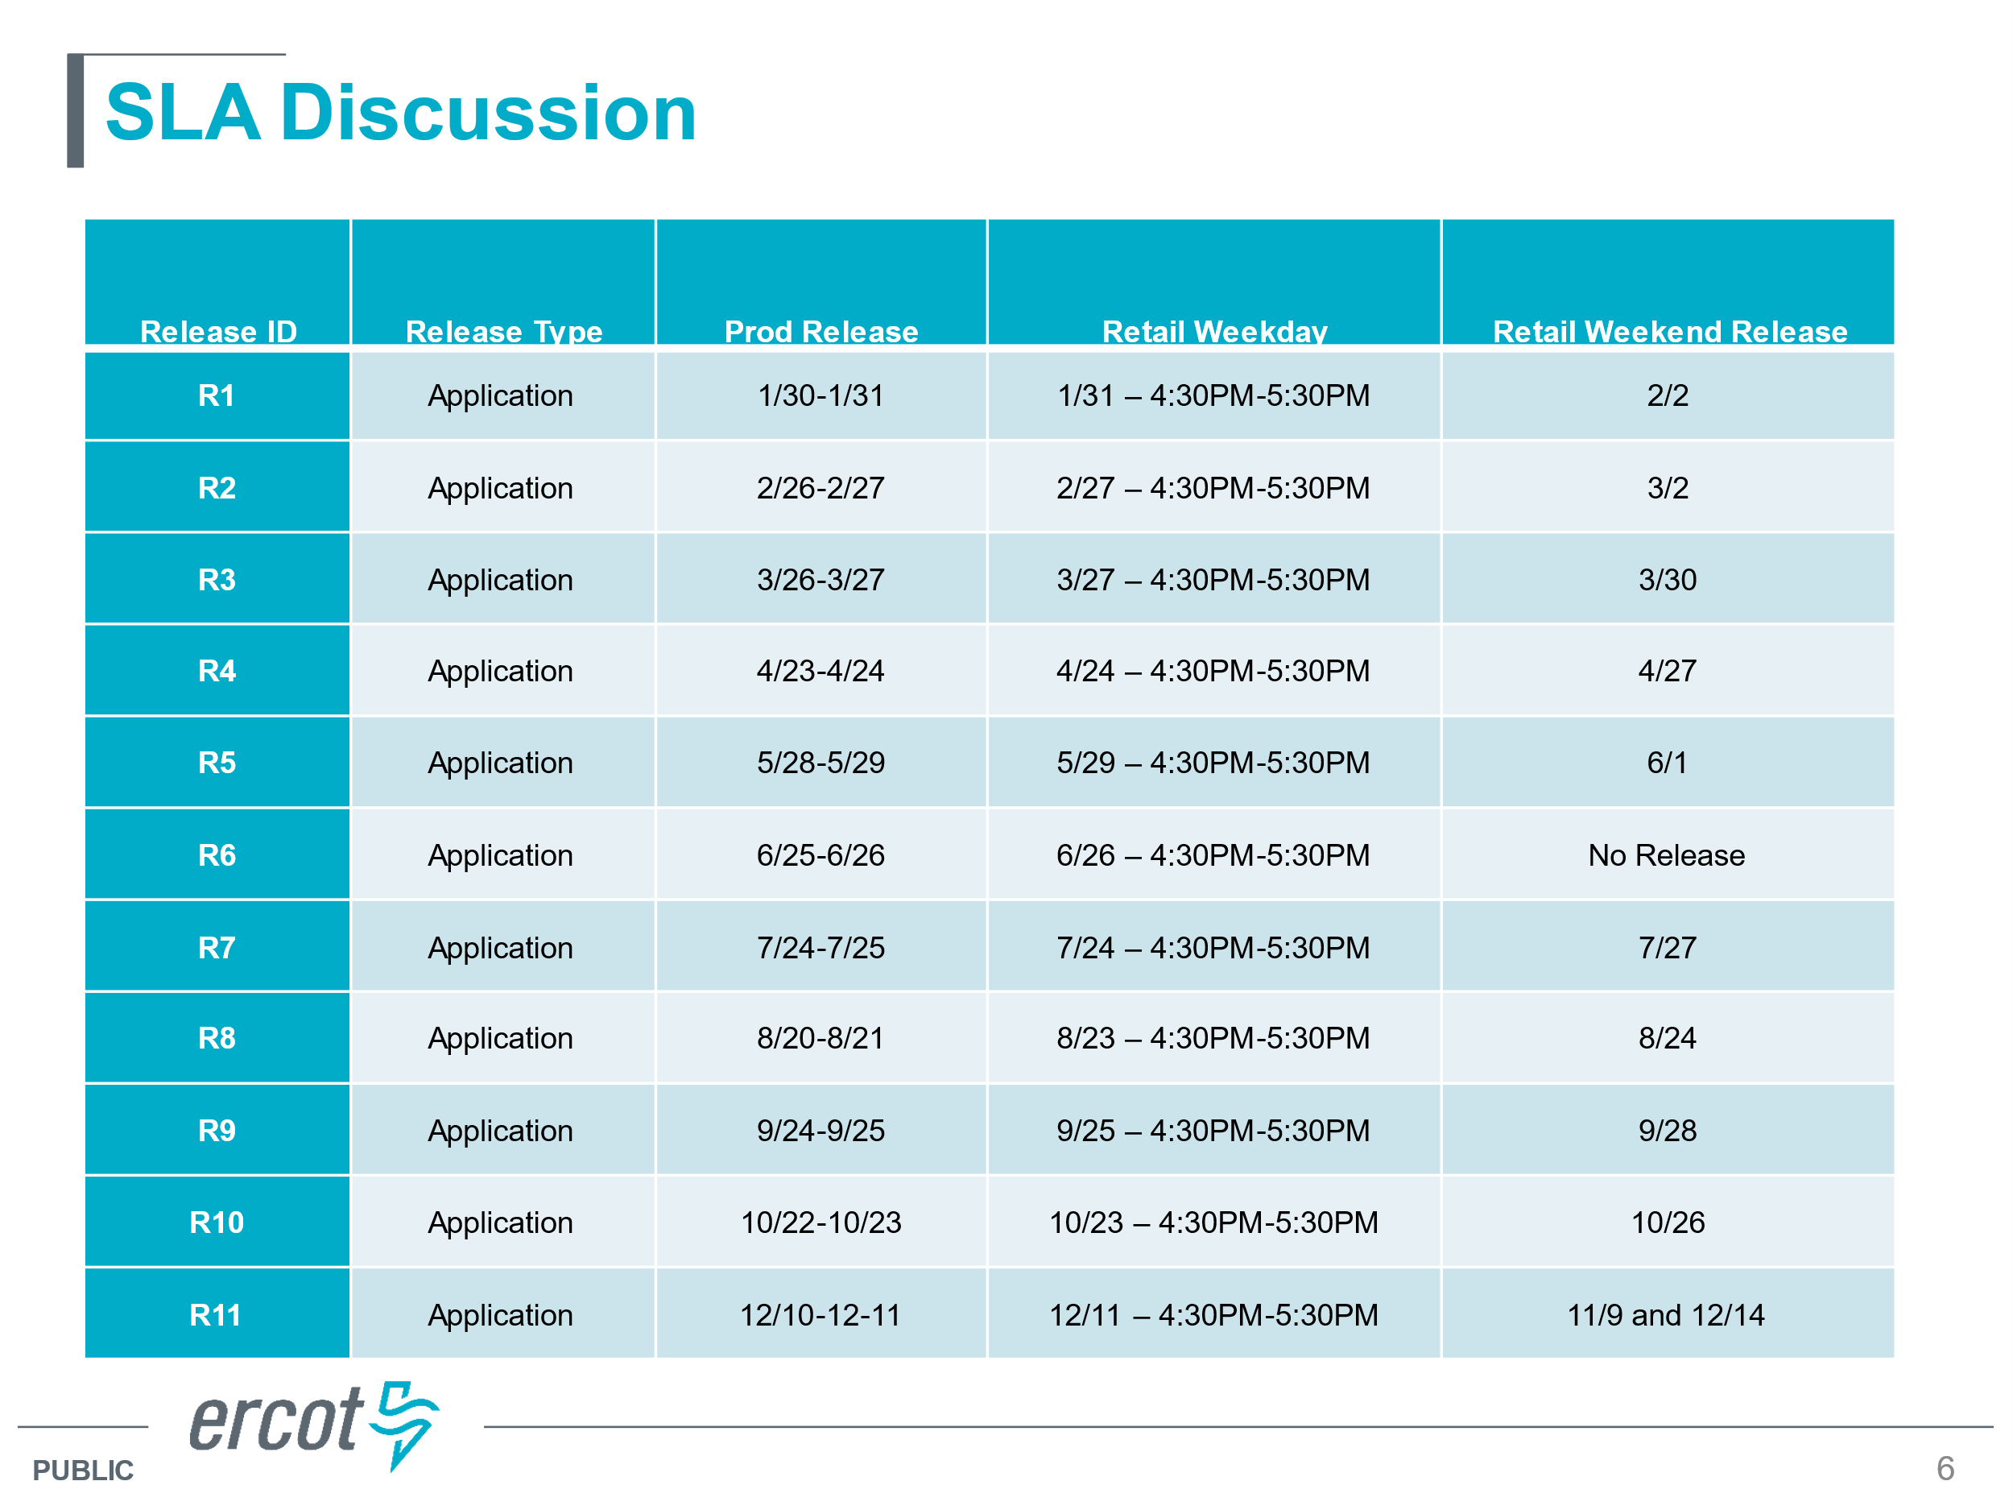
  + Goal: the approach will be consistent with 2024, yet begin moving toward alignment of production releases with retail releases where one hour outages would occur mid-week; NAESB outages will remain for the non-business days
  + Mick and Dave are moving forward with protocol and market guide revision reviews (binding doc review which Dave is pulling) “Pending compliant updates to relevant binding documents”
  + Group seems comfortable with SLA calendar and proposed times

**SCR 817 MarkeTrak Validations –**

* Great training held this morning with an emphasis on IAS MT changes. Attendance topped at 225 call ins.
* Updated presentation was posted to the training page
* RMTE is available and some market participants are logging in and testing
* Communication of IGL MarkeTrak Transition Schedule

A series of market notices will be sent:

October 26th encouraging REPs to “clean up” IAS MTs as the last day for TDSPs to transition to ‘ready to receive will be Friday, November 1st at 5:00 PM

November 4th advising REPs to no longer transition to TDSP and hold onto MTs where agreement has been reached until 11/11 to send the BDMVIs. For any MTs in the state of ‘ready to receive’, please send BDMVIs by Friday 11/8 at noon to follow existing workflow.

November 11th instructing REPs on how to manage in flight MTs that were transitioned to the TDSP during the week of 11/4 – 11/8: MTs must be transitioned back to the submitting REP for ‘agreement’ again, then the new workflow can be followed.

* Service Address approach was confirmed as discussed during the training where County Name will be placed in both the “address” and “city” fields.

**MarkeTrak Subtype Volume for first half of 2024**

Observations:

1. IALs – seasonal until first half is higher this year
2. IAGs – up from same time last year
3. SH – seasonal with second half of year higher – off heels of heat moratoriums
4. U&B – Dispute – system/transition/weather related
5. Rescissions – over time tracking up
6. Missing TXNs – higher with new entrant
7. More market participants are submitting Bulk Insert MTs
8. Siebel Changes - higher with new entrant
9. ERCOT Initiated – exceptions in ERCOT system (e.g. special characters)
10. Other – reducing with TDSPs redirecting and providing guidance

**NEXT MEETING** **Wednesday, December 4th @ 9:30 AM** **WebEx Only**

**DRAFT AGENDA**

* ERCOT Reports
  + System Instances & MT Performance
  + Listserv
  + 2025 Retail Release Calendar Proposed Revisions
* SCR817 / TXSET Follow Up
  + Any observations on new changes
  + Lessons Learned
* MT Subtypes Volume Analysis – 2024 – results
  + Usage & Billing – Missing
  + Switch Hold
  + Rescissions
  + IAGs/IALs