

System Planning

**Monthly Status Report**

Report Highlights

* ERCOT is currently reviewing proposed transmission improvements with a total estimated cost of $3.397 billion as of October 31, 2024.
* Transmission Projects endorsed in 2024 total $3.034 billion as of October 31, 2024.
* All projects (in engineering, routing, licensing, and construction) total approximately $16.504 billion[1] as of October 1, 2024.
* Transmission Projects energized in 2024 total approximately $2.435 billion[2] (as of October 1, 2024).

Regional Planning Group Reviews

RPG Projects under Review:

* AEPSC has submitted the Brownsville Area Improvements Transmission Project (RPG Project ID: 24RPG008). This is a Tier 1 project that is estimated to cost $387.70 million. ERCOT has completed the independent review on September 27, and the recommended project is estimated to cost $423.80 million. TAC voted unanimously to endorse the project on October 30, 2024. ERCOT will present the recommendation for ERCOT Board of Directors endorsement on December 3, 2024.
* Oncor has submitted the Delaware Basin Stages 3 and 4 Project (RPG Project ID: 24RPG010). This is a Tier 1 project that is estimated to cost $202.20 million. This project is currently under ERCOT’s independent review.
* Oncor has submitted the Delaware Basin State 5 Project (RPG Project ID: 24RPG015). This is a Tier 1 project that is estimated to cost $744.60 million. This project is currently under ERCOT’s independent review.
* REC has submitted the Rand Area Loop Project (RPG Project ID: 24RPG016). This is a Tier 2 project that is estimated to cost $32.20 million. ERCOT completed the independent review on October 21, and the recommended project is estimated to cost $32.20 million. ERCOT will not issue an endorsement letter for this project, as it is needed to solely meet REC planning criteria.
* Oncor has submitted the Venus Switch to Sam Switch 345-kV Line Project (RPG Project ID: 24RPG017). This is a Tier 1 project that is estimated to cost $118.90 million. This project is currently under ERCOT’s independent review.
* Oncor has submitted the Connell 345/138-kV Switch and Connell to Rockhound 345-kV Double-Circuit Line Project (RPG Project ID: 24RPG020). This is a Tier 1 project that is estimated to cost $110.62 million. This project is currently under ERCOT’s independent review.
* Oncor has submitted the Forney 345/138-kV Switch Rebuild Project (RPG Project ID: 24RPG021). This is a Tier 1 project that is estimated to cost $103.50 million. This project is currently under ERCOT’s independent review.
* Oncor has submitted the Wilmer 345/138-kV Switch Project (RPG Project ID: 24RPG022). This is a Tier 1 project that is estimated to cost $158.20 million. This project is currently under ERCOT’s independent review.
* WETT has submitted the WETT Delaware Basin Stage 5 Project Alternative (RPG Project ID: 24RPG023). This is a Tier 1 project that is estimated to cost $305.50 million. This project is currently under ERCOT’s independent review.
* Oncor and LCRA TSC have submitted the Hartring to Upland 138-kV Line and Benedum Autotransformer Addition Project (RPG Project ID: 24RPG024). This is a Tier 2 project that is estimated to cost $94.00 million. This project is currently under ERCOT’s independent review.
* Oncor has submitted the Gunter 345/138-kV Switch Project (RPG Project ID: 24RPG025). This is a Tier 3 project that is estimated to cost $51.20 million. The RPG review of this project was completed on September 4, and ERCOT has issued an acceptance letter.
* CNP has submitted the Jordan/Mont Belvieu Area Improvement Project (RPG Project ID: 24RPG026). This is a Tier 3 project that is estimated to cost $76.89 million. The RPG review of this project was completed on September 13, and ERCOT has issued an acceptance letter.
* CNP has submitted the Baytown Area Load Addition Project (RPG Project ID: 24RPG028). This is a Tier 1 project that is estimated to cost $141.65 million. This project is currently under ERCOT’s independent review.
* Oncor has submitted the Tredway 138-kV Switch and Expanse to Tredway 138-kV 2nd Circuit Project (RPG Project ID: 24RPG029). This is a Tier 1 project that is estimated to cost $119.03 million. This project is currently under ERCOT’s independent review.
* CNP has submitted the Partial Rebuild of 138-kV Ckt.05A Sienna Tap to Missouri City Tap Project (RPG Project ID: 24RPG030). This is a Tier 3 project that is estimated to cost $28.56 million. The RPG review of this project was completed on October 10. Pursuant to the Protocol Section 3.11.4.3.1 (d), this project has been reclassified as a Tier 4 neutral project.
* LST has submitted the Central Texas 345-kV Transmission Project (RPG Project ID: 24RPG031). This is a Tier 1 project that is estimated to cost $342.00 million. This project is currently in the RPG study mode.
* CNP has submitted the Southwest Houston 345-kV Reliability Project (RPG Project ID: 24RPG032). This is a Tier 1 project that is estimated to cost $569.32 million. This project is currently in the RPG comment period.

RPG Project Reviews Completed in 2024:

|  |  |  |  |  |  |
| --- | --- | --- | --- | --- | --- |
| RPG Project ID | RPG Project Name | Submitted Entity | Tier | Estimated Cost  ($ Millions) | Review Completion Month |
| 24RPG002 | Rockhound 345/138-kV Switch and Grey Well Draw to Buffalo 2nd 138-kV Circuit Project | Oncor | Tier 3 | 97.00 | February |
| 23RPG028 | Rio Medina Project | STEC | Tier 2 | 71.70 | February |
| 23RPG023 | Pecos County Transmission Improvement Project | TNMP | Tier 1 | 114.80 | February |
| 24RPG005 | Montfort Switch to Shankle Switch 138-kV Line Project | Oncor | Tier 3 | 33.80 | February |
| 24RPG006 | Prairieland 345/138-kV Switch and Prairieland Switch to Quartz Sand Switch/Hog Mountain Pod 138-kV Line Project | Oncor | Tier 3 | 56.00 | March |
| 23RPG032 | San Antonio South Reliability II Project  (San Miguel to Marion 345-KV Project) | BEC | Tier 1 | 435.00 | April |
| 24RPG009 | Sonora to Uvalde to Campwood to Bandera Area Transmission Project | AEPSC, LCRA TSC & BEC | Reclassified from Tier 3 to Tier 4 per Protocol | 76.00 | April |
| 24RPG011 | Gonzales STATCOM Transmission Project | AEPSC | Reclassified from Tier 3 to Tier 4 per Protocol | 34.50 | April |
| 24RPG012 | Clute to Velasco ckt 26 Upgrades Project | CNP | Tier 3 | 68.23 | May |
| 24RPG013 | FPP Yard 2 to Lytton Springs Transmission Line Overhaul Project | LCRA TSC & AEN | Reclassified from Tier 3 to Tier 4 per Protocol | 60.00 | May |
| 24RPG014 | Sim Gideon to Cedar Hill Transmission Line Upgrade Project | LCRA TSC | Tier 3 | 77.90 | May |
| 23RPG034 | West Texas 345-kV Infrastructure Rebuild Project | Oncor | Tier 1 | 1,120.00 | June |
| 23RPG003 | Energy Eastside 345/138-kV Switching Station Project | CPS Energy | Reclassified from Tier 1 to Tier 3 per Protocol | 47.00 | July |
| 23RPG004 | Omicron Reliability Project | CPS Energy | Tier 2 | 45.70 | July |
| 24RPG018 | Salado Switch to Hutto Switch 138-kV Line Project | Oncor | Tier 3 | 87.60 | July |
| 24RPG019 | Vineyard Switch to Cypress Waters 138-kV Circuit Addition Project | Oncor | Tier 3 | 93.04 | July |
| 24RPG001 | Temple Area Project | Oncor | Tier 1 | 272.60 | August |
| 24RPG007 | Canton Area Loop Project | REC | Tier 2 | 26.03 | August |
| 24RPG025 | Gunter 345/138-kV Switch Project | Oncor | Tier 3 | 51.20 | September |
| 24RPG026 | Jordan/Mont Belvieu Area Improvement Project | CNP | Tier 3 | 76.89 | September |
| 24RPG027 | Long Draw Second 345/138-kV Autotransformer Project | WETT | Tier 3 | 28.00 | September |
| 24RPG030 | Partial Rebuild of 138-kV Ckt.05A Sienna Tap to Missouri City Tap Project | CNP | Reclassified from Tier 3 to Tier 4 per Protocol | 28.56 | October |
| 24RPG016 | Rand Area Loop Project | REC | Tier 2 | 32.20 | October |

More information on current and past RPG projects can be found on the ERCOT MIS Secure (digital certificate required): https://mis.ercot.com/secure/data-products/grid/regional-planning

Past email communication on RPG projects can be found on the ERCOT listserv by signing up for the REGPLANGROUP list: <http://lists.ercot.com/scripts/wa-ERCOT.exe?A0=REGPLANGROUP>

Planning Model Activities

The short-term calendar of major planning model events is as follows:

* By October 15, 2024 24SSWG_U1 Cases and TPIT will be posted
* By November 8, 2024 24SSWG_U1 Contingencies and Data Dictionary will be posted

The following table shows interconnection projects that met Planning Guide section 6.9(1) and 6.9(2) and were modeled in the SSWG cases as a full model or as a simple model in accordance with Planning Guide section 6.9. 



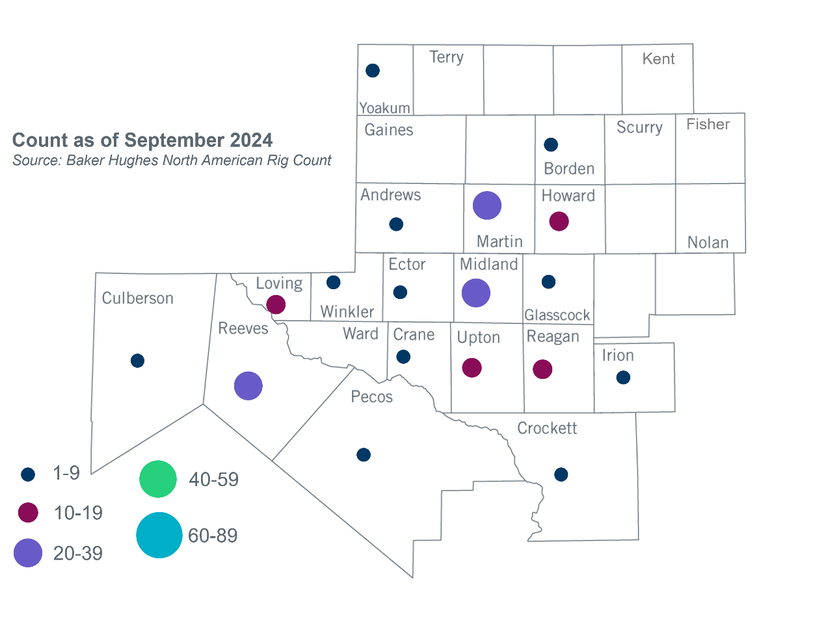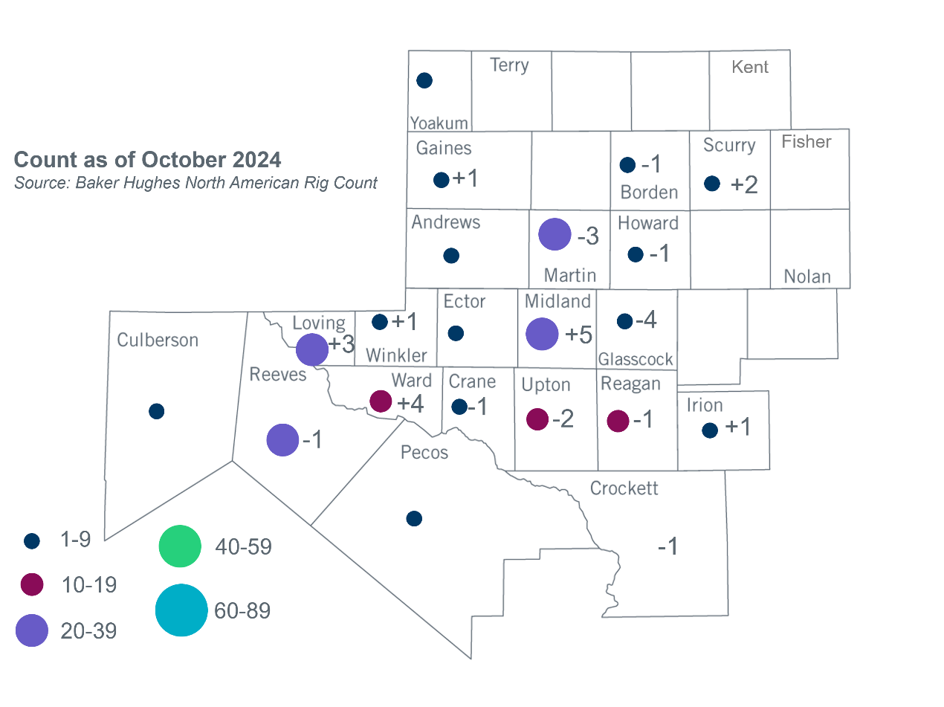Permian Basin Oil Rig Count[3]Other Notable Activities

* On October 18, 2024, ERCOT sumitted the report detailing ERCOT's proposed assignments of Transmission Service Provider (TSP) responsibility for ownership, construction, and operation of the transmission facilities associated with the common local projects and import paths identified in the Permian Basin Reliability Plan Study Report.
* ERCOT presented the Extra-High Voltage (EHV) infrastructure update at the October 2024 RPG meeting.
* ERCOT presented the 2024 Long-Term System Assessment (LTSA) transmission expansion analysis update for the Current Trends scenario at the October 2024 RPG meeting.

1. Based on the Total Project Estimated Cost for all future projects listed in the Transmission Project Information and Tracking (TPIT) report. TPIT is updated three times each year based on information TSPs provide in Model on Demand (MOD) as specified in the ERCOT Steady State Working Group Procedure Manual. The latest TPIT is available at https://www.ercot.com/gridinfo/planning.
2. Based on the Total Project Estimated Cost for all completed projects with Projected In-Service Dates in 2024 listed in the TPIT.
3. +/- symbol indicates the increase or decrease from the previous month in oil rigs present in each county. There are 203 rigs, including an increase of 2 oil rigs, in the Permian Basin from September to October 2024.