**IBRWG Update**

**December 2024**

**Chair: Julia Matevosyan, Vice-Chair: Miguel Cova Acosta**

**IBRWG met on December 13th (Webex, Open Meeting).**

The agenda and the presentation slides are available [here](https://www.ercot.com/calendar/12132024-IBRWG-Meeting-_-Webex)

82 people attended the meeting (at peak)

**IBRWG Main Meeting**

**NERC Update**

Rachele Coyne (TRE)

* Presented status of NERC Projects as a part of FERC Order 901, Milestone 2. NERC fulfilled the FERC deadline for these projects. Projects primarily related to IBR performance and monitoring.
* NERC is now gearing up for Milestone 3, the projects under this Milestone are related to modeling, including EMT.
* NERC will be holding a Technical Conference on Jan 15-16 in Phoenix to start engaging with industry early on these projects.
* Texas RE Regional Project Standard Authorization Request SAR-013 to revise BAL-001-TRE-2.
* The scope of the SAR is to:
* provide for widening generator Governor deadband
* define PFR performance requirements for BESS
* clarify roles of GO, BA and Compliance Enforcement Authority (CEA) pertaining to compliance time periods
* This SAR **will not** be expanded to address concerns with the impact of curtailment on wind generation discussed in the last two IBRWG meetings. A separate SAR can be drafted if necessary
* With regard to Category 2 IBR (20-75 MW) Registration, TRE is in the process of identifying facilities and owners for registration between May 2025-2026.
* NERC Level 2 IBR Modeling Alert Response. Preliminary observations indicate widespread modelling concerns such as lack of verification, tools and metrics for accuracy. TRE will present the results at IBRWG on 01/17/25.

**Advanced Grid Support Requirements for Inverter-Based ESRs (NOGRR272 & PGRR121)**

Fred Huang (ERCOT)

* Background: ERCOT successfully integrated large numbers of IBRs so far and the interconnection queue going forward is also dominated by IBRs. ERCOT is looking for ways to integrate them stably and with the least constraints. Solutions such as SynCons and transmission expansion are already being applied today but are lagging in time and insufficient to fully remove constraints. Moving forward, ERCOT is exploring additional viable options. In the past 5 years grid forming technology has been picking up in regions experiencing similar growth in IBRs and similar stability issues.
* Since 2023 ERCOT has been bringing status updates to IBRWG on this topic and appreciates group’s feedback so far.
* The draft NOGRR and PGRR were provided even before these were posted.
* NERC also recognized the benefits of grid forming publishing two white papers in 2021 and 2023 respectively.
* ERCOT engaged Electranix to help identify and develop testing framework in case ERCOT were to adapt this technology.
* ERCOT does see benefit from grid forming technologies (1) with regard to transient dynamic voltage and frequency response, particularly in weak grid conditions (2) reduction of the risk of IBR tripping or unstable operation (3) increase od GTC limits which could reduce generation curtailment due to stability constraints.
* Fred highlighted that, unlike in some other regions, at least at this stage ERCOT doesn’t require any additional hardware or additional overload/overcurrent capability for provision of these capabilities, i.e. all capabilities are required within equipment rating. ERCOT also doesn’t require any changes to energy market dispatch for provision of advance grid support capabilities.
* ERCOT will continue monitoring the technology development to see if such advanced grid support capability can be also reliably provided by wind and solar technology in the future.
* The NOGRR language describes high level capability required from ESRs with AGS.
* The PGRR provides additional information with regard to modeling details.
* [Advanced Grid Support Energy Storage Resource (AGS-ESR): Functional Specification and Test Framework](https://www.ercot.com/files/docs/2024/09/16/ERCOT%20Advanced%20Grid%20Support%20ESR%20Test%20Requirement_.pdf) that was presented in September IBRWG meeting is the proposal for additional model quality tests that are applicable to AGS-ESR to assess their AGS capability.
* ERCOT is working on redlines for DWG Procedure Manual to include these additional tests and will bring it to IBRWG in February.
* There’ll be no additional commissioning tests for AGS-ESR at least for now.
* Discussion: primarily around implementation date, benefits of more targeted application and some detailed clarifying questions related to simulation testing.
* ERCOT noted that as per the interconnection queue with SGIA before 4/1/2025, they are already looking at 25-30 GW of additional IBR capacity.
* ERCOT understands the impact on the ongoing projects and will work with stakeholders on a reasonable implementation date.
* There are several projects in the queue with SGIA where developers saw the benefit of AGS due to weak grid conditions and looking to implement AGS-ESR already today.
* ERCOT thought about more targeted application, but based on how the grid is moving forward expects the regions with the issues to expand with further gen expansion dominated by IBRs. So ERCOT is trying to be ahead of the game and prevent future issues.
* **ERCOT encourages stakeholders to submit comments in any way they see convenient either directly to ERCOT or through RR commenting process**.

**Global overview of mandatory vs voluntary vs market-based requirements** Julia Matevosyan (ESIG)

* Based on the discussion at ROS there was a question about how other areas are implementing grid forming requirements around the world, so this is what this presentation is going to cover.
* GFM Progress Globally: on the right-hand side system operators that already have the specs on the right hand side OEMs that have commercial GFM offerings.

* The table of real world grid-connected GFM projects is available [here](https://www.esig.energy/working-users-groups/reliability/grid-forming/gfm-landscape/projects/)
* Often times the GFM specifications have an accompanying document with testing specifications.
* All of the “tests” that are mentioned here are simulation-based except for Fingrid that has two additional commissioning tests (physical tests) for GFM capability.
* High level functionalities in the requirements are well aligned but the level of details and details themselves vary.
* Requirements are often split into core capabilities (doesn’t require additional hardware design considerations) and advanced capabilities (that do), such as black start capabilities or capabilities to sustain a viable electrical island.
* Requirements are only for ESR vs for all future IBRs

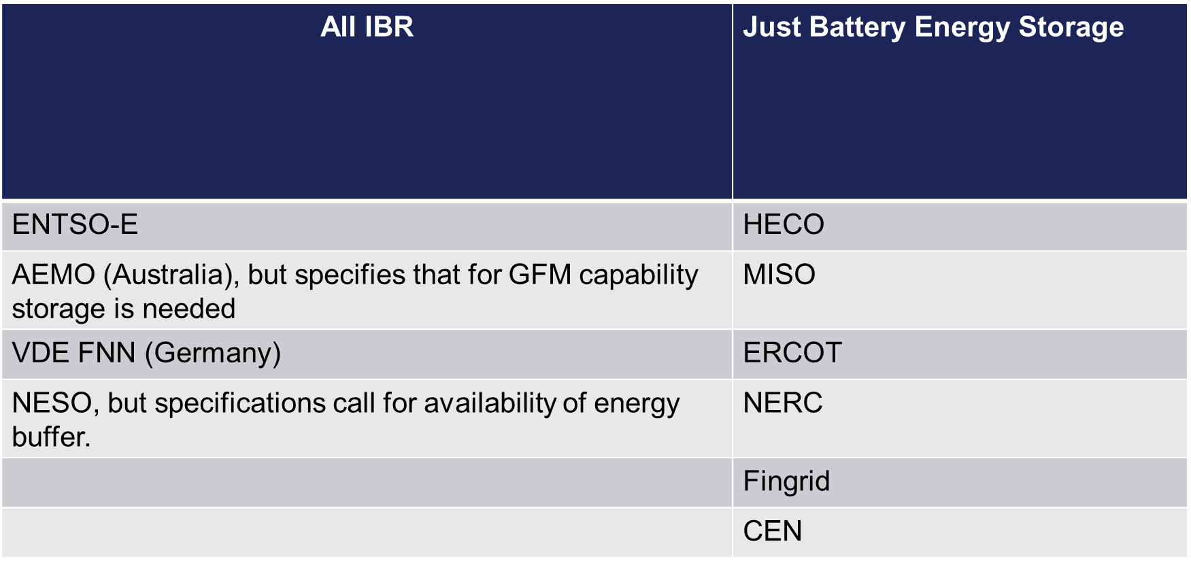

* The table below is sorting out the requirements into voluntary, compulsory or based on incentives. (=> indicates the ISO moving from one column to another over time)

* Jeff Billo commented that AEMO is also moving towards a Requirement
* Discussion around applicability to ESRs only – Analogous to requirement for PSS form thermal generation or PFR capability requirements form all capable resources (exclude nuclear and legacy wind).
* Discussion around HECO’s procurement of GFM and if the costs are covered? - HECO procures all resources through competitive RfP (no market) and pays to selected resources, whatever their cost is. If HECO is asking for GFM resources any costs are factored in RfP offer.
* Discussion around inertia market – this is something ERCOT discussed before and continues to monitor.
* Again, discussion about implementation timeline. In other areas seems to be 3 years from approval of grid forming requirement to expecting resources with this capability online – A request was made to see how it compares project development timelines in ERCOT and post 04/01/25 SGIA date proposed by ERCOT for AGS-ESR capability.
* There is a value in bringing OEMs with commercially available grid forming equipment to talk about their equipment capabilities and reflect on ERCOT’s proposal.