**TDTMS**

**December 4th, 2024, 9:30 AM**

**WebEx only**

|  |  |  |  |  |  |  |
| --- | --- | --- | --- | --- | --- | --- |
| Attendee | Company | Attendee | Company | | Attendee | Company |
| Jordan Troublefield | ERCOT | Bill Snyder | | AEP | Monica Jones | CNP |
| Dave Michelson | ERCOT | Kyle Patrick | | NRG | Eric Lotter | GridMonitor |
| Sheri Wiegand | Vistra | Mick Hanna | | ERCOT | Kathy Scott | CNP |
| Tammy Stewart | ERCOT | Steven Pliler | | Vistra | Toney Guitierez | AEP |
| Dee Lowerre | NRG | Eric Newman | | Texas RE | Yvette Perez | Octopus |
| Kathryn Thurman | ERCOT | John Schatz | | Vistra | Melinda Earnest | AEP |
| Livia | Just | James Langdon | | Vistra | James Wade | CES |
| Cindy Duong | Just | Sam Pak | | Oncor | Angela Ghormley | Calpine |
|  |  | Mansoor Khanmohamed | | BP Energy |  |  |

Monica Jones opened the meeting with the Antitrust Admonition and introductions of those on the WebEx were made.

Meeting minutes from the October 24th meeting were reviewed and approved.

**ERCOT System Instances & MarkeTrak Monthly Performance Review -**

* Market SLAs met for November. MarkeTrak performance remains well within SLO.
* No API issues experienced post TXSET 5.0 and SCR817
* TDTMS supports the proposed SLAs for 2025 noting the Retail Weekday with * “Pending compliant updates to relevant binding documents”.
* NPRR 1259 was reviewed with additional language “The following timing requirement calculations will not include the duration of a planned and approved ERCOT retail system outage:” and supported by TDTMS. The language allows ERCOT to exclude planned outages from performance measures in reporting to PUCT and the market.
* ACTION ITEM: TDTMS leadership will review the RMG switch hold language to determine if the above same verbiage needs to be added to the expected timelines. The review will be taken up next meeting.

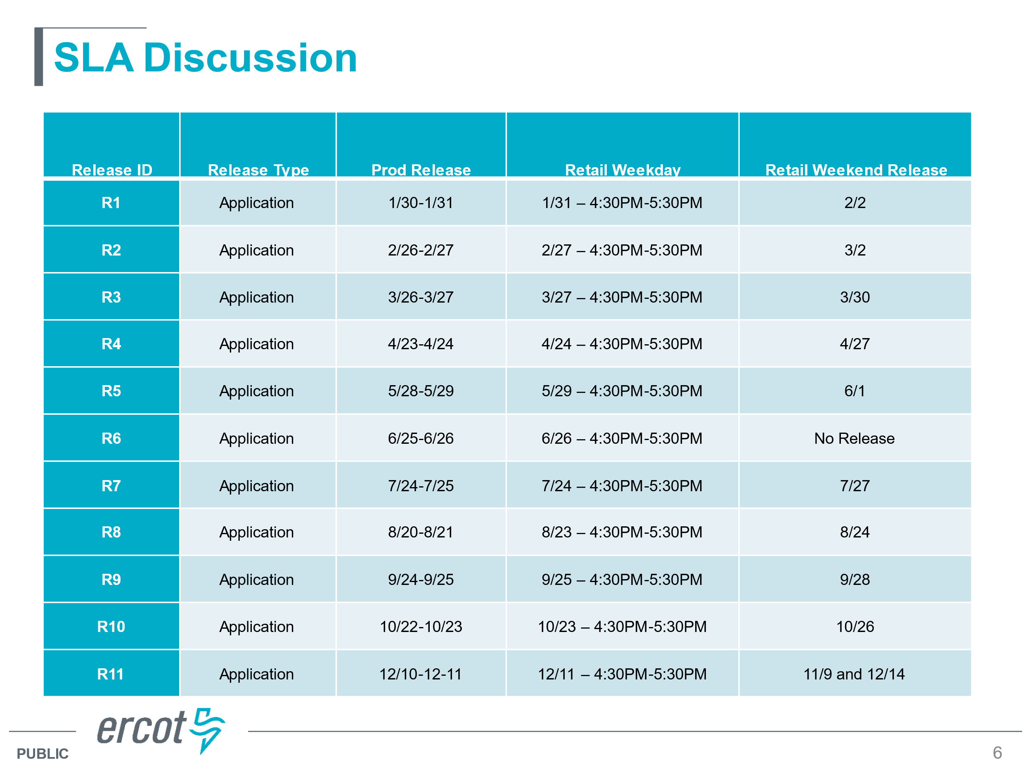

**SCR 817/TXSET Follow Up –**

* Tammy Stewart reported she had “nothing to report” indicating MarkeTrak was functioning as expected. The **Switch Hold API defect** was corrected and placed in production on Monday 12/2. She did receive a question regarding the new Meter Cycle Change Request subtype questioning if the User’s Guide needed to be updated stating the expected outcome. It was decided TDSPs may add comments indicating the cycle change will occur in one to two billing cycles.
* **Suggested enhancement**: For Switch Hold subtype, add a drop down for the “disagree” transition indicating reason for the disagreement: Same customer/Association found OR invalid documentation with an additional drop down similar to the TDSP drop down
* **Critical Care Flags**: one REP was concerned TDSPs were no longer replacing the critical care flag if an IGL had occurred. Per RMG, the TDSPs were to reset the CC flag for a CC customer who experienced an IGL. Typically, an MVI will clear the CC flag. The concern was with TDSPs no longer included in the workflow for IGL MTs, would they have the visibility to reset the CC flag. ACTION ITEM: TDSPs were to review their internal business processes and the topic will be discussed at the next TDTMS meeting. Should REPs expect an 814_20 to reset the flag or will the information be received via the 814_05 response transaction.
* **In Flight IGLs** during the TXSET 5.0/SCR817 transition: Apparently there was some confusion on how to handle those IGLs where agreement was reached and the Losing CR was to send their BDMVI. MTs were transitioned back to the submitting REP where the MT needed to transition once again to the Losing CR. Tammy explained a slide was included in the training deck outlining the flow.
* **Banner on MT**: the suggestion was made to leave the banner on MT until the end of the year unless additional work was being performed on the tool where the banner could be removed at that time. Banner states “IAG workflows are changing effective 11/11/24…” with a link to the training material. ACTION ITEM: ERCOT to remove banner by end of year.
* **Observations post 11/11/24:**
  + Oncor reports some REPs were still utilizing the Projects subtype for meter cycle change requests and they have been unexecuting redirecting REP to use the newly created subtype. They have not seen activity on the Service Address subtype to revise any County Names. And finally, they are seeing use of the new AMS LSE vs Sum of 867subtype.
  + CNP and AEP report no production issues and find the IGL process quicker.
* **New views in ERCOT**: Kathryn Thurman demonstrated the minor changes to the Find ESI and Find Transaction views to accommodate market participants. Find Transaction will now resize with the user’s screen thus spreading out the columns and minimizing the ‘wrapping’. A new ‘Back’ button was added to the top of the Find Transaction view, however, it was reported it was not working. Kathryn asked if the extra lines in Find ESI view could be removed. Market participants agreed. If users are not seeing the new views, they will likely have to clear their cache to reset. Any issues should be reported to Kathryn.

**MarkeTrak Subtype Volume**

Sheri presented the following data results from the small group working sessions and hit the highlights of the data:



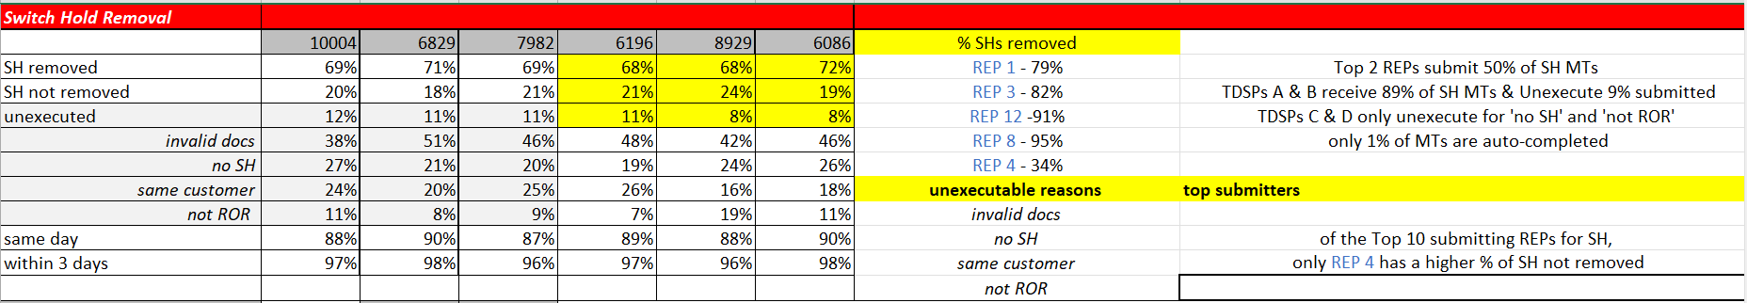

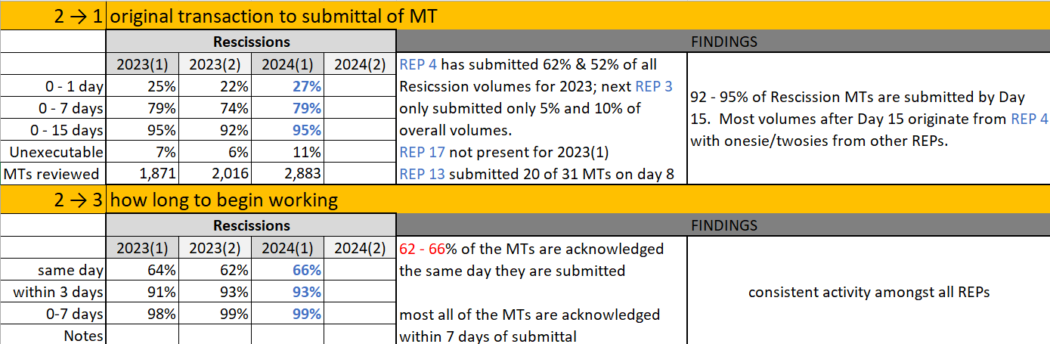

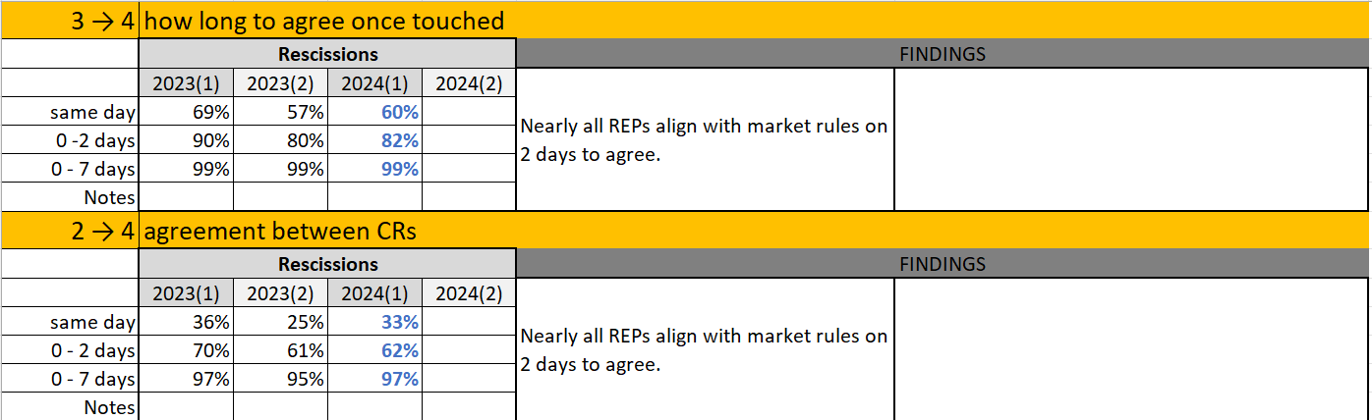

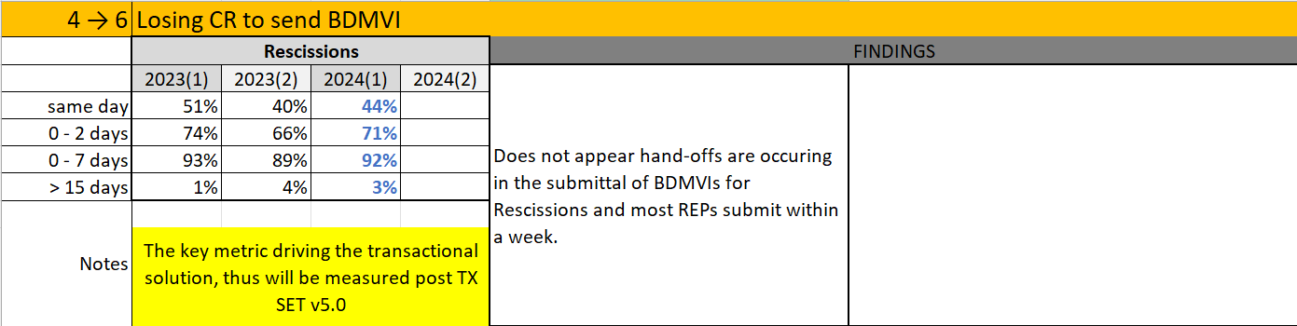

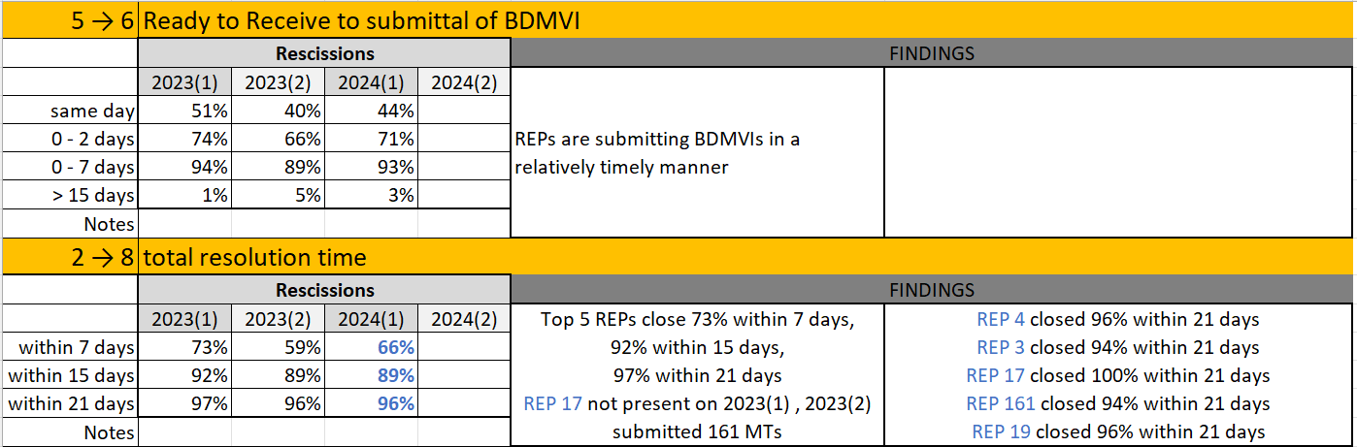

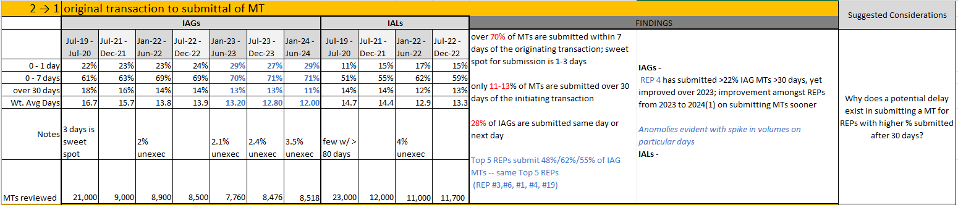

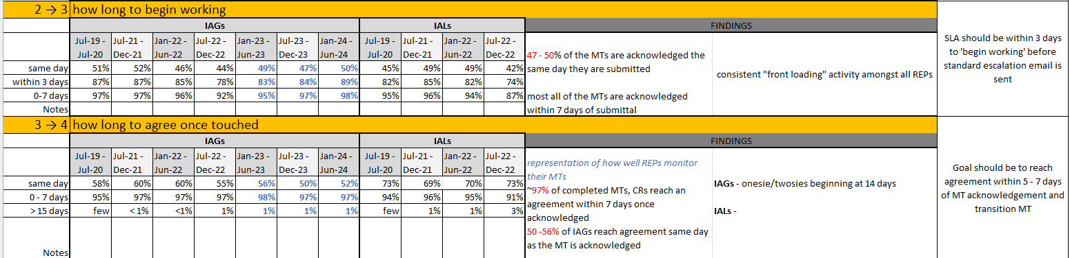 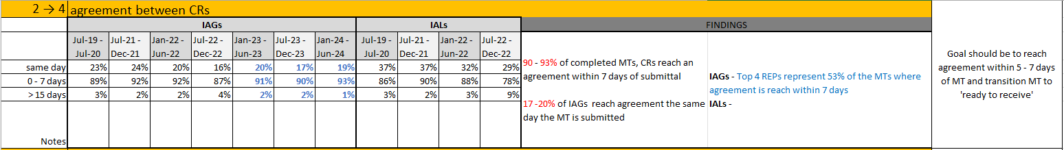 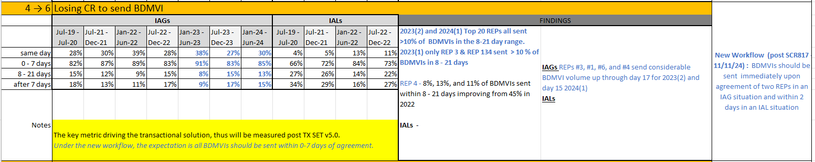 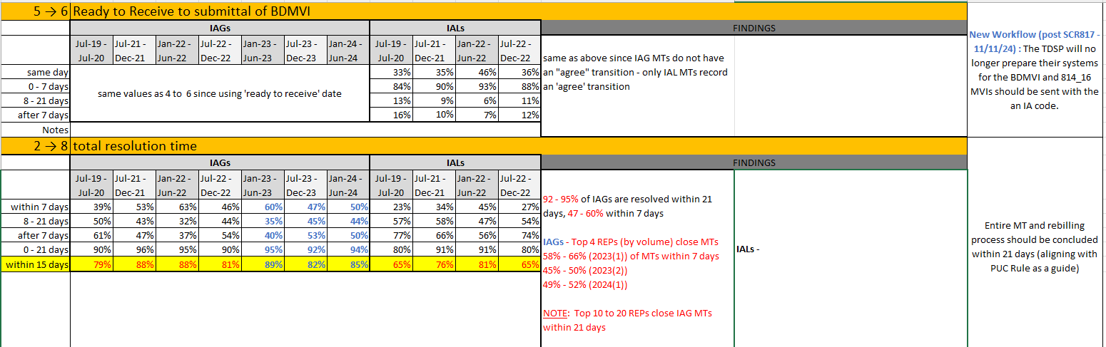

Overall, the goal of the data analysis to reveal efficiency opportunities, whether that be for the entire market or particular market participants identifying gaps in business processes. REPs are encouraged to review their specific performance based on their REP #. ACTION ITEM: Spreadsheets will be posted to the main TDTMS meeting page for REP’s reference.

**NEXT MEETING: Tuesday,** **January 14th at 1:00 PM**  **WebEx Only**

**DRAFT AGENDA**

* Elections - Leadership
* ERCOT Reports
  + System Instances & MT Performance
  + Listserv
  + RMG: Switch Hold language to allow for planned retail outages
* Critical Care Flags -process to re-establish post an IGL
* MT Subtypes Volume Analysis – IAL – results
* Goals & Accomplishments