NPRR Number | 1253 | NPRR Title | Incorporate ESR Charging Load Information into ICCP
Date |  | January 14, 2024
Submitter’s Information
Name |  | Matt Mereness and Mark Patterson
E-mail Address |  | Matt.mereness@ercot.com, Mark.patterson@ercot.com
Company |  | ERCOT
Phone Number |  | 512-248-3089, 512-569-5539
Cell Number
Market Segment |  | Not applicable

Comments

ERCOT offers the following comments with respect to Nodal Protocol Revision Request (NPRR) 1253.

While ERCOT appreciates the benefit of creating new telemetry points and reporting requirements to improve and align the current 4-Coincident Peak (4-CP) calculations with the impacts of Energy Storage Resource (ESR) charging/discharging, ERCOT does not have the bandwidth or time needed to accomplish this work for Summer 2025 without jeopardizing Real-Time Co-optimization plus Batteries (“RTC+B”) efforts. As shown in the 1/14/25 Impact Analysis, the new reporting requirements impact the same systems and development teams that are being used for RTC+B market trials that begin in May 2025. Although an Inter-Control Center Communications Protocol (ICCP)-only change may be possible, ERCOT would not be able to complete the reporting development in a manner that would make the same information available to all Market Participants in the same unified manner.

The design changes for RTC+B will eliminate the need for this NPRR. Considering ERCOT is unable to complete the work needed to implement the changes for NPRR1253 prior to implementation of RTC+B in December 2025, ERCOT believes NPRR1253 is unnecessary. For transparency, ERCOT initiated discussions at the 1/14/25 Real-Time Co-optimization plus Batteries Task Force (RTCBTF) meeting regarding the alignment of 4-CP-related calculations and reporting with the RTC+B battery-related improvements.

For the Summer 2025 period, ERCOT offers a reminder of the data currently available to Market Participants regarding the necessary ESR impacts on the dashboards to off-set the current ERCOT load displays. The data used to produce the Energy Storage Resources dashboard can be accessed by clicking on the Chart context menu located on the top right corner of the expanded dashboard (3 horizonal dashes).
The 5-minute averages for ESR Discharging, ESR Charging and Net Output values are available to download in various formats.

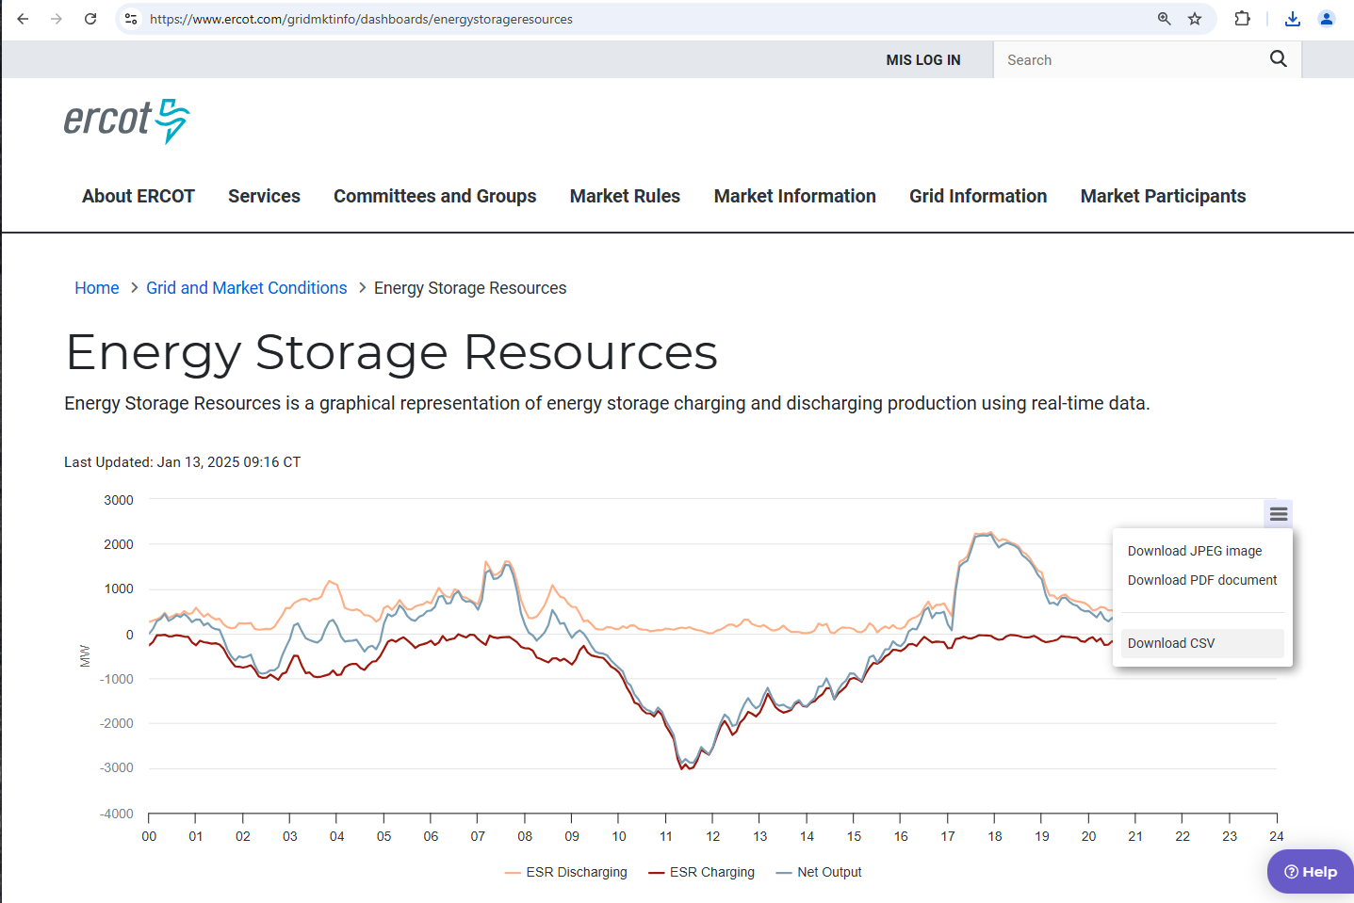

Revised Cover Page Language
None
Revised Proposed Protocol Language
None

