**TDTMS**

**January 14th, 2024, 1:30 PM**

**WebEx only**

|  |  |  |  |  |  |  |
| --- | --- | --- | --- | --- | --- | --- |
| Attendee | Company | Attendee | Company | | Attendee | Company |
| Jordan Troublefield | ERCOT | Bill Snyder | | AEP | Monica Jones | CNP |
| Dave Michelson | ERCOT | Kyle Patrick | | NRG | Eric Lotter | GridMonitor |
| Sheri Wiegand | Vistra | Mick Hanna | | ERCOT | Kathy Scott | CNP |
| Catherine Meiners | ERCOT | Steven Pliler | | Vistra | Rob Bevill | TNMP |
| Amy Sue Stirland | LP&L | Sam Pak | | Oncor | Stephen Wilson | Vistra |
| Kathryn Thurman | ERCOT | Amy MacDonald | | Pogo | Tomas Fernandez | NRG |
| Kelly Brink | ERCOT |  | |  |  |  |

Jordan Troublefield of ERCOT conducted the TDTMS leadership elections for 2025. Congratulations to

* Sheri Wiegand – Chair
* Monica Jones – Co-Vice Chair
* Sam Pak – Co-Vice Chair

Meeting minutes from the December 4th meeting were reviewed (including ACTION items) and approved.

* Sam Pak noted the spreadsheets from MarkeTrak Subtype Analysis will be posted on the main TDTMS meeting page once he “cleans up” the files

**ERCOT System Instances & MarkeTrak Monthly Performance Review -**

* Market SLAs met for December. All SLAs were met for 2024 despite April incident. MarkeTrak performance remains well within SLO.
* New slide 4 of the IT report was added to include the MT volumes on a monthly basis which could contribute to some slow down query detail responses. Volumes peaked in October 2024 likely due to market participant who inadvertently processed a broker file resulting in almost 1000 IAGs. Mick confirmed one to two days of daily spikes were contributors.

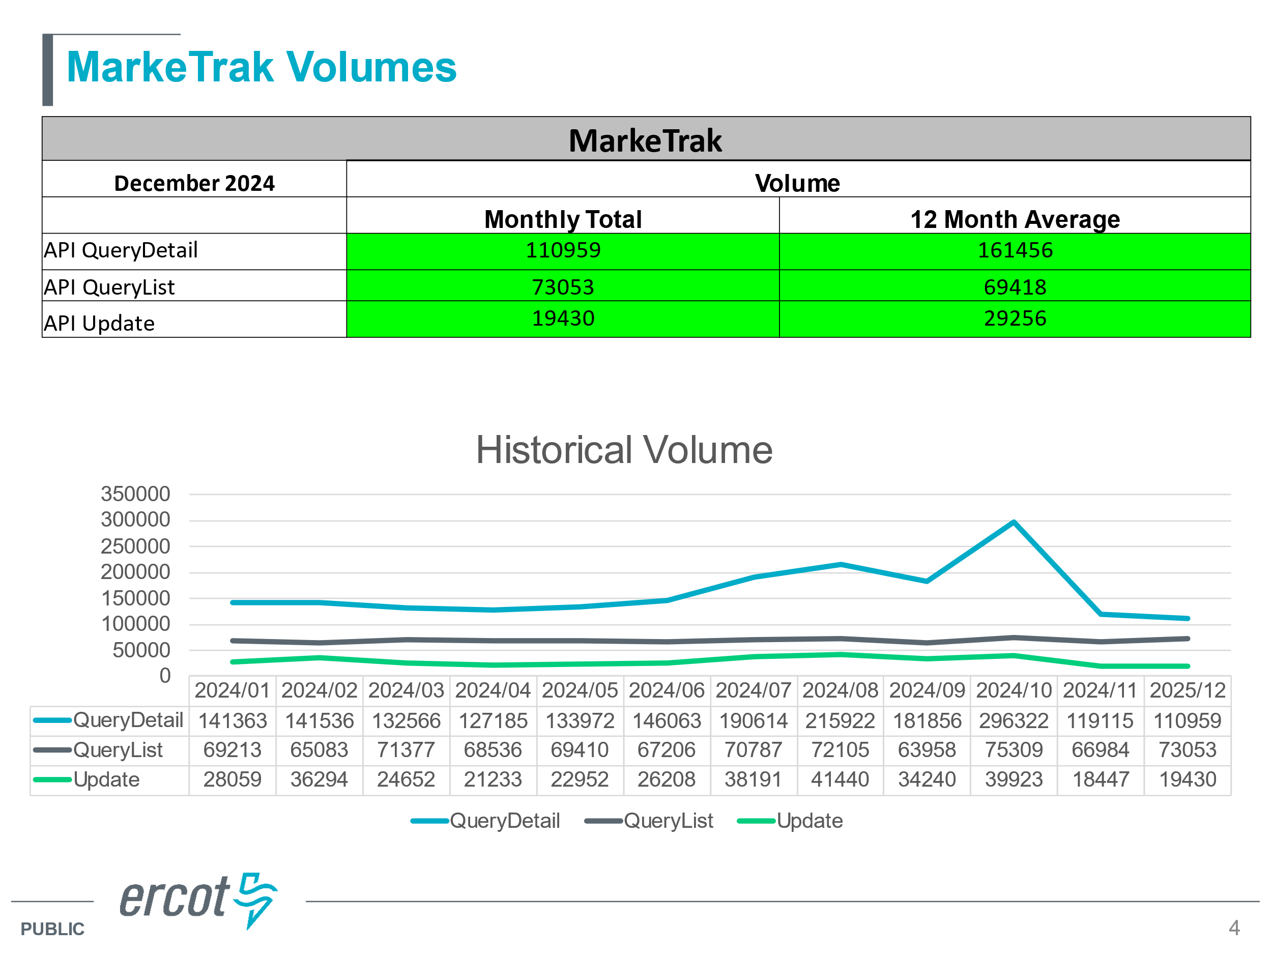

* No listserv incidents
* WG reviewed language in RMG around Switch Hold removal processing to see if the new retail release calendar and NPRR 1259 language will address potential delays of the “four business hours” processing window. The WG felt the no additional language was required in the RMG nor to the NPRR 1259 to address the impacts of the retail release calendar.

**727 Extract Enhancements**

* With the new attributes (i.e. county name, meter service type) it was suggested these attributes be included in some existing ERCOT extracts such as the 727 extract for a streamlined process
* Kelly Brink and Dave Michelson explain the architecture of the extracts available.
  + Initially, the TDSP extract data (new elements) is maintained in the registration system while the 727 is held in the settlement system
  + ERCOT has created an ‘ESI ID Join Diagram’ (ERCOT.com > Services > User’s Guides > Retail > ESI ID Join Diagram) which is a road map allowing market participants to create queries with the data elements desired
  + Essentially by joining various elements of different extracts, a market participant is able create a shadow settlement database “to see what ERCOT sees”
* Dave explained the Technology Working Group will be the forum for the technical teams to discuss API enhancements (API iterative model), technical specifications requested, etc
* If new extracts are desired, business requirements would need to be vetted, a possible SCR created, then a solution can move through the stakeholder process

**Critical Care Flags Post IAG**

* The business processes for each TDSP were reviewed on how Critical Care status is reinstated in the resolution of an IAG as noted in RMG

*(5) After the Losing CR regains the ESI ID, the TDSP will reinstate any critical care designations that have not expired and were previously assigned to the Customer at the ESI ID and submit the 814_20, ESI ID Maintenance Request.*

* + **CNP** – IA/CR code on an MVI will convert the order to act as a SWI thus carrying over all attributes of the previous customer (classification, rate code, load profile, CC flag, etc). An 814_20 will not be sent to reactivate the CC flag, however, the 814_05 received will have the CC flag
  + **AEP** – CCR team will manually check if previous account had CC status and send an 814_20 to reinstate
  + **Oncor** – process has not changed post TXSET 5.0 – teams monitor MTs and accounts and will manually send 814_20 to reinstate the CC flag
  + **LP&L**  - manual monitoring process of IGLs, re-establish on LP&L side and send 814_20 to reinstate
  + **TNMP** – automated daily report to determine if CC flag needs to be reset and will send 814_20 to reinstate CC flag

**Tampering Flags Post IAG**

* The business processes for each TDSP were reviewed on how Tampering Switch Holds are reinstated in the resolution of an IAG as noted in the RMG

*(4) If the Gaining CR placed a switch hold on an ESI ID that was gained inadvertently via the 650_01, Service Order Request, the Gaining CR shall request the removal of all switch holds from the ESI ID via a 650_01 transaction before proceeding towards a resolution of the Inadvertent Gaining or Inadvertent Losing MarkeTrak issue. However, if a switch hold was placed on the ESI ID by the Transmission and/or Distribution Service Provider (TDSP) due to tampering, the Losing CR may request that the TDSP reinstate the tampering switch hold on the ESI ID.*

* **Oncor, LP&L,** **AEP, and TNMP** all have processes in place to place the SH back on the IAGd ESI with an 814_20
* **CNP,** as later reported by Kathy Scott…

*Does the TDSP Reinstate the Tampering Switch Hold following a completed “IA” or “CR”  IAG MVI?   For CNP that would be NO because the current REP of Record at the time the Switch Hold was applied would have been invoiced for the Tampering Charges.   That same REP of Record would have been responsible for removing the Switch Hold(s) Deferred Payment and/or Tampering Switch Hold before the “IA” or “CR” IAG Move-In transaction would be accepted.   We will not reapply the Tampering Switch Hold once the REP of Record (losing) has relinquished the Switch Hold from the ESI ID.*

This topic will be discussed again at the next TDTMS meeting on February 19th.

**MarkeTrak Subtype Volume**

The small working group will perform the analysis on the Inadvertent Loss subtypes and report the findings to the WG. ACTION: Sheri will request the data to perform the analysis for the second half of 2024. Tomas questioned if we could find the # of duplicates submitted for an ESI – i.e. an IAL is submitted by the Losing REP and the Gaining REP unexecutes the MT and submits a Rescission MT for resolution. The number of unexecutables is expected to be higher for IALs.

Oncor noted they are intending to provide more ‘real time’ analysis of IGLs showing historical trends by REP. Information will be delivered through their REP Relations team.

**NEXT MEETING: Wednesday,** **February 19th at 9:30 AM**  **WebEx Only**

**DRAFT AGENDA**

* ERCOT Reports
  + System Instances & MT Performance
  + Listserv
* SCR817 – Mapping of 867 vs Sum of LSE data
* SCR817 – Review of Lessons Learned – what worked, what could we have done better, any misses
* ERCOT MIS – ‘key dates’ and ‘transaction status’
* Critical Care Flags -process to re-establish post an IGL
* MT Subtypes Volume Analysis – IAL – results
* Goals 2025 review