

**RTC+B Market Trials Handbook 1.0**

**RTC QSE Submission Testing**

**version: Final Feb 7, 2025**

As described in the RTC+B Market Trials Planning Document, there are six major areas of Market Trial and Transition Activity. Each of these activities will have:

1. Defined Objective(s) for each Activity
2. Entry Criteria (for both ERCOT and QSEs) prior to starting activity
3. Defined Key activities during trial for ERCOT and QSE
4. Exit Criteria

This Handbook will focus specifically on RTC QSE Submission Testing (see below).

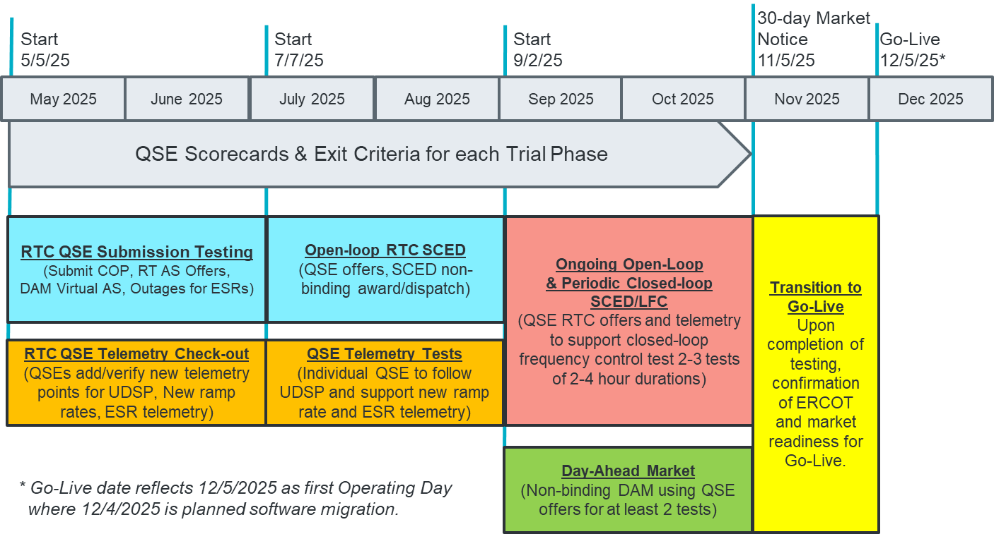

**1.0 QSE MARKET SUBMISSION TESTING**

**1.1 Defined Objectives:**

* *ERCOT will deploy RTC+B Code into a market facing trials environment* 
  + *MMS-API, MMS-UI, OS-API, OS-UI*
  + *This test will be similar to MOTE testing, limited to receiving data from QSE*
* *QSE will test their market submissions for defined transactions (including COP, RT AS Offers, RT Energy Offers, DAM AS Only Offers, 3 Part Supply Offers)*
* *ERCOT will maintain scorecard of QSE participation as defined in this Handbook*
* *Goal is for 95% of QSEs to demonstrate successful submissions, and have mitigation plans in place for remaining 5% to address in next trial phase.*

**1.2 Entry Criteria:**

* **1.2.1 ERCOT Entry Criteria**
  + **Publish technical changes** to EIP Interface Specification, XSDs, and Market Submission Whitepaper (at least 9 months prior to market trial)
    - **ERCOT has published Technical Changes and are available at these links (some of which need digital certificate):**
      * [Market Submission Validation Rules](https://www.ercot.com/mp/data-products/data-product-details?id=np4-450-m)
      * [EIP specifications](https://www.ercot.com/services/mdt/userguides)
      * [Sample XSDs](https://www.ercot.com/services/mdt/xsds)
  + **Publish Business Process flows summary of changes** for context of technical change (at least 8 months prior to market trial- may be met by Market Submission Whitepaper)
    - **ERCOT provided walkthrough a RTCBTF August 14, 2024 meeting, and memorialized the material on the RTCBTF training page.**
      * [**Presentation at RTCBTF on Aug 14, 2024**](https://www.ercot.com/files/docs/2024/08/07/Issue%209-%20RTC%20B%20Market%20Submissions%20Changes%20slides.pptx)
      * Training Page link <https://www.ercot.com/committees/tac/rtcbtf/training>
        + Select New Modified Market Submissions
  + **Publish “Trials Handbook”** with details of specific functionality and testing (at least 3 months prior to market trial)
    - Scope of functional testing (and for clarity, out of scope items, eg reports)
    - Duration of Activity
    - Required market participation and Market Readiness Scorecard specifics (expected progression from 0%-100% and mitigation if not complete)
    - Details of access to environment (eg, Digital Certificates)
    - **This document is the Handbook**
  + **Systems Testing and Readiness**
    - FAT testing and initial iTest Testing of MMS-API, MMS-UI, OS-API, OS-UI
    - Deployed into Market Trials environment
    - Will be met on or before May 5, 2025
* **1.2.2 QSE Entry Criteria**
  + **QSE systems ready** to connect to ERCOT systems and submit defined transactions
  + **QSE assigned staff** for attending weekly market trials WebEx meetings and submitting data to ERCOT per the applicable Handbook

**1.3. Key Activities during Market Trial:**

* QSEs participate in weekly WebEx meetings (May 5- June 30)
  + Every Monday 10am-10:30 am CPT (ahead of first meeting ERCOT will send reminders and post meeting on ERCOT calendar)
  + Meeting agenda:
    - Expectations of QSEs for the week
    - Communicate any known issues with on-going trial
    - Provide snapshot of cumulative QSE scorecards
    - Support any technical and/or business questions
* During the period of May 5 – June 30 the following market participants are expected to perform the following activities to ensure modified submission transactions that impact reliability have been tested:
  + **QSEs with Generation Resources** will be expected to complete at least one successful submission for each of the following transactions that are new or have been modified. Note: QSE only needs a submission for a single resource in their portfolio, or sub-QSE portfolio.
    - COP – submit new AS Capability fields
    - TPO – verify not impacted by changes made for single-model ESR
  + **QSEs with Load Resources** will be expected to complete at least one successful submission for each of the following transactions that are new or have been modified. Note: QSE only needs a submission for a single resource in their portfolio, or sub-QSE portfolio
    - COP – submit new AS Capability fields
  + **QSEs with Energy Storage Resources** will be expected to complete at least one successful submission for each of the following transactions that are new or have been modified. Note: QSE only needs a submission for a single resource in their portfolio, or sub-QSE portfolio
    - **OUTAGE SCHEDULDER- submission of outage for single-model ESR**
    - COP – submit negative LSL/HSL for ESR; submit new AS Capability fields
    - TPO (EB/OC) – submit TPO (EOC only) that includes negative MW quantity to reflect ESR Energy Bid/Offer Curve
* QSEs demonstrate successful Market Submissions testing and meet readiness criteria
  + ERCOT will publish 3 dashboards, one for each type of Resource defined above.
    - Green: all submissions types completed at least once during the trial
    - Yellow: some submissions types completed at least once during the trial
    - Red: no submissions received
  + Scoring will begin to be published after May 16, 2025 (2 week grace period to start trial)

**1.4. Exit Criteria**

* Goal is for 95% of QSEs to demonstrate successful submissions, and mitigation plans in place for remaining 5% to address in next trial phase.