

**RTC+B Market Trials Handbook 2.0**

**RTC QSE Telemetry Point Check-Out**

**version: Final Feb 7, 2025**

As described in the RTC+B Market Trials Planning Document, there are six major areas of Market Trial and Transition Activity. Each of these activities will have:

1. Defined Objective(s) for each Activity
2. Entry Criteria (for both ERCOT and QSEs) prior to starting activity
3. Defined Key activities during trial for ERCOT and QSE
4. Exit Criteria

This Handbook will focus specifically on RTC QSE Telemetry Check-Out (see below).

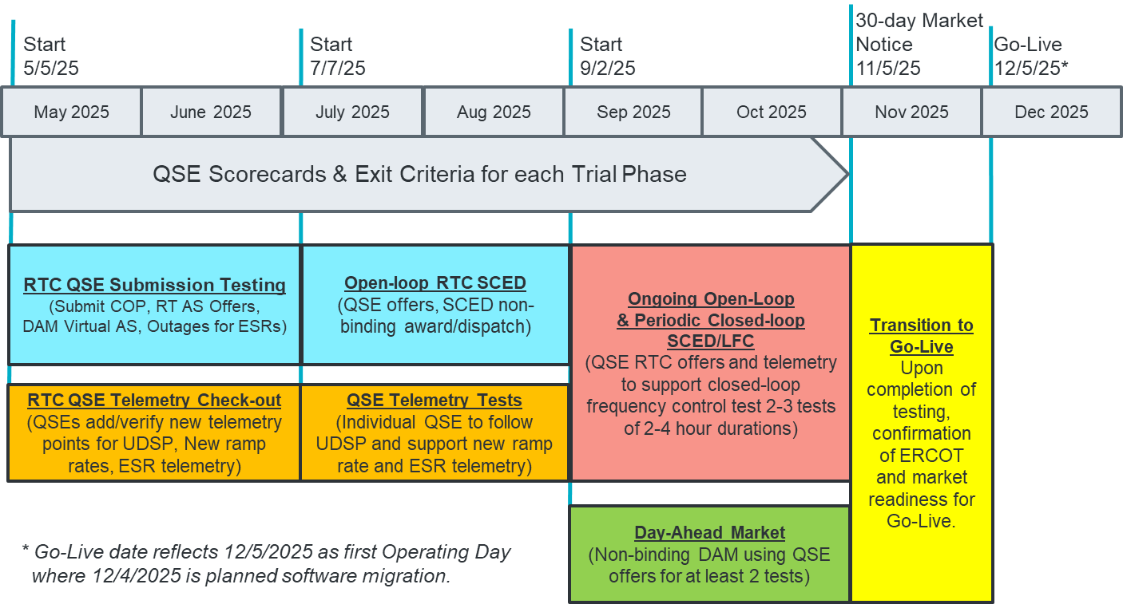

**2.0 QSE TELEMETRY POINT CHECK-OUT**

**1. Defined Objectives:**

* *ERCOT will deploy RTC+B Code into a market facing trials environment*
  + *EMS SCADA/ICCP*
  + *This test window is for QSEs to set-up new telemetry points*
  + *QSEs will not follow telemetry points in this phase*
* *QSE will add telemetry points for EMS/ICCP system interface with ERCOT (UDSP, New Ramp Rates, and ESR Telemetry)*
* *ERCOT will maintain scorecard of QSE participation as defined in Handbook*
* *Goal is for 98% of QSEs to demonstrate successful submissions, and mitigation plans in place for remaining 2% to address in next trial phase.*

**2. Entry Criteria:**

* **2.1 ERCOT Entry Criteria**
  + **Publish technical changes** to ICCP changes (at least 9 months prior to market trial)
    - **ERCOT has published the ICCP Handbook with RTC+B changes:**
      * Nodal ICCP Handbook RTC+B v4.01
      * Link: <https://www.ercot.com/services/mdt/userguides>
  + **Publish Business Process flows summary of changes** for context of technical change (at least 8 months prior to market trial- may be met by Market Submission Whitepaper)
    - **ERCOT provided walkthrough at RTCBTF June 14, 2024 meeting.**
      * **Link to [Presentation at RTCBTF on June 14, 2024](https://www.ercot.com/files/docs/2024/06/14/issue-9_rtcb_telemetry_changes_061424_v2.pptx)**
  + **Publish “Trials Handbook”** with details of specific functionality and testing (at least 3 months prior to market trial)
    - Scope of functional testing (and for clarity, out of scope items, eg reports)
    - Duration of Activity
    - Required market participation and Market Readiness Scorecard specifics (expected progression from 0%-100% and mitigation if not complete)
    - **This document is the Handbook**
  + **Systems Testing and Readiness**
    - FAT testing and initial iTest Testing of EMS, SCADA
    - Deployed into Market Trials environment
    - Will be met on or before May 5, 2025
* **2.2 QSE Entry Criteria**
  + **QSE Systems ready** to connect to ERCOT systems and submit defined telemetry
  + **QSE assigned staff** for attending weekly market trials WebEx meetings and submitting data to ERCOT per the applicable Handbook

**3. Key Activities during Market Trial:**

* QSEs participate in weekly WebEx meetings (May 5- June 30)
  + Every Monday 10am-10:30 am CPT (ahead of first meeting ERCOT will send reminders and post meeting on ERCOT calendar)
  + Meeting agenda:
    - Expectations of QSEs for the week
    - Communicate any known issues with on-going trial
    - Provide snapshot of cumulative QSE scorecards
    - Support any technical and/or business questions
* Market participants are expected to perform the following activities:

1. Now-April, ERCOT needs telemetry point requests to/from QSEs
   1. ICCP Service Request containing new RTC ICCP (link to Service Request)
      1. QSE ICCP names/tags/object
      2. Use existing process ([ICCPSupport@ercot.com](mailto:ICCPSupport@ercot.com))
2. Each ICCP request will go into a future Network Model Load (timing determined by ERCOT)
3. QSE->ERCOT: After the model load, QSE can populate telemetry into ICCP points and send to ERCOT (and can begin as early as possible)
4. ERCOT-> QSE: After the model load, ERCOT will have ability to send values (may be static at first, before SCED is running), but do not follow instructions.
5. ERCOT to coordinate communication with QSEs to confirm points received inbound and outbound for (check-out)
6. Target to have all telemetry check-out complete with QSEs by June 30, 2025

* QSEs demonstrate successful addition of telemetry points and meet readiness criteria:
  + ERCOT will a provide weekly QSE scorecards:
    - Green: all telemetry checked-out
    - Yellow: some telemetry being received but not checked-out
    - Red: no telemetry
  + Scoring will begin to be published after May 16, 2025 (2 week grace period to start trial)

**4. Exit Criteria**

* Goal is for 98% of QSEs to demonstrate successful submissions, and mitigation plans in place for remaining 2% to address in next trial phase.