|  |  |  |  |
| --- | --- | --- | --- |
| NPRR Number | [1269](https://www.ercot.com/mktrules/issues/NPRR1269) | NPRR Title | RTC+B Three Parameters Policy Issues |
|  | |  | |
| Date | | March 11, 2025 | |
|  | |  | |
| Submitter’s Information | | | |
| Name | | Jeff McDonald / Andrew Reimers | |
| E-mail Address | | [jmcdonald@potomaceconomics.com](mailto:jmcdonald@potomaceconomics.com) / [areimers@potomaceconomics.com](mailto:areimers@potomaceconomics.com) | |
| Company | | Potomac Economics, Ltd., Independent Market Monitor (IMM) | |
| Phone Number | | 512-225-7077 (Jeff) / 409-656-4403 (Andrew) | |
| Cell Number | |  | |
| Market Segment | | Not applicable | |

|  |
| --- |
| Comments |

The IMM appreciates the opportunity to comment on Nodal Protocol Revision Request (NPRR) 1269, which includes three separate proposals for parameters associated with Real-Time Co-optimization (RTC). Our comments relate to two of those parameters: 1) the proxy offer methodology for incomplete Ancillary Service offer curves, and 2) the Ancillary Service Demand Curve (ASDC) floor of $15/MWh proposed by ERCOT for Reliability Unit Commitment (RUC) and the subsequent porting of this ASDC floor to the Day-Ahead Market (DAM) and Real-Time Market (RTM) proposed by Texas Competitive Power Advocates (TCPA) TCPA.

**Summary**

Our comments on the various parameters defined by NPRR1269 can be summarized as follows:

* Regarding proxy offers for incomplete or empty Ancillary Service Offers, using the minimum of $2,000 or the price corresponding to 95% of the capacity in the Ancillary Service Plan for each product does not reflect a competitive offer and exposes consumers to unnecessary and excessive costs. A cap of no more than $15 on proxy offers would be sufficient to ameliorate the concerns expressed by the stakeholders.
* Regarding the proposed ASDC floor for RUC, we have not seen sufficient evidence as to the extent of the problem this floor is meant to resolve and do not believe such a fix is necessary for RUC to function properly upon RTC go-live.
* Regarding the proposed ASDC floor for the DAM and RTM, the arguments in support of such a floor are not supported by economic fundamentals or empirical evidence and could result in over $100mm in excess costs to consumers per year.

**Parameters for Ancillary Service proxy offers**

The IMM previously submitted the following comments on NPRR1269 regarding the proxy offer methodology:

* In order to minimize the impact on price formation, proxy offers should be set at fixed values corresponding to the variable cost, including opportunity cost, to provide the service. In particular, the price on the ASDC corresponding to 95% of the Ancillary Service Plan for a given product results in proxy prices that are excessively high at times and could lead to reliability and market performance issues similar to what we already identified with the proxy offer methodology for energy. By that same token, capping the proxy price for Ancillary Services at $2,000 is arbitrary and excessively high relative to the cost to provide the service.

One way to estimate a minimally impactful proxy offer that approximates the actual or perceived cost of providing the service is to look at the DAM offers for providing Ancillary Service. The hourly aggregate Ancillary Service Offers in DAM for all of 2024 are summarized in Figure 1:

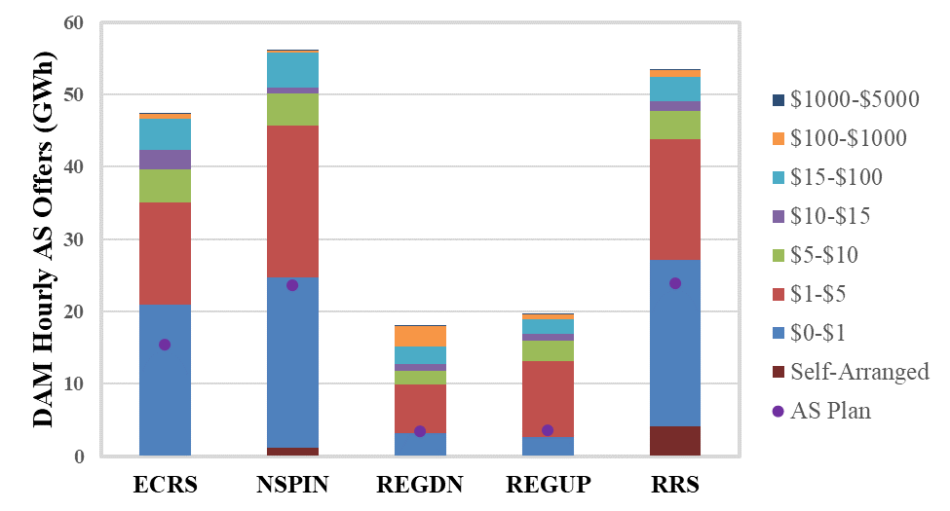

*Figure 1. Aggregate hourly offers for Ancillary Service in DAM compared against the aggregate hourly Ancillary Service Plans for all of 2024*

Figure 1 shows the following:

* On average, there are enough Ancillary Service Offers priced at $1 or less to cover the entire plans for ERCOT Contingency Reserve Service (ECRS), Non-Spinning Reserve (Non-Spin), and Responsive Reserve (RRS). For regulation service, there are enough offers priced below $5 to cover the entire Ancillary Service Plan.
* Including self-arranged Ancillary Service, approximately 90% of each up-reserve product is priced at no more than $15

The IMM maintains that (i) it is the participant’s responsibility to submit complete offer curves, and (ii) in the event that the participant chooses not to honor this obligation, the proxy offer methodology should be designed to minimize impacts to price formation. The expressed intention of the proxy offer methodology proposed by NPRR1269 is to limit the likelihood that Resources that fail to submit complete offer curves are awarded Ancillary Service over Resources that submit complete and competitive offer curves. The offer data presented in Figure 1 indicate that this goal can be achieved with a proxy offer price much less than the minimum of $2,000 or the value on the ASDC corresponding to 95% of the Ancillary Service Plan. A proxy offer capped at $15 could accomplish the same goal without subjecting consumers to unnecessary and excessive costs.

**Ancillary Service Demand Curves (ASDCs) for use in Reliability Unit Commitment (RUC) studies**

NPRR1269 also proposes a floor on the ASDC curves used in RUC. The effect of such floors is to allow RUC to produce more expensive commitment solutions to ensure there is sufficient capacity available to serve the entire Ancillary Service Plan. We are open-minded about the use of such floors in RUC, but we have not seen sufficient evidence as to the extent of the problem that would support the necessity of such a fix. ERCOT has only presented the results of a few RUC cases and sensitivities on those cases, and we are unaware of any explicit requirement that the RUC commitment solution must always result in sufficient reserves to serve the whole Ancillary Service Plan. Further, regardless of the commitment decisions produced by the RUC engine, the operators will still have broad discretion to select resources for commitment. We see no reason why RTC can’t go live without ASDC floors in RUC, allowing ERCOT to make adjustments at a later date if they are determined to be necessary.

In addition to ERCOT’s proposal to impose ASDC floors in RUC, TCPA proposed that the same ASDC floors be implemented in the DAM and RTM. Their expressed arguments in favor of this proposal include the following:

* **The ASDCs floors in RUC should necessarily be implemented in the DAM and RTM so there is consistency as to the value of procuring Ancillary Service.** This is a non-sequitur. The RUC process includes numerous differences in how the cost functions are formulated in the optimization because RUC is used for an entirely different purpose than DAM or RTM. For example, energy and Ancillary Service offers are scaled by a factor of 0.001 so that RUC weighs those costs less than the cost of start-up and minimum generation. The max shadow price for transmission constraint violations is also much higher in RUC than it is in DAM or RTM.
* **Without floors on the ASDCs, the markets won’t procure the whole Ancillary Service Plan,** **particularly for Non-Spin and ECRS,** **under normal conditions.** Referring back to Figure 1, approximately 90% of DAM offers for Non-Spin and ECRS in 2024 were priced below $15. That volume of offers corresponds to 2-3x the capacity needed to meet the Non-Spin and ECRS plans on average. There is no empirical basis to claim that these products will not be procured under normal system conditions. The markets will only go short of these reserves at times when system conditions are relatively tight, and the co-optimization is trading off Ancillary Service for energy as intended.

Beyond the stakeholder arguments in favor of this proposal, we have the following additional concerns:

* Imposing floors on the ASDCs amounts to changing the Aggregate Operating Reserve Demand Curve (AORDC), which is separate policy decision that warrants its own deliberate analysis and discussion. Numerous stakeholders have shared ideas as to how the AORDC should be reformulated or whether it should be replaced entirely by individual, independently formulated ASDCs. Insisting on a change to the shape of the AORDC at this time could result in delaying RTC go-live due to protracted discussion among stakeholders.
* The “bridge solution” implemented on the ORDC in 2023 introduced price floors of $10 and $20 for reserve levels less than 7,000 MW and 6,500 MW, respectively. The reserve level on the AORDC corresponding to $15 is roughly 6,983 MW. Thus, the AORDC is already in line with the bridge solution, and TCPA’s proposal represents a substantial expansion of the established price floors.
* The capacity of reserves priced between $15 and the full Ancillary Service Plan according to the AORDC varies from almost 1,000 MW on average to over 3,000 MW at maximum. Increasing the price of Ancillary Service Shortages within this range to $15 could result in excess costs to the market of more than $100mm per year.

The cost estimate is based on both the additional cost of procuring Ancillary Service when it is being priced according to the proposed $15 ASDC price floor and the corresponding increase in energy prices. This estimate is based on the AORDC, the hourly Ancillary Service Plan, and the historical pricing outcomes of the ORDC as follows:

* We considered intervals in 2022-2024 where the ORDC printed between $15 and the value corresponding to the full Ancillary Service Plan on the AORDC that will be used in RTC. For example, if the total Ancillary Service Plan was 8,000 MW, the corresponding value on the AORDC is $0.78. Thus, if the ORDC printed between $0.78 and $15 for that interval, we assume the ASDC floor would have been binding.
* Taking the difference between the realized ORDC price and $15, we multiply that price difference by the volume of Ancillary Service that would have been procured after adjusting for the Ancillary Service shortage implied by the realized ORDC price. For example, if the realized ORDC was $1, the corresponding Ancillary Service volume is 7,921 MW, and the resulting excess cost for procuring Ancillary Service is $110,894.
* We then then also multiply that cost difference by the settlement load to estimate the corresponding impact on the cost of energy. The increase in the energy price in general should be at least as high as the increase in the Ancillary Service price.

Based on this methodology, we produced the following estimates as to how these ASDC floors would have impacted the cost of energy and Ancillary Service from 2022-2024:

|  |  |  |
| --- | --- | --- |
| Year | Increased Ancillary Service Cost ($MM) | Increased Energy Cost ($MM) |
| 2022 | 6 | 38 |
| 2023 | 18 | 136 |
| 2024 | 2 | 17 |

Note that the effect on increased prices for energy is likely to be underestimated for two reasons:

1. This methodology assumes that Ancillary Service can be traded off for energy on a one-to-one basis. In practice, the market may have to go short multiple MWs of ECRS or Non-Spin to produce the next MW of energy depending on the ramp rates of the reserves available in the system. In such cases, the impact of these ASDC floors on the energy price would be even more significant than what is assumed in this analysis.
2. The price produced by the ORDC is capped by the value of system lambda. When system lambda is very high, as it was for much of summer 2023 after the implementation of ECRS, the value of the ORDC is suppressed, thus obscuring many additional intervals that would have been impacted by these ASDC floors.

|  |
| --- |
| Revised Cover Page Language |

None

|  |
| --- |
| Revised Proposed Protocol Language |

None