RMTTF Meeting

Tuesday, February 25, 2025

1:30 PM

This meeting is being held WebEx and in person at ERCOT.

ERCOT

8000 Metropolis (Building E), Suite 100

Austin, TX 78744

Tomas Fernandez chaired the meeting.

Tomas welcomed everyone, introduced the two other co-Chairs; Debbie McKeever with Oncor and Melinda Earnest with AEP.

Tomas proceeded with reading the antitrust statement, introductions followed.

**Introductions:**

Those in the room introduced themselves and Tomas read the names listed on the WebEx. All attendees with companies are noted below.

**Attendees**

* Kathy Scott Centerpoint
* Bill Snyder AEP
* Amy Sue Stirland LP&L
* Debbie McKeever Oncor
* Melinda Earnest AEP
* Sheri Wiegand Vistra
* Monica Jones Centerpoint
* Jordan Troublefield ERCOT
* Eric Lotter GridMonitor
* Tomas Fernandez NRG
* Jesse Macias AEP
* Rob Bevill TNMP

**Meeting Agenda**

Tomas read the agenda. No questions were asked. No changes were made.

It was noted that the RMTTF meeting page for today included a different agenda in the body of the meeting page, but the Word document/agenda posted is the correct agenda. Debbie said she will notify ERCOT and thanked Jesse for bringing it to our attention.

**Meeting Notes**

Meeting notes from the last meeting were reviewed.

None of the leadership received requests for changes.

No one attending requested changes.

Meeting notes for our last meeting are considered final.

**LMS Stats**

ERCOT Learning Management System (LMS) counts for Web Based training modules weren’t received prior to the start of this meeting. Art will get those to the RMTTF leadership ASAP so they can be included in today’s meeting notes.

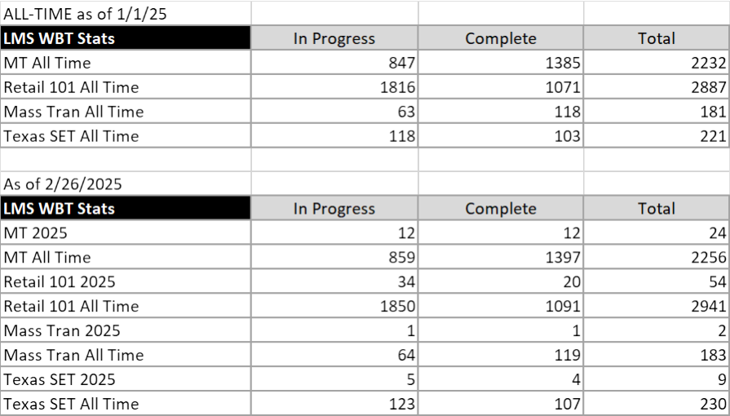

**MarkeTrak Part 1 Training – given this morning at 8:30 AM**

Tomas led the discussion. The instructors (Tomas, Monica, Sheri, Melinda, Kathy, Debbie) expressed this was one of the most engaging sessions. Many questions were asked. More than 60 registered for the class. We will check with Art for the number that actually attended.

Surveys for MarkeTrak part 1 and part 2 will be reviewed at our next meeting.

During the training this morning, some slides were identified that need updates and/or clarity. We will do that for sure before the next MarkeTrak training.

**ERCOT Update at TDTMS - MarkeTrak System issues: Feb 10, 11**

Below is a quick update of a discussion that happened at the last TDTMS meeting.

ERCOT explained that there was a MarkeTrak outage on Monday, February 10, possibly associated with the ERCOT Planned outage that took place on Sunday, February 9.

ERCOT provided an update on an issue experienced with logging in on February 11 which included users reporting “No Concurrent Licenses”.

TDTMS and ERCOT discussed that this message indicates MarkeTrak users exceed licenses available. Suggestion was for this to be mentioned at MarkeTrak Training. A slide was created, but after discussion at the RMTTF meeting, it was decided to not include a slide until we understand more about the issue. If there was something specific about February 11th that caused this issue, maybe this is an isolated case.

Might be better for ERCOT to send another Market notice. By addressing it in training, that would only reach those that attend that particular MarkeTrak Training class. All users to be made aware. Can also be expressed at TDTMS meeting by leadership and also included in the TDTMS updates to RMS. Sheri said she can do that and will ask ERCOT;” What could have caused the number of User numbers to be so high on those days?” Sheri will put this topic on the TDTMS agenda to review the issue and get an info from ERCOT.

If after that discussion at TDTMS, if it’s decided that we need a slide included in the training, based on info we have to date and what was provided at TDTMS, based on today’s discussion, we can tweak the slide created by ERCOT to include or clarify:

• “Issue a ticket when first experiencing a MarkeTrak issue” (this is the current process)

• “Each user signed into MarkeTrak, is using a license”. Licenses aren’t assigned to a user.

• “Please Sign Out – don’t just X out. X out will not disconnect you from the license.

There’s a limited number of licenses and if the users logging in reach the maximum, then others attempting to login, will get the message “No concurrent licenses”.

Another suggestion is that maybe funding should be provided for additional licenses. Would an SCR be needed?

**Goals and Accomplishments**

These were drafted during this meeting. We will get the date for the 2024 Retail 101 training.

**TX SET 5.0 Presentation - Finalize**

Slides were reviewed individually. Tomas made the updates to the slides during the meeting except for those that need new Screen Shots. Those Slide changes need to be done ASAP.

Note! Slides 101 through 110 will need to be done by ERCOT. Tomas is coordinating.

List of slides that need changes;

* 32
* 33
* 45
* 93
* 95
* 101
* 102
* 103
* 104
* 105
* 106
* 107
* 108
* 109
* 110

New Checkpoint question to be added: When is the only instance a backdated move-in transaction would not include an IA or CR code? Answer: Safety Net

**Dates for 2025 Retail Training and Meetings**

Current calendar is below. * Designates WebEx only. ** Designates In person only.

|  |  |  |  |
| --- | --- | --- | --- |
| Date | Time | Training or meeting | Comments |
| **FEBRUARY** |  |  |  |
| Tuesday, February 25 | 8:30 AM | MarkeTrak Part 1 * | 7:45 AM, Instructors arrive at ERCOT |
| Tuesday, February 25 | 1:30 PM | RMTTF meeting | WebEx and in person in at ERCOT |
| Wednesday, February 26 | 8:30 AM | MarkeTrak Part 2 * | 7:45 AM, Instructors arrive at ERCOT |
| **MARCH** |  |  |  |
| Thursday, March 20 | 9:30 AM | RMTTF meeting | WebEx and in person - Dallas at Oncor |
| **APRIL** |  | NO MEETING |  |
| Tuesday, April 29 | TBD | Training Set up | Instructors arrive late afternoon to Set up |
| Wednesday, April 30 | 8:30 AM | TX SET training ** | 7:45 AM: Instructors arrive at CNP |
| **MAY** |  |  |  |
| Thursday, May 1st | 9:30 AM | RMTTF Meeting | WebEx and in person at CNP |
| **JUNE** |  |  |  |
| Tuesday, June 24 |  | Training Set up | Instructors arrive late afternoon to Set up |
| Wednesday, June 25 | 8:30 AM | TX SET Training ** | In person only – Irving at Vistra |
| Thursday, June 26 | 9:30 AM | RMTTF | WebEx and in person in Dallas at Oncor |
| **JULY** |  | NO MEETING |  |
| **AUGUST** |  |  |  |
| Thursday, August 7 | 9:30 AM | RMTTF meeting * | WebEx only |
| **SEPTEMBER** |  |  |  |
| Wednesday, September 24 | 8:30 AM | MarkeTrak Part 1* | 7:45 AM: Instructors arrive at Oncor |
| Wednesday, September 24 | 1:30 PM | RMTTF meeting | WebEx and In person in Dallas at Oncor |
| Thursday, September 25 | 8:30 AM | MarkeTrak Part 2 * | 7:45 AM: Instructors arrive at Oncor |
| **OCTOBER** |  |  |  |
| Tuesday, October 28 | 1:30 PM | RMTTF Meeting | WebEx and in person in Dallas at Oncor |
| Wednesday, October 29 | 8:30 AM | TX SET Training * | 7:45 AM: Instructors arrive at Oncor |
| **NOVEMBER** |  | NO MEETING |  |
| **DECEMBER** |  |  |  |
| Thursday, December 4 | 9:30 AM | RMTTF meeting * | WebEx only |

For WebEx training, instructors will gather together to present. This has been found to be effective with eliminating AV issues with transitioning from one presenter to another.

**Other Business**

Our next meeting will be March 20th in Person and WebEx in Dallas at Oncor.

There is no other business.

**Adjourn**

Tomas thanked everyone for attending and reminded everyone that if they were registered for MarkeTrak Part 2: Inadvertent Gain/Switch Hold, the training will be held tomorrow at 8:30 AM.

Tomas adjourned the meeting.