|  |  |  |  |
| --- | --- | --- | --- |
| NPRR Number | [1269](https://www.ercot.com/mktrules/issues/NPRR1269) | NPRR Title | RTC+B Three Parameters Policy Issues |
|  | |  | |
| Date | | March 31, 2025 | |
|  | |  | |
| Submitter’s Information | | | |
| Name | | Keith Collins / David Maggio | |
| E-mail Address | | [Keith.Collins@ercot.com](mailto:Keith.Collins@ercot.com) / [David.Maggio@ercot.com](mailto:David.Maggio@ercot.com) | |
| Company | | ERCOT | |
| Phone Number | | 512-248-6707 / 512-248-6998 | |
| Cell Number | |  | |
| Market Segment | | Not applicable | |

|  |
| --- |
| Comments |

ERCOT staff appreciates the opportunity to provide comments on Nodal Protocol Revision Request (NPRR) 1269 in order to provide its perspective on the discussion at the March 26, 2025 Technical Advisory Committee (TAC) meeting, namely the concept of an Ancillary Service Demand Curve (ASDC) floor in the Day-Ahead Market (DAM) and Real-Time Market (RTM) and the appropriate level for the Ancillary Service (AS) proxy offer floor, and to summarize results of the analysis of the impact of the NPRR. The analysis assessed the impact of incorporating the ASDC floor into the DAM and RTM and quantifies the potential impact to the RTM.

***ERCOT’s perspective on the ASDC floor in the DAM and RTM***

ERCOT supports the application of the ASDC floor for DAM and RTM, as approved by TAC. There are several reasons for this:

1. In light of the Ancillary Service quantities used currently and anticipated in the near-term, there is a legitimate concern that DAM and RTM pricing may be insufficient to incent self-commitment of Resources for the tail amounts of AS and may lead to increased Reliability Unit Commitment (RUC) instructions, even when there is sufficient Resource capability otherwise to the meet the AS Plan (i.e., when the system is not in true shortage conditions).
2. Given the importance of price formation and incentives, using the market to signal conditions sufficient to induce self-commitment is preferred to RUC actions. While ERCOT can ensure operational reliability in the short term through RUC commitments, long term reliability requires proper price signals. The ASDC floor works toward enhancing these price signals.
3. The proposed $15 per megawatt (MW) per hour is a relatively modest ASDC price for smaller levels of shortages and well below the minimum prices for Regulation Up Service (Reg-Up) and Responsive Reserve Service (RRS) already included in NPRR1268. It can also allow Ancillary Service Offers below $15 per MW per hour to clear and support meeting the AS Plan when that may not have been possible otherwise. In many hours, absent the ASDC floor, the market will be unwilling to procure the AS Plan unless it would be free or nearly free. This is particularly relevant to the ERCOT Contingency Reserve Service (ECRS) and Non-Spinning Reserve Service (Non-Spin).
4. The distinction that this is a floor on the ASDCs and not a floor on the *price* for AS is important. To the degree there are sufficient AS offers and Resource capability, those offers would be setting the price, not the ASDCs. The ASDCs and the proposed floors primarily come into play only when procurement is “short” relative to the AS Plan.
5. The deeper concern for those opposed to the concept of an ASDC floor in the DAM and RTM seems to be the quantities that feed into the AS Plan generally. A more thorough review of the process for determining these quantities is already underway with the development of a “full statistical” analysis tool and the consideration of “closer to the Operating Day” AS quantity determination. As described further below, if there are AS quantity reductions, this concept will automatically adjust to account for such changes.

***Analysis of the RTM impacts in having an ASDC Floor***

With the discussion on applying the ASDC floor concept to the DAM and RTM, stakeholders were interested in understanding what the impacts to the market of such a floor may be. To provide this understanding, ERCOT analyzed the RTM impacts looking at various months and hours of the day across periods in 2023 and 2024. In total, the dataset used consists of approximately 12,000 Security-Constrained Economic Dispatch (SCED) intervals across seven different months and 216 different Operating Days, covering both peak and off-peak system conditions.

ERCOT staff considered three different study cases:

1. Real-Time Co-optimization (RTC) without ASDC floors;
2. RTC with $15 per MW per hour ASDC floors; and
3. A case where prices are derived from outputs of Cases 1 and 2 to explicitly isolate the impacts of the ASDC floor and address the lack of Ancillary Service Offer data available for the simulations.

It is important to note that simulations of historical Operating Days are hampered by a lack of existing Real-Time Ancillary Service Offers, given that the market doesn’t currently operate with RTC. This means that the simulation results can be dominated by proxy offers. Combined, Cases 2 and 3 attempt to address this and provide the range of expected pricing outcomes with Case 2 providing extreme estimate on the high end and actual outcomes falling in between the two and being dependent on offer behavior.

As can be seen in Figure 1, ASDC floors do not set the price for AS for most intervals. Across the full study window, the ASDC floor for ECRS or Non-Spin set the price for only 177 intervals (1.4%). For the remainder of intervals, AS prices are being driven either by market offers or other portions of the ASDC where the floor is not applicable.

*Figure 1*

With the ASDC floors in place for the RTM, average hourly procurement of ECRS and Non-Spin increases by approximately 92 MW (2.0%). A breakout by study month can be seen in Figure 2. Procurement increases are for intervals where AS shortages are relatively marginal, i.e., not deeper levels of scarcity. ASDC floors improve procurement amounts but shortages are not eliminated, and it should not be expected that all shortages are eliminated.

*Figure 2*

Figures 3 and 4 summarize prices and “value” impact for energy and each of the AS for the full study period. For this analysis, “value” is calculated as price multiplied by awards, either Base Points or AS awards. With the lack of Real-Time AS offers, Case 2 provides a higher-end evaluation of potential price changes. Case 3 numbers provide the other end of the range of outcomes. The increase in prices and values between Cases 1 and 3 is negligible, with a combined estimated increase in energy and AS value of 0.026%. Even with Case 2 providing a more extreme estimate, the change in overall prices and values is incremental with the percent increases in average energy prices and total energy value at 0.4% and 0.5%, respectively. Looking at combined energy and AS, the Case 2 estimate of increased value is 1.1%.

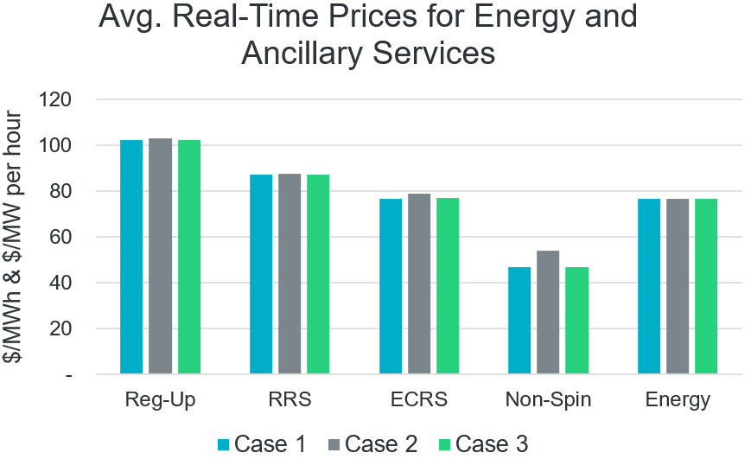

*Figure 3*

*Figure 4*

***Conclusions on having an ASDC floor in DAM and RTM***

There is a legitimate concern that DAM and RTM pricing under RTC may be insufficient to incentivize self-commitment of Resources for the tail amounts of AS required and accordingly lead to increased RUC instructions, even when there is sufficient Resource capability otherwise. $15 per MW per hour is a relatively modest ASDC price for smaller levels of shortages and the impact to average overall prices is minimal. The ASDC floors also help to decrease the levels of AS shortages when there are sufficient competitive offers. For stakeholders more concerned about the AS Plan quantities, a more thorough review of the process for determining these quantities is already underway. In the event of a change to AS quantities, any ASDC floor that is applied would automatically adjust and have less effect on outcomes overall. This is because the point on the curve at which the ASDC floor comes into effect is a function of the total quantity of the AS Plan. If the total AS Plan quantity required decreases, then the price floor will automatically reflect the new requirement level because that point may meet the curve at a point at which the floor does not apply. For instance, if the AS Plan quantity of reserves were adjusted down from 10,000 MW to 9,250 MW, the ASDC floor would not go beyond a quantity of 9,250 MW. For these reasons, ERCOT staff supports the version of NPRR1269 passed by TAC, specifically the concept of applying the ASDC floor of $15 per MW per hour to the DAM and RTM.

***ERCOT’s perspective on the AS proxy floor***

Proxy offer floors are needed when an offer is missing or does not cover the full capability of a Resource. The concept of a proxy offer exists in the current RTM and is used when an Energy Offer Curve is missing or incomplete due to human or technical issues. The Independent Market Monitor (IMM) noted that missing offers generally have historically been a limited issue and has agreed to report on missing offers.

The proposed AS proxy offer floor in NPRR 1269 as approved by TAC is a compromise that strikes a balance between concerns raised by various stakeholders. For context:

* ERCOT staff originally proposed an AS proxy offer of $0 per MW per hour.
* Certain stakeholders proposed a proxy offer of $2,000 per MW per hour.
* The compromise proxy offer floor reached is the lesser value of:
  + $2,000 per MW per hour; or
  + The point on the ASDC for the AS that intersects with a quantity that is 95% of the AS Plan for that AS product.

ERCOT’s original proposed proxy offer floor of $0 per MW per hour accomplished two of three objectives. First, it allowed the software to solve without observing unwarranted shortages in AS awards. Second, it ensured that any Market Participant that may strategically withhold their offers to benefit from a higher proxy offer price would not benefit inappropriately. However, the initial ERCOT proxy offer did not reflect marginal costs across a wide range of Resource technologies, a third objective. Furthermore, the initial proxy offer floor was viewed by many stakeholders as punitive to those Market Participants who do properly submit offers to cover the capability of their Resources because the proxy offer could be awarded ahead of competitive offers.

The stakeholder-proposed AS proxy offer floor of $2,000 per MW per hour allowed the software to solve, but raised other concerns. First, it would not prevent Market Participants that may be strategically withholding their offers from benefiting inappropriately. Also, it would ensure that under most circumstances for most Resource technologies, the proxy offer would be larger than a Resource’s marginal costs. The most concerning aspect of that proposal is that it could result in increased reliability risk by creating shortages in AS awards when a reserve shortage does not truly exist.

The proposed compromise AS proxy offer floor attempts to address concerns with strategic withholding and also reflect the value of the AS at the 95% of quantity in most circumstances. It would only be $2,000 per MW per hour when the 95% quantity value is higher. This ultimately will be a better reflection of cost across a range of Resource technologies, but at the same time mitigates improper strategic withholding of offers. Most importantly, it mitigates the reliability risk of using $2,000 per MW per hour in all cases.

The compromise AS proxy offer floor as described has been used in all of ERCOT’s ASDC analysis to date and ERCOT did not identify any concerns with these values in this analysis. Ultimately, the values represented a balance between the ERCOT and Market Participant proposals.

|  |
| --- |
| Revised Cover Page Language |

None

|  |
| --- |
| Revised Proposed Protocol Language |

None